**SMART PARKING IN IOT**

**PHASE 3: Development part 1**

**Hardware Design**

Hardware equipment that we need in order to build the project are given below:

1. Arduino UNO
2. Ultrasonic Sensor
3. LCD Screen
4. Bread Board
5. Power Supply
6. Connecting Wires

**Block Diagram**

Block Diagram of our proposed system is given below :

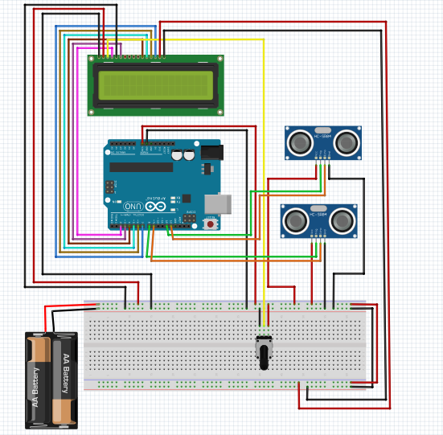

Figure-1 : Block diagram of Smart Car Parking System

**FLOW CHART**

The flow chart includes how the system works. The program flow chart is given below:

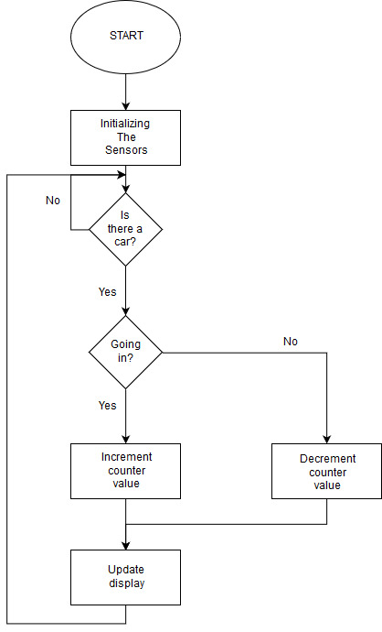

Figure-2 : Flow chart of Smart Car Parking System

**CODE:**

**import** time

**import** RPi.GPIO **as** GPIO

**import** time

**import** os,sys

**from** urllib.parse **import** urlparse

**import** paho.mqtt.client **as** paho

GPIO.setmode(GPIO.BOARD)

GPIO.setwarnings(False)

'''

define pin for lcd

'''

*# Timing constants*

E_PULSE = 0.0005

E_DELAY = 0.0005

delay = 1

*# Define GPIO to LCD mapping*

LCD_RS = 7

LCD_E = 11

LCD_D4 = 12

LCD_D5 = 13

LCD_D6 = 15

LCD_D7 = 16

slot1_Sensor = 29

slot2_Sensor = 31

GPIO.setup(LCD_E, GPIO.OUT) *# E*

GPIO.setup(LCD_RS, GPIO.OUT) *# RS*

GPIO.setup(LCD_D4, GPIO.OUT) *# DB4*

GPIO.setup(LCD_D5, GPIO.OUT) *# DB5*

GPIO.setup(LCD_D6, GPIO.OUT) *# DB6*

GPIO.setup(LCD_D7, GPIO.OUT) *# DB7*

GPIO.setup(slot1_Sensor, GPIO.IN)

GPIO.setup(slot2_Sensor, GPIO.IN)

*# Define some device constants*

LCD_WIDTH = 16 *# Maximum characters per line*

LCD_CHR = True

LCD_CMD = False

LCD_LINE_1 = 0x80 *# LCD RAM address for the 1st line*

LCD_LINE_2 = 0xC0 *# LCD RAM address for the 2nd line*

LCD_LINE_3 = 0x90*# LCD RAM address for the 3nd line*

**def on_connect**(**self**, mosq, obj, rc):

**self**.subscribe("Fan", 0)

**def on_publish**(mosq, obj, mid):

**print**("mid: " + **str**(mid))

mqttc = paho.Client() *# object declaration*

*# Assign event callbacks*

mqttc.on_connect = on_connect

mqttc.on_publish = on_publish

url_str = os.environ.get('CLOUDMQTT_URL', 'tcp://broker.emqx.io:1883')

url = urlparse(url_str)

mqttc.connect(url.hostname, url.port)

'''

Function Name :lcd_init()

Function Description : this function is used to initialized lcd by sending the different commands

'''

**def lcd_init**():

*# Initialise display*

lcd_byte(0x33,LCD_CMD) *# 110011 Initialise*

lcd_byte(0x32,LCD_CMD) *# 110010 Initialise*

lcd_byte(0x06,LCD_CMD) *# 000110 Cursor move direction*

lcd_byte(0x0C,LCD_CMD) *# 001100 Display On,Cursor Off, Blink Off*

lcd_byte(0x28,LCD_CMD) *# 101000 Data length, number of lines, font size*

lcd_byte(0x01,LCD_CMD) *# 000001 Clear display*

time.sleep(E_DELAY)

'''

Function Name :lcd_byte(bits ,mode)

Fuction Name :the main purpose of this function to convert the byte data into bit and send to lcd port

'''

**def lcd_byte**(bits, mode):

*# Send byte to data pins*

*# bits = data*

*# mode = True for character*

*# False for command*

GPIO.output(LCD_RS, mode) *# RS*

*# High bits*

GPIO.output(LCD_D4, False)

GPIO.output(LCD_D5, False)

GPIO.output(LCD_D6, False)

GPIO.output(LCD_D7, False)

**if** bits&0x10==0x10:

GPIO.output(LCD_D4, True)

**if** bits&0x20==0x20:

GPIO.output(LCD_D5, True)

**if** bits&0x40==0x40:

GPIO.output(LCD_D6, True)

**if** bits&0x80==0x80:

GPIO.output(LCD_D7, True)

*# Toggle 'Enable' pin*

lcd_toggle_enable()

*# Low bits*

GPIO.output(LCD_D4, False)

GPIO.output(LCD_D5, False)

GPIO.output(LCD_D6, False)

GPIO.output(LCD_D7, False)

**if** bits&0x01==0x01:

GPIO.output(LCD_D4, True)

**if** bits&0x02==0x02:

GPIO.output(LCD_D5, True)

**if** bits&0x04==0x04:

GPIO.output(LCD_D6, True)

**if** bits&0x08==0x08:

GPIO.output(LCD_D7, True)

*# Toggle 'Enable' pin*

lcd_toggle_enable()

'''

Function Name : lcd_toggle_enable()

Function Description:basically this is used to toggle Enable pin

'''

**def lcd_toggle_enable**():

*# Toggle enable*

time.sleep(E_DELAY)

GPIO.output(LCD_E, True)

time.sleep(E_PULSE)

GPIO.output(LCD_E, False)

time.sleep(E_DELAY)

'''

Function Name :lcd_string(message,line)

Function Description :print the data on lcd

'''

**def lcd_string**(message,line):

*# Send string to display*

message = message.ljust(LCD_WIDTH," ")

lcd_byte(line, LCD_CMD)

**for** i **in** **range**(LCD_WIDTH):

lcd_byte(**ord**(message[i]),LCD_CHR)

lcd_init()

lcd_string("welcome ",LCD_LINE_1)

time.sleep(0.5)

lcd_string("Car Parking ",LCD_LINE_1)

lcd_string("System ",LCD_LINE_2)

time.sleep(0.5)

lcd_byte(0x01,LCD_CMD) *# 000001 Clear display*

*# Define delay between readings*

delay = 5

**while** 1:

*# Print out results*

rc = mqttc.loop()

slot1_status = GPIO.**input**(slot1_Sensor)

time.sleep(0.2)

slot2_status = GPIO.**input**(slot2_Sensor)

time.sleep(0.2)

**if** (slot1_status == False):

lcd_string("Slot1 Parked ",LCD_LINE_1)

mqttc.publish("slot1","1")

time.sleep(0.2)

**else**:

lcd_string("Slot1 Free ",LCD_LINE_1)

mqttc.publish("slot1","0")

time.sleep(0.2)

**if** (slot2_status == False):

lcd_string("Slot2 Parked ",LCD_LINE_2)

mqttc.publish("slot2","1")

time.sleep(0.2)

**else**:

lcd_string("Slot2 Free ",LCD_LINE_2)

mqttc.publish("slot2","0")

time.sleep(0.2)