Assessment of Marginal Workers in Tamil Nadu – A SocioEconomic Analysis

# Preprocessing and Loading dataset:

Introduction:

* Data Validation: Loading and preprocessing allow us to check the data for errors, inconsistencies, and missing values. It's essential to ensure that our dataset is accurate and reliable for analysis.
* Data Cleaning: Preprocessing helps us to clean and fix issues in the data, such as removing duplicates, handling missing values, and dealing with outliers. Clean data leads to more robust and reliable results.
* Understanding the Data: Loading data allows you to examine its structure, dimensions, and contents. Preprocessing helps in summarizing and visualizing data, which is crucial for gaining insights and understanding its characteristics.
* Reducing Resource Usage: Preprocessing can involve reducing the memory or storage requirements of the dataset, making it more manageable for analysis.

Importing libraries:

import pandas as pd

import matplotlib.pyplot as plt

import seaborn as sns

Code:

import pandas as pd

# Load the dataset into a Pandas DataFrame

file_path = 'DDW_B06SC_3300_State_TAMIL_NADU-2011 (1).csv'

data = pd.read_csv(file_path)

# Display the first few rows of the dataset to get an overview

print(data.head())

# Check the data types of each column

print(data.dtypes)

# Summary statistics of the dataset

print(data.describe())

# Check for missing values

print(data.isnull().sum())

# If needed, you can perform additional preprocessing such as data cleaning, handling missing values, or renaming columns.

# Ensure that numeric columns are of the appropriate data type (int or float)

numeric_columns = data.columns[1:]

data[numeric_columns] = data[numeric_columns].apply(pd.to_numeric)

# Now, the dataset is loaded, and you can proceed with your data analysis and visualization.

Age group Worked for 3 months or more but less than 6 months - Persons \

0 Total 1200828

1 `5-14 27791

2 15-34 514340

3 35-59 542581

4 60+ 115103

Worked for 3 months or more but less than 6 months - Males \

0 589003

1 14125

2 259560

3 251957

4 62833

Worked for 3 months or more but less than 6 months - Females \

0 611825

1 13666

2 254780

3 290624

4 52270

Worked for less than 3 months - Persons \

0 221386

1 2447

2 92423

3 99202

4 27165

Worked for less than 3 months - Males \

0 99368

1 1247

2 43892

3 40691

4 13465

Worked for less than 3 months - Females \

0 122018

1 1200

2 48531

3 58511

4 13700

Industrial Category - A - Cultivators - Persons \

0 64235

1 1710

2 24863

3 29692

4 7930

Industrial Category - A - Cultivators - Males \

0 34632

1 825

2 12711

3 15927

4 5151

Industrial Category - A - Cultivators - Females ... \

0 29603 ...

1 885 ...

2 12152 ...

3 13765 ...

4 2779 ...

Industrial Category - N to O - Females \

0 3565

1 11

2 1754

3 1619

4 175

Industrial Category - P to Q - Persons \

0 11080

1 122

2 7536

3 3205

4 211

Industrial Category - P to Q - Males \

0 4019

1 71

2 2718

3 1131

4 93

Industrial Category - P to Q - Females \

0 7061

1 51

2 4818

3 2074

4 118

Industrial Category - R to U - HHI - Persons \

0 16833

1 427

2 8346

3 6591

4 1457

Industrial Category - R to U - HHI - Males \

0 4266

1 169

2 2127

3 1487

4 483

Industrial Category - R to U - HHI - Females \

0 12567

1 258

2 6219

3 5104

4 974

Industrial Category - R to U - Non HHI - Persons \

0 122088

1 19305

2 68929

3 26498

4 7065

Industrial Category - R to U - Non HHI - Males \

0 55801

1 9774

2 32803

3 9675

4 3394

Industrial Category - R to U - Non HHI - Females

0 66287

1 9531

2 36126

3 16823

4 3671

[5 rows x 64 columns]

Age group object

Worked for 3 months or more but less than 6 months - Persons int64

Worked for 3 months or more but less than 6 months - Males int64

Worked for 3 months or more but less than 6 months - Females int64

Worked for less than 3 months - Persons int64

...

Industrial Category - R to U - HHI - Males int64

Industrial Category - R to U - HHI - Females int64

Industrial Category - R to U - Non HHI - Persons int64

Industrial Category - R to U - Non HHI - Males int64

Industrial Category - R to U - Non HHI - Females int64

Length: 64, dtype: object

Worked for 3 months or more but less than 6 months - Persons \

count 6.000000e+00

mean 4.002760e+05

std 4.590478e+05

min 1.013000e+03

25% 4.961900e+04

50% 3.147215e+05

75% 5.355208e+05

max 1.200828e+06

Worked for 3 months or more but less than 6 months - Males \

count 6.000000

mean 196334.333333

std 223894.178166

min 528.000000

25% 26302.000000

50% 157395.000000

75% 257659.250000

max 589003.000000

Worked for 3 months or more but less than 6 months - Females \

count 6.000000

mean 203941.666667

std 235402.173170

min 485.000000

25% 23317.000000

50% 153525.000000

75% 281663.000000

max 611825.000000

Worked for less than 3 months - Persons \

count 6.000000

mean 73795.333333

std 84219.057978

min 149.000000

25% 8626.500000

50% 59794.000000

75% 97507.250000

max 221386.000000

Worked for less than 3 months - Males \

count 6.000000

mean 33122.666667

std 37567.179424

min 73.000000

25% 4301.500000

50% 27078.000000

75% 43091.750000

max 99368.000000

Worked for less than 3 months - Females \

count 6.000000

mean 40672.666667

std 46756.236588

min 76.000000

25% 4325.000000

50% 31115.500000

75% 56016.000000

max 122018.000000

Industrial Category - A - Cultivators - Persons \

count 6.000000

mean 21411.666667

std 24252.722080

min 40.000000

25% 3265.000000

50% 16396.500000

75% 28484.750000

max 64235.000000

Industrial Category - A - Cultivators - Males \

count 6.000000

mean 11544.000000

std 12978.785829

min 18.000000

25% 1906.500000

50% 8931.000000

75% 15123.000000

max 34632.000000

Industrial Category - A - Cultivators - Females \

count 6.000000

mean 9867.666667

std 11293.940104

min 22.000000

25% 1358.500000

50% 7465.500000

75% 13361.750000

max 29603.000000

Industrial Category - A - Agricultural labourers - Persons ... \

count 6.00000 ...

mean 302584.00000 ...

std 348616.58324 ...

min 557.00000 ...

25% 31129.75000 ...

50% 225372.50000 ...

75% 423894.00000 ...

max 907752.00000 ...

Industrial Category - N to O - Females \

count 6.000000

mean 1188.333333

std 1411.727122

min 6.000000

25% 52.000000

50% 897.000000

75% 1720.250000

max 3565.000000

Industrial Category - P to Q - Persons \

count 6.000000

mean 3693.333333

std 4648.545909

min 6.000000

25% 144.250000

50% 1708.000000

75% 6453.250000

max 11080.000000

Industrial Category - P to Q - Males \

count 6.000000

mean 1339.666667

std 1677.172104

min 6.000000

25% 76.500000

50% 612.000000

75% 2321.250000

max 4019.000000

Industrial Category - P to Q - Females \

count 6.000000

mean 2353.666667

std 2971.543886

min 0.000000

25% 67.750000

50% 1096.000000

75% 4132.000000

max 7061.000000

Industrial Category - R to U - HHI - Persons \

count 6.000000

mean 5611.000000

std 6478.460959

min 12.000000

25% 684.500000

50% 4024.000000

75% 7907.250000

max 16833.000000

Industrial Category - R to U - HHI - Males \

count 6.000000

mean 1422.000000

std 1616.378669

min 0.000000

25% 247.500000

50% 985.000000

75% 1967.000000

max 4266.000000

Industrial Category - R to U - HHI - Females \

count 6.000000

mean 4189.000000

std 4865.908425

min 12.000000

25% 437.000000

50% 3039.000000

75% 5940.250000

max 12567.000000

Industrial Category - R to U - Non HHI - Persons \

count 6.000000

mean 40696.000000

std 46571.506791

min 291.000000

25% 10125.000000

50% 22901.500000

75% 58321.250000

max 122088.000000

Industrial Category - R to U - Non HHI - Males \

count 6.000000

mean 18600.333333

std 21515.733645

min 155.000000

25% 4964.250000

50% 9724.500000

75% 27045.750000

max 55801.000000

Industrial Category - R to U - Non HHI - Females

count 6.000000

mean 22095.666667

std 25128.037565

min 136.000000

25% 5136.000000

50% 13177.000000

75% 31300.250000

max 66287.000000

[8 rows x 63 columns]

Age group 0

Worked for 3 months or more but less than 6 months - Persons 0

Worked for 3 months or more but less than 6 months - Males 0

Worked for 3 months or more but less than 6 months - Females 0

Worked for less than 3 months - Persons 0

..

Industrial Category - R to U - HHI - Males 0

Industrial Category - R to U - HHI - Females 0

Industrial Category - R to U - Non HHI - Persons 0

Industrial Category - R to U - Non HHI - Males 0

Industrial Category - R to U - Non HHI - Females 0

Length: 64, dtype: int64

import pandas as pd

import matplotlib.pyplot as plt

import seaborn as sns

# Print the column names in your dataset

print(data.columns)

# Load the dataset into a Pandas DataFrame

file_path = 'DDW_B06SC_3300_State_TAMIL_NADU-2011 (1).csv'

data = pd.read_csv(file_path)

Index(['Age group',

'Worked for 3 months or more but less than 6 months - Persons',

'Worked for 3 months or more but less than 6 months - Males',

'Worked for 3 months or more but less than 6 months - Females',

'Worked for less than 3 months - Persons',

'Worked for less than 3 months - Males',

'Worked for less than 3 months - Females',

'Industrial Category - A - Cultivators - Persons',

'Industrial Category - A - Cultivators - Males',

'Industrial Category - A - Cultivators - Females',

'Industrial Category - A - Agricultural labourers - Persons',

'Industrial Category - A - Agricultural labourers - Males',

'Industrial Category - A - Agricultural labourers - Females',

'Industrial Category - A - Plantation, Livestock, Forestry, Fishing, Hunting and allied activities - Persons',

'Industrial Category - A - Plantation, Livestock, Forestry, Fishing, Hunting and allied activities - Males',

'Industrial Category - A - Plantation, Livestock, Forestry, Fishing, Hunting and allied activities - Females',

'Industrial Category - B - Persons', 'Industrial Category - B - Males',

'Industrial Category - B - Females',

'Industrial Category - C - HHI - Persons',

'Industrial Category - C - HHI - Males',

'Industrial Category - C - HHI - Females',

'Industrial Category - C - Non HHI - Persons',

'Industrial Category - C - Non HHI - Males',

'Industrial Category - C - Non HHI - Females',

'Industrial Category - D & E - Persons',

'Industrial Category - D & E - Males',

'Industrial Category - D & E - Females',

'Industrial Category - F - Persons', 'Industrial Category - F - Males',

'Industrial Category - F - Females',

'Industrial Category - G - HHI - Persons',

'Industrial Category - G - HHI - Males',

'Industrial Category - G - HHI - Females',

'Industrial Category - G - Non HHI - Persons',

'Industrial Category - G - Non HHI - Males',

'Industrial Category - G - Non HHI - Females',

'Industrial Category - H - Persons', 'Industrial Category - H - Males',

'Industrial Category - H - Females',

'Industrial Category - I - Persons', 'Industrial Category - I - Males',

'Industrial Category - I - Females',

'Industrial Category - J - HHI - Persons',

'Industrial Category - J - HHI - Males',

'Industrial Category - J - HHI - Females',

'Industrial Category - J - Non HHI - Persons',

'Industrial Category - J - Non HHI - Males',

'Industrial Category - J - Non HHI - Females',

'Industrial Category - K to M - Persons',

'Industrial Category - K to M - Males',

'Industrial Category - K to M - Females',

'Industrial Category - N to O - Persons',

'Industrial Category - N to O - Males',

'Industrial Category - N to O - Females',

'Industrial Category - P to Q - Persons',

'Industrial Category - P to Q - Males',

'Industrial Category - P to Q - Females',

'Industrial Category - R to U - HHI - Persons',

'Industrial Category - R to U - HHI - Males',

'Industrial Category - R to U - HHI - Females',

'Industrial Category - R to U - Non HHI - Persons',

'Industrial Category - R to U - Non HHI - Males',

'Industrial Category - R to U - Non HHI - Females'],

dtype='object')

import pandas as pd

import matplotlib.pyplot as plt

import seaborn as sns

# Load the dataset into a Pandas DataFrame

file_path = 'DDW_B06SC_3300_State_TAMIL_NADU-2011 (1).csv'

data = pd.read_csv(file_path)

# Example 1: Bar Chart

# Create a bar chart to visualize the total number of marginal workers in different age groups.

age_groups = data['Age group']

total_workers_3_6_months = data['Worked for 3 months or more but less than 6 months - Males']

plt.figure(figsize=(10, 6))

plt.bar(age_groups, total_workers_3_6_months)

plt.title('Total Number of Marginal Workers Working 3-6 Months by Age Group')

plt.xlabel('Age Group')

plt.ylabel('Total Count')

plt.xticks(rotation=45)

plt.tight_layout()

plt.show()

# Example 2: Pie Chart

# Create a pie chart to show the distribution of marginal workers by age group.

plt.figure(figsize=(6, 6))

plt.pie(total_workers_3_6_months, labels=age_groups, autopct='%1.1f%%', startangle=140)

plt.title('Distribution of Marginal Workers Working 3-6 Months by Age Group')

plt.axis('equal')

plt.show()

# Example 3: Heatmap

# Create a heatmap to visualize the correlation between age groups and the total number of workers.

# Select relevant columns for correlation analysis

correlation_data = data[['Age group', 'Worked for 3 months or more but less than 6 months - Males']]

# Convert age group to a numerical representation

age_group_mapping = {age_group: index for index, age_group in enumerate(age_groups)}

correlation_data['Age group'] = correlation_data['Age group'].map(age_group_mapping)

plt.figure(figsize=(8, 6))

sns.heatmap(correlation_data.corr(), annot=True, cmap='coolwarm', linewidths=0.5)

plt.title('Correlation Heatmap: Age Group vs. Workers (3-6 Months)')

plt.xlabel('Age Group')

plt.ylabel('Workers (3-6 Months)')

plt.tight_layout()

plt.show()

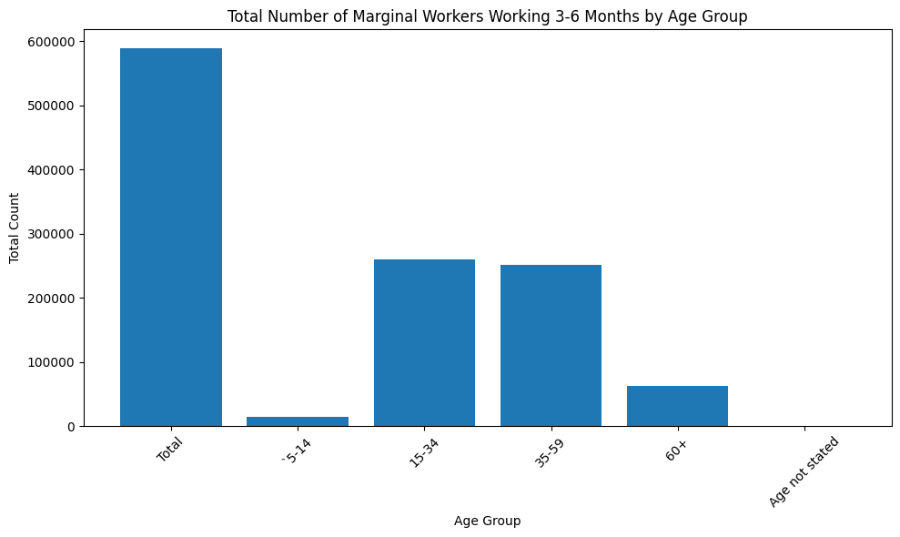

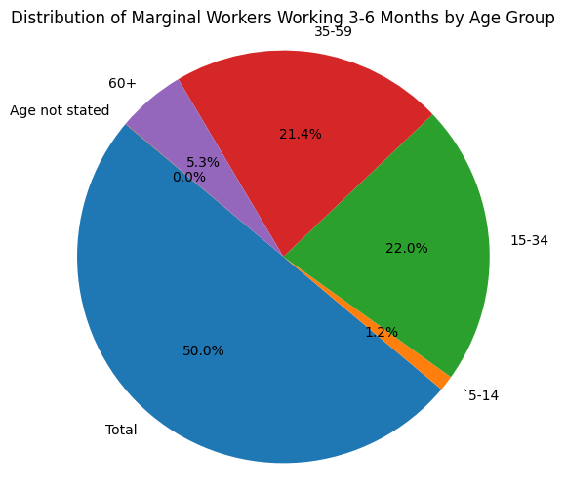

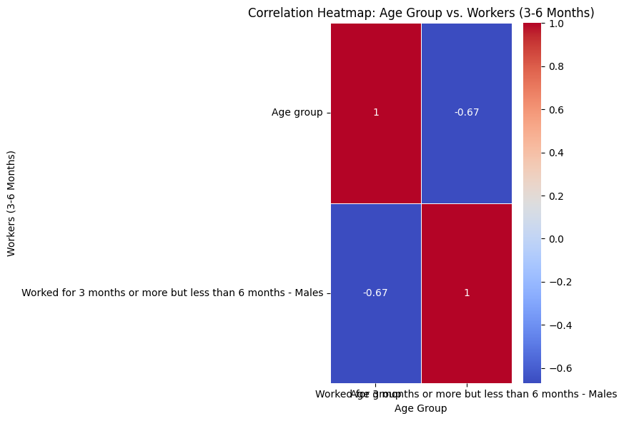

Conclusion:

Loading and Preprocessing datasets in Python are fundamental steps in the data analysis process. They ensure that the data is of high quality, appropriately structured, and optimized for analysis, ultimately leading to better insights and more accuracy.