Assessment of Marginal Workers in Tamil Nadu

Demographic analysis and Visualization :

The aim is to perform a demographic analysis and create visualizations of the marginal workers in Tamil Nadu based on their industrial category, age and sex. The data for this analysis is obtained from the Census of India 2011, which provides information of the marginal workers classified by various criteria, such as age, sex and industry. The data is aggregated and manipulated using spreadsheet(Excel) and Python programming language to calculate the percentage and number of marginal workers in different age groups and industrial category. The results are then visualized using data visualization libraries(matplotlib and seaborn) to create charts and graphs that show the patterns and trends of marginal workers in Tamil Nadu. This analysis provides some recommendations for further research and policy interventions.

1. Visualization of Cultivators :

import pandas as pd

import matplotlib.pyplot as plt

import seaborn as sns

# Load the dataset into a Pandas DataFrame

file_path = '/content/DDW_B06SC_3300_State_TAMIL_NADU-2011.csv'

data = pd.read_csv(file_path)

# Example 1: Bar Chart

# Create a bar chart to visualize the total number of marginal workers in different age groups.

age_groups = data['Age group']

Industrial_category= data['Cultivators']

plt.figure(figsize=(5, 5))

plt.bar(age_groups, Industrial_category)

plt.title('Cultivators')

plt.xlabel('Age Group')

plt.ylabel('Total Count')

plt.xticks(rotation=45)

plt.tight_layout()

plt.show()

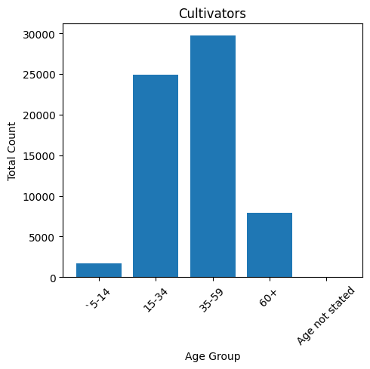

The industrial category(Cultivators) consists most workers belonging to 35-59 age group.

1. Visualization of Agricultural laborers :

age_groups = data['Age group']

Industrial_category= data['Agricultural labourers']

plt.figure(figsize=(5, 5))

plt.bar(age_groups, Industrial_category)

plt.title('Agricultural labourers')

plt.xlabel('Age Group')

plt.ylabel('Total Count')

plt.xticks(rotation=45)

plt.tight_layout()

plt.show()

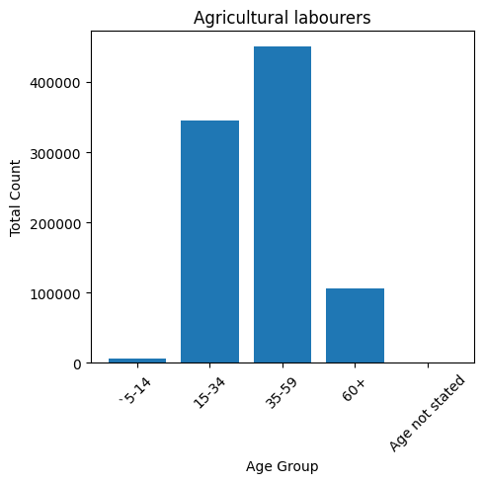

The industrial category(Agricultural laborer’s) consists most workers belonging to 35-59 age group.

1. Visualization of Hunters and allied activists :

age_groups = data['Age group']

Industrial_category= data['Hunting and allied activities']

plt.figure(figsize=(5, 5))

plt.bar(age_groups, Industrial_category)

plt.title('Hunting and allied activities')

plt.xlabel('Age Group')

plt.ylabel('Total Count')

plt.xticks(rotation=45)

plt.tight_layout()

plt.show()

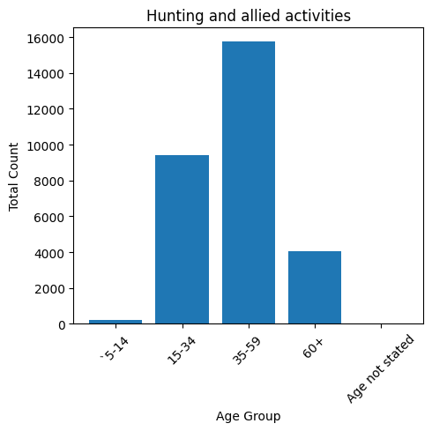

The industrial category(Hunting and allied activities) consists most workers belonging to 35-59 age group.

1. Visualization of Industrial Category B Workers :

age_groups = data['Age group']

Industrial_category= data['Industrial Category - B ']

plt.figure(figsize=(5, 5))

plt.bar(age_groups, Industrial_category)

plt.title('Industrial Category - B ')

plt.xlabel('Age Group')

plt.ylabel('Total Count')

plt.xticks(rotation=45)

plt.tight_layout()

plt.show()

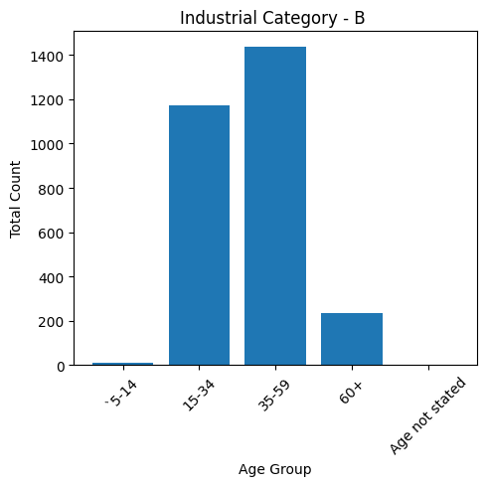

The industrial category(Industrial Category – B) consists most workers belonging to 35-59 age group.

1. Visualization of Category – C – HHI Workers :

age_groups = data['Age group']

Industrial_category= data['Category - C - HHI']

plt.figure(figsize=(5, 5))

plt.bar(age_groups, Industrial_category)

plt.title('Category - C - HHI')

plt.xlabel('Age Group')

plt.ylabel('Total Count')

plt.xticks(rotation=45)

plt.tight_layout()

plt.show()

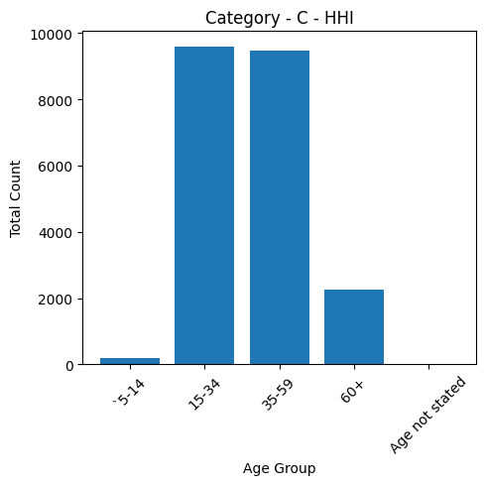

The industrial category(Category – C - HHI) consists most workers belonging to 15-34 age group.

1. Visualization of Category – C – Non HHI Workers :

age_groups = data['Age group']

Industrial_category= data['Category - C - Non HHI']

plt.figure(figsize=(5, 5))

plt.bar(age_groups, Industrial_category)

plt.title('Category - C - Non HHI')

plt.xlabel('Age Group')

plt.ylabel('Total Count')

plt.xticks(rotation=45)

plt.tight_layout()

plt.show()

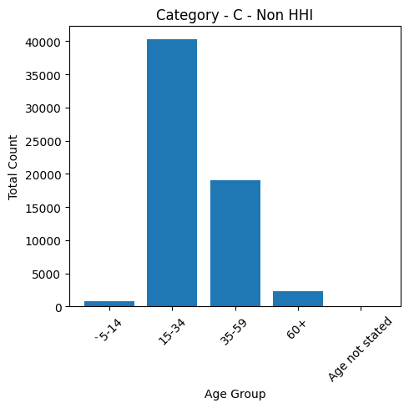

The industrial category(Category – C – Non HHI) consists most workers belonging to 15-34 age group.

1. Visualization of Category – D&E Workers :

age_groups = data['Age group']

Industrial_category= data['Category - D & E']

plt.figure(figsize=(5, 5))

plt.bar(age_groups, Industrial_category)

plt.title('Category - D & E')

plt.xlabel('Age Group')

plt.ylabel('Total Count')

plt.xticks(rotation=45)

plt.tight_layout()

plt.show()

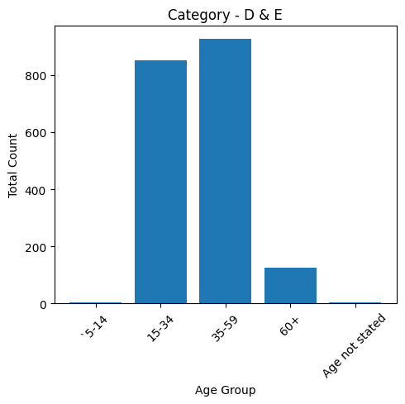

The industrial category(Category – D&E­) consists most workers belonging to 35-59 age group.

1. Visualization of Category – F Workers :

age_groups = data['Age group']

Industrial_category= data['Category - F']

plt.figure(figsize=(5, 5))

plt.bar(age_groups, Industrial_category)

plt.title('Category - F')

plt.xlabel('Age Group')

plt.ylabel('Total Count')

plt.xticks(rotation=45)

plt.tight_layout()

plt.show()

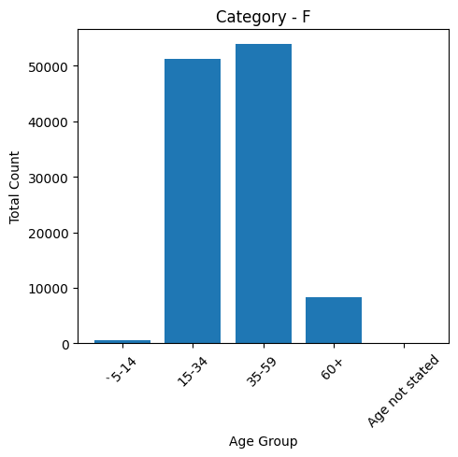

The industrial category(Category - F) consists most workers belonging to 35-59 age group.

1. Visualization of Category – G – Non HHI Workers :

age_groups = data['Age group']

Industrial_category= data['Category - G - Non HHI']

plt.figure(figsize=(5, 5))

plt.bar(age_groups, Industrial_category)

plt.title('Category - G - Non HHI')

plt.xlabel('Age Group')

plt.ylabel('Total Count')

plt.xticks(rotation=45)

plt.tight_layout()

plt.show()

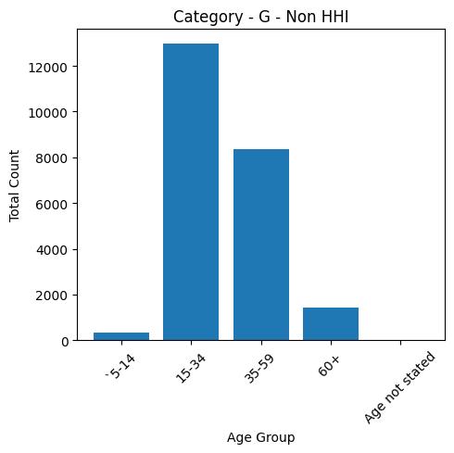

The industrial category(Category - G – Non HHI) consists most workers belonging to 15-34 age group.

1. Visualization of Category – H Workers :

age_groups = data['Age group']

Industrial_category= data['Category - H']

plt.figure(figsize=(5, 5))

plt.bar(age_groups, Industrial_category)

plt.title('Category - H')

plt.xlabel('Age Group')

plt.ylabel('Total Count')

plt.xticks(rotation=45)

plt.tight_layout()

plt.show()

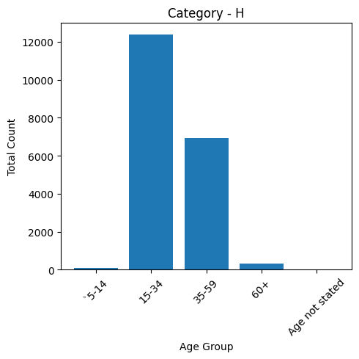

The industrial category(Category - H) consists most workers belonging to 15-34 age group.

1. Visualization of Category – I Workers :

age_groups = data['Age group']

Industrial_category= data['Category - I']

plt.figure(figsize=(5, 5))

plt.bar(age_groups, Industrial_category)

plt.title('Category - I')

plt.xlabel('Age Group')

plt.ylabel('Total Count')

plt.xticks(rotation=45)

plt.tight_layout()

plt.show()

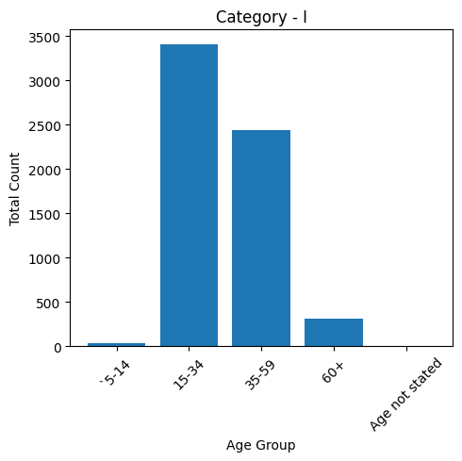

The industrial category(Category - I) consists most workers belonging to 15-34 age group.

1. Visualization of Category – J – HHI Workers :

age_groups = data['Age group']

Industrial_category= data['Category - J - HHI']

plt.figure(figsize=(5, 5))

plt.bar(age_groups, Industrial_category)

plt.title('Category - J - HHI')

plt.xlabel('Age Group')

plt.ylabel('Total Count')

plt.xticks(rotation=45)

plt.tight_layout()

plt.show()

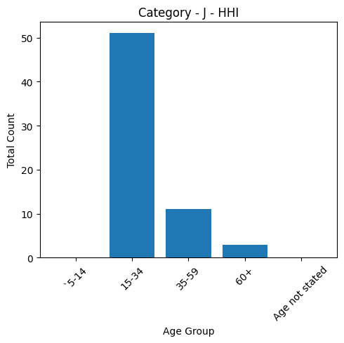

The industrial category(Category – J - HHI) consists most workers belonging to 15-34 age group.

1. Visualization of Category – J – Non HHI Workers :

age_groups = data['Age group']

Industrial_category= data['Category - J - Non HHI']

plt.figure(figsize=(5, 5))

plt.bar(age_groups, Industrial_category)

plt.title('Category - J - Non HHI')

plt.xlabel('Age Group')

plt.ylabel('Total Count')

plt.xticks(rotation=45)

plt.tight_layout()

plt.show()

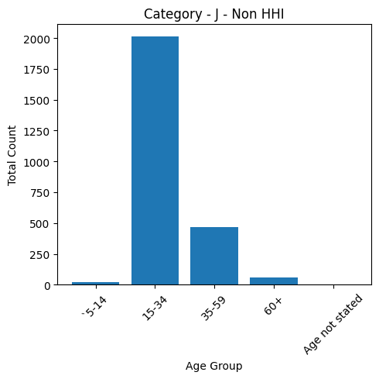

The industrial category(Category – J - Non HHI) consists most workers belonging to 15-34 age group.

1. Visualization of Category – K to M Workers :

age_groups = data['Age group']

Industrial_category= data['Category - K to M']

plt.figure(figsize=(5, 5))

plt.bar(age_groups, Industrial_category)

plt.title('Category - K to M  ')

plt.xlabel('Age Group')

plt.ylabel('Total Count')

plt.xticks(rotation=45)

plt.tight_layout()

plt.show()

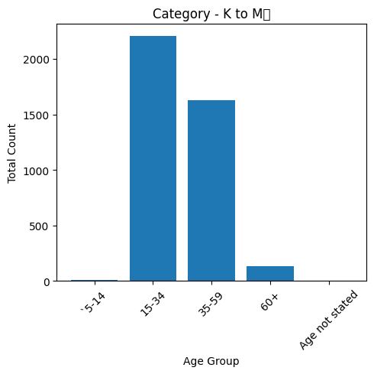

The industrial category(Category - K to M) consists most workers belonging to 15-34 age group.

1. Visualization of Category – N to O Workers :

age_groups = data['Age group']

Industrial_category= data['Category - N to O']

plt.figure(figsize=(5, 5))

plt.bar(age_groups, Industrial_category)

plt.title('Category - N to O')

plt.xlabel('Age Group')

plt.ylabel('Total Count')

plt.xticks(rotation=45)

plt.tight_layout()

plt.show()

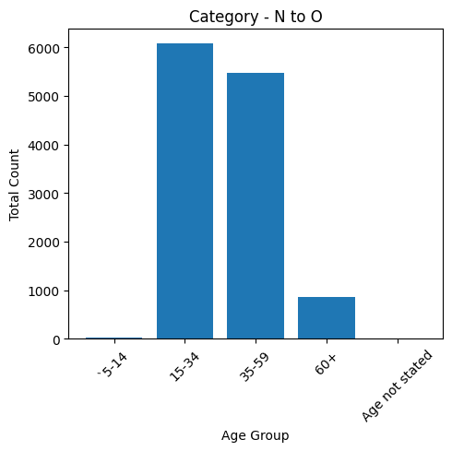

The industrial category(Category – N to O) consists most workers belonging to 15-34 age group.

1. Visualization of Category – P to Q Workers :

age_groups = data['Age group']

Industrial_category= data['Category - P to Q']

plt.figure(figsize=(5, 5))

plt.bar(age_groups, Industrial_category)

plt.title('Category - P to Q')

plt.xlabel('Age Group')

plt.ylabel('Total Count')

plt.xticks(rotation=45)

plt.tight_layout()

plt.show()

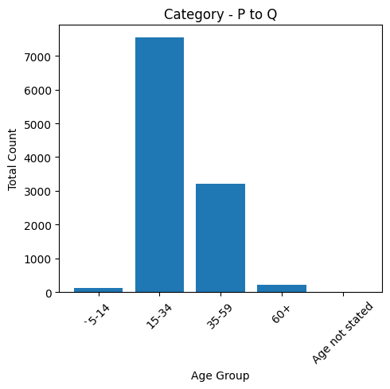

The industrial category(Category – P to Q) consists most workers belonging to 15-34 age group.

1. Visualization of Category – R to U HHI Workers :

age_groups = data['Age group']

Industrial_category= data['Category - R to U - HHI']

plt.figure(figsize=(5, 5))

plt.bar(age_groups, Industrial_category)

plt.title('Category - R to U - HHI')

plt.xlabel('Age Group')

plt.ylabel('Total Count')

plt.xticks(rotation=45)

plt.tight_layout()

plt.show()

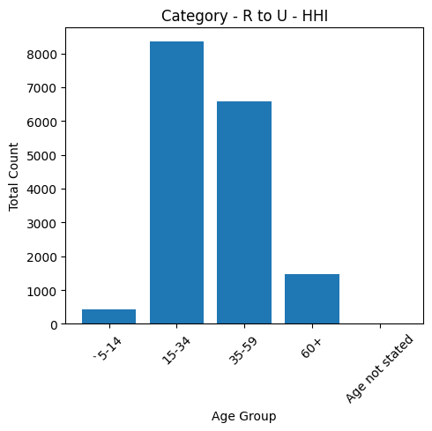

The industrial category(Category – R to U - HHI) consists most workers belonging to 15-34 age group.

1. Visualization of Category – R to U Non HHI Workers :

age_groups = data['Age group']

Industrial_category= data['Category - R to U - Non HHI']

plt.figure(figsize=(5, 5))

plt.bar(age_groups, Industrial_category)

plt.title('Category - R to U - Non HHI')

plt.xlabel('Age Group')

plt.ylabel('Total Count')

plt.xticks(rotation=45)

plt.tight_layout()

plt.show()

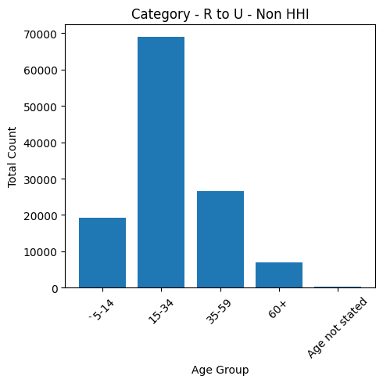

The industrial category(Category – R to U - Non HHI) consists most workers belonging to 15-34 age group.

1. Visualization of Different Industrial Categories Workers :

#import the libraries

import pandas as pd

import matplotlib.pyplot as plt

#providing the dataset to visualise

data = pd.read_csv('/content/industrial_category.csv')

categories = data['Industrial categories']

values = data['total number of workers']

#plot the pie chart

plt.figure(figsize=(8, 18))

plt.pie(values, labels=categories, autopct='%1.1f%%', startangle=0)

plt.title('Percentage of Workers in Different Industrial Categories')

plt.show()

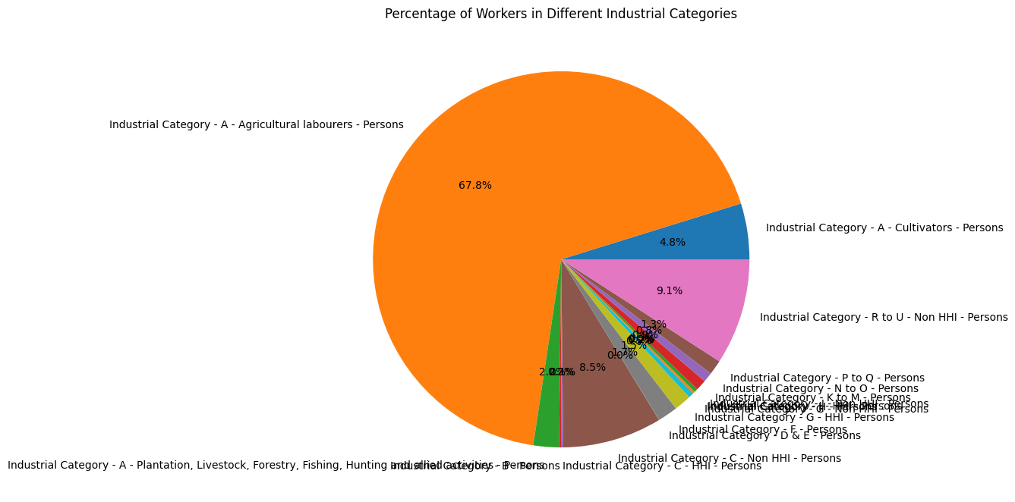

The above visualization shows that 67.8% of workers are Agricultural laborer’s which is the majority industry in Tamil Nadu.

1. Visualization of Different Age group Workers :

#import the libraries

import pandas as pd

import matplotlib.pyplot as plt

#providing the dataset to visualise

data = pd.read_csv('/content/dataset.csv')

categories = data['Age group']

values = data['sumation']

#plot the pie chart

plt.figure(figsize=(8, 18))

plt.pie(values, labels=categories, autopct='%1.1f%%', startangle=0)

plt.title('Percentage of Workers in Different Age groups’)

plt.show()

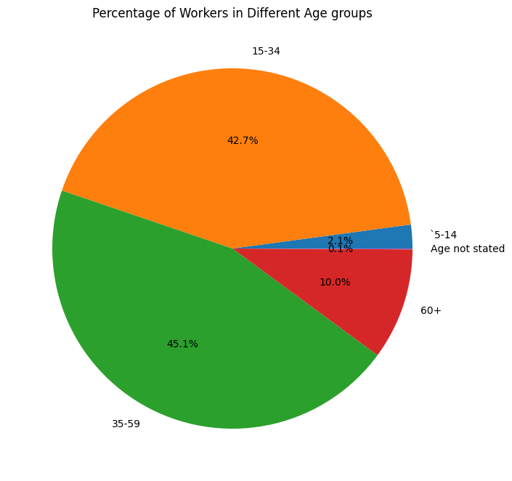

The above visualization shows that the workers under the age group of 35-59 are the majority workers in Tamil Nadu(45.1%) followed by the workers under the age group 15-34 (42.7%).

Conclusion:

The bar charts helps to analyze the age distribution of marginal workers which offers a concise and informative snapshot of this demographic group and the pie chart helps to analyze the workers in different industrial categories. This visualization is a valuable resource for policymakers, researchers, and stakeholders seeking to better understand the age and economic state of marginal workers in Tamil Nadu.