

**OBJECTIVE**:

Mark Analyzer is student –friendly application to notice them their reports

Periodically.

**USERS**:

* Admin
* Faculties
* Students

**Functional Requirements**:

* Create an application to be a helper for students to notify and advise

About their reports.

* It must have login, profile, home page and data for the marks.
* It should be safe and secure to the user and administration.
* The application should allow the admin, faculties to change,

Update, replace marks and performance of the students.

* Should represent data in graphical form to check whether he/she is

Improving or not, and appreciate or advise respectively.

* Should collect information from student whether they like the app.
* Give some reference that Helps the student to improve at the point

Where they lag.

* To permit the admin to know all details.
* Helps Student to contact Faculty.

**Post Condition:**

* To be seen by the admin whether the student is aware of their report.
* To store reports in a separate file that can be acc3essed by admin.

**Non-Functional Requirements:**

**Security**

* App platform –User Name/Password-Based Credentials.
* Should not accessed by any anonymous.

**Performance:**

* Overall Performance -<10s

**Availability**

* For all.

**Standard Features:**

* Scalability
* Maintainability
* Usability

**Logging & Auditing**

* The app must login with any Devices.

**Browser Compatibility:**

* Must be accessed by all browsers.

**Technology Stack:**

**Database**: MySQL or Oracle or MSSQL

**Key points to remember**:

* The id (frontend) and attributes(backend) mentioned in the SRS should not be

Altered.

**Application assumptions:**

* The First page should be the login page.
* Without logging in the user cannot access the dashboard.
* Use admin and their password to login in to their specific Dashboard.

**Validations:**

* Email must be same as given in institution.
* Password should be changed as the will of user.

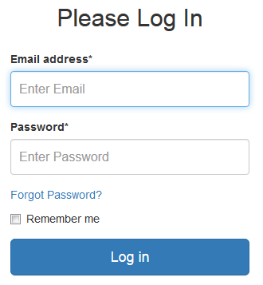

**Frontend:**

**Student:**

1. **Login**: Design a Login page for students where the students of the institution

can log using the registered username and password.

2. **Dashboard:** Design a home page and name it as *dashboard* and the navigation

bar and lists and all the reports a scored by time available with appropriate filters.

3.**Reports and Feedback**: Design a report named *mark secured* and another

Component as *Feedback* as the remarks for the score he/she secured.

**Faculty:**

1.**Login**: There should be another option as teachers and faculties and they

Should login with user id and password.

2.**Dashboard**: The home page must be named as *Dashboard* and the

Navigation bar must contain option as follows:

* Mark deleting
* Mark editing
* Mark Updating

***Admin:***

1.**Login**: An Option should be allotted for admin to login with their User id

and password.

2.**Dashboard**: The Home page must be named as *Admin’s Page* and the

Navigation bar must show options like:

* Student’s Performance
* Faculties Response.

3.**Editing options**: The admin should be shown some special options

Such as removing a participant from the application in case of misuse.

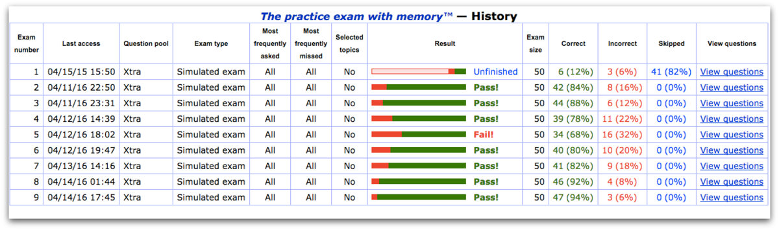

**Backend:**

**Class and Method description:**

1. **Login Mode**l:

Email: String

Password: string

**Controller Layer:**

2) **Login Controller:** To control the user login.

1. **Method:**

I. CheckUser (Login Data): This method helps the user to sign up for the application

And must return true or false.

3) **Score controller:** To control the update/delete/edit of score board and for admin

To report the user.

A) To help the faculty to edit the score.

B) To help the admin to change to overview to status of each student.

C) To help the admin to access special functions.