1. Using Java 8 Map Functional, Stream and Collectors, Create a Java program for the following:

a. Convert String to uppercase and join them with comma(,)

b. Convert a List with String more than 2 characters and count number of String which starts with ‘a’ and count empty string.

*Examples of Strings:* “abc”, “an”, “”, “apple”, “bcd”, ””, ”jk”

**a. Convert String to uppercase and join them with comma(,)**

**With own defined Strings**

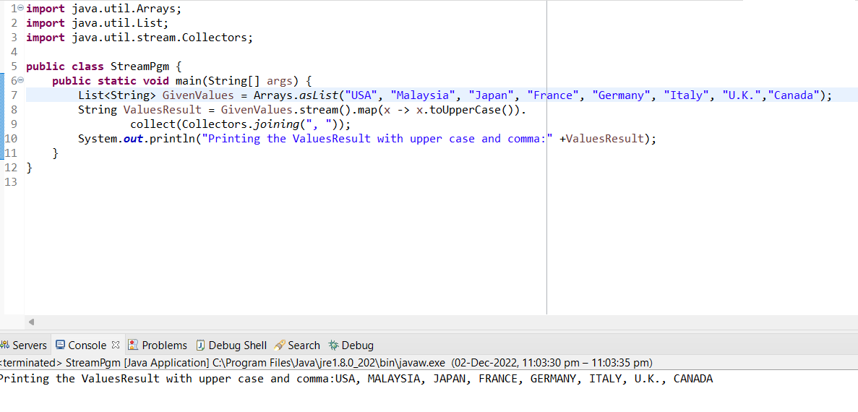

**With the given example of Strings**

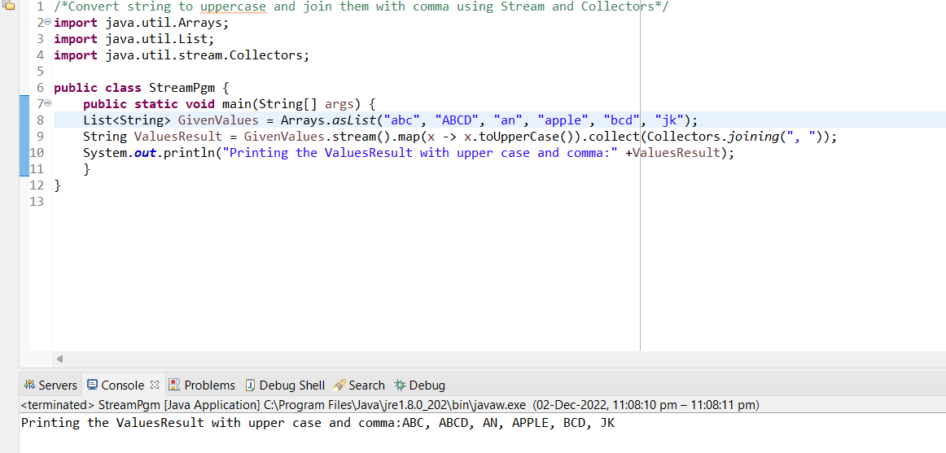

**With own defined Strings**

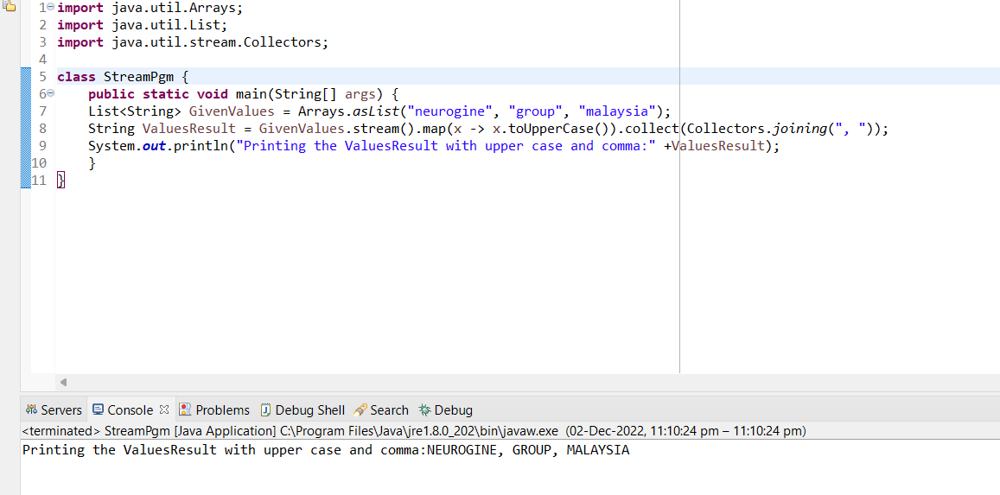

**b. Convert a List with String more than 2 characters and count number of String which starts with ‘a’ and count empty string.**

