**Banknote Classification Dataset**

Banknotes are one of the most important assets of a country. Some miscreants introduce fake notes which bear a resemblance to original note to create discrepancies of the money in the financial market. It is difficult for humans to tell true and fake banknotes apart especially because they have a lot of similar features. Fake notes are created with precision, hence there is need for an efficient algorithm (ANN) which accurately predicts whether a banknote is genuine or not.

**The first step is to define and explore the dataset.**

We will be working with the “Banknote” standard binary classification dataset.

The banknote dataset involves predicting whether a given banknote is authentic given a number of measures taken from a photograph.

The dataset contains 1,372 rows with 5 numeric variables. It is a classification problem with two classes (binary classification).

Below provides a list of the five variables in the dataset.

1.variance of Wavelet Transformed image (continuous).

2.skewness of Wavelet Transformed image (continuous).

3.kurtosis of Wavelet Transformed image (continuous).

4.entropy of image (continuous).

5.class (integer).

**Result And Analysis**:

Performance Measure Following measures have been used to measure the performance of the models implemented

• Accuracy – The accuracy of the test is its ability to differentiate the genuine and fake note test cases correctly. Accuracy = (TP +TN)/(TP+TN + FP + FN)

• Sensitivity - The sensitivity of a test is its ability to determine the genuine note cases correctly. Sensitivity = TP/(TP + FN)

• Specificity - The specificity of a test is its ability to determine the fake note cases correctly. Specificity = TN /(TN + FP)

• Precision - The precision of a test is its ability to determine the number of notes that classifier labeled as genuine is actually genuine Precision = TP/(TP + FP)

Where,

• True Positive (TP) = the number of cases correctly identified as genuine notes.

• True negative (TN) = the number of cases correctly identified as fake notes.

• False positive (FP) = the number of cases incorrectly identified as genuine notes.

• False negative (FN) = the number of cases incorrectly identified as fake notes.

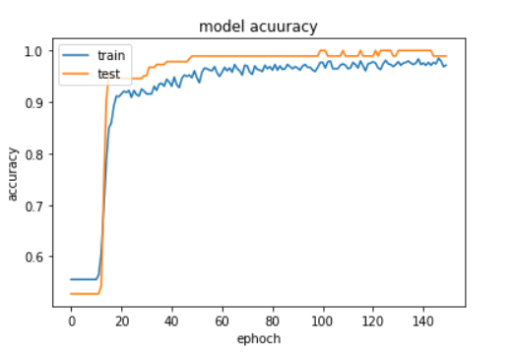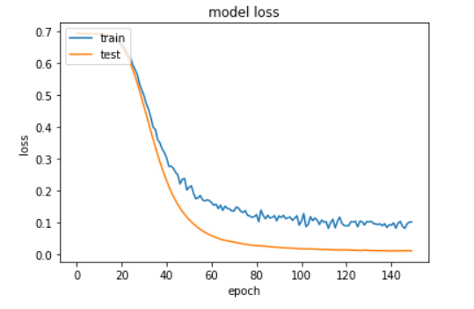

**CONCLUSION**

After analyzing ANN techniques used to detect forged banknotes. ROC and other metrics have been calculated to compare the performances of both the techniques. The result shows that back-propagation neural network outperforms and gives 100% success rate. These techniques are an efficient way of solving the problem for all banking machines that accept all types of notes. In future, this work can be extended by categorizing the notes into different categories as Genuine, Low-Quality forgery, High-Quality forgery, Inappropriate ROI.