S. Bala Sai Shankar  20/64, Periyannan Street,  Namakkal – 637 001.  Mail : bs77890@yahoo.com  Cell : 99941 46188 | 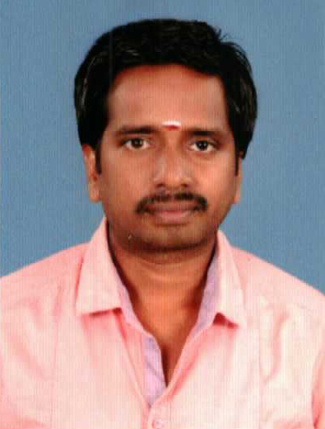

Objective
To get a challenging and developing job.
Am flexible & willing to work on any department in any branch.

Work Experience - (BPO 9 years)
Working as Wedding album designer.
Worked as an administrator in HCL learning centre, Namakkal (May1, 2012 - August-31, 2012).
Worked as senior process associate in Tata Consultancy Services, Chennai ( july2006 - Feb2012).
Worked as a data entry operator in Trendz facilities management, Chennai (March2003-July2006).

Skills
Package : Excel, Mail Communication, Photo Shop, Typing.

Academic Details
Qualified B.A. (Psychology) in the year 2000.

Personal Details

Name : S. Bala Sai Shankar.

Date of birth : 18-05-1977.

Nationality : Indian.

Religion : Hindu.

Marital Status : Married.

Languages Known : Tamil, English, Telugu (speak only).

I do hereby declare that all the above furnished details are true to my knowledge.

Date : (S. Bala Sai Shankar)

