Step 1
Created an ec2 instance, ubuntu as OS, and set up the security group ssh (22) and http (80)

Step 2 software installation, used the below commands to install the packages.

sudo apt update && sudo apt upgrade -y
sudo apt install git nginx -y
curl -fsSL https://deb.nodesource.com/setup_18.x | sudo -E bash -
sudo apt install nodejs -y
sudo npm install -g pm2

step 3 cloned the git repository
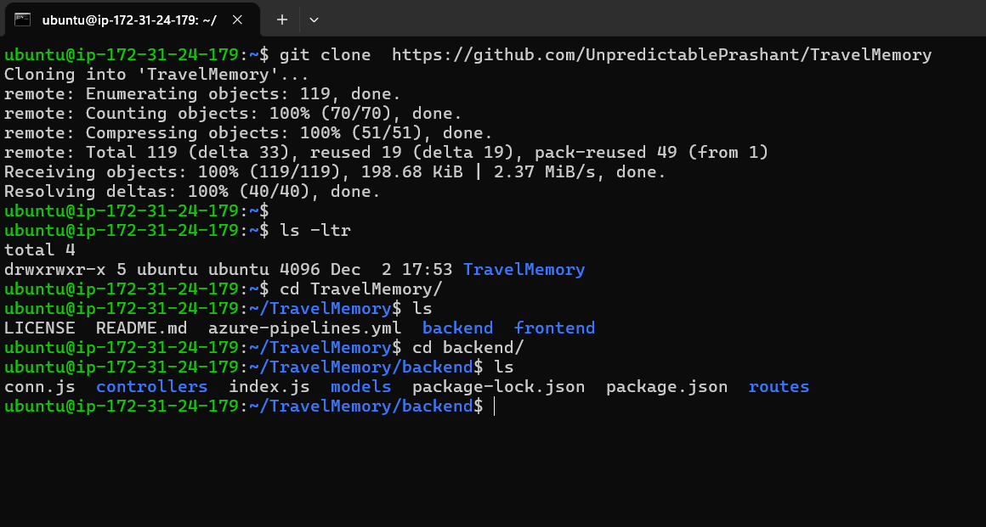
Step 4 Backend setup
cd backend
npm install

created .env file, included following part,
PORT=3000
MONGO_URL=your MongoDB Atlas connection

Step5 started the back-end server with the commands
pm2 start index.js
pm2 save

Step 6 frontend setup
cd ../frontend
npm install

build
npm run build
copied the build files to the nginx folder
sudo rm -rf /var/www/html/*
sudo cp -r build/* /var/www/html/

Step7- Configuring the Nginx server
sudo nano /etc/nginx/sites-available/default
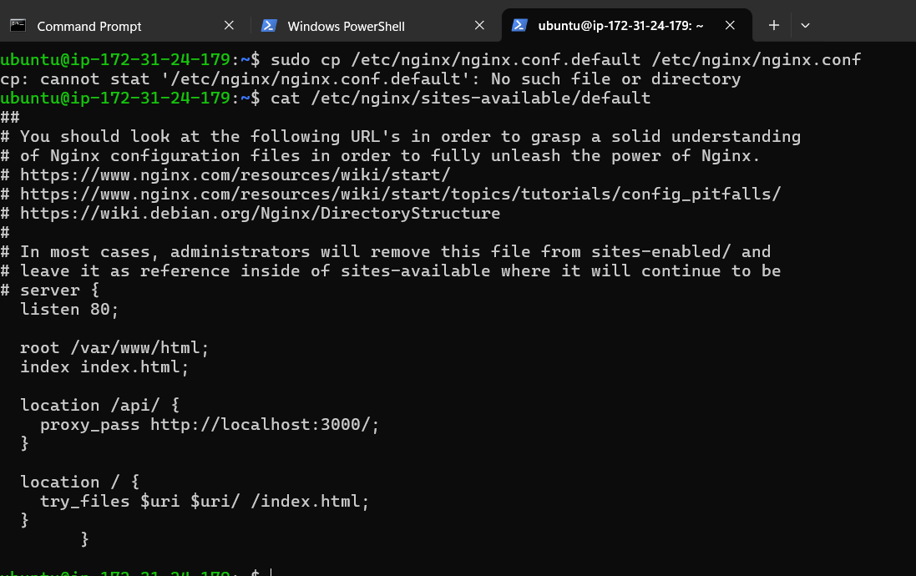
Now restart the nginx server with the command
Sudo systemctl restart nginx
Now, the webpage is access able through public Ip address
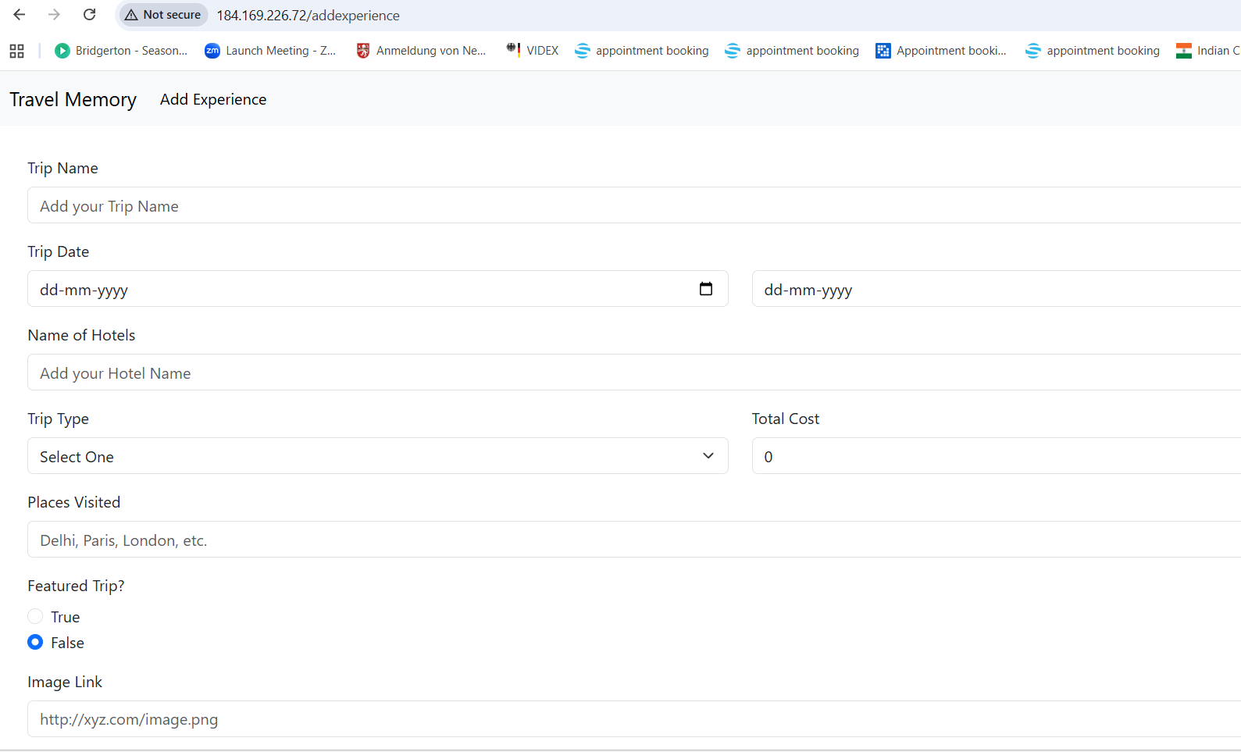

Next phase is to scale the application.
For this I have created an AMI image of the running server and launched 2 ec2 instance for frontend application and 2 backend servers with the AMI image.

Created separate target groups for the frontend and backend applications
Launched single application load balancer and invoked the both the target group init.

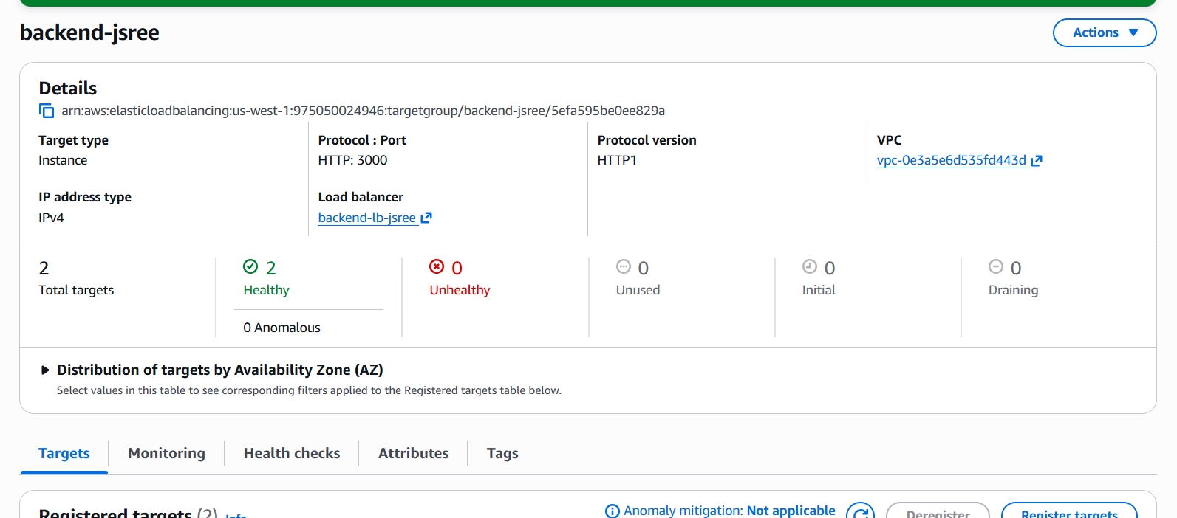
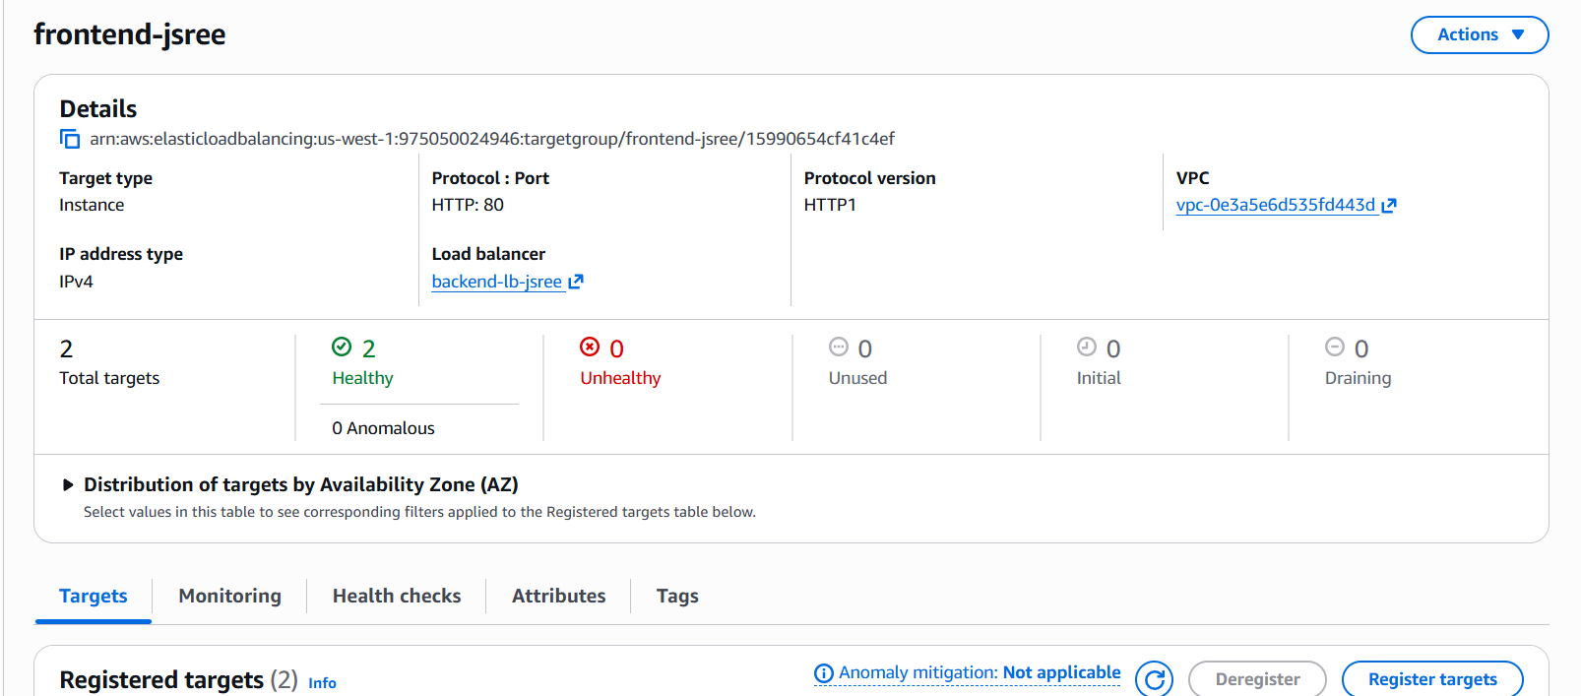

Domain setup with the cloudflare
I have already purchased a domain name called Jeyashree.online from the Namecheap website.
Logged in into Cloudflare, entered my domain name in the list.
Cloudflare showed me two name servers
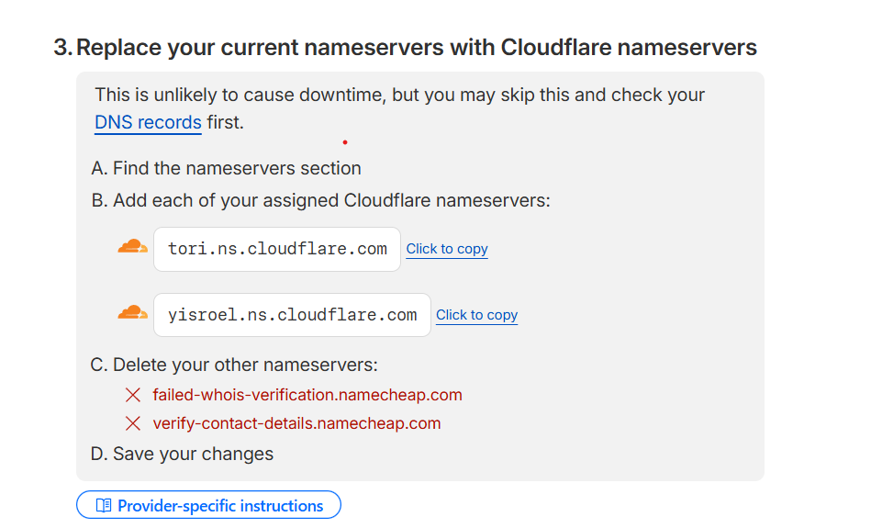
I updated these in the domain register. I took around 30 mins to update.

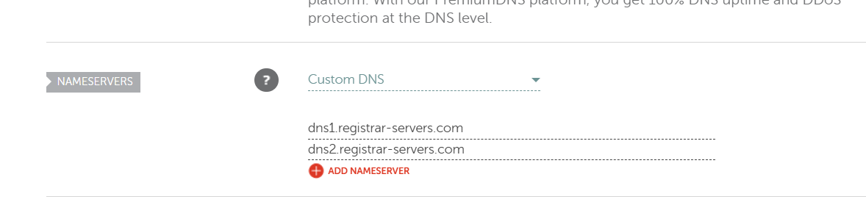
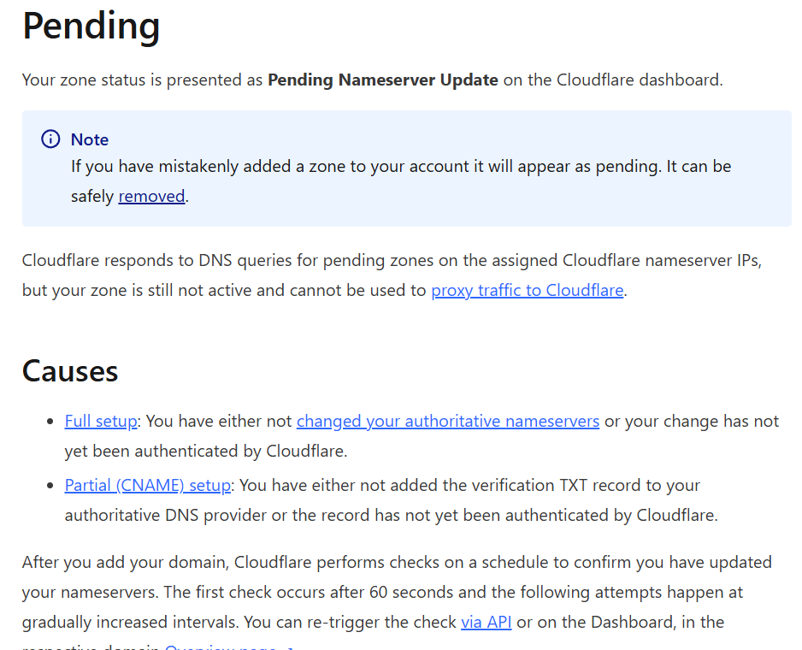

DNS record creation
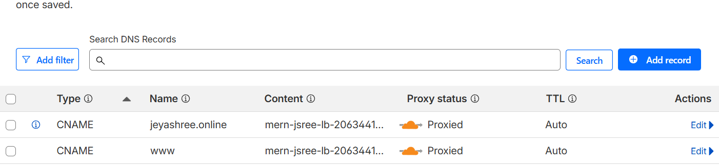

Now, could access the website through the domain name
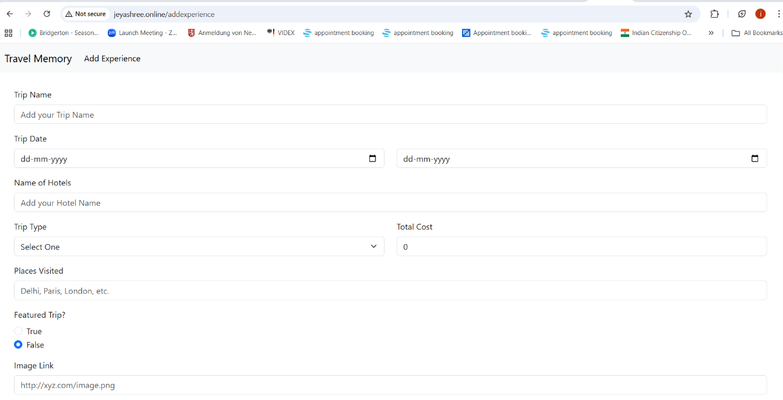
To make the website work for Https, I created the Cloudflare origin certificate for the domain Jeyashree.online and www.jeyashree.online
Imported those key and certificate into AWS load balancer and added listener for the port 443. Now the https works.
