**Project Report Template**

**1.Introduction:**

**1.1 Overview:**

Podcasts are becoming the primary source of gathering information in the age of the Internet. It is a fantastic way to hear about the experts you care about, and it is relatively easy to find good podcasts. The demand of podcasts is repeatedly growing up. More people are thinking about the best podcast app for Android. This document serves as the project documentation for the podcast application project. This project aims to create a mobile app that allows users to access and listening audio podcasts. The application will provide users with a wide selection of audio podcasts, including both popular and niche titles, and will allow them to create personal playlists of their favorite podcasts. Additionally, the application will support social features, such as user profile pages, podcast sharing, and podcast recommendations. The concept of this project is to create an interactive podcast platform that allows users to easily find podcasts. The platform will be tailored to each user’s interests and preferences, allowing them to browse through recommended podcasts and easily find content that they like. The platform will also feature an interactive social aspect, where users can connect and share their thoughts and opinions on different podcast episodes. Additionally, users will be able to create playlists of their favorite episodes and easily search for new ones. The platform will also provide access to other related content such as news and blog posts about the topics discussed in the podcast episodes. The goal of this project is to create an easy-to-use and engaging platform that helps users find and share the best podcast content.

**1.2 Purpose:**

Podcasts play an important role in filling up your time with the latest news, in-depth storytelling, comedy shows, and many more. There are several podcasts app available in the market, but we will discuss some of the best only.

**2.Problem Definition & Design Thinking**

**2.1 Empathy Map**

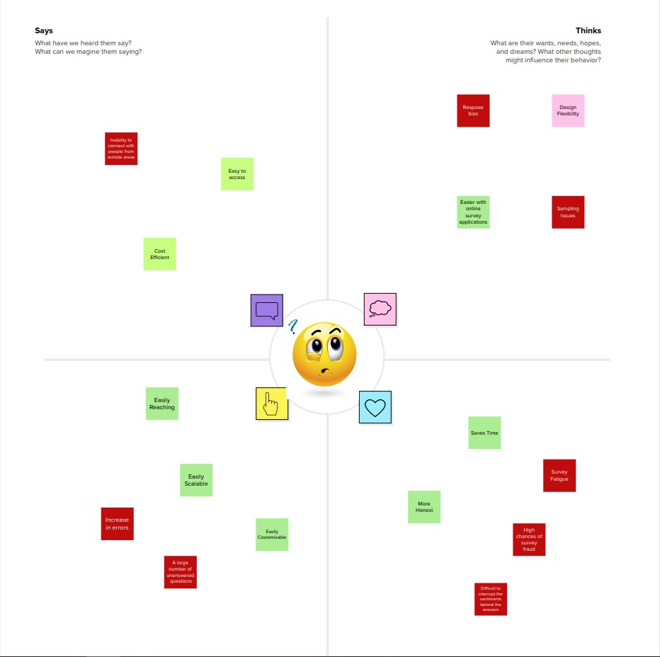

2.2 Ideation & Brainstorming Map

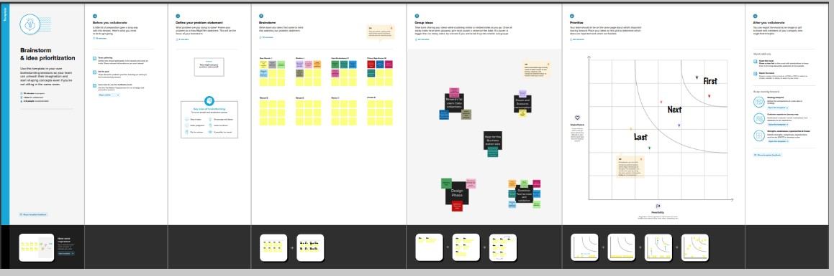

3.Result:

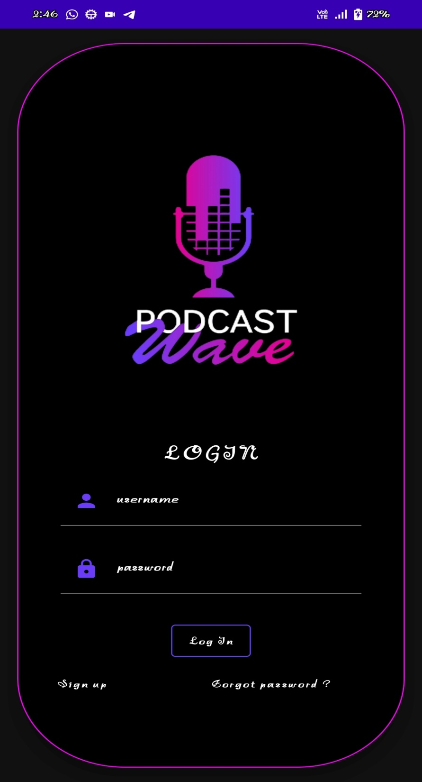

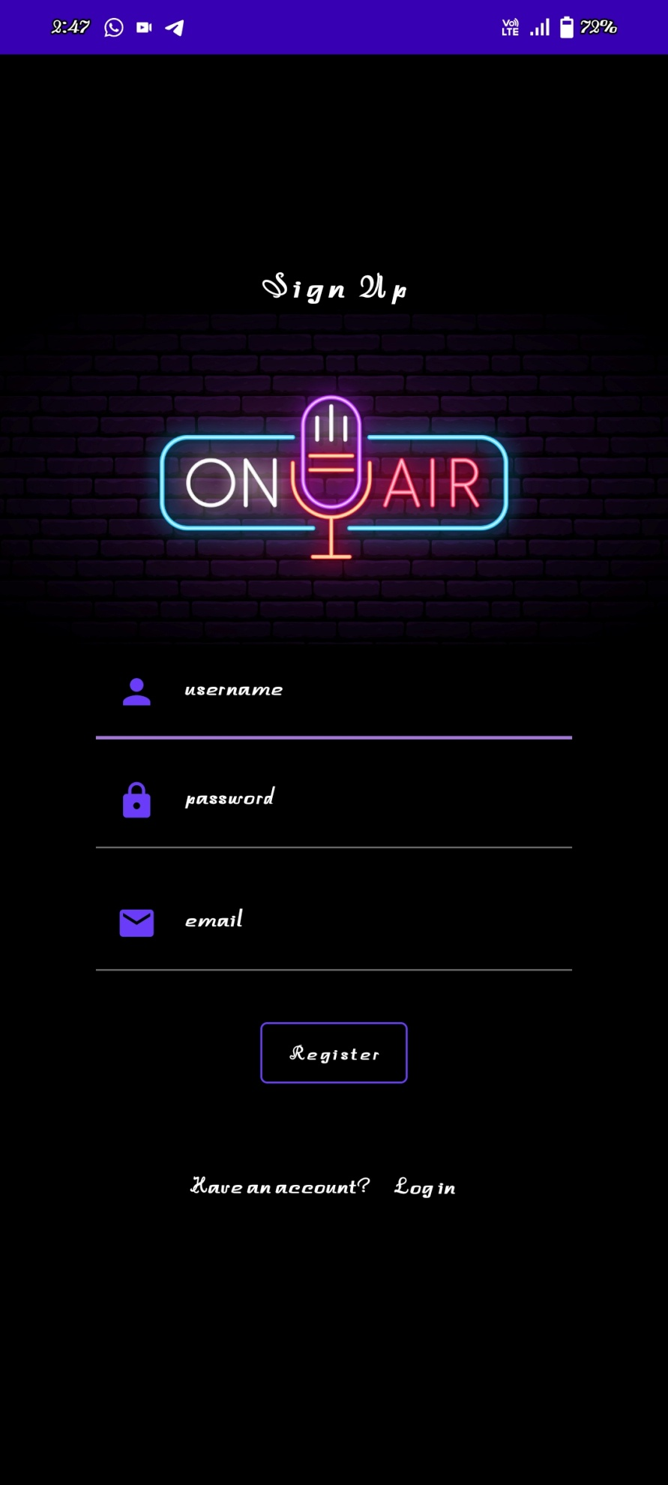

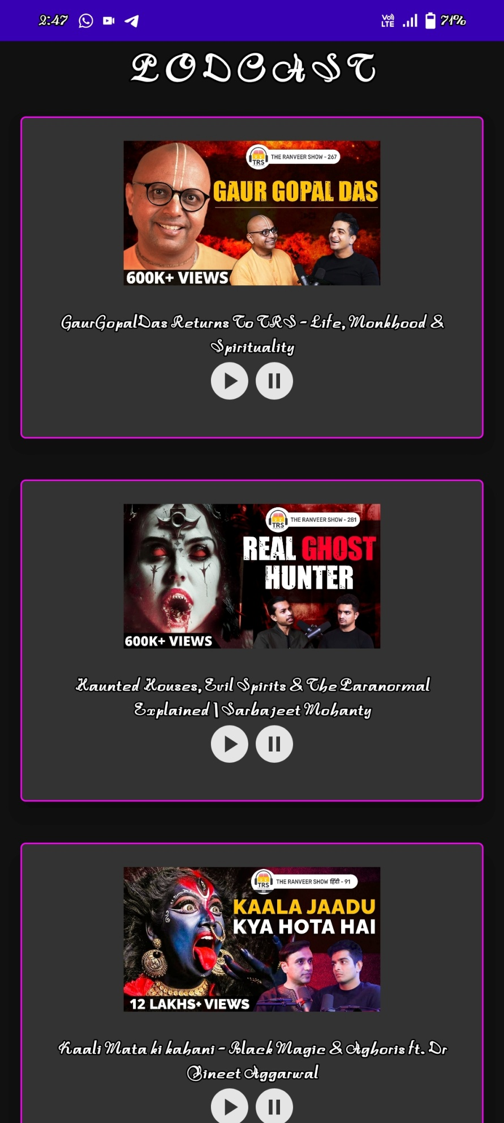

**Abstract:**

The Podcast Project App is a mobile application designed to make it easier for podcasters to create, and distribute their podcast. The app allows users to easily upload their podcast episodes and set up a podcast website. It also provides a suite of powerful analytics tools to help users better understand their audience and optimize their content. Additionally, the app includes access to a global community of podcasters, giving users the support and resources, they need to succeed. With its intuitive design and comprehensive features, the Podcast Project App is the perfect platform for aspiring podcasters to start and grow their podcast. The Podcast Project app would enable users to create their own podcast series. They could record episodes, edit audio, and upload their podcast to popular streaming services. The app would also provide users with tools to analyze the success of their podcast, including metrics such as reviews..

**Literature Survey**

A literature survey is a systematic and comprehensive review of existing literature and research related to a particular topic. For a podcast app project, a literature survey could involve researching and analyzing existing podcast apps, features, and trends in the industry. Here are some steps to follow for a literature survey: [1] The official Android Developer Documentation offers a wide range of resources for developers looking to build Android apps, including podcast apps. The documentation includes detailed guides, tutorials, and sample code to help developers learn and implement best practices. The website is regularly updated to reflect the latest developments in Android app development.[2] Search for relevant literature: Conduct a search for relevant literature, including academic papers, industry reports, and news articles. Use search engines, academic databases, and industry publications to find relevant information.[3] Analyze the literature: Once you have compiled a list of relevant literature, analyze it to identify key themes, trends, and insights related to your research question. Take notes and organize the information into a cohesive structure.[4] Synthesize the findings: Synthesize the findings of the literature survey into a summary of key insights and trends. Identify gaps in the literature and areas for further research. [5] Draw conclusions: Draw conclusions based on the findings of the literature survey. How do the existing podcast apps and features relate to your own podcast app project? What can you learn from the industry trends and insights?[6] Use the findings to inform your project: Use the findings of the literature survey to inform the design, development, and marketing of your podcast app project. Incorporate relevant features and design elements, and consider the monetization strategies and user acquisition tactics used by successful podcast apps. By conducting a literature survey, you can gain valuable insights and inspiration for your podcast app project, while also contributing to the existing body of knowledge on podcast app development and trends.

**Proposed System:**

The proposed system for the podcast app project is to create a user-friendly app that allows users to access a wide variety of podcasts. The app will be able to search through a database of podcasts, allowing users to easily find and access the content they are looking for. Additionally, the app will include features such as the ability to share podcasts with others, and bookmark favorite podcasts. Finally, the app will include a recommendation system, so users can discover new content they may be interested in.The proposed podcast app system aims to provide users with an intuitive and user-friendly platform for discovering, and listening to their favorite podcasts. The app will have a sleek and modern design that allows users to easily browse through a wide variety of podcasts based on genre, popularity, or personal preferences. The system will also offer personalized recommendations and preferences. Additionally, the system will provide social sharing features, allowing users to share their favorite episodes with friends and on social media. The podcast app system will be available on multiple platforms Android and enhancements to ensure a seamless listening experience for all users.

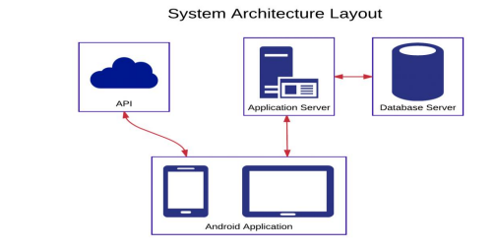

**Working**:

The podcast app project is an Android application that allows users to browse, search, and listen to podcasts. Here are some of the key components and functionalities of the podcast app project that work with Android Studio: [1] [1] User Interface: The podcast app project uses Android Studio to create the user interface. The user interface includes various components such as buttons, text views, and list views that allow users to interact with the app. [2] [2] Podcast Feed: The podcast app project uses RSS feeds to retrieve podcast data. Android Studio is used to create the code that fetches the podcast data from the RSS feeds. [3] [3] Audio Player: The podcast app project includes an audio player that allows users to listen to podcast episodes. Android Studio is used to create the audio player user interface and handle audio playback. [4] [4] Search Functionality: The podcast app project includes a search feature allowing users to search for podcasts by keyword or category. Android Studio is used to create the search user interface and to handle the search functionality. [5] [5] Notifications: The podcast app project includes a notification system that alerts users when new episodes of their favorite podcasts are available. Android Studio is used to create the notification system. [6] Overall, Android Studio is a key component of the podcast app project, providing the tools needed to create the user interface, handle audio playback, retrieve podcast data, and manage user authentication.

**Conclusion:**

In conclusion, the podcast app project is a mobile application that provides users with a convenient and easy way to browse, search, and listen to podcasts. This project utilizes various components and functionalities to create an intuitive user interface that enhances the user experience. One of the key features of the podcast app project is its ability to fetch podcast data from RSS feeds. This allows users to discover new podcasts and stay up-to-date with their favorite shows. Additionally, the app's audio player provides a seamless listening experience, making it easy for users to enjoy their favorite podcasts on the go. The search functionality is also a crucial component of the podcast app project, allowing users to find podcasts by keyword or category. This makes it easier for users to discover new shows that align with their interests. Furthermore, the user authentication system provides an additional layer of security and personalization, allowing users to create accounts, log in, and save their favorite podcasts for easy access. Overall, the podcast app project is a valuable tool for podcast enthusiasts, providing a user-friendly platform for discovering and listening to podcasts. By utilizing the components and functionalities of Android Studio, this project is able to provide a seamless and enjoyable user experience.

Source Code:

import android.content.Context

import android.media.MediaPlayer

import android.os.Bundle

import androidx.activity.ComponentActivity

import androidx.activity.compose.setContent

import androidx.compose.foundation.BorderStroke

import androidx.compose.foundation.Image

import androidx.compose.foundation.layout.*

import androidx.compose.foundation.rememberScrollState

import androidx.compose.foundation.verticalScroll

import androidx.compose.material.*

import androidx.compose.runtime.*

import androidx.compose.ui.Alignment

import androidx.compose.ui.Modifier

import androidx.compose.ui.graphics.Color

import androidx.compose.ui.res.painterResource

import androidx.compose.ui.text.font.FontWeight

import androidx.compose.ui.text.style.TextAlign

import androidx.compose.ui.unit.dp

import androidx.compose.ui.unit.em

import androidx.compose.ui.unit.sp

import com.example.podcastplayer.ui.theme.PodcastPlayerTheme

class MainActivity : ComponentActivity() {

override fun onCreate(savedInstanceState: Bundle?) {

super.onCreate(savedInstanceState)

setContent {

PodcastPlayerTheme {

// A surface container using the 'background' color from the theme

Surface(

modifier = Modifier.fillMaxSize(),

color = MaterialTheme.colors.background

) {

playAudio(this)

}

}

}

}

}

@Composable

fun playAudio(context: Context) {

Column(modifier = Modifier.fillMaxSize()) {

Column(horizontalAlignment = Alignment.CenterHorizontally, verticalArrangement = Arrangement.Center) {

Text(text = "PODCAST",

modifier = Modifier.fillMaxWidth(),

textAlign = TextAlign.Center,

color = Color(0xFF6a3ef9),

fontWeight = FontWeight.Bold,

fontSize = 36.sp,

style = MaterialTheme.typography.h1,

letterSpacing = 0.1.em

)

}

Column(modifier = Modifier

.fillMaxSize()

.verticalScroll(rememberScrollState())) {

Card(

elevation = 12.dp,

border = BorderStroke(1.dp, Color.Magenta),

modifier = Modifier

.padding(16.dp)

.fillMaxWidth()

.height(250.dp)

)

{

val mp: MediaPlayer = MediaPlayer.create(context, R.raw.audio)

Column(

modifier = Modifier.fillMaxSize(),

horizontalAlignment = Alignment.CenterHorizontally

) {

Image(

painter = painterResource(id = R.drawable.img),

contentDescription = null,

modifier = Modifier

.height(150.dp)

.width(200.dp),

)

Text(

text = "GaurGopalDas Returns To TRS - Life, Monkhood & Spirituality",

textAlign = TextAlign.Center,

modifier = Modifier.padding(start = 20.dp, end = 20.dp)

)

Row() {

IconButton(onClick = { mp.start() }, modifier = Modifier.size(35.dp)) {

Icon(

painter = painterResource(id = R.drawable.play),

contentDescription = ""

)

}

IconButton(onClick = { mp.pause() }, modifier = Modifier.size(35.dp)) {

Icon(

painter = painterResource(id = R.drawable.pause),

contentDescription = ""

)

}

}

}

}

Card(

elevation = 12.dp,

border = BorderStroke(1.dp, Color.Magenta),

modifier = Modifier

.padding(16.dp)

.fillMaxWidth()

.height(250.dp)

)

{

val mp: MediaPlayer = MediaPlayer.create(context, R.raw.audio_1)

Column(

modifier = Modifier.fillMaxSize(),

horizontalAlignment = Alignment.CenterHorizontally

) {

Image(

painter = painterResource(id = R.drawable.img_1),

contentDescription = null,

modifier = Modifier

.height(150.dp)

.width(200.dp)

)

Text(

text = "Haunted Houses, Evil Spirits & The Paranormal Explained | Sarbajeet Mohanty",

textAlign = TextAlign.Center,

modifier = Modifier.padding(start = 20.dp, end = 20.dp)

)

Row() {

IconButton(onClick = { mp.start() }, modifier = Modifier.size(35.dp)) {

Icon(

painter = painterResource(id = R.drawable.play),

contentDescription = ""

)

}

IconButton(onClick = { mp.pause() }, modifier = Modifier.size(35.dp)) {

Icon(

painter = painterResource(id = R.drawable.pause),

contentDescription = ""

)

}

}

}

}

Card(

elevation = 12.dp,

border = BorderStroke(1.dp, Color.Magenta),

modifier = Modifier

.padding(16.dp)

.fillMaxWidth()

.height(250.dp)

)

{

val mp: MediaPlayer = MediaPlayer.create(context, R.raw.audio_2)

Column(

modifier = Modifier.fillMaxSize(),

horizontalAlignment = Alignment.CenterHorizontally

) {

Image(

painter = painterResource(id = R.drawable.img_2),

contentDescription = null,

modifier = Modifier

.height(150.dp)

.width(200.dp)

)

Text(

text = "Kaali Mata ki kahani - Black Magic & Aghoris ft. Dr Vineet Aggarwal",

textAlign = TextAlign.Center,

modifier = Modifier.padding(start = 20.dp, end = 20.dp)

)

Row() {

IconButton(onClick = { mp.start() }, modifier = Modifier.size(35.dp)) {

Icon(

painter = painterResource(id = R.drawable.play),

contentDescription = ""

)

}

IconButton(onClick = { mp.pause() }, modifier = Modifier.size(35.dp)) {

Icon(

painter = painterResource(id = R.drawable.pause),

contentDescription = ""

)

}

}

}

}

Card(

elevation = 12.dp,

border = BorderStroke(1.dp, Color.Magenta),

modifier = Modifier

.padding(16.dp)

.fillMaxWidth()

.height(250.dp)

)

{

val mp: MediaPlayer = MediaPlayer.create(context, R.raw.audio_3)

Column(

modifier = Modifier.fillMaxSize(),

horizontalAlignment = Alignment.CenterHorizontally

) {

Image(

painter = painterResource(id = R.drawable.img_3),

contentDescription = null,

modifier = Modifier

.height(150.dp)

.width(200.dp),

)

Text(

text = "Tantra Explained Simply | Rajarshi Nandy - Mata, Bhairav & Kamakhya Devi",

textAlign = TextAlign.Center,

modifier = Modifier.padding(start = 20.dp, end = 20.dp)

)

Row() {

IconButton(onClick = { mp.start() }, modifier = Modifier.size(35.dp)) {

Icon(

painter = painterResource(id = R.drawable.play),

contentDescription = ""

)

}

IconButton(onClick = { mp.pause() }, modifier = Modifier.size(35.dp)) {

Icon(

painter = painterResource(id = R.drawable.pause),

contentDescription = ""

)

}

}

}

}

Card(

elevation = 12.dp,

border = BorderStroke(1.dp, Color.Magenta),

modifier = Modifier

.padding(16.dp)

.fillMaxWidth()

.height(250.dp)

)

{

val mp: MediaPlayer = MediaPlayer.create(context, R.raw.audio_4)

Column(

modifier = Modifier.fillMaxSize(),

horizontalAlignment = Alignment.CenterHorizontally

) {

Image(

painter = painterResource(id = R.drawable.img_4),

contentDescription = null,

modifier = Modifier

.height(150.dp)

.width(200.dp),

)

Text(

text = "Complete Story Of Shri Krishna - Explained In 20 Minutes",

textAlign = TextAlign.Center,

modifier = Modifier.padding(start = 20.dp, end = 20.dp)

)

Row() {

IconButton(onClick = { mp.start() }, modifier = Modifier.size(35.dp)) {

Icon(

painter = painterResource(id = R.drawable.play),

contentDescription = ""

)

}

IconButton(onClick = { mp.pause() }, modifier = Modifier.size(35.dp)) {

Icon(

painter = painterResource(id = R.drawable.pause),

contentDescription = ""

)

}

}

}

}

Card(

elevation = 12.dp,

border = BorderStroke(1.dp, Color.Magenta),

modifier = Modifier

.padding(16.dp)

.fillMaxWidth()

.height(250.dp)

)

{

val mp: MediaPlayer = MediaPlayer.create(context, R.raw.audio_5)

Column(

modifier = Modifier.fillMaxSize(),

horizontalAlignment = Alignment.CenterHorizontally

) {

Image(

painter = painterResource(id = R.drawable.img_5),

contentDescription = null,

modifier = Modifier

.height(150.dp)

.width(200.dp),

)

Text(

text = "Mahabharat Ki Poori Kahaani - Arjun, Shri Krishna & Yuddh - Ami Ganatra ",

textAlign = TextAlign.Center,

modifier = Modifier.padding(start = 20.dp, end = 20.dp)

)

Row() {

IconButton(onClick = { mp.start() }, modifier = Modifier.size(35.dp)) {

Icon(

painter = painterResource(id = R.drawable.play),

contentDescription = ""

)

}

IconButton(onClick = { mp.pause() }, modifier = Modifier.size(35.dp)) {

Icon(

painter = painterResource(id = R.drawable.pause),

contentDescription = ""

)

}

}

}

}

}

}

}