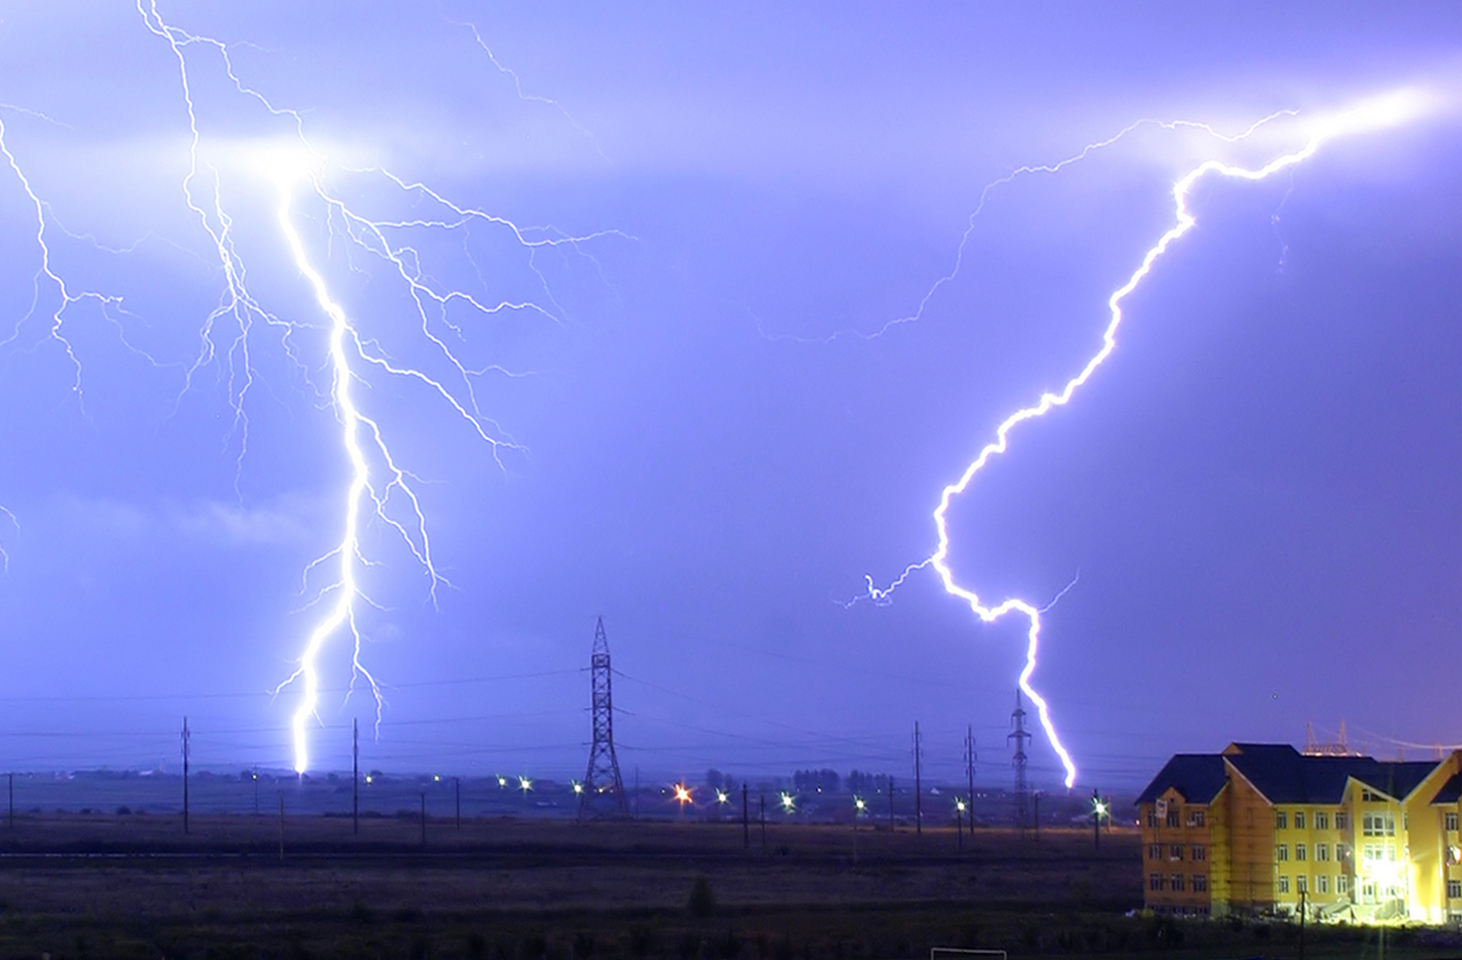

MEASURE ENERGY CONSUMPTION

S.Jeyasubha

950921104013

Phase_2 Submission

**MEASURE ENERGY CONSUMPTION**

***TEAM MEMBERS***

**K. MAHABOOB FATHINA**

**950921104019**

PHASE_2 SUBMISSION

**Introduction:**

* **Objective:**

The primary goal is to enhance the accuracy and robustness of the energy consumption prediction system using innovative techniques such as ensemble methods, deep learning architectures, and time series analysis.

* **Dataset Overview:**

The dataset (link: [*Hourly Energy Consumption Dataset*](https://www.kaggle.com/datasets/robikscube/hourly-energy-consumption)) provides hourly energy consumption data, which will be utilized for training and testing predictive models.

**Ensemble Methods:**

* **Introduction:**

Ensemble methods combine multiple models to improve predictive performance.

* **Techniques:**

**Random Forest:** Employ a Random Forest model to capture complex relationships in the energy consumption data.

**Gradient Boosting:** Implement Gradient Boosting algorithms to enhance predictive accuracy.

**Integration:** Combine the predictions from individual models to form a robust ensemble prediction.

**Deep Learning Architectures:**

* **Introduction:**

Deep learning architectures leverage neural networks for complex pattern recognition.

* **Techniques:**

**Recurrent Neural Networks (RNN):**

Utilize RNNs to capture temporal dependencies in the hourly energy consumption data.

**Long Short-Term Memory (LSTM):**

Implement LSTM networks for improved memory retention in time series data.

* **Model Training:**

Train deep learning models on the provided dataset, optimizing for predictive accuracy.

**Time Series Analysis:**

* **Introduction:**

Time series analysis is crucial for understanding temporal patterns in energy consumption.

* **Techniques:**

**Seasonal Decomposition:**

Decompose the time series data into trend, seasonal, and residual components.

**Autoregressive Integrated Moving Average (ARIMA):**

Apply ARIMA models to capture autocorrelation and trends in the time series.

**Program Implementation:**

* **Data Preprocessing:**

Clean and preprocess the hourly energy consumption dataset, handling missing values and outliers.

* **Algorithm Implementation:**

Implement the ensemble methods, deep learning architectures, and time series analysis techniques using suitable programming languages (e.g., Python) and frameworks (e.g., TensorFlow, Scikit-Learn).

* **Model Evaluation:**

Evaluate the performance of each model using appropriate metrics (e.g., Mean Absolute Error, Root Mean Squared Error).

**Comparative Analysis:**

* **Performance Metrics:**

Compare the accuracy and robustness of ensemble methods, deep learning architectures, and time series analysis techniques.

* **Visualization:**

Create visualizations to illustrate the effectiveness of each technique in predicting future energy consumption patterns.

**Conclusion:**

I believe that these innovative techniques have the potential to significantly improve the accuracy and robustness of energy consumption prediction systems. By exploring these techniques, we can develop more effective tools for managing energy consumption and improving energy efficiency.

# 