Case Study Report



**Tech Saksham**

Data Analytics with Power BI

**“SupplyChainAnalysisofInventories”**

**“CollegeName”**

MSS WAKF BOARD COLLEGE

|  |  |
| --- | --- |
| **NM ID** | **NAME** |
| 74895FDA497032F8DOD4A880553BE55D | surya |

|  |  |
| --- | --- |
|  |  |
|  | Trainer Name |
|  | Master Trainer |

**ABSTRACT**

**Supply chain management includes the planning and execution of the whole flow of a good or service. Essentially, supply chain management oversees the end-to-end processes involved in the production and distribution of goods or services, from raw material sourcing to delivery to the end customer. It encompasses various activities such as procurement, manufacturing, logistics and inventory management, with the goal of optimizing efficiency, reducing costs and meeting customer demand**

**INDEX**

|  |  |  |
| --- | --- | --- |
| **Sr. No.** | **Table of Contents** | **Page No.** |
| 1 | **Chapter1:Introduction** | 4 |
| 2 | **Chapter2:ServicesandToolsRequired** | 7 |
| 3 | **Chapter3:ProjectArchitecture** | 9 |
| 4 | **Chapter4:ModelingandResult** | 11 |
| 5 | **Conclusion** | 16 |
| 6 | **FutureScope** | 17 |
|  |  |  |
|  |  |  |

**CHAPTER 1**

**INTRODUCTION**

* 1. **Problem Statement**

**These issues can lead to inefficiencies, errors in data management, operational disruptions and compromised data security.Risks in the supply chain primarily arise from volatility in the markets. Changing consumer demand, trade wars, raw material shortages, climate change, stricter environmentalregulations, economicuncertaintiesandpolicychanges,industrial unrest, etc., contribute to supply chain management risks and challenges.**

* 1. **Proposed Solution**

**Whendemandisvolatile,retailersshouldshapethedemandbasedonavailable inventory through promotions and marketing. On the supply side, focus on autonomous recalibration of inventory, stock, and replenishment policies to minimize exception- driven approach to execution.**

* 1. **Feature**

• **SupplyChainAnalysis:**Thedashboardwillprovidesupplychain analysis of data. •

**Customer Segmentation:** It will segment based on various parametersusedindashboardsumofquentityandsumofdiscount. **•**

**TrendAnalysis:**Thedashboardwillidentifyanddisplaytrendsin customer behavior. •

**PredictiveAnalysis:**Itwillusehistoricaldatatopredictfuture customer behavior

* 1. **Advantages**

**\* Bettercollaboration.Informationflowisaprominentchallengeforcompanies. * Improvedqualitycontrol.**

**\* Higherefficiencyrate.**

**\* Keepingupwithdemand.**

**\* Shippingoptimization.**

**\* Reducedoverheadcosts.**

**\* Improvedriskmitigation.**

**\* Improvedcash flow.**

* 1. **Scope**
  2. **\* Supplier Performance Analysis:**

Supply chain analysts assess supplier performance metrics, such as on-time delivery, lead times, quality, and cost, to evaluate supplier performance. They identify areas for improvement, negotiate suppliercontracts,andworktoenhancesupplierrelationshipstoensureareliable and efficient supply chain.

**\* Inventory Control:**

Inventory control professionals are responsible for monitoring and managing inventory levels to prevent excess inventory or stock outs.Theyimplementinventorycontrolpolicies,suchasABCanalysis,Just-In-Time (JIT) inventory systems, and cycle counting, to optimize inventory management practices

**CHAPTER 2**

**SERVICES AND TOOLS REQUIRED**

**2.1 Services Used**

* **Data Collection and Storage Services**: Banks need to collect and store customer data in real-time. This could be achieved through services like Azure Data Factory, Azure Event Hubs, or AWS Kinesis for real-time data collection, and Azure SQL Database or AWS RDS for data storage.
* **Data Processing Services**: Services like Azure Stream Analytics or AWS Kinesis Data Analytics can be used to process the real-time data.
* **Machine Learning Services**: Azure Machine Learning or AWS SageMaker can be used to build predictive models based on historical data.

**2.2 Tools and Software used**

**Tools**:

* **PowerBI**: The main tool for this project is PowerBI, which will be used to create interactive dashboards for real-time data visualization.
* **Power Query**: This is a data connection technology that enables you to discover, connect, combine, and refine data across a wide variety of sources.

**Software Requirements**:

* **PowerBI Desktop**: This is a Windows application that you can use to create reports and publish them to PowerBI.
* **PowerBI Service**: This is an online SaaS (Software as a Service) service that you use to publish reports, create new dashboards, and share insights.
* **PowerBI Mobile**: This is a mobile application that you can use to access your reports and dashboards on the go.

**CHAPTER 3**

**PROJECT ARCHITECTURE**

**3.1 Architecture**

**USER FRONTEND BACKEND**

|  |  |  |
| --- | --- | --- |
|  | **HTML 5** | **NODEJS 14.0**  **Database** |

Here’s a high-level architecture for the project:

1. DataCollection:

Supplychaindataiscollectedfromvarioussourceslike Customer Name, Customer Full Name, Gender etc. This could be achieved using services like Azure Event Hubs or AWS Kinesis. 2. DataStorage:

Thecollecteddataisstoredinadatabaseforprocessing. Azure SQL Database or AWS RDS can be used for this purpose.

1. Thestoreddataisprocessedinsupplychainusing services like Azure Stream Analytics or AWS Kinesis Data Analytics.
2. MachineLearning:

Predictivemodelsarebuiltbasedonprocesseddata using Azure Machine Learning or AWS Sage Maker. These models can help in predicting customer behavior, detecting fraud, etc.

1. DataVisualization:

Theprocesseddataandtheresultsfromthepredictive models are visualized in real-time using Power BI. Power BI allows you to create interactive dashboards that can provide valuable insights into the data.

1. DataAccess:

ThedashboardscreatedinPowerBIcanbeaccessedthrough Power BI Desktop, Power BI Service (online), and Power BI Mobile. This architecture provides a comprehensive solution for real-time analysis of bank customers.However,it’simportanttonotethatthespecificarchitecturemayvary depending on the bank’s existing infrastructure, specific requirements, and budget. It’s also important to ensure that all tools and services comply with relevant data privacy and security regulations

**CHAPTER 4**

**MODELING AND RESULT**

**Manage relationsh**

**The“disp”filewillbeusedasthemainconnectorasitcontainsmostkeyidentifier (account id, client id and disp id) which can be use to relates the 8 data files together. The “district” file is use to link the client profile geographically with “district id”**

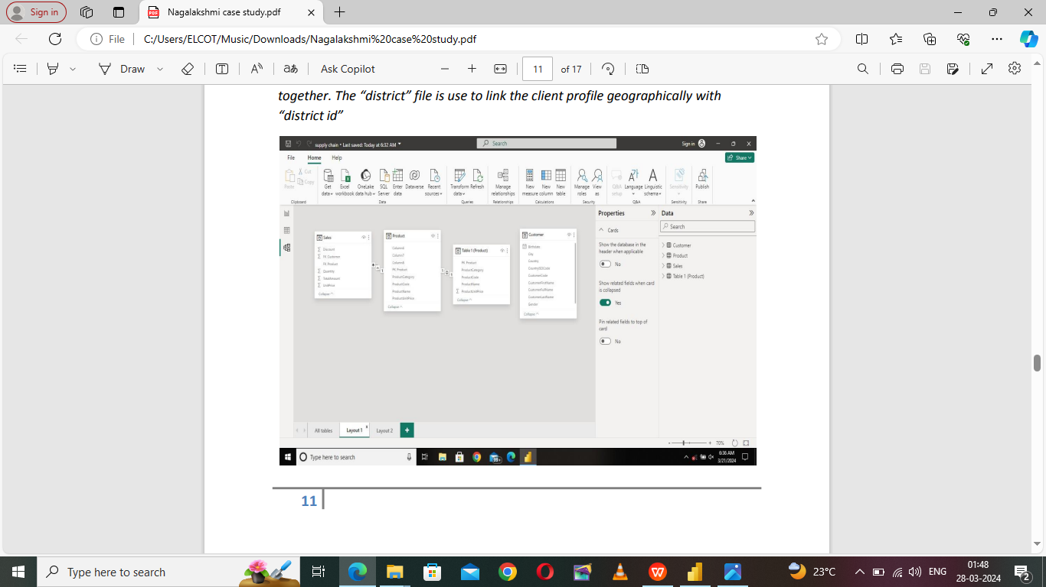

ModelingforGenderandAge data Notice thattheGenderandageof theclientaremissingfromthedata. Thesecan beformulatedfromthebirthnumberYYMMDDwhereatmonths(the3rdand4th digits) greater than 50 means that client is a Female. We can create a column for Gender. Forbirthday,weneedtoreducethebirthmonthofthefemaleby50and then change the date format to DD/MM/YYYY adding 1900 to the year. ForAge,weshallassumeitisyear1999asexplainpreviouslyanduseitto minus from the birth yea

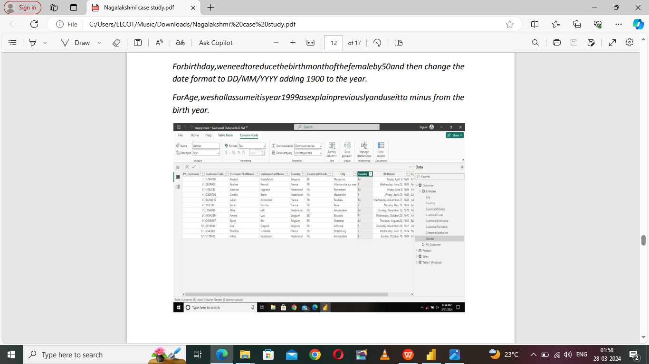

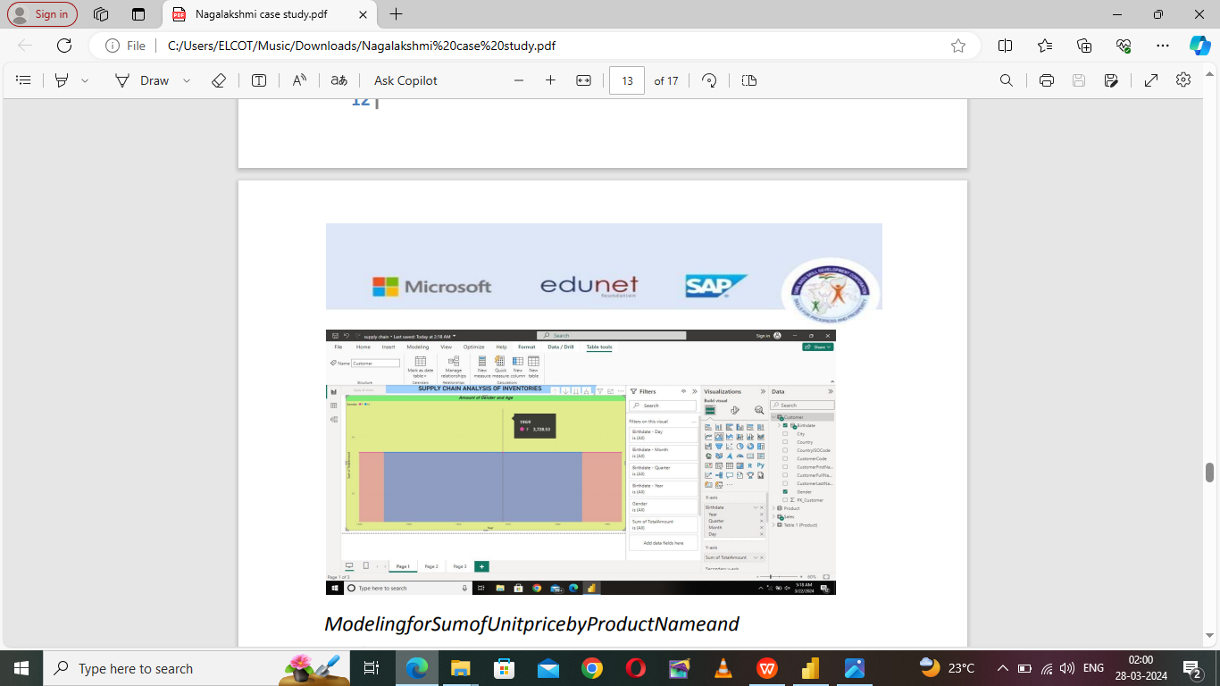

**ModelingforSumofUnitpricebyProductNameand Productcategory**

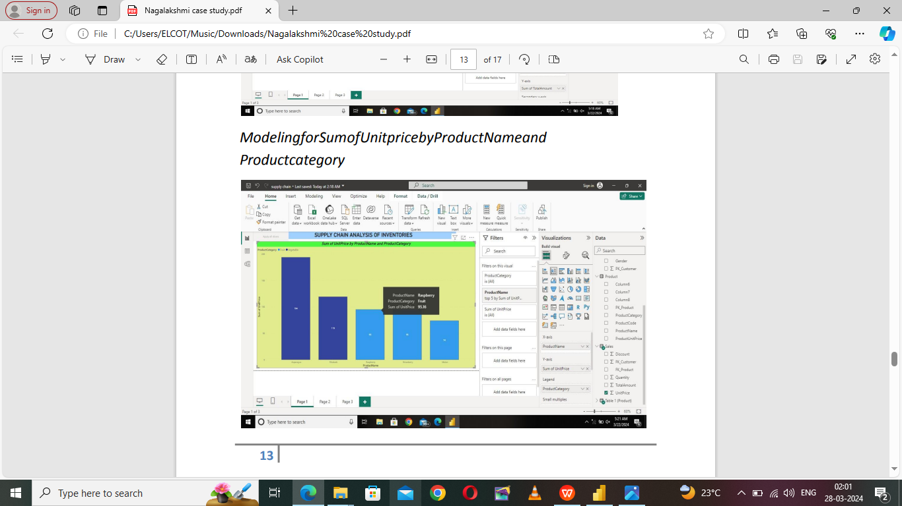

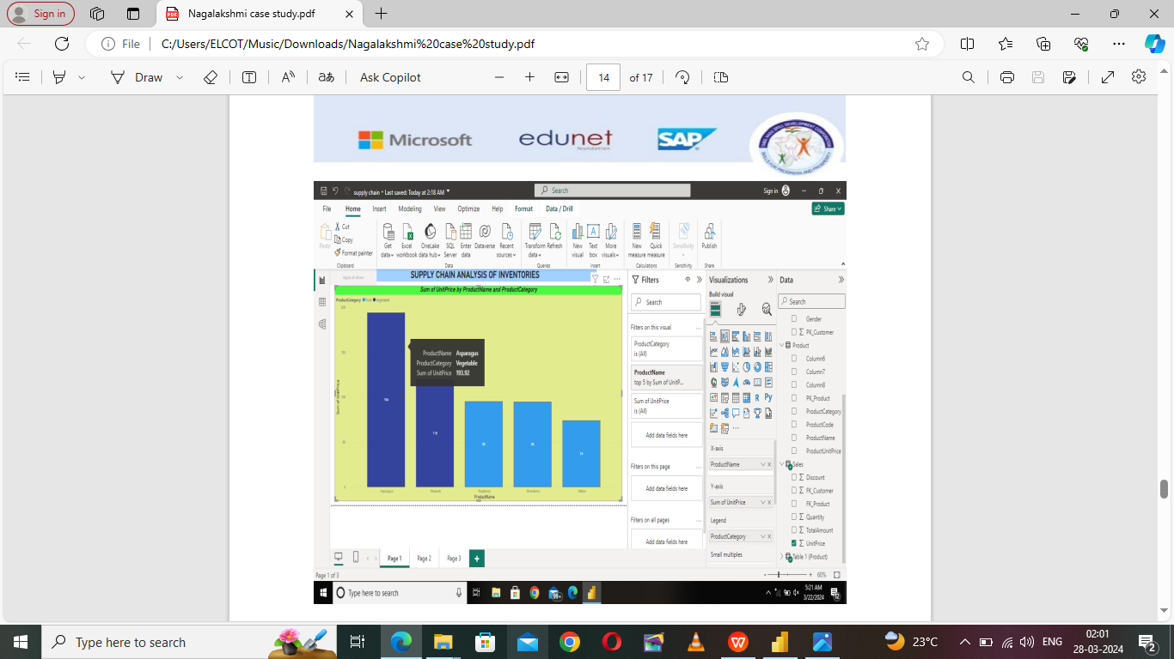

**Dashboard**

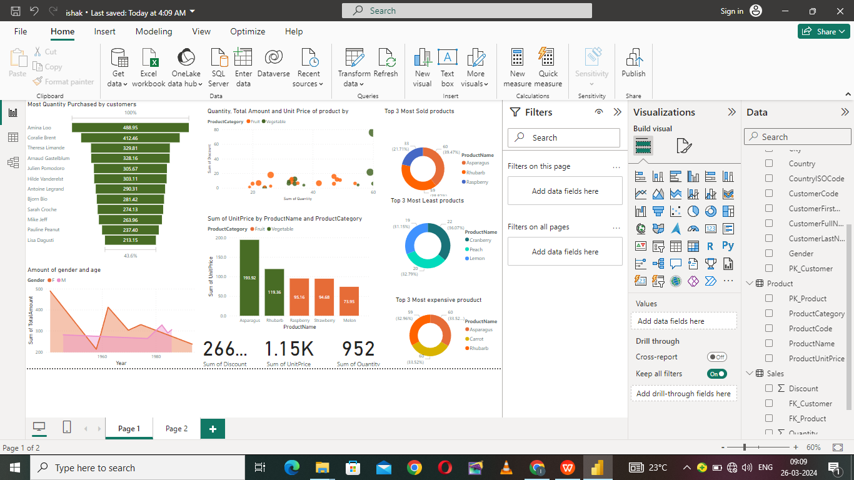

**CONCLUSION**

Theproject“SupplyChainAnalysisofInventories”usingPowerBIhassuccessfully demonstrated the potential of data analytics. The supply chain analysis data has provided valuable insights into customer behavior, preferences, and trends, thereby facilitating informed decision-making. The interactive dashboards and reports have offered a comprehensive view of customer data, enabling the identification of patterns and correlations.The project has also highlighted the importance of data visualization in making complex data more understandable and accessible. The use of Power BI has made it possible to present data in a visually appealing and easy-to-understand format, there by aiding in better decision-makin

**FUTURE SCOPE**

The future scope of this project is vast. With the advent of advanced analytics and machine learning, PowerBI can be leveraged to predict future trends based on historical data. Integrating these predictive analytics into the project could enable the bank to anticipate customer needs and proactively offer solutions. Furthermore, PowerBI’s capability to integrate with various data sources opens up the possibility of incorporating more diverse datasets for a more holistic view of customers. As data privacy and security become increasingly important, future iterations of this project should focus on implementing robust data governance strategies. This would ensure the secure handling of sensitive customer data while complying with data protection regulations. Additionally, the project could explore the integration of real-time data streams to provide even more timely and relevant insights. This could potentially transform the way banks interact with their customers, leading to improved customer satisfaction and loyalty.

**LINK**

<https://github.com/githubtraining/hellogitworld.git>