CAP 931 CAPSTONE PROJECT REPORT
AI Sales Assistant Using Multi-Agent LLMs

Learner: Jeya Kasinathan
Project: AI Sales Assistant
Technologies: Python, LangChain, Groq, Streamlit
Course: CAP 931 - Build a Sales Agent Prototype Using Multi-Agent GPT Models
GitHub Repository: https://github.com/Jeyavardhini/capstone_sales_agent

Final Project Documentation

1. Project Overview
The AI Sales Assistant is a multi-agent application designed to help sales representatives research prospective customers and generate actionable account insights. The application collects information about the product being sold, the prospective company, competitors, value proposition, and target customer through a user-friendly Streamlit interface.
The system retrieves publicly available information from company websites and additional research URLs. Multiple specialized AI agents process this information to create a structured sales account brief containing company strategy, technology strategy, competitor information, leadership insights, potential business needs, sales opportunities, recommended next steps, and research sources.
The project demonstrates practical application of prompt engineering, multi-agent orchestration, large language models (LLMs), web-data extraction and integration, Python application development, LangChain, Groq API integration, and Streamlit interface development.

2. Project Objectives
- Build a functional AI Sales Assistant.
- Create a user-friendly Streamlit interface.
- Integrate an LLM using Groq and LangChain.
- Retrieve publicly available company information from URLs.
- Implement multiple specialized AI agents rather than relying on a single general prompt.
- Analyze company strategy, competitors, leadership, and potential business needs.
- Generate a concise and useful sales account brief.
- Preserve research URLs so users can verify information used by the system.
- Apply prompt-engineering techniques to improve relevance and organization of AI-generated outputs.

3. System Architecture
User
↓
Streamlit Interface
↓
User Inputs
↓
Web Research Tool
↓
Sales Agent
↓
Research Agent
↓
Analysis Agent
↓
Report Agent
↓
Final Sales Account Brief

Agent Responsibilities
Sales Agent: Organizes the initial sales opportunity using the product, prospective company, competitors, value proposition, and target customer.
Research Agent: Combines the sales context with publicly available website information and source URLs to identify relevant company, technology, competitor, and leadership information.
Analysis Agent: Evaluates the collected research and identifies meaningful business insights, potential needs, risks, and sales opportunities.
Report Agent: Transforms the analysis into a concise and structured sales account brief for a sales representative.
This modular design separates responsibilities across specialized agents, making the workflow easier to understand, test, maintain, and improve.

4. Streamlit Inputs
The Streamlit interface collects the following information:
- Product Name
- Company URL
- Product Category
- Competitors
- Value Proposition
- Target Customer
- Competitor Research URLs
- Additional Research URLs
- Optional Product Overview Document
These inputs provide the context needed by the AI agents to generate relevant sales insights.
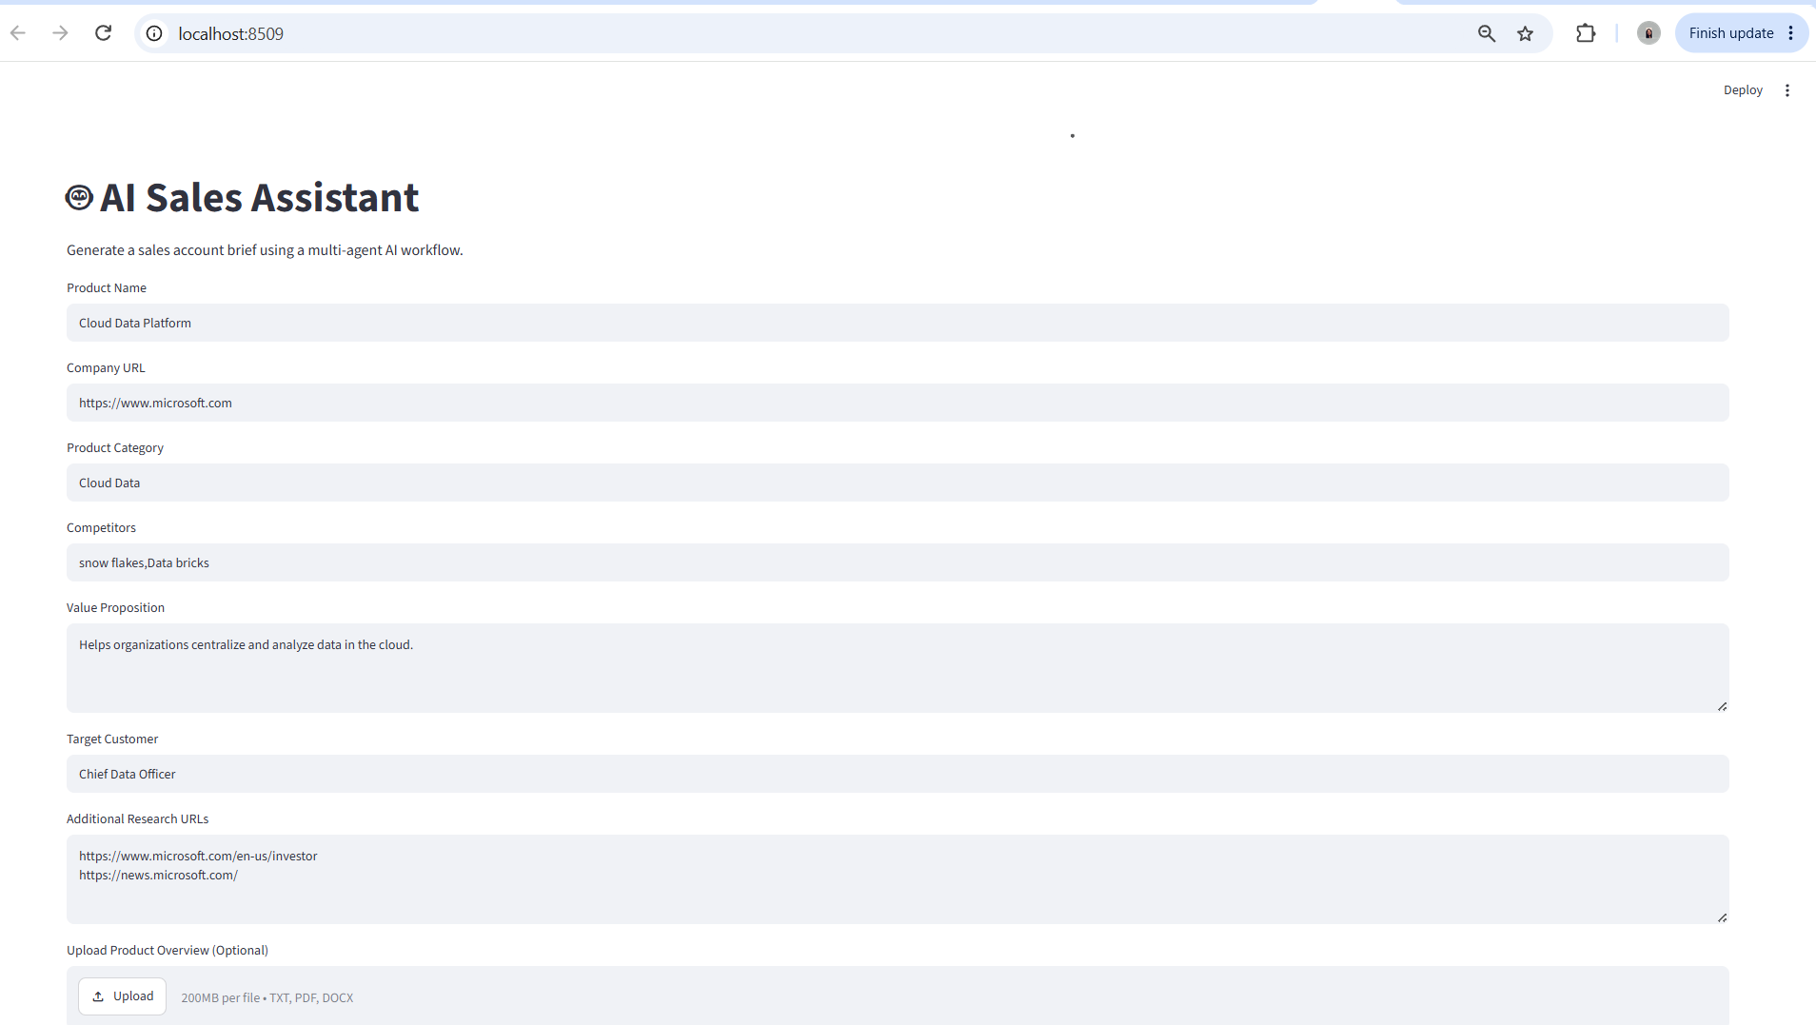
Figure 1 - AI Sales Assistant Streamlit Input Interface

5. LLM and Model Selection
The application uses openai/gpt-oss-20b through Groq, integrated with LangChain. Groq was selected for fast inference and straightforward LangChain integration. The model is configured with a low temperature to encourage consistent, predictable, and structured business-research outputs.
Instead of relying on a single model call, the application divides responsibilities among Sales, Research, Analysis, and Report agents. This approach allows each prompt to focus on a specific responsibility and makes individual parts of the workflow easier to test and refine.

Strengths
- Fast response generation
- Structured output
- LangChain integration
- Specialized prompts for individual tasks
- Modular development and testing

Limitations
LLM-generated conclusions can occasionally be inaccurate, incomplete, or unsupported. To reduce this risk, the application supplies public web content and source URLs to the research workflow and instructs agents not to invent unavailable information. Source verification remains important when AI-generated information is used for real business decisions.

6. Web Research and Data Integration
The application includes a custom web-research component that retrieves readable content from public company webpages. The initial implementation supported a single company URL; it was later expanded to support multiple research URLs.
- Company homepage
- Investor relations page
- News or press-release page
- Leadership page
- Other relevant public sources
Retrieved company, additional, and competitor webpage content is combined and passed directly to the Research Agent along with the source URLs and original sales context. The Research Agent prompt now includes both web_content and source_url and instructs the model to base factual findings on the supplied public sources and identify information that cannot be verified.

7. Prompt Engineering Experiments
Prompt engineering was used throughout development to improve the quality and relevance of generated responses. Initial prompts produced broad and generic sales information. Prompts were progressively refined by assigning specialized roles, defining required output sections, supplying web context, and passing source URLs through the workflow.
Prompt / Workflow Version | Observed Result
Basic prompt | Produced generic sales information
Structured prompt | Produced more organized responses
Role-specific agents | Improved separation of responsibilities
Web context added | Produced more company-specific information
Source URLs added | Improved traceability of research
Multiple URLs added | Broadened available company research
The final implementation uses prompt chaining across specialized agents rather than relying on a single general-purpose prompt.

8. Challenges and Solutions

Challenge 1 - Python Version Compatibility
Problem: Some required dependencies were incompatible with the original Python environment.
Solution: Changed the project environment to Python 3.12 to improve package compatibility.

Challenge 2 - uv Workspace Configuration
Problem: Workspace configuration caused the project to use an incorrect Python requirement.
Solution: Corrected the project configuration so the capstone could use its required Python environment independently.

Challenge 3 - Dependency Installation
Problem: Some Python dependencies initially failed to install correctly.
Solution: Used a compatible Python version and uv dependency management.

Challenge 4 - Groq Authentication
Problem: API authentication initially failed because of API-key configuration.
Solution: Corrected the .env configuration and successfully tested the Groq API connection.

Challenge 5 - Model Availability
Problem: An initially selected model name was unavailable.
Solution: Updated the application to use an available Groq-hosted model.

Challenge 6 - Python Module and Import Errors
Problem: Missing or incorrectly referenced agent modules caused import errors.
Solution: Corrected the agent file structure and Python imports.

Challenge 7 - Windows Application Control
Problem: Windows Application Control prevented the Streamlit executable from launching normally.
Solution: Started Streamlit through Python using: uv run python -m streamlit run .\src\capstone_sales_agent\app.py

Challenge 8 - Python Indentation Errors
Problem: Nested Streamlit, if/else, and spinner blocks produced indentation errors.
Solution: Reorganized code using consistent Python indentation.

Challenge 9 - Single-Source Research
Problem: The initial web-research implementation could process only one webpage.
Solution: Added support for multiple research URLs.

Challenge 10 - API-Key Security
Problem: API credentials needed protection from accidental GitHub publication.
Solution: Added .env to .gitignore and kept API credentials outside the Git repository.

9. System Output
The completed application was tested using a real-company scenario with Microsoft. The final AI-generated sales brief includes company strategy, technology strategy, competitor mentions, leadership information, business needs, sales opportunities, recommended next steps, and research sources.
The screenshots below demonstrate the generated account brief. The insights are AI-generated research outputs and should be verified against the listed primary sources before being used for business decisions.
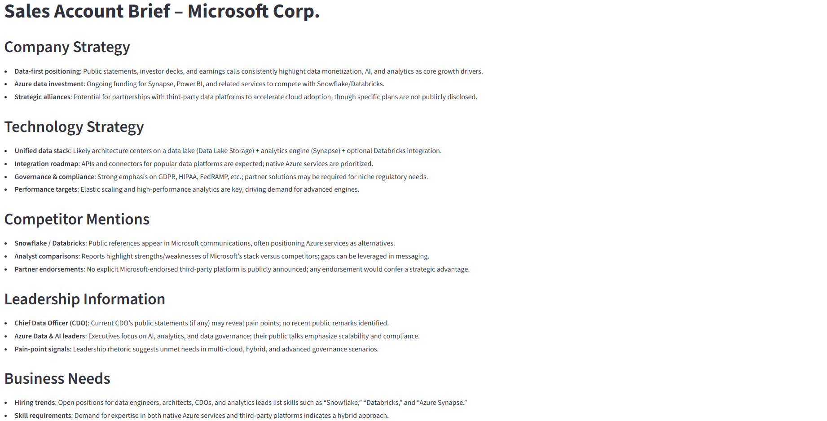
Figure 2 - AI-Generated Sales Account Brief
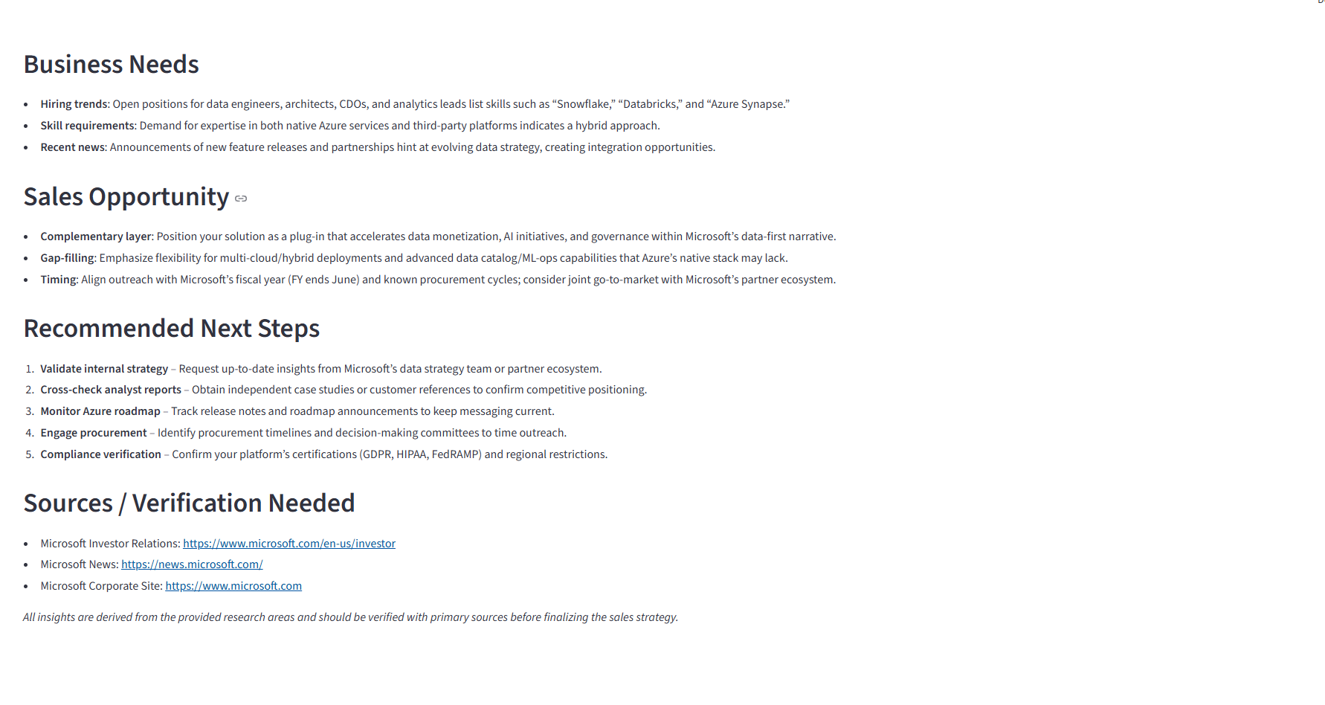
Figure 3 - Sales Opportunities, Recommended Next Steps, and Research Sources

10. Time Management
Project Phase | Time Allocation
Environment setup and dependency configuration | 20%
Agent development and prompt engineering | 35%
Web research and Streamlit integration | 30%
Testing, debugging, documentation, and GitHub submission | 15%
The largest portion of time was allocated to agent development and prompt engineering because the multi-agent workflow represented the core functionality of the application. Significant development time was also dedicated to web integration and Streamlit because these components connected the LLM workflow to real public information and provided the user-facing interface.

11. Production Deployment Plan
The current application is a working prototype. A production version would require additional controls for security, reliability, scalability, and maintenance.

Security
- Store API keys in a secure secrets-management service.
- Add user authentication and authorization.
- Validate URLs and uploaded files.
- Use HTTPS.
- Prevent sensitive information from appearing in logs.
- Restrict unsupported or potentially unsafe inputs.

Reliability and Monitoring
- Centralized logging
- Application monitoring
- API-error handling
- Rate-limit handling
- Retry mechanisms where appropriate
- LLM usage and cost monitoring
- Automated testing

Scalability
A production version could be containerized and hosted on a cloud platform. Multiple application instances could be deployed as usage increases. Frequently requested research data could be cached where appropriate to reduce unnecessary external requests and LLM usage.

Maintenance
- Model availability
- Model performance
- Prompt quality
- Dependency updates
- API changes
- Security vulnerabilities
- LLM cost and token consumption

12. Future Improvements
- Automatic discovery of relevant company sources
- Stronger citation and claim-to-source tracking
- Expanded document analysis for additional file formats and richer document structures
- Annual report and 10-K analysis
- Automated leadership research
- Job-posting analysis
- CRM integration
- Automated email alerts
- Cloud deployment
- Structured output validation
- Automated test coverage
- Sales presentation/deck generation

13. Project Development Evidence
The project was developed and tested in Visual Studio Code using a modular source structure with separate agent and tool modules, a Streamlit application, workflow orchestration, tests, dependency configuration, and project documentation.
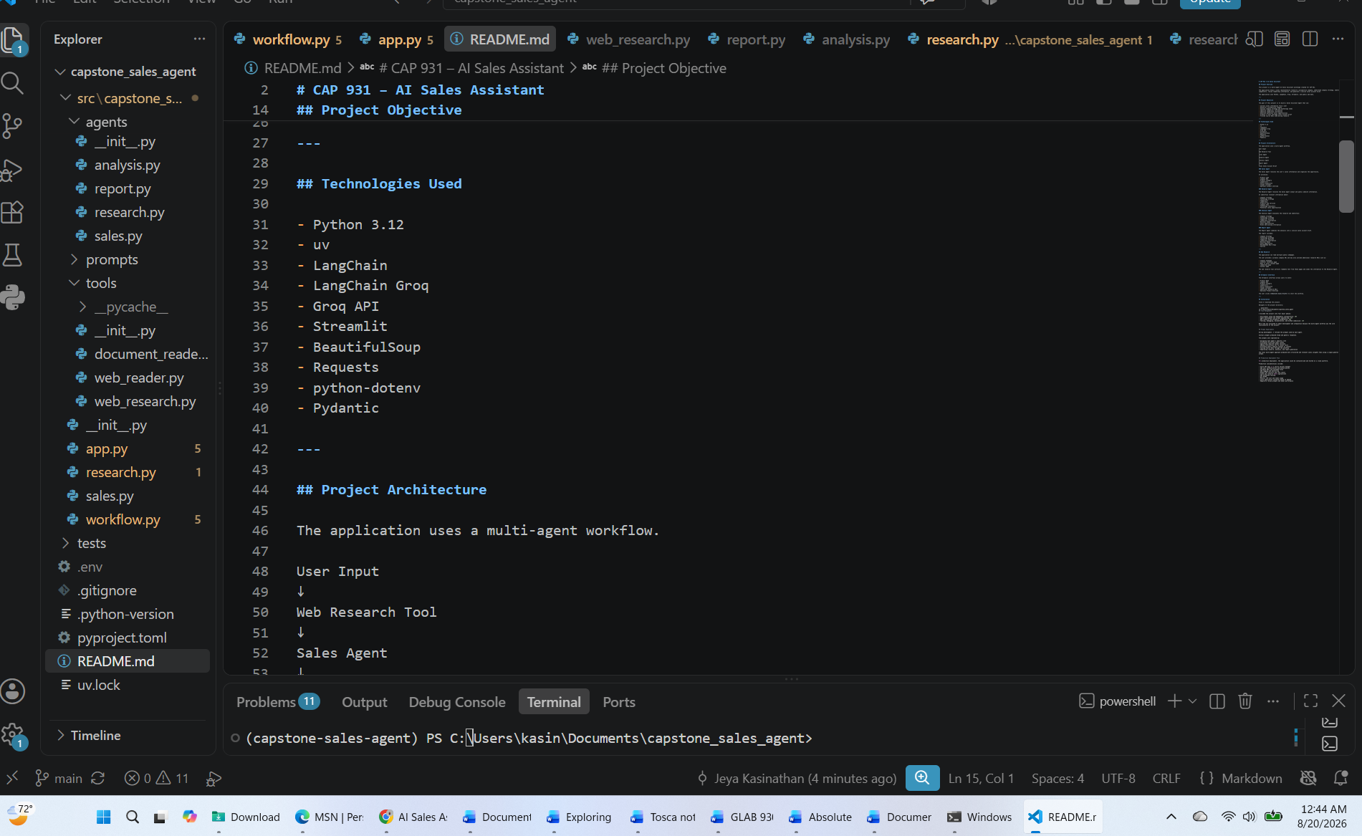
Figure 4 - AI Sales Assistant Project in Visual Studio Code

14. Corrections Made After Review
Following the initial CAP 931 project review, I made several improvements to strengthen the accuracy, functionality, and completeness of the AI Sales Assistant.

1. Web Research Grounding
The Research Agent was updated so that the retrieved web_content and source_url values are included directly in its prompt. The agent is instructed to base factual findings on the supplied public web content and to clearly identify information that cannot be verified from those sources.

2. Source URL Integration
Source URLs are now passed through the research workflow so the generated account brief can preserve traceable research sources. The Research Agent is also instructed not to invent additional URLs.

3. Competitor Web Research
A Competitor Research URLs input was added to the Streamlit interface. Users can provide competitor webpages in addition to competitor names, and those URLs are included in the web-research stage.

4. Product Document Integration
The Sales Agent prompt was updated to use the optional product_document content. When a product overview is uploaded, its extracted text is now available to the Sales Agent and can contribute to the sales opportunity analysis.

5. TXT, PDF, and DOCX Support
The document-upload workflow now processes TXT, PDF, and DOCX files. PDF extraction uses pypdf and DOCX extraction uses python-docx, and the extracted text is passed into the application workflow.

6. Dependency Updates
The capstone pyproject.toml and uv.lock were updated to include the document-processing dependencies pypdf and python-docx.

7. Duplicate File Cleanup
Outdated duplicate sales.py and research.py files outside the agents directory were removed. The active agent implementations are maintained under src/capstone_sales_agent/agents/.

8. Improved Research Reliability
The Research Agent prompt now emphasizes source-grounded factual findings, no invented facts or URLs, explicit handling of unverified information, and separation of verified research from interpretation.

9. Documentation Improvements
The documentation was expanded to describe prompt experiments, web-data integration, model selection, time management, challenges and solutions, production deployment considerations, and the corrections made after review.

Result of the Corrections
These changes address the major issues identified during the initial review. Most importantly, retrieved public web content is now connected directly to the Research Agent prompt. The revised workflow also supports competitor-source research and TXT/PDF/DOCX product documents, producing a stronger connection between supplied source data and AI-generated sales insights.
User Input → Company / Additional / Competitor URLs → Web Research → Web Content + Source URLs → Research Agent → Analysis Agent → Report Agent → Grounded Sales Account Brief

15. Conclusion
The CAP 931 AI Sales Assistant demonstrates how large language models can be integrated into a practical business application using a multi-agent architecture. The completed prototype combines Python, LangChain, Groq, Streamlit, prompt engineering, and public web research to transform user-provided sales information into structured account insights.
Developing the project demonstrated the importance of environment management, modular application design, API security, web-data integration, source verification, prompt refinement, testing, debugging, and error handling when developing LLM-powered applications.
The final application demonstrates an end-to-end workflow in which a sales representative provides information through Streamlit, the application researches publicly available company information, specialized AI agents process and analyze the information, and the system generates a structured sales account brief.
Future development could transform the prototype into a more comprehensive sales-intelligence platform through automated source discovery, document analysis, CRM integration, alerts, enhanced citation tracking, and production cloud deployment.

