L’assurance-maladie obligatoire suisse dans l’impasse. Une analyse du compromis socio-politique derrière la Loi fédérale sur l’assurance maladie (LAMal)
  - Annexe
Celâl Güney
Gaia Valenti

Annexe
Table 1: Votations en lien avec le système de santé en Suisse depuis 1848. Source: Swissvote
Date | Votation | Résultat | % Oui
30.07.1882 | Loi sur les épidémies | 0 | 21.10
26.10.1890 | Droit de légiférer sur l'assurance en cas d'accident et de maladie | 1 | 75.44
20.05.1900 | Loi sur l'assurance maladie, accidents et militaire | 0 | 30.21
04.02.1912 | Loi sur l'assurance en cas de maladie et d'accidents | 1 | 54.36
04.05.1913 | Lutte contre les maladies de l'homme et des animaux | 1 | 60.32
22.05.1949 | Loi sur la lutte contre la tuberculose | 0 | 24.85
08.12.1974 | Initiative «pour une meilleure assurance-maladie» | 0 | 26.71
08.12.1974 | Contre-projet à l'initiative «pour une meilleure assurance-maladie» | 0 | 31.84
10.03.1985 | Suppression de l'obligation de la Confédération d'allouer des subventions dans le domaine de la santé publique | 1 | 52.99
06.12.1987 | Loi sur l'assurance-maladie | 0 | 28.72
16.02.1992 | «Initiative des caisses-maladie» | 0 | 39.27
26.09.1993 | Mesures concernant l'assurance-maladie | 1 | 80.55
04.12.1994 | Loi sur l'assurance-maladie | 1 | 51.80
04.12.1994 | Initiative «pour une saine assurance-maladie» | 0 | 23.45
26.11.2000 | Initiative «pour des coûts hospitaliers moins élevés» | 0 | 17.89
09.02.2003 | Loi sur les participations cantonales aux coûts des traitements hospitaliers | 1 | 77.36
18.05.2003 | «Initiative-santé» | 0 | 27.09
11.03.2007 | Initiative pour une caisse maladie unique | 0 | 28.76
01.06.2008 | Article constitutionnel sur l'assurance-maladie | 0 | 30.52
17.05.2009 | Article constitutionnel sur les médecines complémentaires | 1 | 67.03
17.06.2012 | Loi sur l'assurance-maladie (Réseaux de soins) | 0 | 23.95
22.09.2013 | Loi sur les épidémies | 1 | 60.00
09.02.2014 | Initiative «Financer l'avortement est une affaire privée» | 0 | 30.18
18.05.2014 | Arrêté fédéral concernant les soins médicaux de base | 1 | 88.07
28.09.2014 | Initiative «Pour une caisse publique d'assurance-maladie» | 0 | 38.16
28.11.2021 | Initiative sur les soins infirmiers | 1 | 60.98
15.05.2022 | Principe du consentement présumé pour le don d’organes | 1 | 60.20
09.06.2024 | Initiative d’allègement des primes | 0 | 44.53
09.06.2024 | Initiative pour un frein aux coûts dans le système de santé | 0 | 37.23
24.11.2024 | Financement uniforme des prestations ambulatoires et stationnaires | 1 | 53.31
Table 2: Statistiques descriptives: variables dépendantes Source: Panel Selects vague 1 et 4.
 | Vague 1 | Vague 2
Characteristic | N = 8,197¹ | N = 8,197¹
assurance_maladie_franchise_pour
Fortement contre | 2,284 (28%)
Contre | 2,393 (30%)
Ni pour, ni contre | 2,147 (26%)
Pour | 980 (12%)
Fortement pour | 306 (3.8%)
Unknown | 87
Vote choice: Premium Relief Initiative
No answer |  | 0 (0%)
Yes (accepted) |  | 1,505 (42%)
No (rejected) |  | 1,231 (34%)
Blank |  | 63 (1.7%)
Don't remember |  | 809 (22%)
Unknown |  | 4,589
¹n (%)
 | Vague 1 | Vague 2
Characteristic | N = 8,197¹ | N = 8,197¹
eseg10
Business and administration professionals | 309 (4.1%) | 328 (5.0%)
Clerks and skilled service employees | 558 (7.4%) | 565 (8.6%)
Lower status employees | 290 (3.8%) | 297 (4.5%)
Managers | 791 (10%) | 783 (12%)
Professionals | 1,520 (20%) | 1,568 (24%)
Retired | 1,870 (25%) | 1,392 (21%)
Skilled industrial employees | 283 (3.7%) | 279 (4.2%)
small entrepreneurs | 160 (2.1%) | 168 (2.6%)
Student | 561 (7.4%) | 193 (2.9%)
Technicians and associated professionals employees | 778 (10%) | 784 (12%)
Unemployed or disabled | 466 (6.1%) | 212 (3.2%)
Unknown | 611 | 1,628
gender
Male | 4,133 (51%) | 2,605 (53%)
Female | 4,051 (49%) | 2,292 (47%)
Unknown | 13 | 3,300
langue
German | 5,961 (73%)
French | 1,845 (23%)
Italian | 373 (4.6%)
Romansh | 18 (0.2%)
Own opinion on limiting immigration
No answer | 0 (0%)
Strongly against | 642 (7.9%)
Rather against | 1,628 (20%)
Neither in favor nor against | 1,674 (21%)
Rather in favor | 2,534 (31%)
Strongly in favor | 1,634 (20%)
Unknown | 85
Own opinion on increasing public funding for out-of-home childcare
No answer | 0 (0%)
Strongly against | 597 (7.4%)
Rather against | 1,404 (17%)
Neither in favor nor against | 1,543 (19%)
Rather in favor | 2,933 (36%)
Strongly in favor | 1,625 (20%)
Unknown | 95
Own opinion on strengthening environmental protection in Switzerland
No answer | 0 (0%)
Strongly against | 214 (2.6%)
Rather against | 542 (6.7%)
Neither in favor nor against | 1,269 (16%)
Rather in favor | 3,016 (37%)
Strongly in favor | 3,073 (38%)
Unknown | 83
Opinion on state intervention in economy
No answer | 0 (0%)
Very much in favor of more state intervention in the economy | 427 (5.3%)
Rather in favor of more state intervention in the economy | 1,583 (20%)
Neither nor | 2,589 (32%)
Rather in favor of more competition in the economy | 2,820 (35%)
Very much in favor of more competition in the economy | 672 (8.3%)
Unknown | 106
Opinion on social expenses
No answer | 0 (0%)
Strongly in favor of a reduction | 493 (6.1%)
Rather in favor of a reduction | 1,238 (15%)
Neither nor | 2,938 (36%)
Rather in favor of an increase | 2,720 (34%)
Strongly in favor of an increase | 717 (8.8%)
Unknown | 91
Opinion on European integration
No answer | 0 (0%)
Strongly in favor of closer cooperation with the EU | 1,368 (17%)
Rather in favor of closer cooperation with the EU | 2,735 (34%)
Neither nor | 1,501 (18%)
Rather in favor of reinforcing independence | 1,651 (20%)
Strongly in favor of reinforcing independence | 881 (11%)
Unknown | 61
Opinion on chances for foreigners
No answer | 0 (0%)
Strongly in favor of equal chances | 1,946 (24%)
Rather in favor of equal chances | 2,503 (31%)
Neither nor | 1,168 (14%)
Rather in favor of better chances for Swiss people | 1,813 (22%)
Strongly in favor of better chances for Swiss people | 661 (8.2%)
Unknown | 106
Opinion on existing measures in favor of gender equality
No answer | 0 (0%)
Have already gone much too far | 272 (3.4%)
Have rather gone too far | 757 (9.3%)
Are just about right | 2,769 (34%)
Don't go far enough | 3,204 (39%)
Don't nearly go far enough | 1,110 (14%)
Unknown | 85
Opinion on taxes on high incomes
No answer | 0 (0%)
Strongly in favor of an increase | 1,989 (24%)
Rather in favor of an increase | 3,170 (39%)
Neither nor | 2,240 (28%)
Rather in favor of a reduction | 542 (6.7%)
Strongly in favor of a reduction | 188 (2.3%)
Unknown | 68
Opinion on traditions
No answer | 0 (0%)
Strongly in favor of a modern Switzerland | 1,206 (15%)
Rather in favor of a modern Switzerland | 2,687 (33%)
Neither nor | 1,762 (22%)
Rather in favor of a Switzerland that preserves its traditions | 2,012 (25%)
Strongly in favor of a Switzerland that preserves its traditions | 458 (5.6%)
Unknown | 72
Opinion on current political topics - minimum wage
No answer | 0 (0%) | 0 (0%)
Strongly against | 611 (7.5%) | 467 (9.5%)
Rather against | 1,238 (15%) | 871 (18%)
Rather in favor | 3,306 (41%) | 2,031 (41%)
Strongly in favor | 2,965 (37%) | 1,538 (31%)
Unknown | 77 | 3,290
Opinion on current political topics - increase in retirement age
No answer | 0 (0%)
Strongly against | 2,941 (36%)
Rather against | 2,738 (34%)
Rather in favor | 1,856 (23%)
Strongly in favor | 573 (7.1%)
Unknown | 89
Canton from FSO sample
Aargau | 626 (7.6%) | 369 (7.5%)
Appenzell Ausserrhoden | 63 (0.8%) | 44 (0.9%)
Appenzell Innerrhoden | 14 (0.2%) | 8 (0.2%)
Basel-Landschaft | 265 (3.2%) | 159 (3.2%)
Basel-Stadt | 152 (1.9%) | 91 (1.8%)
Bern | 1,111 (14%) | 687 (14%)
Fribourg | 299 (3.6%) | 194 (3.9%)
Geneva | 358 (4.4%) | 194 (3.9%)
Glarus | 31 (0.4%) | 19 (0.4%)
Graubünden | 199 (2.4%) | 121 (2.5%)
Jura | 60 (0.7%) | 33 (0.7%)
Lucerne | 440 (5.4%) | 274 (5.6%)
Neuchâtel | 162 (2.0%) | 96 (2.0%)
Nidwalden | 53 (0.6%) | 38 (0.8%)
Obwalden | 38 (0.5%) | 28 (0.6%)
Schaffhausen | 74 (0.9%) | 50 (1.0%)
Schwyz | 137 (1.7%) | 83 (1.7%)
Solothurn | 268 (3.3%) | 169 (3.4%)
St. Gallen | 513 (6.3%) | 300 (6.1%)
Thurgau | 253 (3.1%) | 143 (2.9%)
Ticino | 363 (4.4%) | 203 (4.1%)
Uri | 31 (0.4%) | 21 (0.4%)
Valais | 331 (4.0%) | 204 (4.1%)
Vaud | 743 (9.1%) | 414 (8.4%)
Zug | 124 (1.5%) | 77 (1.6%)
Zurich | 1,489 (18%) | 900 (18%)
language
German |  | 3,628 (74%)
French |  | 1,079 (22%)
Italian |  | 212 (4.3%)
Unknown |  | 3,278
Opinion on state intervention in economy
No answer |  | 0 (0%)
Very much in favor of more state intervention in the economy |  | 221 (4.5%)
Rather in favor of more state intervention in the economy |  | 1,143 (23%)
Neither nor |  | 1,673 (34%)
Rather in favor of more competition in the economy |  | 1,584 (32%)
Very much in favor of more competition in the economy |  | 275 (5.6%)
Unknown |  | 3,301
Too many worries about the environment instead of costs and prices
No answer |  | 0 (0%)
Strongly disagree |  | 782 (16%)
Rather disagree |  | 1,238 (25%)
Neither agree nor disagree |  | 1,105 (23%)
Rather agree |  | 1,357 (28%)
Strongly agree |  | 425 (8.7%)
Unknown |  | 3,290
Opinion on current political topics - increase in retirement age
No answer |  | 0 (0%)
Strongly against |  | 1,648 (34%)
Rather against |  | 1,719 (35%)
Rather in favor |  | 1,172 (24%)
Strongly in favor |  | 351 (7.2%)
Unknown |  | 3,307
Opinion on current political topics - foreigners' voting rights
No answer |  | 0 (0%)
Strongly against |  | 881 (18%)
Rather against |  | 1,206 (25%)
Rather in favor |  | 1,814 (37%)
Strongly in favor |  | 997 (20%)
Unknown |  | 3,299
vote_choice
FDP/PLR - Liberal Radical Party |  | 685 (16%)
The Centre (former CVP/ BDP) |  | 705 (16%)
SP/PS - Social Democratic Party |  | 1,095 (25%)
SVP/UDC - Swiss People's Party |  | 874 (20%)
GPS/PES - Green Party |  | 362 (8.2%)
GLP/PVL - Green Liberal Party |  | 437 (9.9%)
Other party, several/all parties |  | 239 (5.4%)
Unknown |  | 3,800
Unknown |  | 3,278
¹n (%)
Table 3: Régressions logit
 | Augmentation franchise minimale |  | Initiative pour l'allègement des primes
Predictors | Odds Ratios | CI | Odds Ratios | CI
(Intercept) | 1.03 | 0.56 – 1.89 | 0.33 ** | 0.14 – 0.75
income adj decile | 0.97 *** | 0.95 – 0.99 | 0.88 *** | 0.86 – 0.91
Own opinion on limiting  immigration | 0.92 ** | 0.87 – 0.98
Own opinion on  strengthening  environmental protection  in Switzerland | 0.89 *** | 0.83 – 0.95
Opinion on social  expenses | 1.17 *** | 1.09 – 1.25
Opinion on European  integration | 1.08 ** | 1.02 – 1.14
Opinion on chances for  foreigners | 1.04 | 0.99 – 1.09
Opinion on existing  measures in favor of  gender equality | 1.07 | 1.00 – 1.14
Opinion on taxes on high  incomes | 0.93 * | 0.87 – 0.99
Opinion on current  political topics-minimum  wage | 1.16 *** | 1.09 – 1.24 | 1.40 *** | 1.26 – 1.55
Opinion on current  political topics-increase  in retirement age | 0.72 *** | 0.67 – 0.76
Probability to vote for  The Centre(former  CVP/BDP) | 0.97 ** | 0.95 – 0.99
Probability to vote for  SP/PS-Social Democratic  Party | 1.05 *** | 1.02 – 1.07
Probability to vote for  GPS/PES-Green Party | 0.98 | 0.95 – 1.00
Probability to vote for  GLP/PVL-Green Liberal  Party | 0.96 ** | 0.94 – 0.99
langue: French | 1.59 *** | 1.39 – 1.83
langue: Italian | 1.19 | 0.88 – 1.61
langue: Romansh | 1.00 | 0.34 – 3.01
Age in years | 1.01 *** | 1.01 – 1.01
gender: Female | 1.34 *** | 1.19 – 1.50 | 0.69 *** | 0.58 – 0.82
I(eseg10 == "Retired")TRUE |  |  | 1.74 *** | 1.33 – 2.28
Left-right self-placement |  |  | 0.93 ** | 0.88 – 0.98
Opinion on state  intervention in economy |  |  | 0.77 *** | 0.69 – 0.85
Too many worries about  the environment instead  of costs and prices |  |  | 1.10 * | 1.01 – 1.20
Opinion on current  political topics-increase  in retirement age |  |  | 0.88 * | 0.80 – 0.97
Opinion on current  political  topics-foreigners'voting  rights |  |  | 1.18 ** | 1.06 – 1.30
vote choice: The  Centre(former CVP/BDP) |  |  | 0.94 | 0.69 – 1.30
vote choice: SP/PS-Social  Democratic Party |  |  | 2.24 *** | 1.57 – 3.19
vote choice:  SVP/UDC-Swiss People's  Party |  |  | 1.14 | 0.84 – 1.57
vote choice:  GPS/PES-Green Party |  |  | 1.95 ** | 1.28 – 2.98
vote choice:  GLP/PVL-Green Liberal  Party |  |  | 1.05 | 0.72 – 1.55
vote choice: Other  party,several/all parties |  |  | 1.68 * | 1.08 – 2.59
Age in years |  |  | 1.01 *** | 1.01 – 1.02
language: French |  |  | 1.66 *** | 1.33 – 2.06
language: Italian |  |  | 2.53 *** | 1.63 – 3.96
Observations | 6280 |  | 2999
R² Tjur | 0.104 |  | 0.229
* p<0.05 ** p<0.01 *** p<0.001

Table 4: Modèle multiniveau: cantons suisses en niveau
Table 5: Régressions logistiques simples: opposition à l’augmentation de la franchise et vote pour l’allègement des primes sur les catégories socio-professionnelles ESEG
 | Augmentation franchise minimale |  | Initiative pour l'allègement des primes
Predictors | Odds Ratios | CI | Odds Ratios | CI
(Intercept) | 0.95 | 0.76 – 1.19 | 0.37 *** | 0.26 – 0.53
eseg10 [Clerks and  skilled service  employees] | 1.59 ** | 1.20 – 2.10 | 1.57 * | 1.01 – 2.48
eseg10 [Lower status  employees] | 1.57 ** | 1.14 – 2.18 | 1.84 * | 1.09 – 3.10
eseg10 [Managers] | 1.10 | 0.84 – 1.43 | 1.10 | 0.72 – 1.68
eseg10 [Professionals] | 1.34 * | 1.05 – 1.71 | 1.57 * | 1.08 – 2.33
eseg10 [Retired] | 1.66 *** | 1.30 – 2.11 | 3.10 *** | 2.16 – 4.52
eseg10 [Skilled  industrial employees] | 1.80 *** | 1.30 – 2.51 | 1.62 | 0.93 – 2.82
eseg10 [small  entrepreneurs] | 1.45 | 0.98 – 2.13 | 1.66 | 0.90 – 3.02
eseg10 [Student] | 1.17 | 0.89 – 1.55 | 1.57 | 0.93 – 2.64
eseg10 [Technicians and  associated professionals  employees] | 1.48 ** | 1.13 – 1.93 | 1.55 * | 1.02 – 2.38
eseg10 [Unemployed or  disabled] | 1.77 *** | 1.32 – 2.38 | 1.73 * | 1.06 – 2.83
Observations | 7535 |  | 3392
R² Tjur | 0.007 |  | 0.035
* p<0.05 ** p<0.01 *** p<0.001

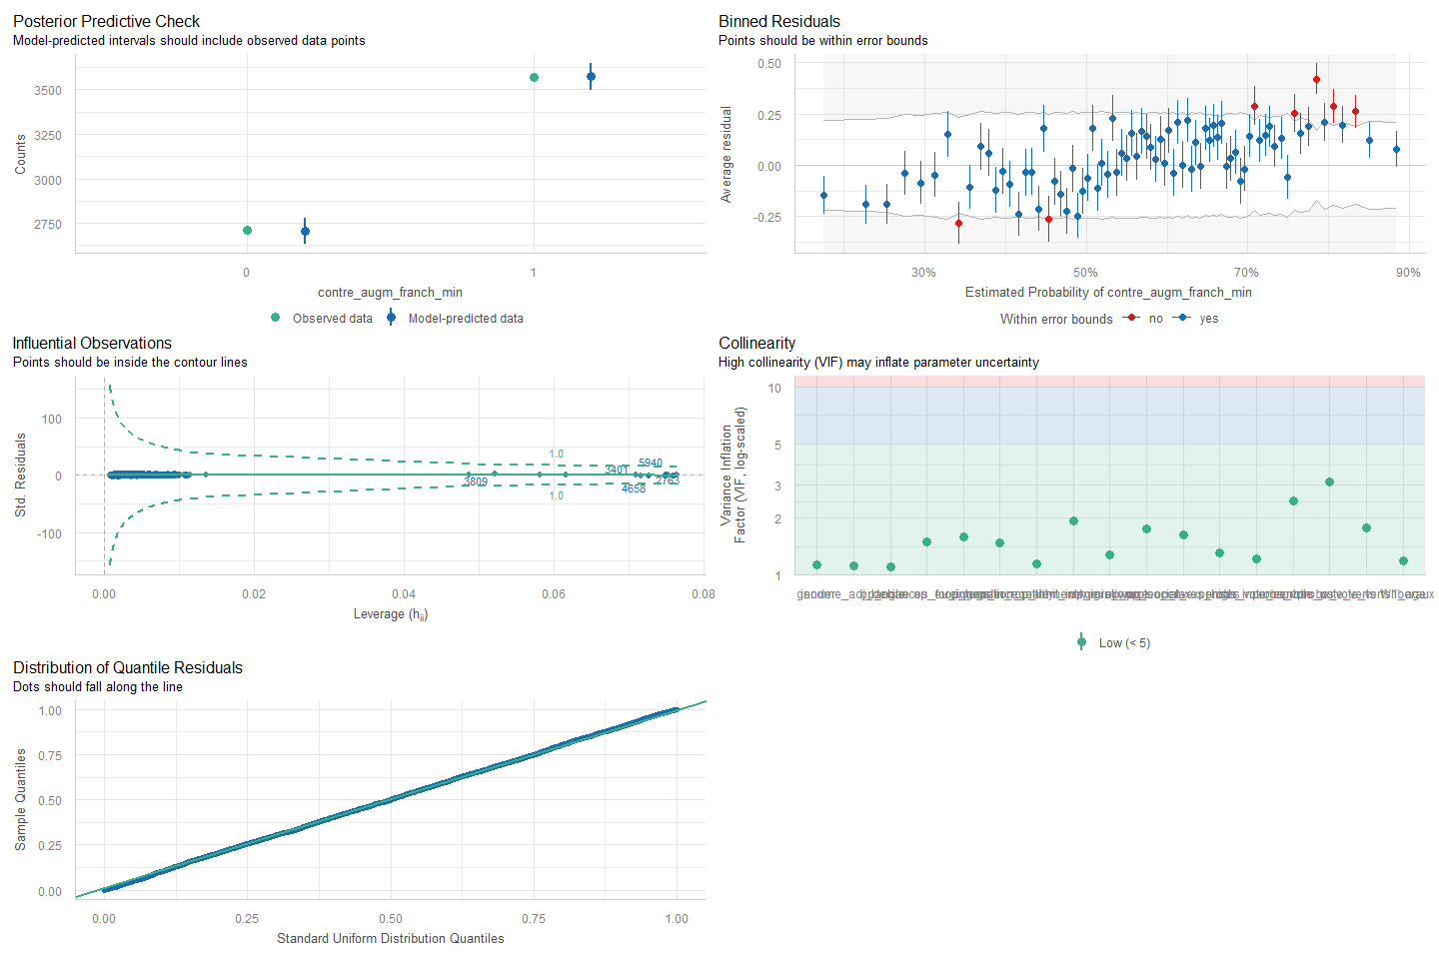
Figure 1: Vérification des hypothèses du modèle logit: augmentation de la franchise minimale
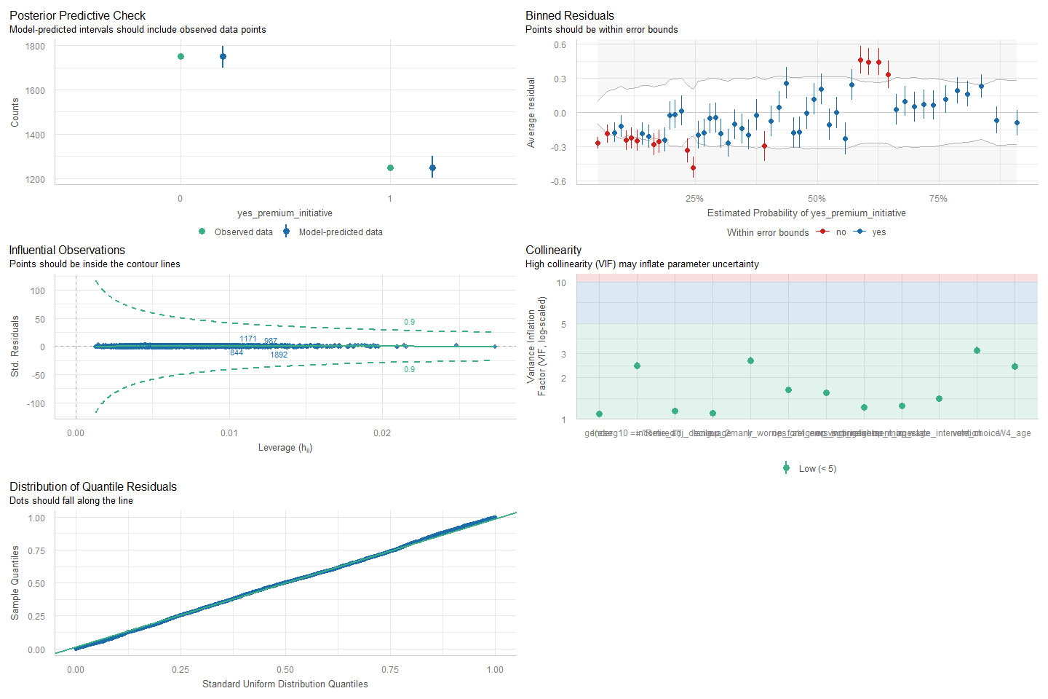
Figure 2: Vérification des hypothèse du modèle logit: initiative pour l’allègement des primes

