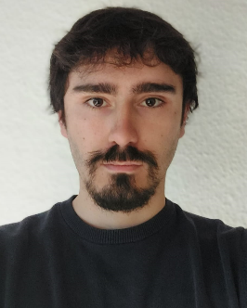**Celâl Güney**

Route des Hospitaliers 107 - 1257 Croix-de-Rozon

Born the 24th August 1998 - Switzerland

+41 79 936 64 31

[celal.98@outlook.com](mailto:celal.98@outlook.com)

[Celal.Gueney@etu.unige.ch](mailto:Celal.Gueney@etu.unige.ch)

<https://jeylal.github.io/celalguney/about.html>

Education

2010: Secondary school, Drize

2014 - 2017: High school maturity, Collège Mme De Staël

Summer 2019: Certificate of Achievement, Renmin University of China (corporate finance, Chinese language)

Autumn 2020: Bachelor in History-Economics-Society, University of Geneva (UNIGE)

Autumn 2022: Complementary Certificate in Applied Statistics, UNIGE

Since autumn 2022: Master in the Political Economy of Capitalism – UNIGE

Professional Experience

Summer 2018: Restaurant employee: Loëx hospital

Summer 2019: Laboratory assistant: HUG (Geneva University Hospital)

June 2020 - April 2021: Long military service – military police security soldier

1 August – 31 January 2024: Research and Teaching Assistant (40%) – University of Geneva

Languages

French: Native German: B2 level

English: Very good knowledge Spanish: B2 level

Informatics and softwares

SPSS: good knowledge Excel: Very good knowledge

Stata: Very good knowledge Office: Very good knowledge

Arcgis (Arcmap, Arcgis pro): Very good knowledge

R Studio: Very good knowledge

Interests and Other

* Political Economy | Comparative Capitalisms
* Institutional Economics | Evolutionary Economics
* Macroeconomics | Post-Keynesian Economics
* Political Cleavages and Inequality
* Economics History | History of Economic Thought and Economic Measures
* Data Science | Econometrics | Statistics | History of Statistics/Econometrics

To get to know me better and see what I am working on, please have a look to my website:

<https://jeylal.github.io/celalguney/about.html>