SUBOP Database Abstraction Layer
Report

1.Introduction 2
1.1.Background 2
1.2.Purpose of the Research 3
1.3.Scope and Objectives 4
2.Research Methadology 5
2.1.Evaluation Criteria 6
2.2.Comparison Approach 7
3.Option A- Adapter Pattern 7
3.1.Architecture Overview 7
3.2.Advantages 8
3.3.Disadvantages 9
3.4.Suitability For SUBOP 10
4.Option B-SQL Alchemy Core 11
4.1.Architecture Overview 11
4.2.Advantages 12
4.3.Disadvantages 13
4.4.Suitability for SUBOP 14
5.Option C- Custom Pipeline DSL 15
5.1.Architecture Overview 15
5.2.Advantages 16
5.3.Disadvantages 17
5.4.Suitability for SUBOP 18
6.SQL Dialect Difference Analysis 19
7.Comparative Evolution 20
9.Recommended Architecture for M4 21
9.1.Recommended Solution 21
9.2.Proposed Architecture 21
9.3.Implementation Considerations 23
9.4.Risks and Mitigation 24
10.Conclusion 25

1.Introduction

1.1.Background
SUBOP (Software United Business Operation Platform) is a database-independent Extract, Transform, Load (ETL) platform designed to simplify data integration across heterogeneous database environments. The platform aims to provide a unified framework that enables organizations to connect multiple data sources, execute ETL pipelines, and transfer data between different database management systems through a common architecture.
One of the primary challenges in modern enterprise data environments is database dependency. Traditional ETL solutions are often tightly coupled to specific database technologies, requiring significant redevelopment effort whenever an organization migrates to a different database platform. In addition, enterprises commonly operate multiple database systems simultaneously, including PostgreSQL, MySQL, Oracle, Microsoft SQL Server, and SQLite, each of which introduces its own SQL dialects, connection mechanisms, data types, and vendor-specific features.
To address these challenges, SUBOP adopts a database-independent architecture based on standardized connectors and a dedicated database abstraction layer. The objective is to allow a single ETL definition to operate consistently across multiple database systems while minimizing database-specific implementation details. By isolating the ETL engine from individual database technologies, the platform seeks to reduce vendor lock-in, improve maintainability, and simplify the integration of new database connectors.
The database abstraction layer is a critical component of the overall SUBOP architecture. It serves as the intermediary between the ETL engine and the underlying database systems, providing a common interface for data access and query execution. However, designing such a layer introduces important architectural trade-offs involving flexibility, implementation complexity, performance, and long-term scalability.
As a result, selecting an appropriate abstraction strategy represents one of the most important design decisions within the SUBOP project. This research investigates multiple abstraction approaches and evaluates their suitability for supporting the database-independent goals of the SUBOP platform.

1.2.Purpose of the Research
Organizations increasingly rely on data originating from multiple heterogeneous systems, including relational databases, cloud platforms, APIs, file-based sources, and real-time event streams. However, existing data integration solutions often suffer from strong dependencies on specific database technologies, resulting in vendor lock-in, duplicated development effort, and increased maintenance costs when database platforms change.
Traditional ETL solutions typically require database-specific configurations, query implementations, and connector logic. As a result, migrating ETL processes from one database system to another frequently requires substantial redevelopment effort. Furthermore, enterprise environments often contain multiple database technologies operating simultaneously, making cross-platform data integration a complex challenge.
SUBOP (Software United Business Operation Platform) is a database-independent data management platform designed to address these challenges by providing an integrated architecture that combines ETL processing, data warehousing, business intelligence, data quality management, and change data capture (CDC) capabilities within a single ecosystem. The platform aims to support multiple database systems through a common abstraction layer while allowing ETL processes to operate independently of the underlying database technology.
A core objective of SUBOP is to enable a single ETL definition to operate across different database management systems with minimal or no code modifications. To achieve this objective, the platform requires a database abstraction layer capable of hiding differences in SQL dialects, data types, connection protocols, and database-specific behaviors. The abstraction layer serves as the foundation for connector interoperability, database portability, and long-term platform scalability.
Because the abstraction layer directly affects connector development, ETL execution, performance, maintainability, and future support for additional database technologies, selecting an appropriate abstraction strategy represents one of the most important architectural decisions within the SUBOP project. This research therefore investigates alternative abstraction approaches and evaluates their suitability for the implementation of the SUBOP database access layer.

1.3.Scope and Objectives
This research focuses on the design and evaluation of database abstraction strategies for the SUBOP platform. The study is limited to the database abstraction layer that operates between the ETL engine and relational database management systems.
The analysis specifically considers support for PostgreSQL, MySQL, Oracle, Microsoft SQL Server, and SQLite, as these systems represent the primary relational database targets for the initial phases of the SUBOP project.
The scope of this research includes:
- Evaluation of alternative database abstraction approaches.
- Analysis of SQL dialect differences across supported databases.
- Assessment of maintainability, extensibility, and implementation complexity.
- Investigation of database portability requirements.
- Recommendation of an architecture suitable for the M4 implementation phase.
The following topics are outside the scope of this research:
- ETL transformation logic and pipeline execution.
- Business Intelligence (BI) components.
- Data Warehouse implementation details.
- Change Data Capture (CDC) mechanisms.
- Frontend and visualization layers.
- Performance benchmarking of production-scale deployments.
Objectives
The primary objective of this research is to identify the most suitable database abstraction strategy for the SUBOP platform.
The specific objectives are:
- To investigate multiple abstraction approaches applicable to the SUBOP architecture.
- To compare the Adapter Pattern, SQLAlchemy Core, and Custom Pipeline DSL approaches.
- To identify major SQL dialect differences among supported database systems.
- To evaluate each approach according to maintainability, extensibility, performance considerations, and implementation effort.
- To determine how database-specific functionality can be managed within a database-independent architecture.
- To provide a justified recommendation for the M4 implementation phase.
- To establish a foundation for future connector development and multi-database support within the SUBOP ecosystem.
The final outcome of this research is a technical recommendation that supports the implementation of a scalable, maintainable, and database-independent abstraction layer for the SUBOP platform.

2.Research Methadology
This research follows a comparative architectural evaluation methodology to identify the most suitable database abstraction strategy for the SUBOP platform. Three alternative approaches were selected based on their relevance to multi-database ETL systems and their applicability to the SUBOP architecture:
- Adapter Pattern
- SQLAlchemy Core
- Custom Pipeline Domain-Specific Language (DSL)
Each approach was analyzed from both a technical and architectural perspective. The evaluation focused on how effectively each solution supports SUBOP's database-independent ETL objectives while maintaining acceptable levels of maintainability, extensibility, and implementation complexity.
The analysis was conducted through literature review, architectural design analysis, technology documentation review, and practical implementation considerations derived from the requirements of the SUBOP abstraction layer.
The results of the evaluation are presented through a structured comparison framework based on predefined evaluation criteria.

2.1.Evaluation Criteria
To ensure a consistent comparison, all candidate approaches were evaluated using the same set of criteria.
Maintainability
The ease with which the abstraction layer can be modified, debugged, and extended over time.
Extensibility
The effort required to support additional database systems, connectors, and future platform capabilities.
Database Independence
The degree to which application logic remains isolated from database-specific implementations and SQL dialect differences.

Implementation Complexity
The estimated development effort, architectural complexity, and learning curve associated with each approach.
Performance Impact
The expected overhead introduced by the abstraction layer compared to native database access.
Scalability
The ability of the solution to support future growth in the number of supported databases and platform features.
Community and Ecosystem Support
The availability of documentation, third-party libraries, industry adoption, and long-term sustainability.
Suitability for SUBOP
The overall alignment of the approach with the objectives, architecture, and development constraints of the SUBOP project.

2.2.Comparison Approach
The comparison was performed by evaluating each abstraction strategy against the predefined evaluation criteria described in Section 2.1.
For each candidate solution, the analysis examined:
- Architectural design and implementation model.
- Advantages and potential benefits.
- Limitations and risks.
- Impact on database portability.
- Impact on future connector development.
- Compatibility with the SUBOP platform architecture.
The three approaches were then compared qualitatively using a decision matrix. Rather than focusing solely on technical capabilities, the evaluation also considered practical project constraints such as implementation effort, maintainability, expected project timeline, and long-term platform sustainability.
The outcome of this comparison forms the basis for the final recommendation presented in last section.

3.Option A- Adapter Pattern

3.1.Architecture Overview
The Adapter Pattern introduces an intermediate abstraction layer between the ETL engine and individual database systems. A common BaseConnector interface defines the operations required by the ETL engine, while each database system provides its own adapter implementation.
Following diagram illustrates the high-level architecture of the Adapter Pattern within the context of the SUBOP abstraction layer.
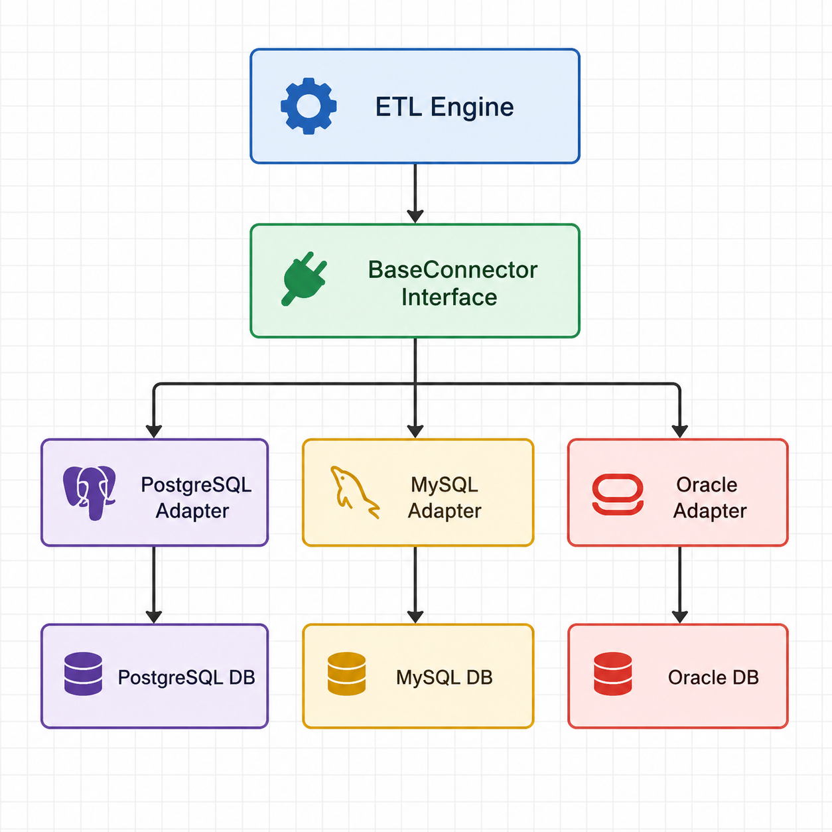
In this architecture, the ETL engine interacts exclusively with the BaseConnector interface and remains unaware of database-specific implementation details. Database adapters are responsible for translating generic operations into database-specific queries, connection handling procedures, and data type mappings.
This approach promotes separation of concerns by isolating database-specific logic within dedicated adapter classes. As a result, support for new database systems can be added by implementing additional adapters without modifying the ETL engine itself.

3.2.Advantages
The Adapter Pattern offers several advantages for a database-independent ETL platform such as SUBOP.
Clear Separation of Concerns
Database-specific logic is isolated within dedicated adapter implementations. The ETL engine interacts only with the common BaseConnector interface, reducing coupling between business logic and database technologies.
Improved Maintainability
Changes to a particular database implementation can be made within the corresponding adapter without affecting the rest of the system. This simplifies maintenance and reduces the risk of introducing unintended side effects.
Extensibility
New database systems can be supported by implementing additional adapters that conform to the BaseConnector interface. Existing ETL functionality can remain unchanged while platform capabilities continue to grow.
Technology Independence
The architecture does not rely on external abstraction frameworks or ORM solutions. This provides full control over the implementation and allows database-specific optimizations when required.
Consistent Development Model
All database connectors follow the same architectural pattern and interface contract. This promotes code consistency and simplifies future connector development.
Alignment with SUBOP Objectives
The Adapter Pattern directly supports SUBOP's goal of reducing database dependency by providing a common access layer between the ETL engine and multiple database systems. The architecture also aligns well with the project's planned connector-based ecosystem and plugin-oriented design.

3.3.Disadvantages
Despite its architectural simplicity, the Adapter Pattern also introduces several limitations that must be considered when designing a database-independent platform such as SUBOP.
Manual SQL Dialect Management
Each database system implements SQL differently. Query syntax, functions, pagination mechanisms, and vendor-specific features must be handled manually within individual adapters. As the number of supported databases increases, managing these differences becomes increasingly complex.
Increased Development Effort
Every supported database requires its own adapter implementation and maintenance. Common functionality often needs to be reimplemented across multiple adapters, resulting in additional development effort.
Scalability Challenges
As more database systems are added, the number of adapter implementations grows accordingly. This may increase maintenance costs and make long-term platform evolution more difficult.
Feature Duplication
Database-specific capabilities often require additional methods or custom implementations within each adapter. As a result, similar functionality may be duplicated across multiple database connectors.
Higher Testing Requirements
Since each adapter contains database-specific logic, comprehensive testing must be performed for every supported database system. This increases the overall testing effort and complexity of quality assurance processes.
Limited Abstraction of Database Differences
While the Adapter Pattern provides a common interface, it does not automatically resolve SQL dialect differences, data type mappings, or vendor-specific behaviors. These challenges remain the responsibility of the adapter implementations and may become significant as the platform expands.

3.4.Suitability For SUBOP
The Adapter Pattern is well aligned with the core objectives of the SUBOP platform, particularly its goal of providing database-independent ETL functionality through a connector-based architecture. By defining a common BaseConnector interface and encapsulating database-specific logic within dedicated adapters, the pattern supports modularity, maintainability, and future extensibility.
The approach also integrates naturally with SUBOP's planned connector ecosystem, where support for additional database systems can be introduced through new adapter implementations. This characteristic makes the Adapter Pattern an attractive foundation for the platform's abstraction layer and supports the project's long-term objective of reducing database dependency.
However, the Adapter Pattern alone does not fully address the challenges associated with SQL dialect differences, data type mappings, and vendor-specific database behavior. As the number of supported databases increases, the effort required to maintain and synchronize adapter implementations may grow significantly.
For this reason, while the Adapter Pattern provides a strong architectural foundation for SUBOP, it may benefit from being combined with additional abstraction technologies that can automate database-specific query generation and dialect handling. Such a hybrid approach could preserve the modular advantages of the Adapter Pattern while reducing implementation complexity and maintenance effort.
Overall, the Adapter Pattern can be considered a suitable solution for SUBOP, particularly as the structural basis of the abstraction layer. Nevertheless, its effectiveness is likely to be improved when combined with complementary technologies that address database-specific differences more efficiently.

4.Option B-SQL Alchemy Core

4.1.Architecture Overview
SQLAlchemy Core is a lightweight database abstraction framework that provides a unified way of constructing and executing database queries across multiple database management systems. Rather than requiring developers to write database-specific SQL statements for each supported platform, SQLAlchemy Core uses a common expression language that can be translated into the appropriate SQL dialect automatically.
The framework achieves database independence through its dialect architecture. Each dialect is responsible for generating database-specific SQL syntax while exposing a consistent programming interface to the application layer. This enables applications to interact with different database systems using the same query construction model.
Following diagram illustrates the high-level architecture of SQLAlchemy Core within the context of the SUBOP abstraction layer.
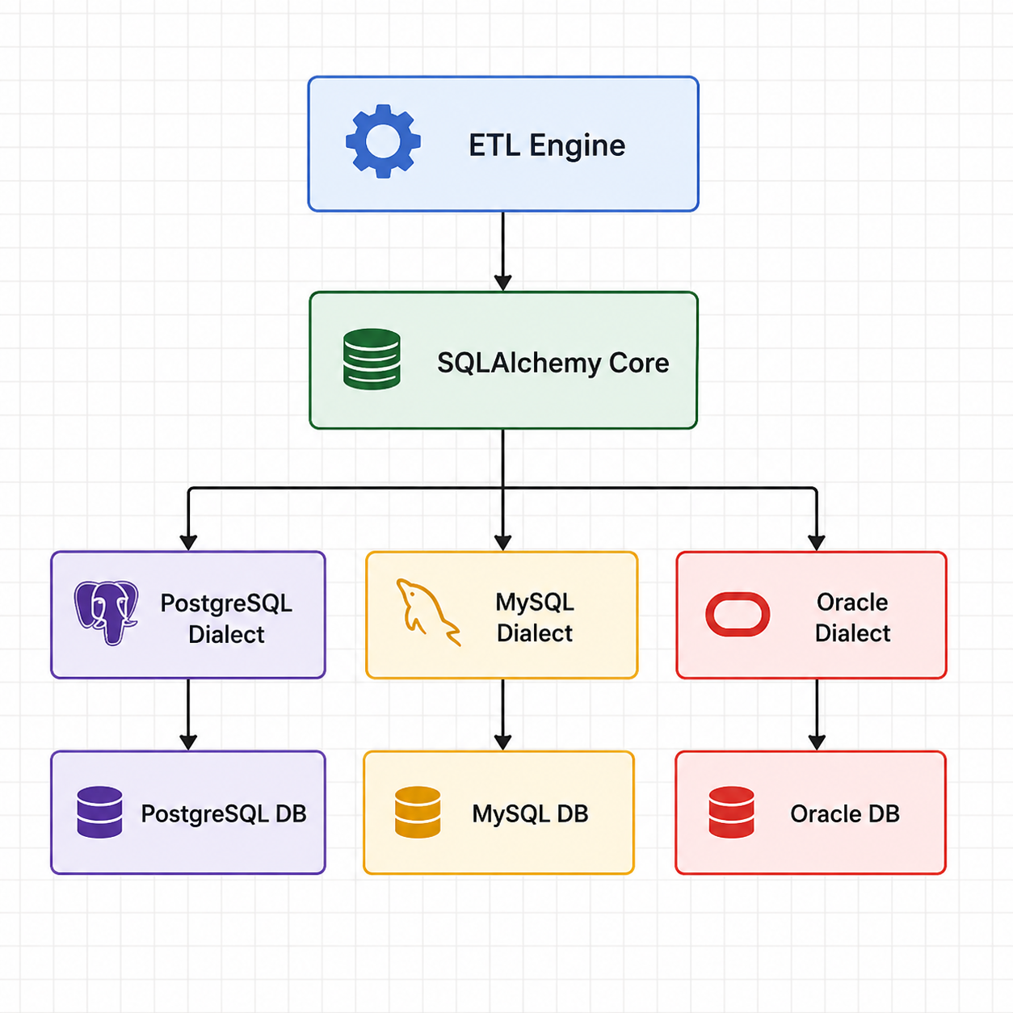
In this architecture, the ETL engine communicates directly with SQLAlchemy Core rather than interacting with database-specific implementations. SQLAlchemy Core generates the appropriate SQL statements through its dialect system and forwards them to the corresponding database driver.
This approach abstracts many database-specific differences, including query syntax and data type handling, allowing developers to work with a single programming model across multiple database platforms. As a result, SQLAlchemy Core can significantly reduce the complexity associated with supporting multiple database systems within the SUBOP platform.

4.2.Advantages
SQLAlchemy Core offers several advantages for a database-independent platform such as SUBOP.
Automatic SQL Dialect Handling
One of the most significant advantages of SQLAlchemy Core is its ability to automatically generate database-specific SQL statements through its dialect system. This reduces the need for manually maintaining separate SQL implementations for each supported database.
Reduced Development Effort
Developers can define queries using a unified expression language rather than writing database-specific SQL code. This significantly decreases implementation effort and accelerates development.
Broad Database Support
SQLAlchemy provides mature support for numerous relational database systems, including PostgreSQL, MySQL, Oracle, Microsoft SQL Server, and SQLite. This aligns well with SUBOP's objective of supporting multiple database platforms.
Improved Maintainability
Since database-specific syntax is handled by SQLAlchemy, application code remains cleaner and easier to maintain. Changes to database implementations often require fewer modifications within the application layer.
Consistent Query Construction
The framework provides a standardized approach for creating and executing queries across different database systems. This promotes consistency and reduces the likelihood of database-specific coding errors.
Strong Community and Ecosystem
SQLAlchemy is one of the most widely adopted database frameworks in the Python ecosystem. Extensive documentation, community support, and long-term maintenance reduce technical risk and improve project sustainability.
Faster Connector Development
Many database-specific details are already managed by SQLAlchemy. This can simplify the implementation of new connectors and reduce the amount of custom code required within the SUBOP platform.

4.3.Disadvantages
Despite its strengths, SQLAlchemy Core also introduces several limitations that must be considered when evaluating its suitability for the SUBOP platform.
Additional Dependency
SQLAlchemy introduces an external framework dependency into the architecture. Future upgrades, compatibility issues, or framework-specific limitations may affect the platform.
Learning Curve
Developers must become familiar with SQLAlchemy's expression language, architecture, and dialect system. This may increase onboarding time for new contributors.
Reduced Low-Level Control
Because SQLAlchemy generates SQL automatically, developers have less direct control over the exact SQL statements executed by the database. In some cases, manual optimization may still be necessary.
Limited Support for Vendor-Specific Features
Although SQLAlchemy handles many database differences, highly specialized database features may not be fully abstracted. Advanced vendor-specific functionality can still require custom implementations.
Potential Performance Overhead
The abstraction process introduces additional layers between the application and the database. While generally small, this overhead may become relevant in performance-critical scenarios.
Framework Constraints
The capabilities of the abstraction layer are partially constrained by the features and design decisions of SQLAlchemy itself. If certain requirements are not supported by the framework, custom workarounds may be required.
Not a Complete Connector Architecture
SQLAlchemy Core primarily addresses query generation and database interaction. It does not provide the complete connector-based architecture envisioned for SUBOP and therefore cannot fully replace higher-level abstraction mechanisms on its own.

4.4.Suitability for SUBOP
SQLAlchemy Core is highly relevant to the objectives of the SUBOP platform due to its strong support for database portability and automatic SQL dialect management. Since one of the primary goals of SUBOP is to enable database-independent ETL operations, SQLAlchemy's ability to generate database-specific SQL from a unified query model directly supports this requirement.
Compared to the Adapter Pattern, SQLAlchemy Core significantly reduces the effort required to handle differences between database systems. Features such as dialect management, query compilation, and data type handling are already implemented within the framework, allowing developers to focus on platform functionality rather than database-specific syntax.
Furthermore, SQLAlchemy supports many of the relational database systems targeted by SUBOP, including PostgreSQL, MySQL, Oracle, Microsoft SQL Server, and SQLite. This broad compatibility aligns well with the platform's long-term vision of supporting multiple database technologies through a unified architecture.
However, SQLAlchemy Core does not provide a complete solution for the connector-oriented architecture planned for SUBOP. While it simplifies database interaction, additional architectural components are still required to manage connector lifecycle, configuration management, plugin support, and database-specific operational behavior.
For this reason, SQLAlchemy Core is best viewed as a complementary technology rather than a complete abstraction strategy on its own. Its strengths in SQL generation and dialect handling can significantly enhance a connector-based architecture while reducing development and maintenance effort.
Overall, SQLAlchemy Core is a strong candidate for the SUBOP abstraction layer and addresses many of the limitations identified in the Adapter Pattern approach. The most suitable implementation strategy may therefore involve combining SQLAlchemy Core with a connector-based architecture to leverage the advantages of both approaches.

5.Option C- Custom Pipeline DSL

5.1.Architecture Overview
A Custom Pipeline Domain-Specific Language (DSL) represents a specialized abstraction approach in which database operations are defined using a SUBOP-specific query language rather than directly through SQL statements or external abstraction frameworks.
In this architecture, users define ETL operations using a custom DSL syntax. These definitions are then processed by a compiler or translation layer that converts the DSL instructions into database-specific SQL statements. The generated SQL is subsequently executed against the target database system.
The primary objective of this approach is to provide complete control over the abstraction layer while creating a unified language that can be used consistently across all supported database platforms. By introducing an intermediate DSL layer, database-specific syntax can be hidden entirely from the ETL engine and end users.
Following diagram illustrates the high-level architecture of a Custom Pipeline DSL within the context of the SUBOP platform.
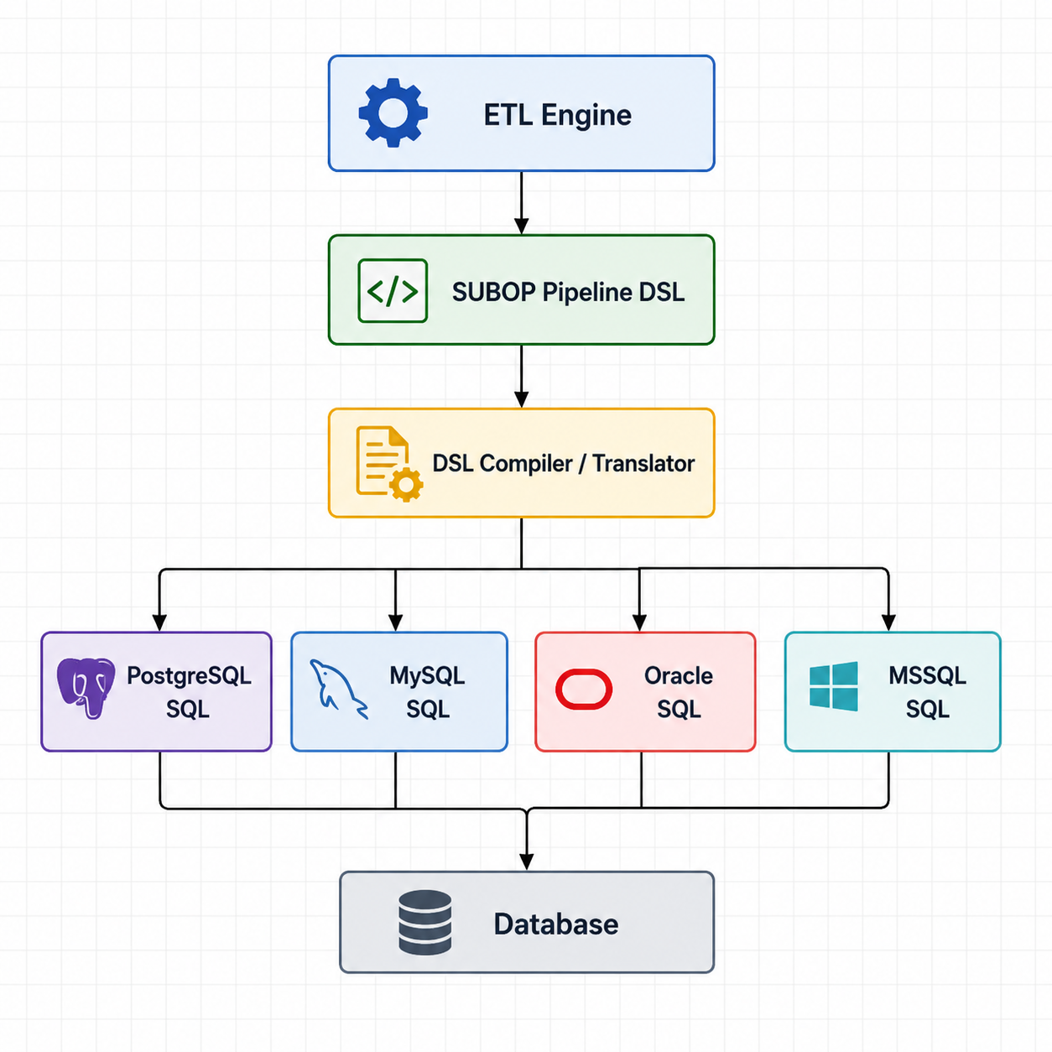
In this architecture, the ETL engine communicates exclusively with the DSL layer. The translation component is responsible for converting DSL statements into database-specific SQL queries and handling dialect differences internally.
Unlike the Adapter Pattern or SQLAlchemy Core approaches, the abstraction logic is fully controlled by the SUBOP platform itself. As a result, all database-specific behaviors, query generation rules, and optimization strategies must be implemented and maintained within the platform.

5.2.Advantages
The Custom Pipeline DSL approach offers several potential advantages for a large-scale data integration platform.
Complete Architectural Control
Since the abstraction layer is developed entirely within the platform, all functionality, syntax rules, and behaviors can be customized according to project requirements.
Maximum Flexibility
The DSL can be designed specifically for ETL workflows and data integration use cases rather than being constrained by the capabilities of an existing framework.
Unified User Experience
Users interact with a single platform-specific language regardless of the underlying database technology. This can simplify pipeline development and improve consistency.
Technology Independence
The platform does not depend on external abstraction frameworks or third-party libraries for query generation and database abstraction.
Future Extensibility
Additional features such as metadata-driven transformations, validation rules, pipeline templates, and optimization mechanisms can be integrated directly into the DSL architecture.
Long-Term Strategic Value
If successfully implemented, a custom DSL could become a unique technological asset that differentiates the SUBOP platform from competing ETL solutions.

5.3.Disadvantages
Despite its flexibility, the Custom Pipeline DSL approach introduces significant technical and organizational challenges.
Extremely High Development Effort
Designing and implementing a DSL compiler requires substantial engineering effort. Query parsing, validation, optimization, SQL generation, and dialect handling must all be developed internally.
High Maintenance Cost
All database-specific logic becomes the responsibility of the SUBOP development team. Supporting additional databases requires continuous maintenance and testing.
Reinventing Existing Solutions
Many capabilities provided by mature frameworks such as SQLAlchemy would need to be reimplemented from scratch, increasing project complexity without necessarily providing proportional benefits.
Increased Technical Risk
Compiler design, query translation, and dialect management introduce significant architectural complexity and increase the risk of implementation issues.
Longer Development Timeline
Building a production-ready DSL may require substantial development time that could otherwise be invested in core platform functionality.
Scalability Challenges
As more database systems and advanced SQL features are supported, the complexity of the translation layer grows significantly.
Limited Community Support
Unlike established frameworks, a custom DSL would rely entirely on internal documentation, development resources, and long-term maintenance efforts.

5.4.Suitability for SUBOP
The Custom Pipeline DSL approach aligns with the long-term vision of creating a fully independent and highly customizable data integration platform. It provides maximum architectural control and offers opportunities to build platform-specific functionality that cannot easily be achieved through existing frameworks.
However, the approach also introduces the highest implementation complexity among all evaluated alternatives. Developing a reliable DSL compiler, maintaining database-specific translation logic, and supporting multiple SQL dialects would require substantial engineering effort and long-term investment.
Given the objectives and timeline of the current SUBOP project, the development of a complete custom DSL may represent an unnecessary level of complexity. Many of the benefits offered by a DSL can already be achieved through a combination of established technologies such as the Adapter Pattern and SQLAlchemy Core while significantly reducing implementation risk.
Therefore, although a Custom Pipeline DSL may be a viable long-term research direction for future platform evolution, it is not considered the most practical solution for the current implementation phase of SUBOP.
Overall, the Custom Pipeline DSL approach demonstrates strong theoretical potential but lower practical suitability compared to the other evaluated alternatives.

6.SQL Dialect Difference Analysis
One of the primary challenges in developing a database-independent platform such as SUBOP is the variation in SQL dialects across database management systems. Although relational databases share common SQL concepts, differences exist in query syntax, auto-increment mechanisms, string operations, and advanced feature support. These differences increase implementation complexity and directly influence the design of the abstraction layer.
The following table summarizes several important SQL dialect differences relevant to the SUBOP platform.
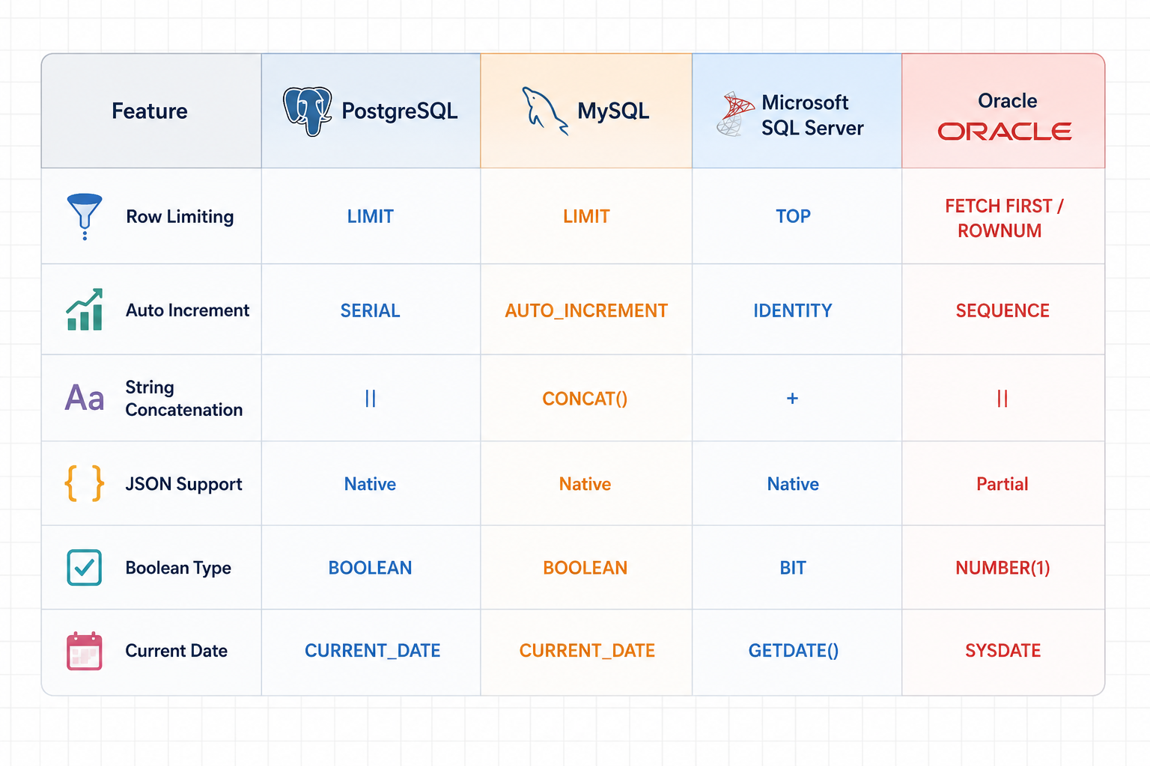
These differences demonstrate the necessity of an abstraction mechanism capable of providing a consistent interface across multiple database systems. Without such a mechanism, database-specific implementations would need to be managed individually, increasing development and maintenance effort.

7.Comparative Evolution
The evaluation indicates that each abstraction strategy offers distinct strengths and weaknesses. The Adapter Pattern provides strong architectural flexibility and aligns well with SUBOP's connector-based design. SQLAlchemy Core significantly reduces development effort through automatic SQL dialect handling and broad database support. In contrast, the Custom Pipeline DSL offers maximum flexibility but introduces substantial implementation complexity and long-term maintenance challenges.
The following table summarizes the comparative assessment of the evaluated approaches.
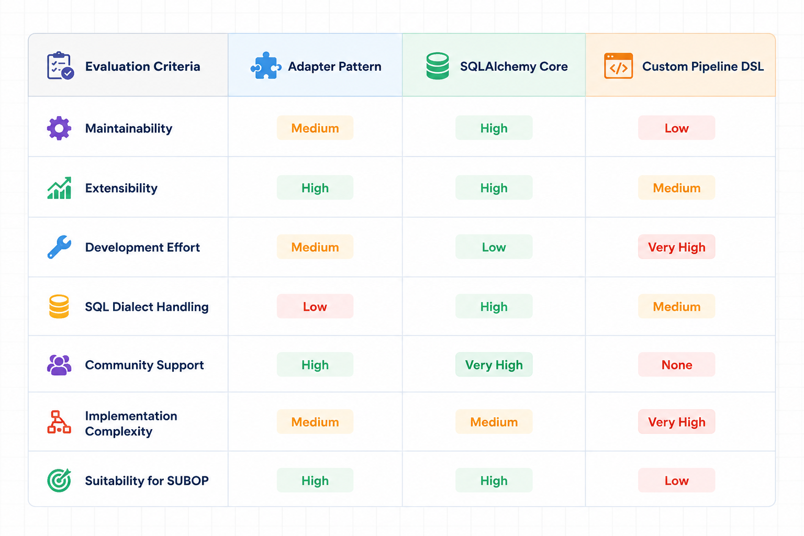
Based on the evaluation, the Adapter Pattern and SQLAlchemy Core approaches demonstrate the strongest alignment with the objectives of the SUBOP platform. While the Custom Pipeline DSL provides greater architectural control, its implementation complexity and maintenance requirements make it less suitable for the current phase of the project.

9.Recommended Architecture for M4

9.1.Recommended Solution
Neither the Adapter Pattern nor SQLAlchemy Core fully satisfies all requirements independently. However, a hybrid architecture combining the Adapter Pattern with SQLAlchemy Core provides the most balanced solution for SUBOP.
The Adapter Pattern and SQLAlchemy Core address different aspects of the abstraction challenge. The Adapter Pattern provides a clear architectural structure through a standardized connector interface, enabling modularity, maintainability, and future extensibility. However, it requires developers to manually manage SQL dialect differences across supported database systems.
SQLAlchemy Core addresses this limitation by providing automatic SQL generation and dialect handling through its built-in database support. This significantly reduces development effort and simplifies multi-database compatibility. Nevertheless, SQLAlchemy Core alone does not provide the connector-oriented architecture required by the SUBOP platform.
By combining both approaches, SUBOP can leverage the architectural flexibility of the Adapter Pattern while benefiting from SQLAlchemy Core's mature dialect management capabilities. The resulting architecture reduces implementation complexity, improves maintainability, and supports the long-term objective of providing database-independent ETL functionality across multiple database systems.
Therefore, the hybrid approach represents the most practical and technically balanced solution for the M4 implementation phase.

9.2.Proposed Architecture
Based on the evaluation conducted throughout this research, a hybrid architecture combining the Adapter Pattern and SQLAlchemy Core is proposed for the M4 implementation phase of SUBOP.
The proposed architecture separates connector management responsibilities from SQL dialect management responsibilities. The Adapter Pattern provides a standardized connector framework through the BaseConnector interface, while SQLAlchemy Core handles database-specific SQL generation and dialect translation. This separation allows each component to focus on its core responsibility and reduces the overall complexity of the system.
As a result, the architecture maintains the modularity and extensibility of a connector-based platform while leveraging SQLAlchemy's mature support for multi-database environments. The proposed solution therefore combines the strengths of both evaluated approaches while minimizing their individual limitations.
The following diagram illustrates the recommended architecture for the SUBOP abstraction layer.
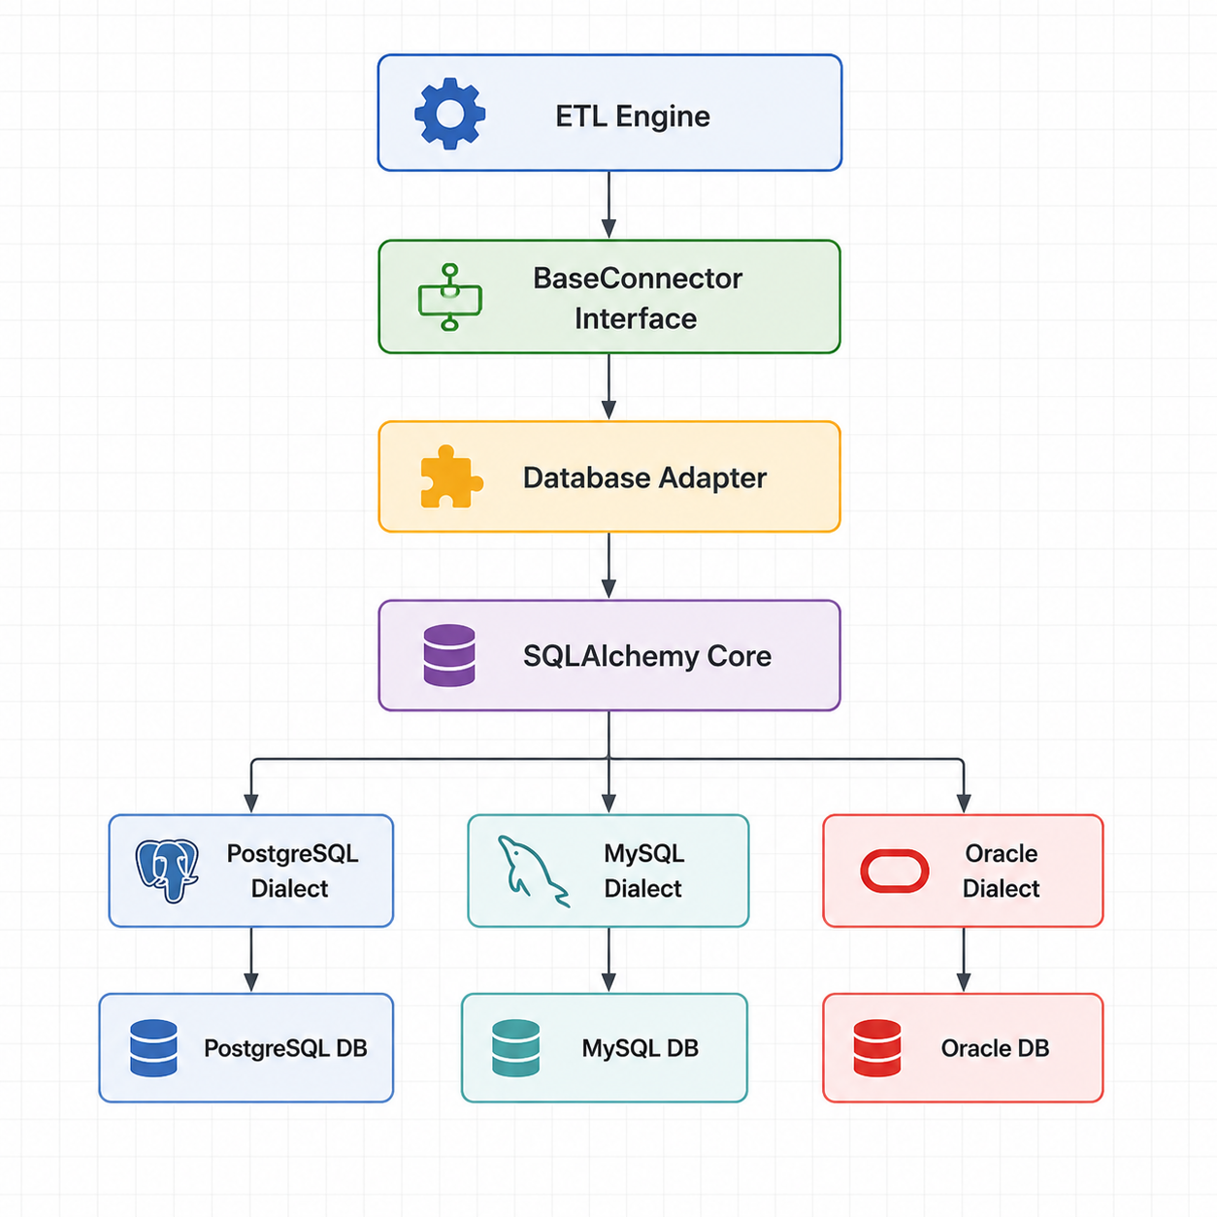
In the proposed architecture, the ETL engine interacts only with the BaseConnector interface and remains independent of database-specific implementations. Individual adapters manage connector behavior and integration logic, while SQLAlchemy Core provides automatic SQL generation and dialect translation for supported database systems.
This layered design reduces coupling between platform components and improves maintainability by assigning clear responsibilities to each architectural layer. Furthermore, the approach simplifies future database support, as new database systems can be integrated through additional adapters and SQLAlchemy dialects without requiring significant modifications to the ETL engine.
Overall, the proposed architecture provides a scalable, maintainable, and database-independent foundation for future development of the SUBOP platform.
The proposed architecture was selected because it combines the primary strengths of the two highest-ranked approaches identified during the evaluation process. The Adapter Pattern contributes a structured and extensible connector architecture, while SQLAlchemy Core provides mature support for SQL dialect management and multi-database compatibility.
By integrating these technologies, the proposed solution minimizes the weaknesses associated with each individual approach while maximizing maintainability, scalability, and database independence. Consequently, the architecture represents the most balanced and practical implementation strategy for the M4 phase of the SUBOP project.

9.3.Implementation Considerations
The implementation of the proposed architecture should be performed incrementally during the M4 phase to reduce complexity and implementation risk.
The first step should be the definition of a standardized BaseConnector interface that specifies the common operations required by the ETL engine. This interface will establish a consistent contract for all database connectors and serve as the foundation of the abstraction layer.
Following the creation of the BaseConnector interface, the existing PostgreSQL connector should be adapted to conform to the new architecture. This will provide an initial proof of concept and allow validation of the proposed design before additional database systems are introduced.
The next implementation step involves integrating SQLAlchemy Core into the connector layer. SQLAlchemy will be responsible for query construction, SQL generation, and dialect management, thereby reducing the need for database-specific SQL implementations.
Once the PostgreSQL implementation has been validated, support for additional database systems such as MySQL, Oracle, and Microsoft SQL Server can be introduced through new adapter implementations. Because the proposed architecture separates connector responsibilities from dialect management, the effort required to support additional databases is expected to be significantly reduced.
This phased implementation strategy minimizes development risk while allowing continuous validation of architectural decisions throughout the M4 development process.

9.4.Risks and Mitigation
Although the proposed architecture offers significant benefits, several implementation risks should be considered during development.
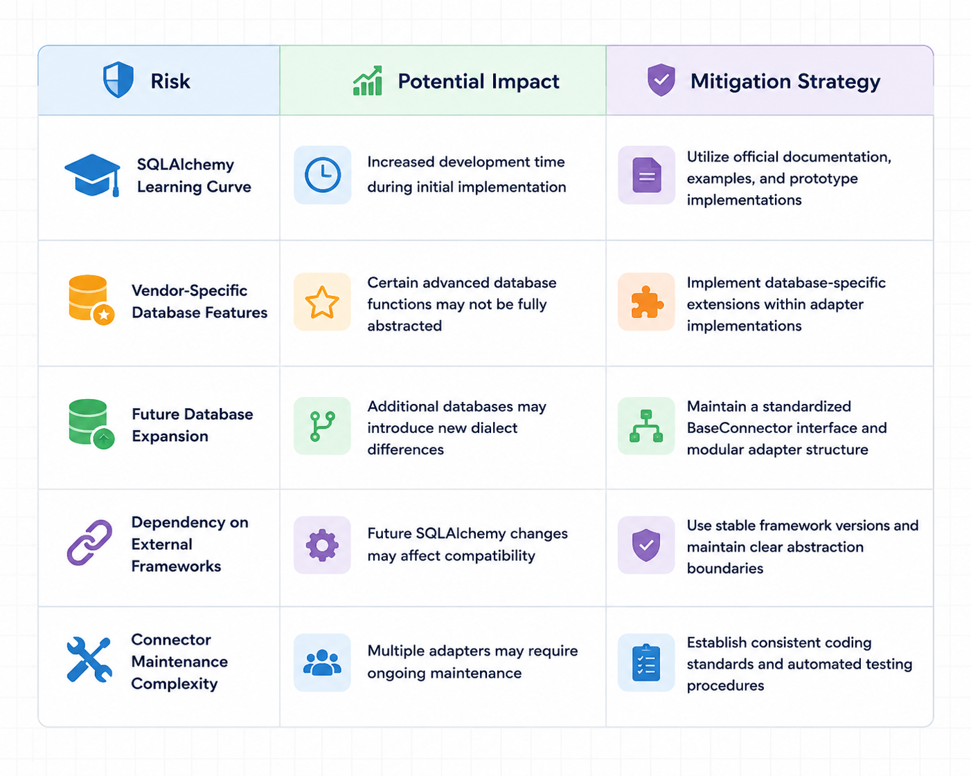
Overall, the following diagram above identified risks are manageable and do not outweigh the benefits provided by the proposed architecture. Through careful implementation and adherence to modular design principles, these risks can be effectively minimized while preserving the long-term maintainability and scalability of the SUBOP platform.

10.Conclusion
This research investigated three alternative approaches for implementing the database abstraction layer of the SUBOP platform: the Adapter Pattern, SQLAlchemy Core, and a Custom Pipeline DSL. Each approach was evaluated according to maintainability, extensibility, implementation effort, SQL dialect handling capabilities, and overall suitability for the objectives of the SUBOP project.
The analysis demonstrated that the Adapter Pattern provides a strong architectural foundation through its modular and connector-oriented design. SQLAlchemy Core offers significant advantages in automatic SQL generation, database portability, and dialect management. In contrast, although the Custom Pipeline DSL provides maximum flexibility and architectural control, its implementation complexity and maintenance requirements make it less suitable for the current phase of the project.
Based on the comparative evaluation, neither the Adapter Pattern nor SQLAlchemy Core independently satisfies all requirements of the SUBOP abstraction layer. However, a hybrid architecture that combines the structural benefits of the Adapter Pattern with the dialect management capabilities of SQLAlchemy Core provides the most balanced and practical solution.
Therefore, this research recommends implementing a hybrid Adapter Pattern and SQLAlchemy Core architecture during the M4 phase. This approach supports SUBOP's long-term goal of providing a scalable, maintainable, and database-independent ETL platform while minimizing implementation risk and development effort.
The proposed architecture establishes a solid foundation for future database expansion and enables the platform to evolve toward a flexible multi-database ecosystem capable of supporting a wide range of enterprise data integration scenarios.

