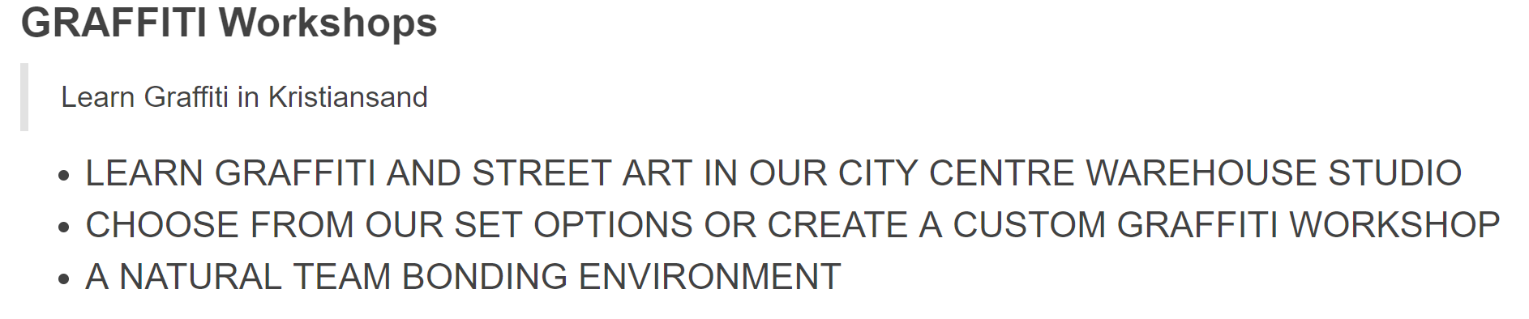

**Kursene er beregnet for skole elever, privat personer og bedrifter. Dette ville vært fint og fått med?**

**Dette her er kurs 1: som tilbyr diverse tekniker altså Draw, Graffiti og Stensil. Også varer det i 2,5 timer.**

**Prisen blir kr 1000 pr** **person en gruppe av 50 personer.**

**Minimum 5 personer pr kurs**

**Draw**

THIS OPTION ALSO INCLUDES A DRAWING WORKSHOP.

OUR GRAFFITI EXPERTS WILL HELP YOUR GROUP PRE-PLAN THEIR DESIGNS, DEVELOP THEIR SKILLS AND ULTIMATELY CREATE MORE IMPRESSIVE WORK!

**Graffiti**

OUR GRAFFITI EXPERTS WILL TEACH YOU AND YOUR GROUP ALL THE BASIC SPRAY PAINT SKILLS YOU NEED TO CREATE AMAZING ARTWORK ON OUR STUDIO WALLS.

**Stensil**

THIS FORMAT GOES INTO MORE DETAIL AND INCLUDES A STENCILLING WORKSHOP WHERE YOUR GROUP WILL LEARN HOW TO CREATE AND SPRAY PAINT YOUR OWN STENCIL ALONG WITH LEARNING ALL THE BASIC SPRAY PAINT SKILLS.

EACH PERSON WILL GET TO TAKE HOME A FINISHED STENCIL.

**Kurs 2 blir en graffiti battle som også varer i 2 timer og prisen blir kr 800 pr person en gruppe av 50 personer.**

**Minimum 5 personer pr kurs**

**Graffiti battle**

THE ULTIMATE WORKSHOP! YOUR GROUP IS SPLIT INTO TEAMS AND A THEME IS CHOSEN BY YOUR CAPTAIN. YOU MUST THEN CREATE THE BEST PIECE OF WORK POSSIBLE (UNDER GUIDANCE OF OUR GRAFFITI EXPERTS) BEFORE THE BATTLE TIMER HITS ZERO. WHEN THE TIME IS UP YOU MUST DOWN YOUR SPRAY PAINT AND THE JUDGES WILL CHOOSE A WINNER. BEST TEAM ARE CROWNED THE CHAMPS!