# Project Description

## List of Components

* Net Core 2.1
* Nugets for Asp Net Core

## Dependencies

* Moq for mocks for unit testings
* Rest Sharp for call web service sended
* Newtonsoft

## Base of architecture

### Domain driven design (Nlayers)

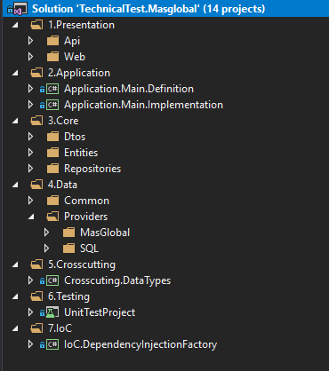

### Using SOLID Principles

More information [here](https://hackernoon.com/solid-principles-made-easy-67b1246bcdf)

### Diagram of Dependency

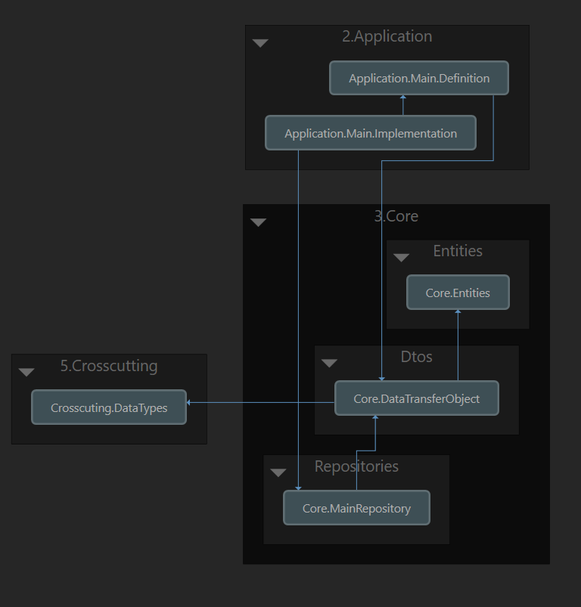

File structure

