1. **CAPTURING STUDENT DETAILS**

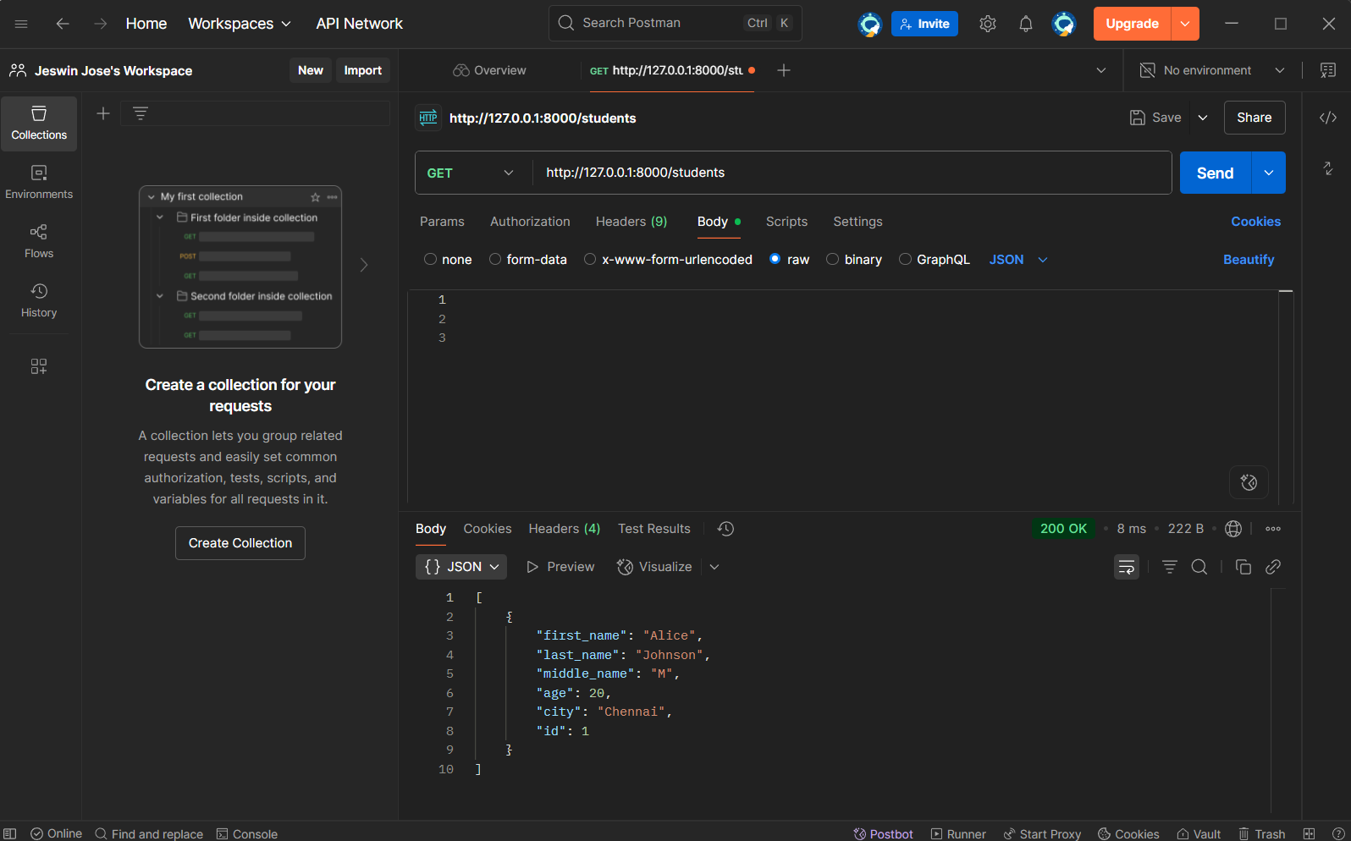

1. **UPDATE STUDENT DETAILS**

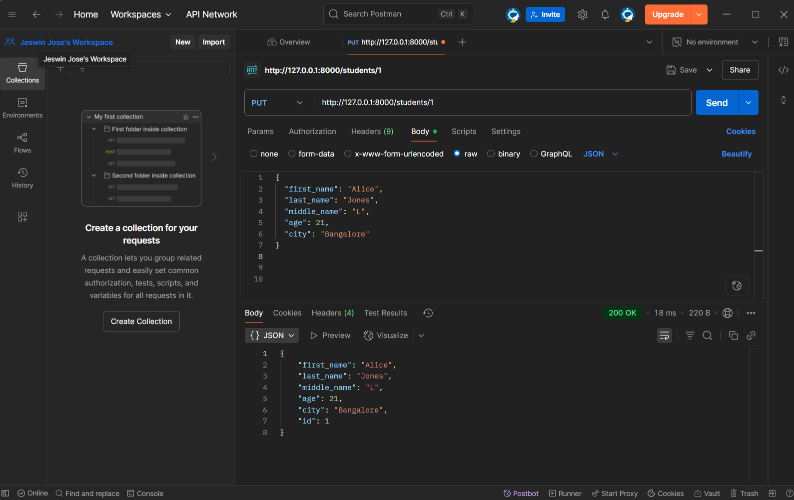

1. **DELETE STUDENT DETAILS**

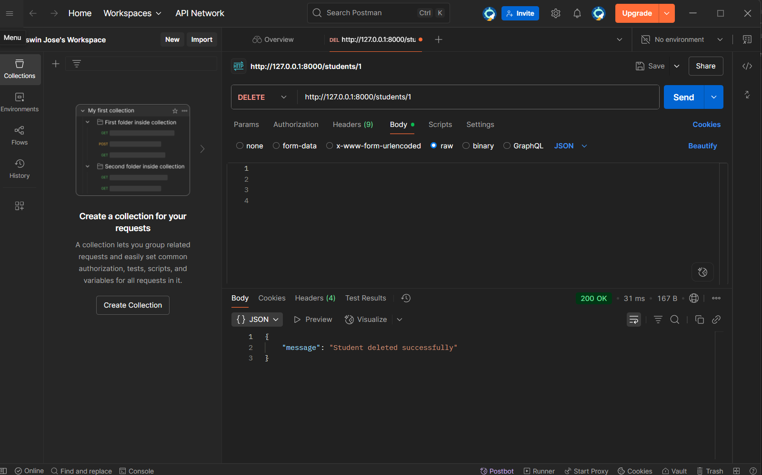

1. **CREATE CLASS INFORMATION**

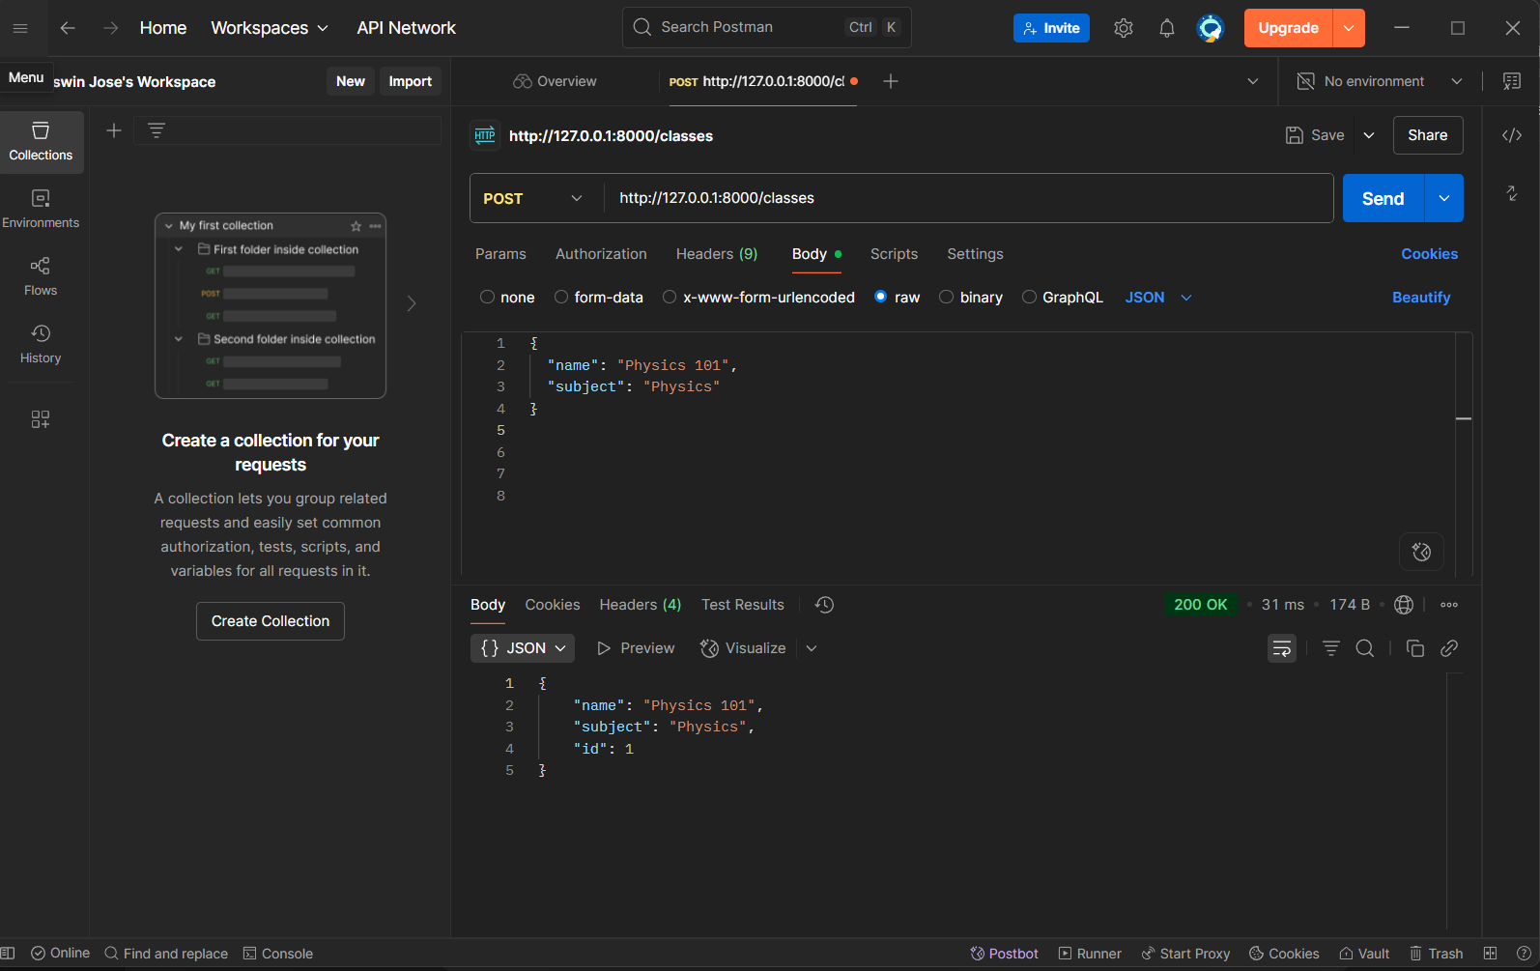

1. **READ ALL CLASSES**

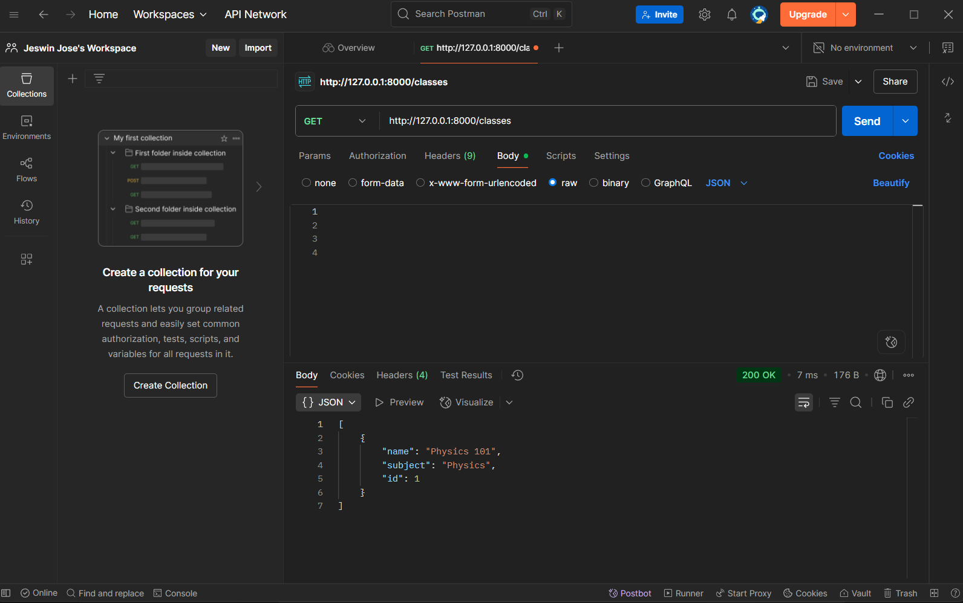

1. **DELETING CLASS INFORMATION**

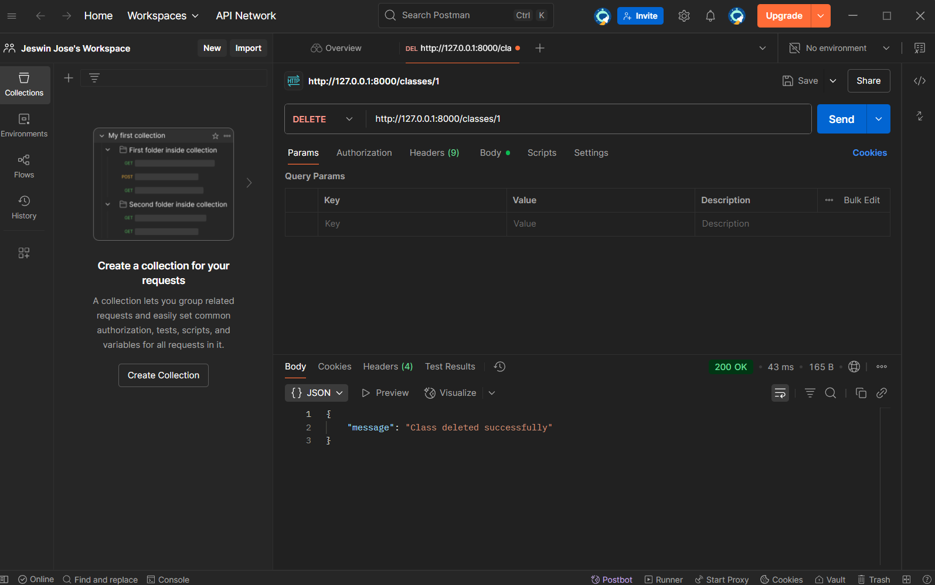

1. **REGISTER STUDENT TO A CLASS**

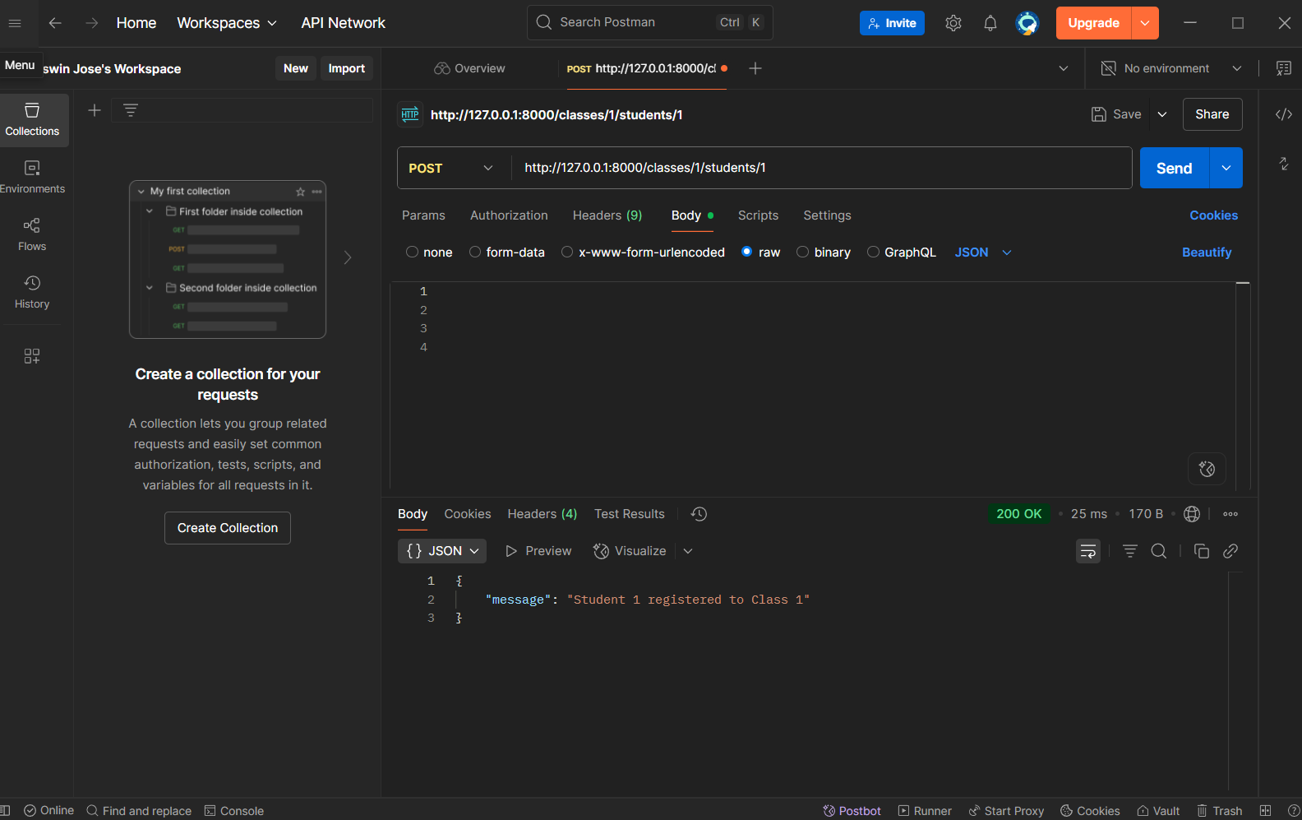

1. **LIST STUDENTS IN A CLASS**

