Project Quant

Mental model philosophy:

By using a blend of Japanese and traditional technical analysis tools and automating it, you can focus on better modelling, measuring and taking advantage of price action, market and human behavior, participation and flow in different trading cycles and across any market. This systematic approach should reduce / lessen the ‘psychological’ interference and human bias on trading results.

Strategy:
The strategy is a combination of Japanese and traditional technical
analysis tools (Renko + Western Indicators) that is trend following
and trend reversing both long and short and actually combines
various technical individual sub-strategies into one to maximise
market price behaviour, PnL's and minimise drawdowns.

We employed a rigorous back test approach to the concept, using
traditional quantitative testing methods, stress testing etc. We also
looked at the distribution of returns and calculated a Value At Risk
number to A. see if the model is 'normal' and B. to ascertain the daily
position risk to the strategy. Again, both this extra bit of analysis gave
us extra comfort in the results. In terms of standard analysis: the
strategy has a risk return of PENDING with a PENDING win ratio
producing on average PENDING points per month.

Automated/Semi-automated process overview:

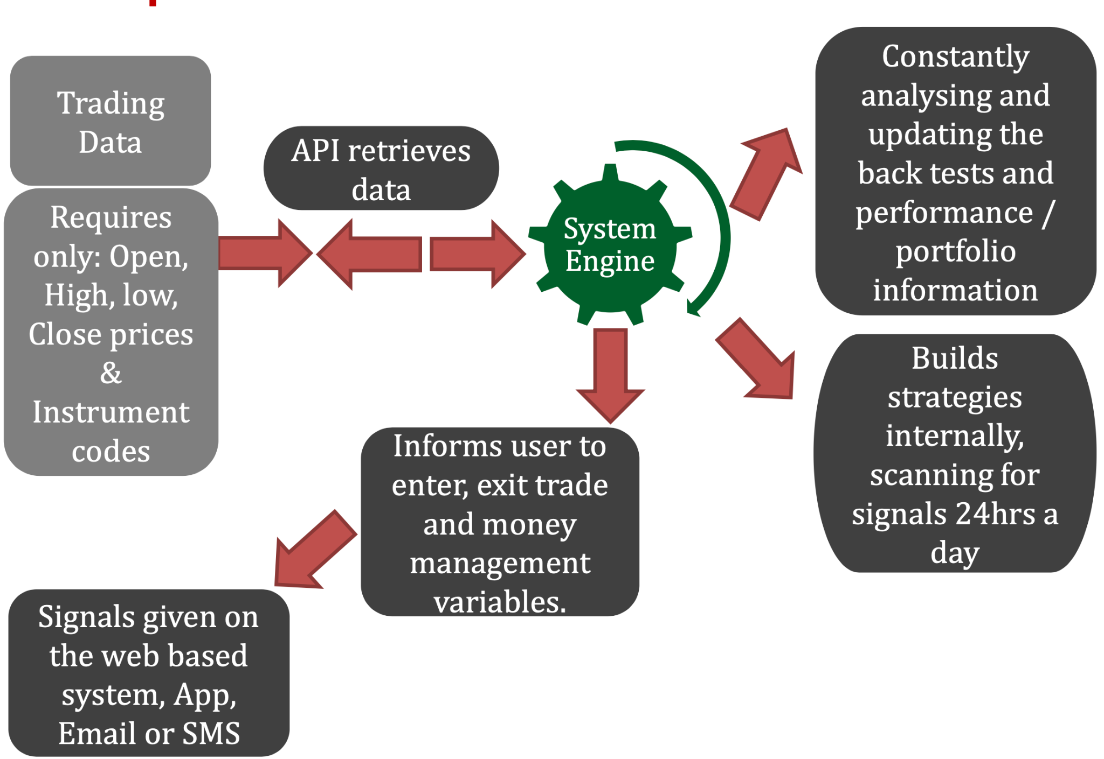

This can also be executed on trading platform to completely automate.

Trading process
Trading is broken into two distinct cycles - Longer Term, Shorter Term. This is done to capture
both trending and reversing markets and to generate regular market interaction. Depending on
your preference, you can trade either individually or both.
Longer Term:
• Markets traded: FX, Equities, indices, Commodities, Metals
• Execution: Quant Renko strategy with sub substrategies:
-Simple stochastic based crossover trend following (Most instruments can work)
-Mean reversion trend (WTI, EURUSD)

Risk and trade management

Instrument Selection: Not any old instrument is traded! It is a
multi asset system, but anything traded into the system has to
meet a stringent selection process before being included. For
example:
• Back test results last 10 yrs over a certain % return.
• Win / Loss ratios, Av Win Loss, Risk Reward numbers.
• Drawdown.
• PnL shape.
• Kellys criterion.
• Fundamental / pre-strategy criteria.
If a trade has met the selection process, it then goes into the
‘Portfolio Optimisation’ process which looks to size the trade
to maximise returns, whilst minimizing the risk.

Portfolio Risk / Trade Sizing: The system works out an
optimal trade size based on an amount you set as your preferred
maximum loss. It comes to a suggested trade max loss risk size
based off the performance of the back test of that instrument
and in context to all the other instruments within the portfolio.
In our case it is set to 3% of initial portfolio value as your max loss per trade, it will
match this up to the best portfolio performer and scale the other
possible trades (up/down)/ instruments accordingly. For
2017/18 results the max loss was set at 5% on any one trade.
We use what is known as ‘Preference Function’ where one
asset is weighed up versus the other, probability, success
and risk appetite. The better trades in our example would be
nearer the 5% level, worse trades move toward 0.

Further Risk Processes: Project Quant is a multi layered risk
trading system with many other safety nets and optimization
procedures and rules in place. There is also:
Drawdown Portfolio Rule: Max drawdown = 30%. If hit all
trading stops and is reviewed.
Value At Risk (VAR) – as in any bank we utilize VAR to measure
risk. We set a daily VAR limit (95% confidence level) that can’t
be breached. We have created our own ‘in house’ VAR calculator.
If it is, the days trading activity has to be reviewed and
explained, both for negative and positive exceptions. The
historical results of this data shows whether the trading model
is working ‘normally’.
Maximum VaR utilization is looking to run between 40% to 60%
on a normal day. i.e. how much of the portfolio fund is roughly
being utilized by risk use. Therefore rather than just trading we
are capturing the volatility and behavior of the underlying
instruments being traded.

Kellys Criterion: is used to analyse whether individual
instruments / asset classes should be scaled up, sized differently
or terminated due to poor performance. A result of 0% means
trading ceases.
Trade scaling: 2 methods: With the optimal trade size
calculated, this can then be divided into 2 units of risk and
added to as individual sub strategy signals are given. (There are
2 sub strategies). On the flip side, the second approach allows
you to scale up with the 2 sub strategies to maximise your
returns – each sub-strategy can work out an individual optimal
size.
Profit and Loss – is calculated in real time within the system by
individual position and at the portfolio level and historical data
is also stored and graphed.

Will need help with correlation matrix -> Correlation Risk – is also monitored and measured. Inside
Quant, we have built a correlation tool that 24/5 monitors all
assets for their correlation over various periods. Rules state that
no more than 4 trades can have a positive correlation >50% i.e.
20% of the portfolio risk at any one time.

