**GDD**

Game Mechanics

* Top-down shooter
* Zombie – AI (slow moving)
* Different guns
  + Pistol
  + Shotgun
  + Rifle
* Buyable doors to different rooms
* Barriers that can be repaired and destroyed
* Multiplayer
* Scoring system

Core Game Play

Run and shoot your way around a map trying to avoid getting hit by zombies, opening door and buying new weapons

Game Flow

Fast past game play non-stop, with levels being the only brake in combat being the time it takes to change rounds which slowly increases making the zombies harder to kill and more zombies

Characters

there will only be the main character (including a duplicate of them for multiplayer) and the zombies that will be chasing them around trying to kill them

Game Play Elements

the elements will include buyable doors, buyable weapons and upgrades that can be bought

Game Physics

the only physics that will be included is the movement of the player/players, zombies and the firing of the bullets

AI

Basic AI for the zombies, they will just follow a player and improvement to the zombies as more rounds pass

Mock-up

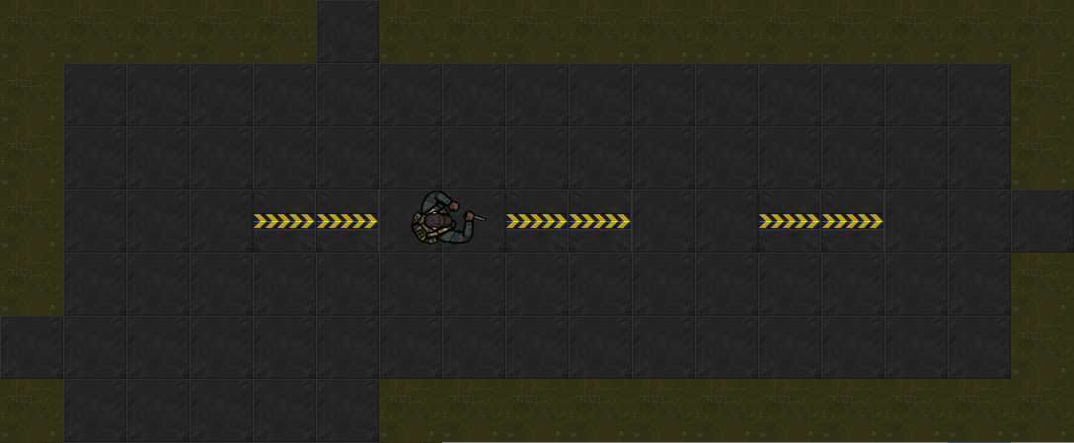

2d art

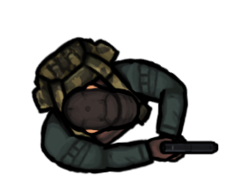 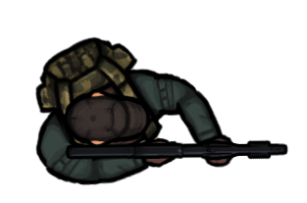

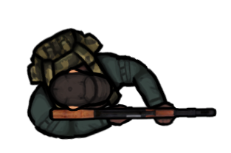 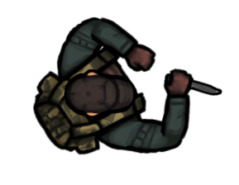

Target Audience, age group

* 10 + audience
* Easy and accessible

Milestones

* Player movement - week one, lesson one
* Map - week one, lesson one
* Player Direction - week one, lesson one
* Player Directions - week one, lesson two
* Buyable doors - week one, lesson two
* Shooting week one, lesson two
* AI - week two, lesson one
* Game states - week two, lesson one
* Buyable Guns - week two, lesson two