This Java code implements a simple file system tree structure, allowing users to create directories, list directory contents, and navigate through the tree using commands like  mkdir ,  ls , and  cd .

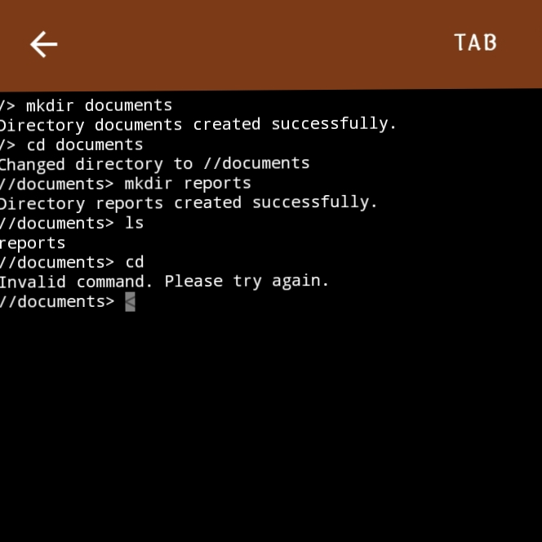

What it is:

This code simulates a file system using a tree data structure, where each node represents a directory. The  Node  class contains information about the directory's name, its parent directory, and a map of child directories.

What it can do:

1. Create Directories ( mkdir ): Users can create new directories within the file system.

2. List Directory Contents ( ls ): Users can view the names of directories and files within the current directory.

3. Change Directory ( cd ): Users can navigate to different directories within the file system, including moving up to the parent directory using  cd .. .

Why I made this:

This application is a simple example of how to implement a tree data structure in Java. It demonstrates concepts like:

- Object-Oriented Programming: Using classes like  FileSystemTree  and  Node  to encapsulate data and behavior.

- Recursion: The  findNode  method utilizes recursion to search for a directory within the tree.

- Data Structures: The use of a  HashMap  to store child directories within a node.

This kind of application can be a valuable learning tool for anyone interested in understanding how file systems work and how to implement tree-based data structures. It can also serve as a starting point for more complex file system simulations or real-world applications.