**REQUIREMENT SPECIFICATIONS**

**Product Constraints**:

Purpose of the Product: The purpose of this online poker application is providing entertainment to those interested in gambling, but not nearby a casino. The system lets users create an account which they can use for participating in various poker games. Users can either join, or host their own games which they can transfer funds from their bank account or through a credit card. The goal of this product is simulating a gambling experience for those not in a local vicinity of a casino as well as forming a community of poker players.

Stakeholders: Some potential stakeholders include banking companies or credit card companies to a lesser extent since our system encourages people transferring funds into and out of their account. Another potential stakeholder is the International Federation of Poker, a recently founded poker organization which holds worldwide poker tournaments and would appreciate an online poker application for expanding the community. Similarly, another organization, FIDPA could benefit from an online poker application by incorporating it into their poker festivals. The application would also benefit from having FIDPA as a stakeholder due to their large community of professional poker players and general poker community.

Users: The intended user base for this application is anyone that is at the legal age gambling. Among this general group of users, one audience are poker players which would benefit from having an application that lets them play poker at any given time. Similarly, people into gambling would also appreciate this application since it lets them gamble from the comfort of their home. Besides those two specific groups though, the intended user-base will remain general so the application could get used by more players.

Requirement Constraints: The requirements constraint involves creating the application with a limited budget since unless we take shortcuts or make it cost money for creating the account, initially the funds the company earns from this application will remain minimal. Eventually funds could get received by offering premium plans or making it so locked accounts must pay a fee for getting unlocked among a couple of ideas. Reliability is another constraint which must have central focus since if anything ranging from a simple transfer or the format of a poker hand.

Naming Conventions and Definitions

* All In: When a player gambles all their money on a certain game.
* Bet: Wagering a sum of money, required by all players for a game.
* Blind: A forced bet where neither player has any idea how much the other player wagered.
* Discard: After the initial cards are given out, players choose anywhere from 1-3 (1-4 if they have an ace in their hand) cards for getting removed from their hand before being given new cards.
* Fold: When a player gives up on a game and forfeits any money they submitted to the pot.
* High Card: In the event a player has no pairs or they’re tied for number of pairs, three-of-a-kind or another hand, this single highest card determines who wins the game.
* Royal Flush: In poker games, when the player has an ace, king, queen, jack, and 10 from the same suit.
* Straight Flush: In poker games, when the player has any five sequential cards of the same suit.
* Four of a Kind: In poker games, when a player has each of a specific number, ace, or face card from each suit.
* Full House: In poker games, when the player has three of a kind for one number, face card or ace, and two matching cards for a different type.
* Flush: In poker games, when all five cards have the same suit.
* Straight: In poker games, any five cards in sequential order.
* Three of a Kind: In poker games, having three of one number card, face card, or ace.
* Two Pair: In poker games, having two instances of two matching cards of one number card, face card, or ace.
* Single Pair: In poker games, having two matching cards of one number card, face card, or ace.
* Suit: In poker, a suit is a type of card which can either be a spade, heart, club, or diamond.
* Face Card: In poker, a king, queen, or jack.

Relevant Facts: A major outside influence with this product is official poker rules and regulations regarding gambling. If either of these aspects change such as adding a new rule into the poker ruleset or laws changing the gambling process than the product must be updated. Other outside influences are malevolent hacker activities which must get combatted by modifying the application’s architecture so it remains secure. Another relevant fact is monitoring the types of credit card and banks the users use (not monitoring they’re actual payment information, but what companies they use for payments). With this knowledge, the application could accommodate accounts from popular credit card companies or banking branches.

Assumptions: If the player is using the online poker application they must have access to their e-mail for notifications, creating an account for the server, and receiving links for private games. Another assumption is that the player is of legal age to gamble depending on their current location. The player must also own a credit card or bank account if they’re looking to add funds into their account. If the player resets their password through SMS, then it is assumed they must own a phone for receiving their password. The player must have a valid internet connection for using the online poker server. The player must have an account for participating in the application.

**Functional Requirements**

The Scope of the Product The project is applied to both desktops and mobile platforms and the budget costs approximately $96,000 a year when including developmental costs and post-delivery maintenance. The product lets users create accounts in a system for creating online poker games. After an account is created, the users must log into their account for accessing the home page. Once the home page is reached users either have the option of adding funds into their account or joining poker games. When transferring funds the users either take money from a credit card or bank account which they can use in the games. The other option is either joining pre-made games or creating their own game.

Functional Requirements:

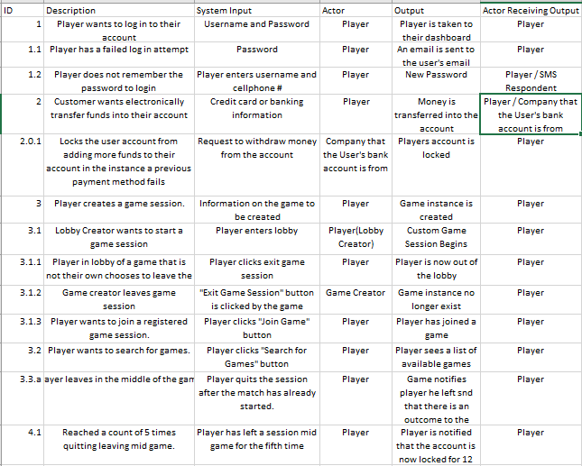

**Non Functional Requirements**:

Look and Feel Requirements The name of our product is PokerTable. The application’s GUI should be minimal and simple so that it isn’t loading much memory, player lag gets heavily reduced and the application is mobile-friendly. Similarly, scrolling through the account menus and the menus for poker lobbies should be straight-forward so users aren’t confused and know how it works. Banners could be used with poker imagery and simple colors so it still looks simple, but highly bland.

Usability Requirements: The product must be simple so that people of any age could efficiently use the product regardless of their technological skill and grasp of gambling. The technology must be available on multiple platforms so users could play whether they’re at their desktop or away from their main computer. The accounts for the application must be easily accessible and editing information must be done with a user control panel in a convenient location on the system.

Performance requirements: The system must highly focus on speed, stability, and security for ensuring the application runs smoothly. Speed is essential for the server since the application is performing many operations like making interactions between the poker server’s database and a bank or credit card company’s database so money is quickly added into a user’s account, the server can keep up with the various poker games, and there is minimal wait time on the users’ end. The server must also be secure since it revolves around gambling and if the servers were susceptible for hackers it would destroy the application’s reputation. The servers must be large and free of errors so that way people don’t get cheated by the system and it can store all the current games and transactions happening in the system.

Operational Requirements: The ideal operational requirements for the poker application is a laptop with a x32 bit processing system and in the case for mobile the product must either have Android OS or iOS. Operational requirements should be as minimal as needed for the application running at a steady capacity without any performance issues. As time goes on the server size might grow; however, these requirements should remain sufficient.

Maintainability and Portability Requirements: The product should be highly adaptable so it can be changed if the application changes the gambling format or any other minimal requirements. Due to the simple layout of the application, maintainability and portability shouldn’t be a problem since changes would only get applied in a few places.

Security Requirements: The user must be able to give valid information to get into the account for the product. In addition, the application cannot reveal credit card, bank account information, or any other personal information to third-party companies. The system immediately deletes any confidential information once the system finishes using it for transferring funds. If the user inserts incorrect information when adding funds into their account, they get locked out for preventing flaws.

Cultural and Political Requirements: The rulesets of poker could vary by location, so one option later in production could be adding other rulesets so it applies to the specific regions. All users must be treated equally in the system; no matches should ever get rigged towards a specific person(s).

Legal Requirements: The user must have their location checked when playing so it ensures their age (which is specified on their profile) they’re following their specific region’s gambling laws. All cases of fraud, thievery, and other scams will be punished by having the application send their IP to the local law-force and pushing charges against these malicious players for their respective crimes.

# Project Issues

Open Issues: Other issues that are being analyzed is the difference in punishing users that try leaving games so they avoid losing money versus an uncontrollable event like a service outage. Another open issue being investigated is determining how serve a user’s punishment should be for entering incorrect information into the payment system. The issue is deciding the difference between whether the transaction fails because a single digit is incorrect versus whether the user is committing fraud.

Off the Shelf Solutions: Although the databases for a login server should remain unique so the code is exclusive to the application, the basic logic of login servers from other products that let users create account could get applied. Similarly, code from poker games could get used for how the games get handled as well as taking components from online games which rely on lobbies. When it comes to reusing other aspects, components could get taken, but not all of it should be duplicated from other problems.

New Problems: New problems created by this product are situations where the server development must be compromised between stability, speed, and security since all three are important, yet only one could be the top priority. Another problem this product creates is proposing judgement in uncertain situations for instance whether a person intentionally disconnects or not. These problems must get addressed for ensuring the application doesn’t cause future problems.

Tasks: The product must have framework for all the necessary servers and databases. These frameworks include a system for creating accounts and logging into them, holding active games in the system for allowing players to join, and a framework for lobbies getting set up. In addition, the format for gambling, rulesets for the poker games, and other aspects must get finalized before developments begin.

Cutovers: Cutovers are completing the tasks that are left incomplete from the fragments taken by past products. For instance, when pulling code from other login databases, if the code runs into an unexpected occurrence than the bugs in that code must get fixed for ensuring it runs correctly. If the code were basic and missing a reset password form, then a cutover would be fixing the code so it resets the password how the application desires it to.

Risks: One major risk of this product is that it heavily relies on transacting a user’s money. If the process isn’t handled correctly than it could become a major problem for the application’s success. The product also has legal issues pertaining to under-age gambling and the application could also run into legal trouble if the product doesn’t strictly follow the laws. There is another risk with the database’s security since there is a large quantity of confidential information which must get properly protected from hackers.

Costs: The early cost for this product would be $12 per year for hosting the domain needed for the online poker application along with $3000 for hosting the website. If using a SQL database for Microsoft Azure for a login server, transferring funds, and holding the poker game and using the largest database option, it could cost $3.23 per hour. At the end of each year the database option would be $28,000~ and adding on the website charges and domain fees it would cost approximately $32,000, the post-delivery maintenance would cost $64,000. The complete product could cost up to $96,000 a year.

User Documentation: The user instructions are placed in an option on a drop-down menu labeled “help”. This menu contains instructions on helping users transfer funds into their account, joining or creating games, adding friends and editing their accounts, and other information needed for using the application.

Future Enhancements / Waiting Room: Later on in the development process, if the online poker application does well it will include other gambling games like Texas hold ‘em or Blackjack. Other future enhancements including creating a casual mode where users bet virtual money opposed to actual funds and possibly creating a ranking system where through-out the spans of a few weeks, players can compete with virtual money and earn a number of points. Rankings are determined by who has the most points after the end of a period. Include stat tracking for games played and games won.