CS551 Advanced Software Engineering
LAB ASSIGNMENT #4
Instructor : Dr. Yugyung Lee
Teaching Assistant : Prady
Student : Fathima Shanthi James
Submission Date : 2/17/2016
Class ID : 58

Wireframe Web application
As per the requirement, Created Wireframes and a web application with 3 pages such as login page, register page and home page.
Login page :
The login page has two buttons
(i) Login - On clicking login button, the page will navigate to home page
(ii) Register - On clicking register button, the page will redirect to register page for new account registration.
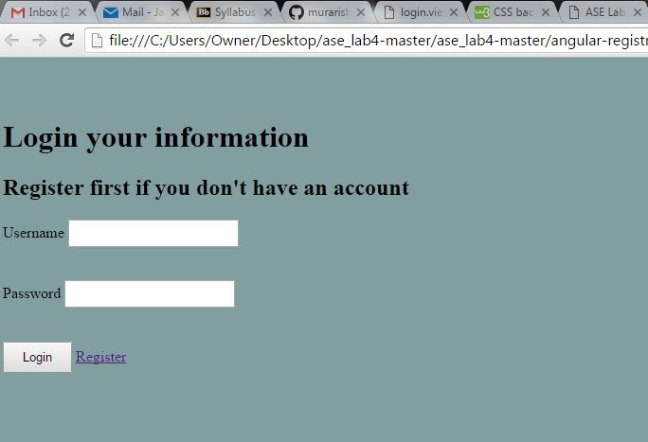
The above screenshot shows the login page with login and register button. If the user already has an account. They can easily login to home page otherwise the user should create an account by using the registration page.

The below screenshot shows the login page where the user is already having an account. Then this page will directly redirect to the home page.

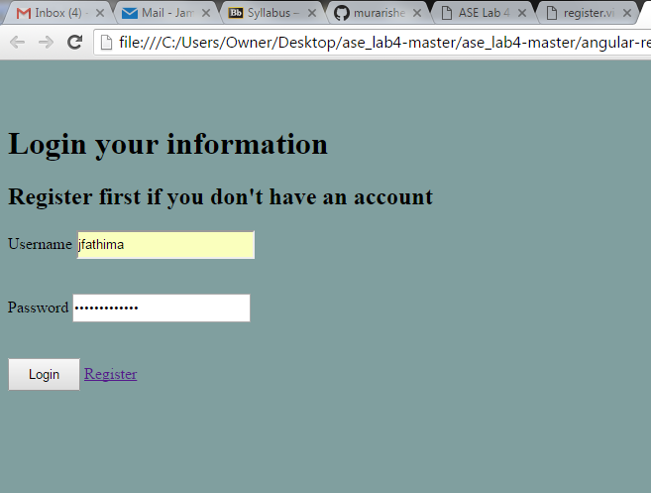

Registration page:
The registration page has a form to take basic information from the user and then it will create a new account for that specific user. After completing the registration page, the user can easily login with their new account.

The below screenshot shows the registration page and all available basic information tabs.

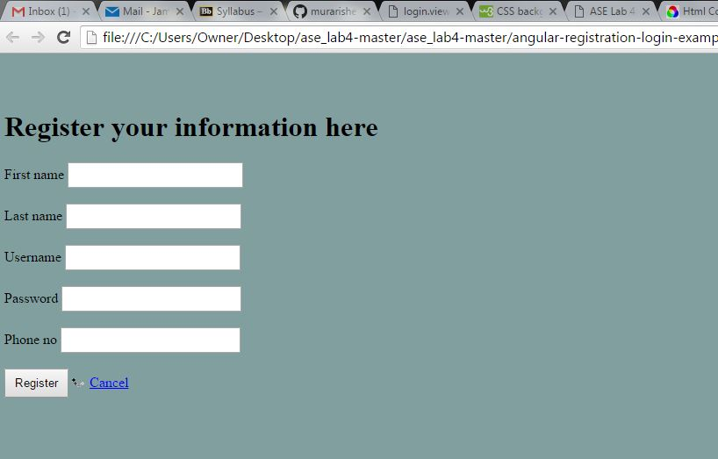

The below screenshot shows the registration page with all the basic information. After entering all the basic information, the user will get a new username and password and this page will redirect to the login page for a normal login.

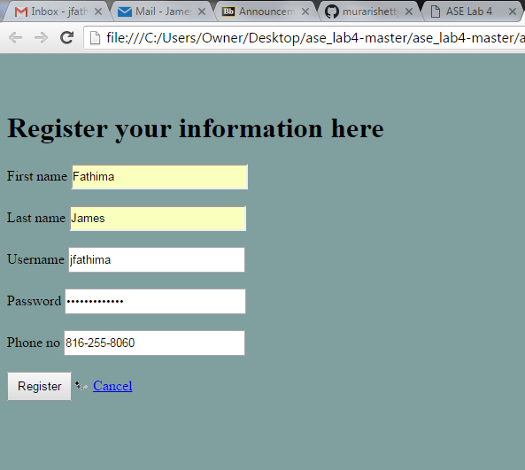

Home page:
The home page is using the Google Map web service to mark Start and End Points and also displaying the weather details for both source and destination places.
Once the user login successfully, the page will redirect to the home page. To get the direction, the user should enter the source and destination places and then hit the get direction button. Then they will see the route with directions for their specified locations.

The below screenshot shows the home page map with source location marked map and destination place as well.
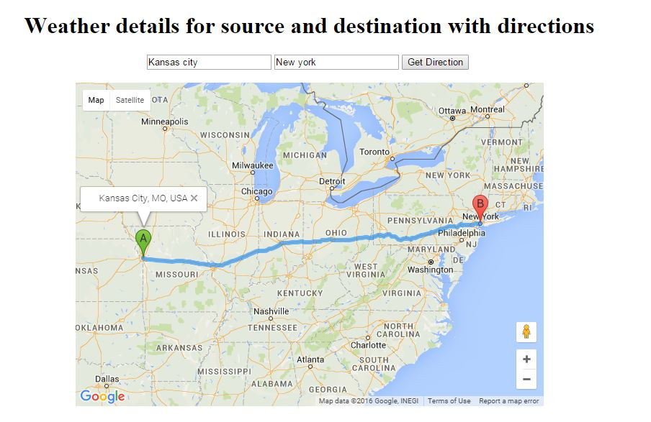
The below screenshot shows the direction for the specified source and marked destination place.
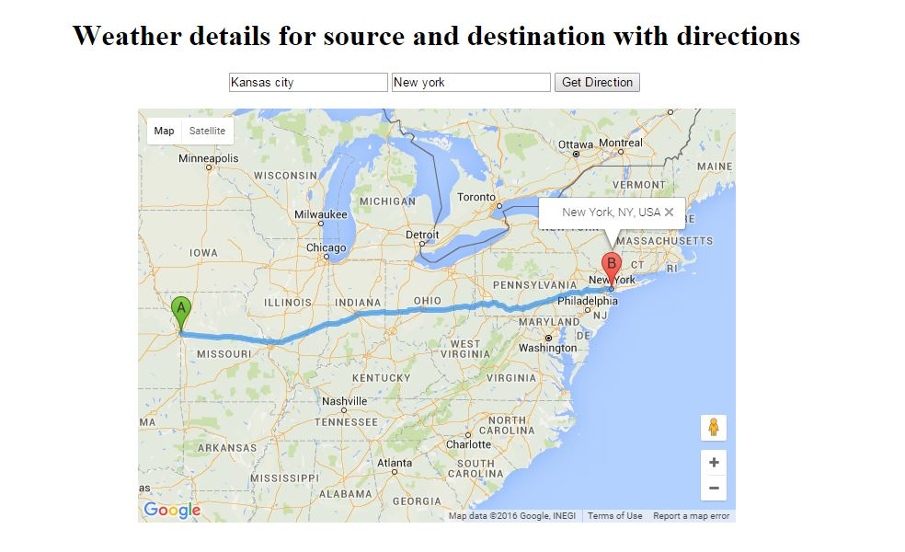
The next and final screenshot is for getting the weather details for both source and destination places. So the below screenshot shows the source place weather (Kansas city) as 61F and the destination place weather (New York) as 37F.
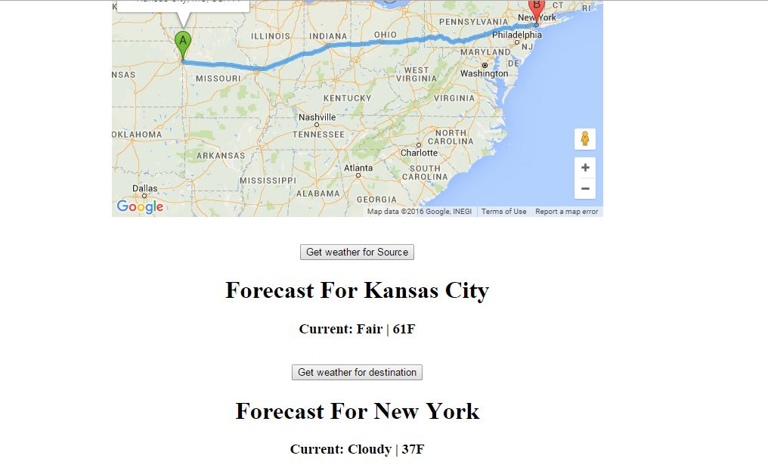
Conclusion:
Based on the requirement, The login page has been created with two buttons such as Login and Register. The user will go to register page by clicking the register button and will create a new account if they already don't have an existing account. Otherwise the user can directly login to the home page by giving their existing account details. The home page is using the external Google Map web service to mark Start and End Points and also displaying the weather details for both source and destination places.

