CS551 Advanced Software Engineering
LAB ASSIGNMENT #6
Instructor : Dr. Yugyung Lee
Teaching Assistant : Prady
Student : Fathima Shanthi James
Submission Date : 03/02/2016
Class ID : 58
1. Implement a web server proxy (related to your own project) to integrate data from at least two Rest services.
In this assignment, I have created two Rest services for the calculation of feet to yard and yard to feet. I used JUnit testing for testing my source code. And also i created a local web server by using the tomcat 8.0.
First Rest service
The below screenshot shows the default value for the yard to feet conversation and it's initially set as 0.

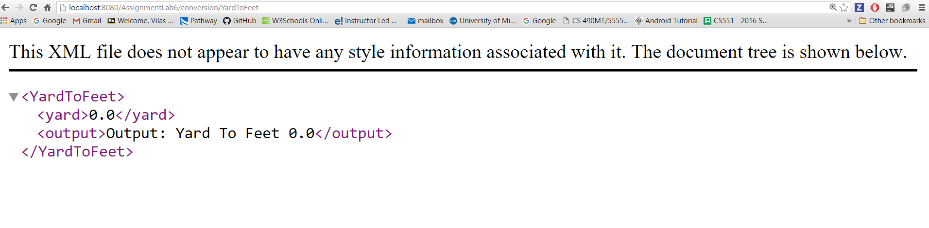
As shown in the below screenshot, the value assigned for the yard as 2 and then determine the feet value, that's 6.

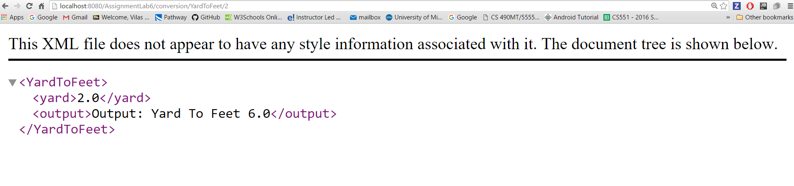
Second Rest service

The second rest service is calculating the feet to yard value as shown in the below screenshots.

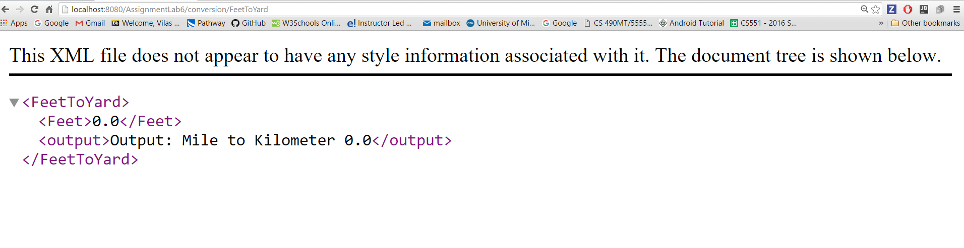

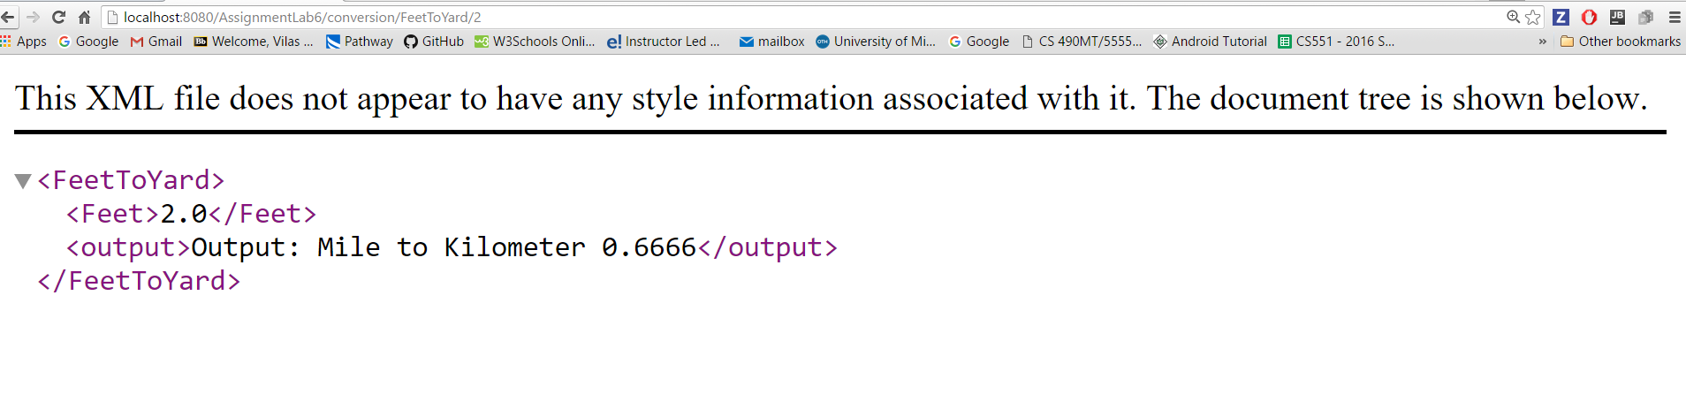

2. Write at least two suitable Junit Test cases for the classes created

The Junit test cases have been created and then tested for two cases as failure and success case.

First Rest service test case

Failure case test

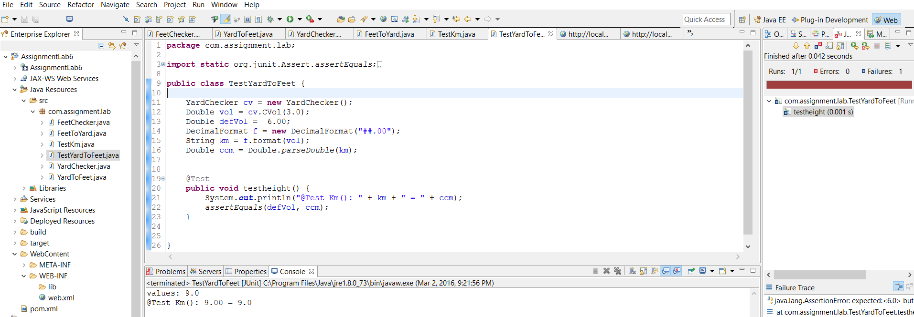

Success case test

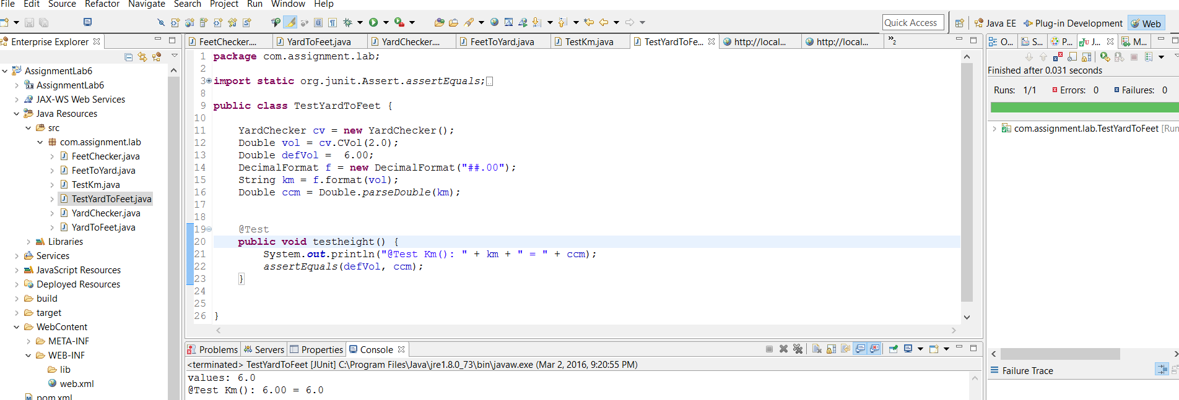

Second Rest service test case

Failure case test

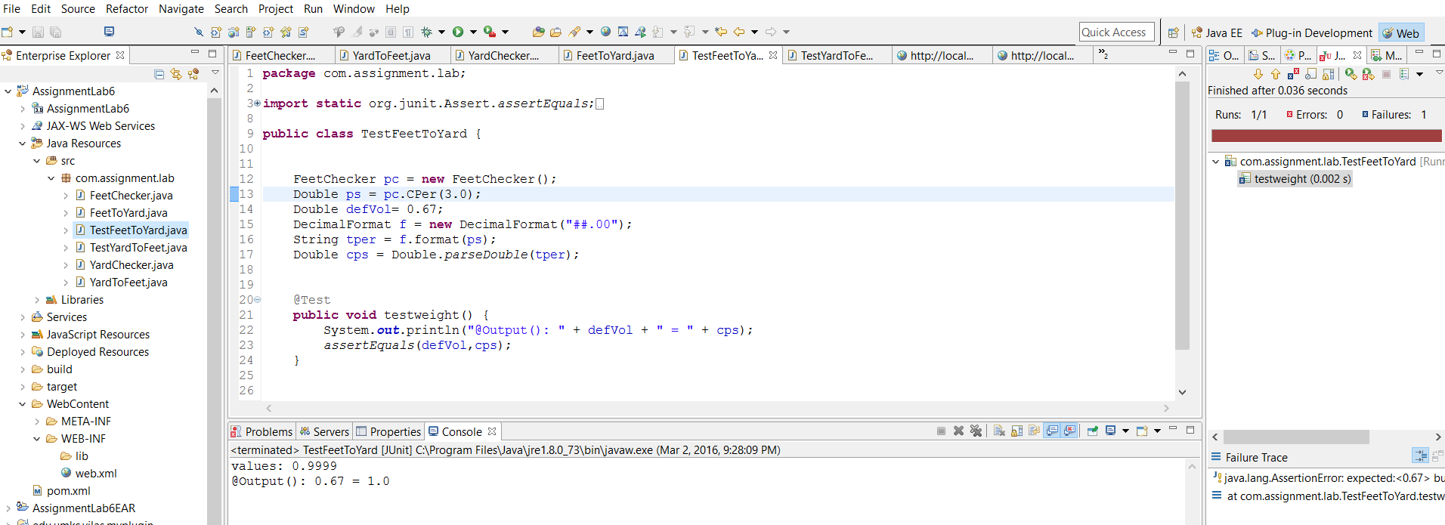

Success case test
