CS551 Advanced Software Engineering
LAB ASSIGNMENT #7
Instructor : Dr. Yugyung Lee
Teaching Assistant : Prady
Student : Fathima Shanthi James
Submission Date : 03/12/2016
Class ID : 58

In this assignment, I used Java middleware for developing at least 4 rest services to create, read, update and delete data (CRUD) on mongo Lab using MongoDB driver.
The below screenshot shows the create page. As per the requirement, the create page has been designed with two buttons such as Create account and Login. If the user already has an account, then they can directly login by clicking the login button. Otherwise the user should create an account by giving the user name, password and email information. After creating the account, the user can login to their account.

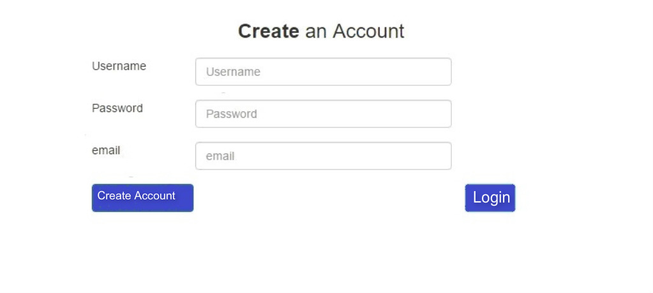

After creating an account, the user will redirect to the login page. The below screenshot shows the login page. By giving the user name and password, the user will redirect to the home page.

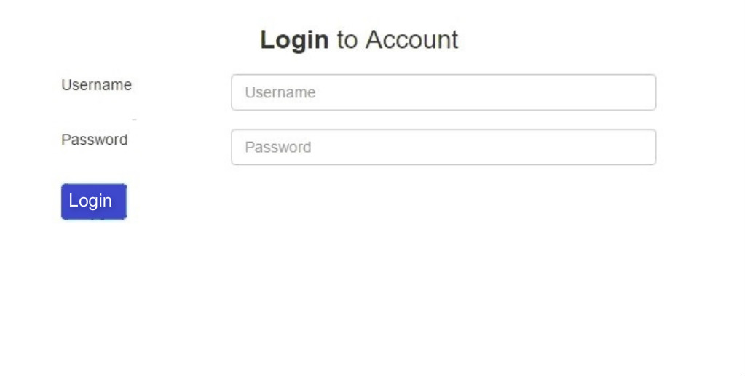
To update an user account, the user has to give their basic credentials and then easily update the account. If the user no longer needs their accounts, they can delete their account by clicking the delete button. The below screenshot shows the update page. If the user give the wrong information for their credentials, then the validation error will be thrown.
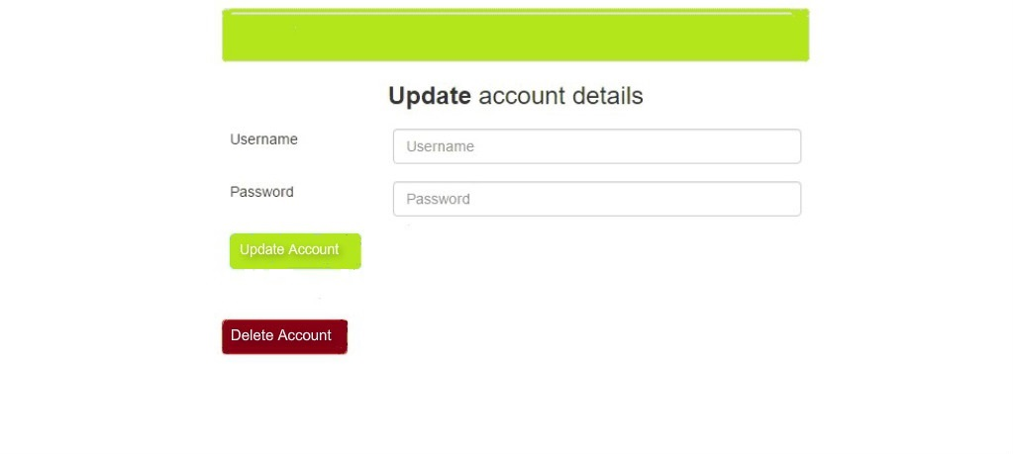

The below screenshot shows the delete page where the user can delete their account. Before deleting their account, the confirmation message will be asked and then by clicking the delete button, the user account will be deleted.

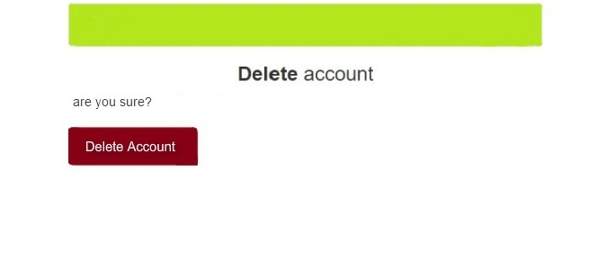
Conclusion:

In this assignment, the Java middleware used for developing at least 4 rest services to create, read, update and delete data (CRUD) on mongo Lab using MongoDB driver.

