CS551 Advanced Software Engineering
LAB ASSIGNMENT #1
Instructor : Dr. Yugyung Lee
Teaching Assistant : Prady
Student : Fathima Shanthi James
Class ID : 58

1. UML Class Diagram for chat application
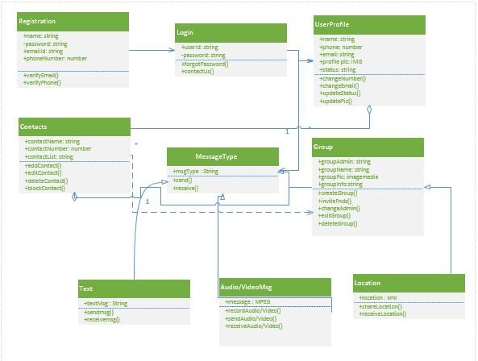

2. Create ZenHub Tool Account. Create a board, 3 iterations, at least 5 tasks and show the analytics graph.
ZenHub is a lightweight browser extension that injects features directly into GitHub's interface. It's simply a drag and drop tool to view the updates of the project. It adds a key, strategic dimension to GitHub allowing dynamic peer feedback, file uploads, etc.
The below screenshot shows the five tasks and the status of the task.
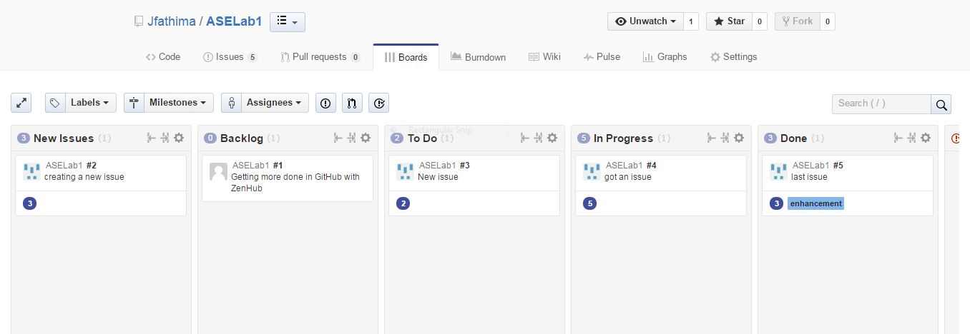
Analytics graph
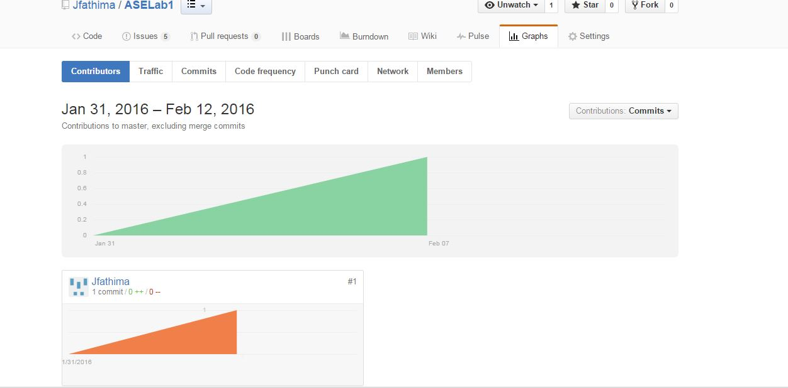
3. Create GitHub Account. Create a repository in remote Github. Clone it to local machine.
GitHub is a Git repository hosting service and project management tool where source code and project will be stored.

The below screenshot shows the repositories of the GitHub account Jfathima

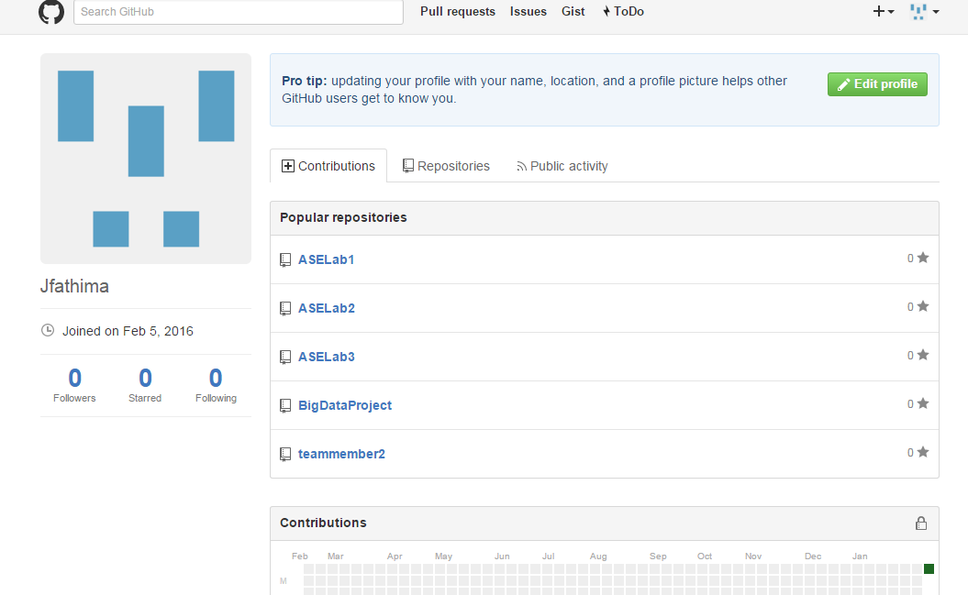

Conclusion
Created (Source and Documentation) directories in local github and then added the screenshots of class diagram and analytics graph under documentation directory in the local windows Github and then synced it to remote Github.

