CS551 Advanced Software Engineering
LAB ASSIGNMENT #10
Instructor : Dr. Yugyung Lee
Teaching Assistant : Prady
Student : Fathima Shanthi James
Submission Date : 04/05/2016
Class ID : 58
Deploy the applications onto Amazon instances and share the URL
I deployed my applications on to my Amazon instances and the below screenshot shows the deployment of yard to feet conversation.
URL :
http://aselab10-fathima.us-west-2.elasticbeanstalk.com/conversion/FeetToYard/3

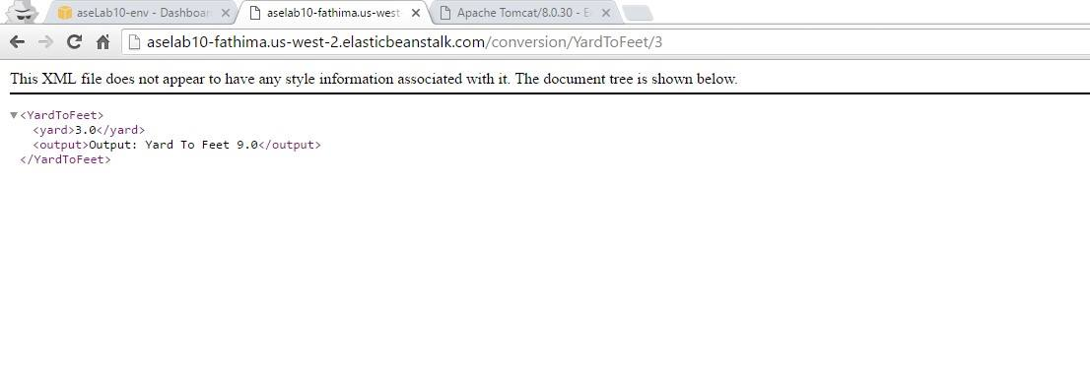
The below screenshot shows the feet to yard conversation. If there is no input values, then the result would be zero as shown in the screenshot.
URL:
http://aselab10-fathima.us-west-2.elasticbeanstalk.com/conversion/YardToFeet

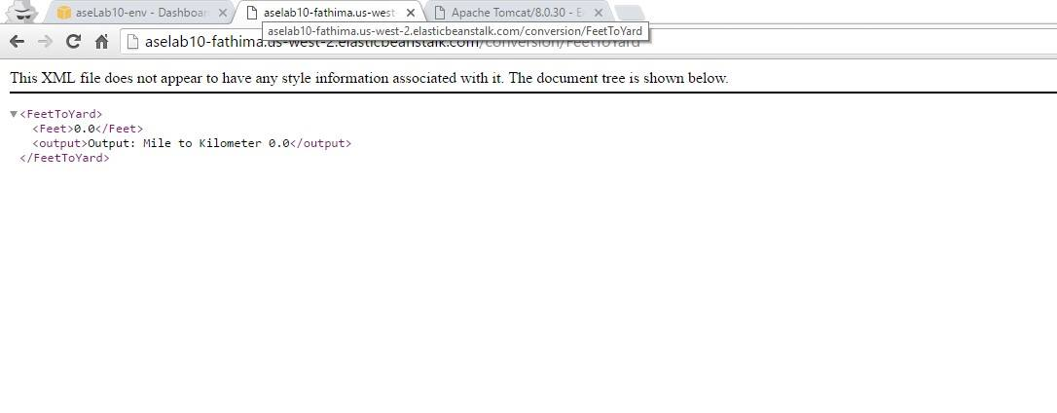
The below screenshot shows the feet to yard conversion with proper input values.
URL:
http://aselab10-fathima.us-west-2.elasticbeanstalk.com/conversion/FeetToYard/3

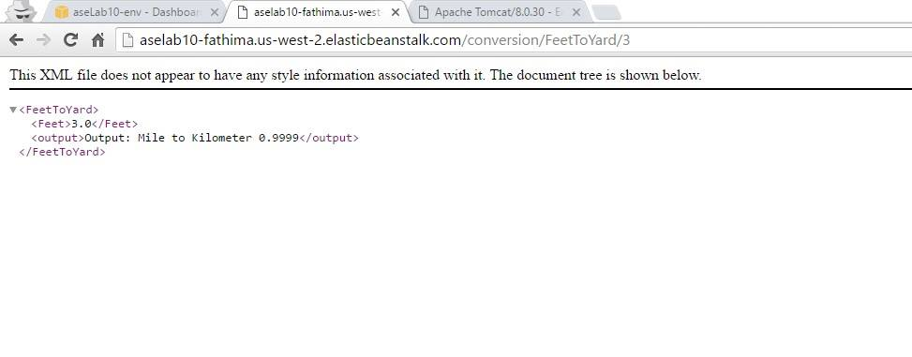
Another screenshot for yard to feet conservation with no input values.
URL :
http://aselab10-fathima.us-west-2.elasticbeanstalk.com/conversion/YardToFeet

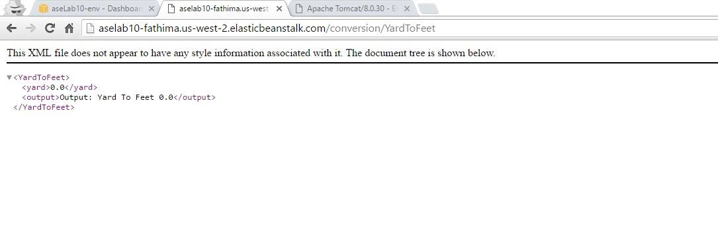
Conclusion:
I deployed my applications onto my Amazon account instances successfully and shared the URL as well.

