Lab Assignment – 2

**Weather Application:**

I have used “open weather map api” for getting weather data. In front end, I have used xml and backend Java.

After login, we have to provide zipcode as input.

In the backend I am reading the data and creating a web request using a child thread (Async).

If the request is successful, the api will send JSON data regarding weather information.

Now I have extracted main information from the given obtained JSON. The api provides kelvin scale temperature. So I converted to Fahreinheit using formula and displaying Fahreinheit.

There is a logout option which redirects to login page.

I have changed weather image as app logo.

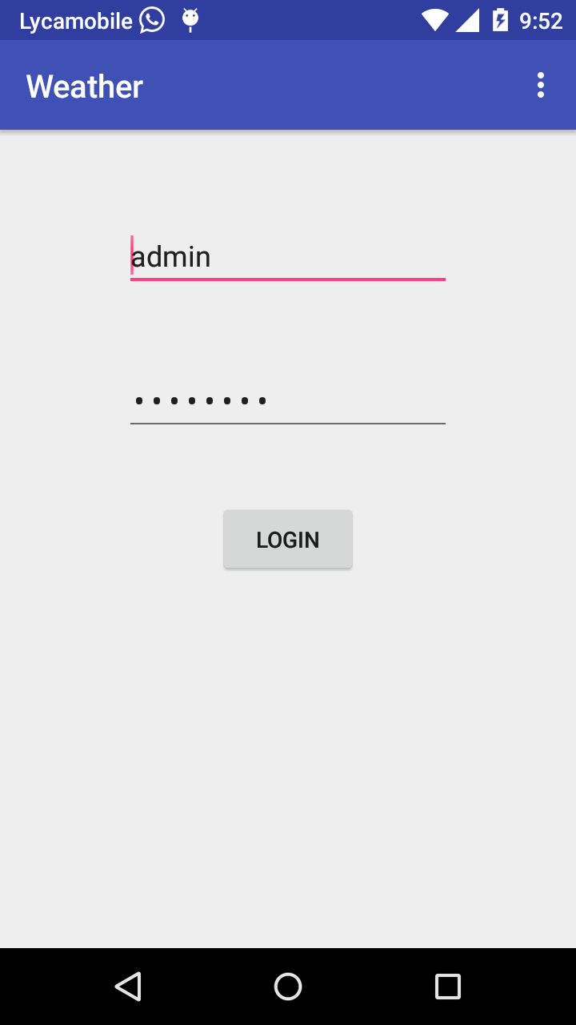

Fig: Login page

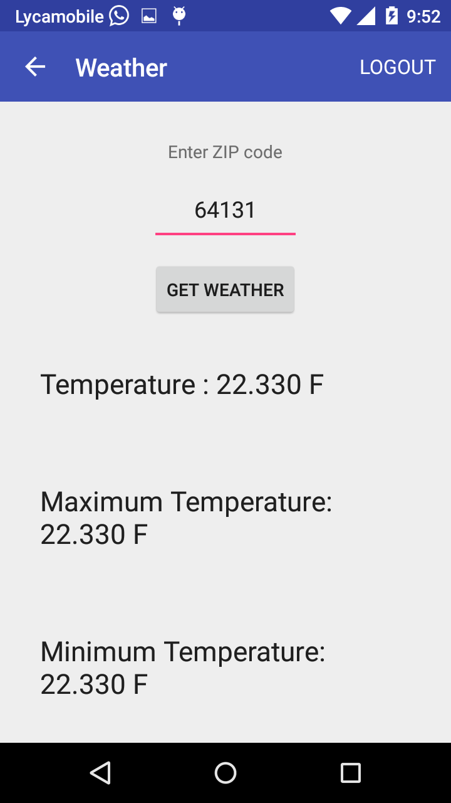

Fig: Home page with weather data for given zip code.

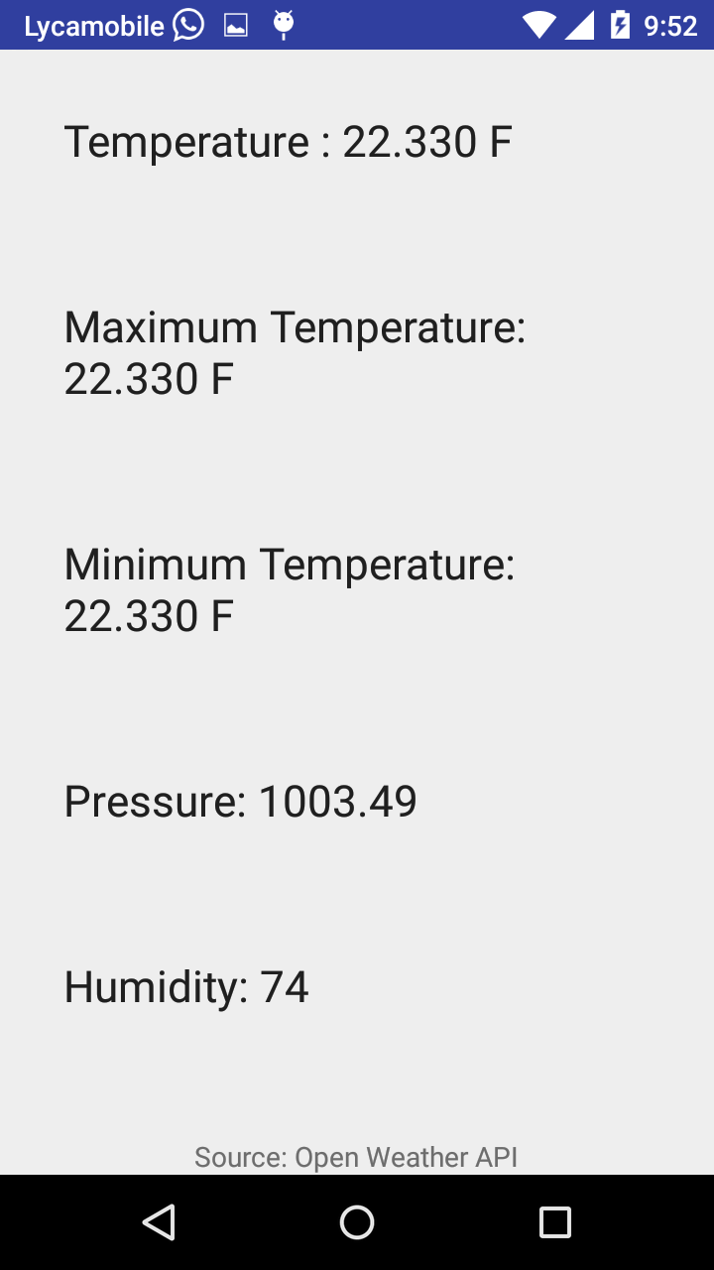

Fig 3: Source of data.