**Advanced Software Engineering (CS551)**

**Lab Assignment – 2**

**Instructor : Dr. Yugyung Lee**

**Teaching Assistant : Prady**

**Student : Fathima Shanthi James**

**Class ID : 58**

**Weather Application**

In this assignment, I have used “open weather map api” for getting the weather data. The app must have a login page and on successful login it

must take the user to the web service interaction page. To implement this requirement, I have used xml as frontend and Java as backend.

In the login page, we should provide the user name and password. After login, we have to provide zipcode as input. In the backend, I am reading the data and creating a web request using a child thread (Async). If the request is successful, the api will send JSON data regarding weather information.

Now I have extracted main information from the given obtained JSON. The api provides kelvin scale temperature. So I converted to Fahreinheit using the standard formula and displaying Fahreinheit temperature. There is a logout option which redirects to login page. Based on the Zipcode, we can get the accurate temperature of specific area.

I got the temperature for the Zipcode 64113 and the accurate temperature was 33.330F.

I have attached the screenshots in the following page. The screenshot includes the login page, zipcode page and then final weather report page.

**Login Page**

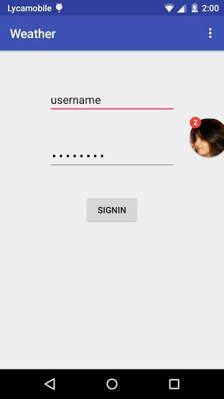

**After login, we have to provide the Zipcode**

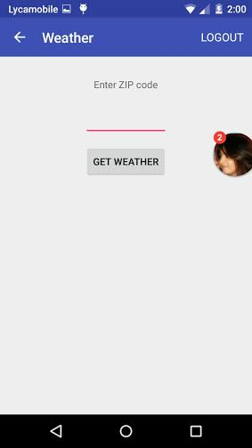

**Displaying the accurate weather**

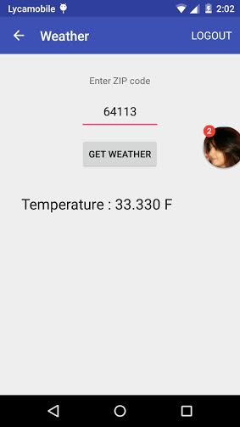

**Conclusion:**

I have successfully implemented the weather app by using the open weather map api. As per the requirement, The app is having a login page and on successful login it takes the user to the web service interaction page.