CS551 Advanced Software Engineering
LAB ASSIGNMENT #3
Instructor : Dr. Yugyung Lee
Teaching Assistant : Prady
Student : Fathima Shanthi James
Class ID : 58

Mobile App Registration
Step 1 : As per the requirement, the registration page has been created with full name, email, address and phone number. The below screenshot shows the registration page. All the login account details can be entered here. Camera is a image button where photo can be updated by clicking on camera button. I have used search button in the address box, by which address can be populated by clicking it without going to map page. Once all the account details entered the page will redirect to do the photo and get location page.

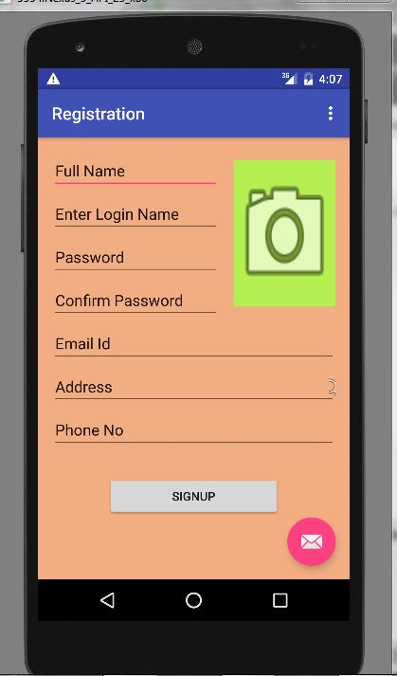

Step 2 : The next page is kind of home page for the take photo and get location options. So In that page, we can see two buttons such as take photo and get location.

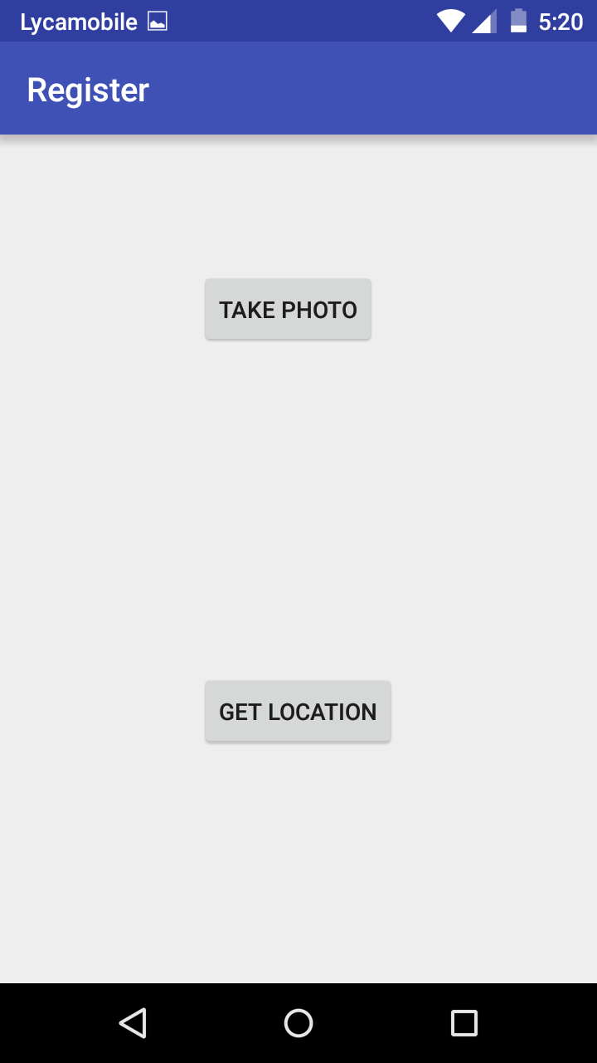

Step 3: By clicking the take photo button image, we can capture and view the picture as shown in the below screenshot. In this same page, we have home button. By clicking that button, We can go to home page.

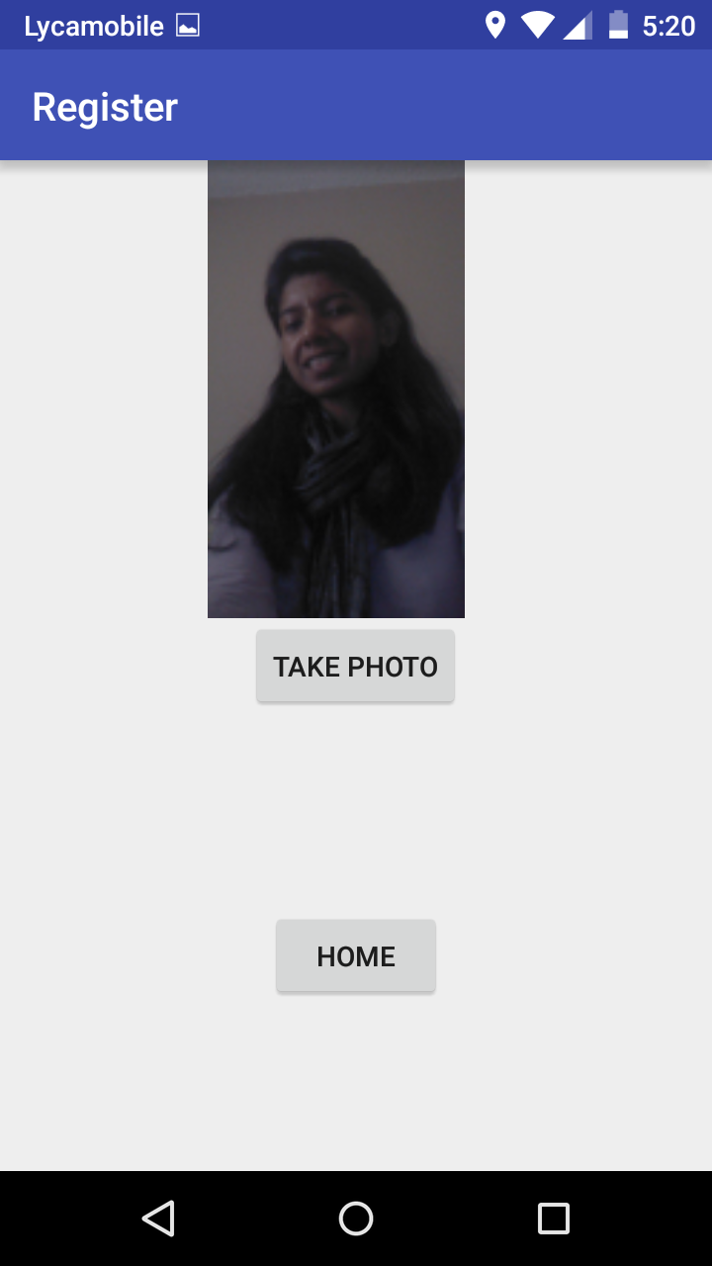

Step 4 : Once the photo has been taken, we can update the picture by clicking the came image button. The below screenshot shows the registration page with updated picture.

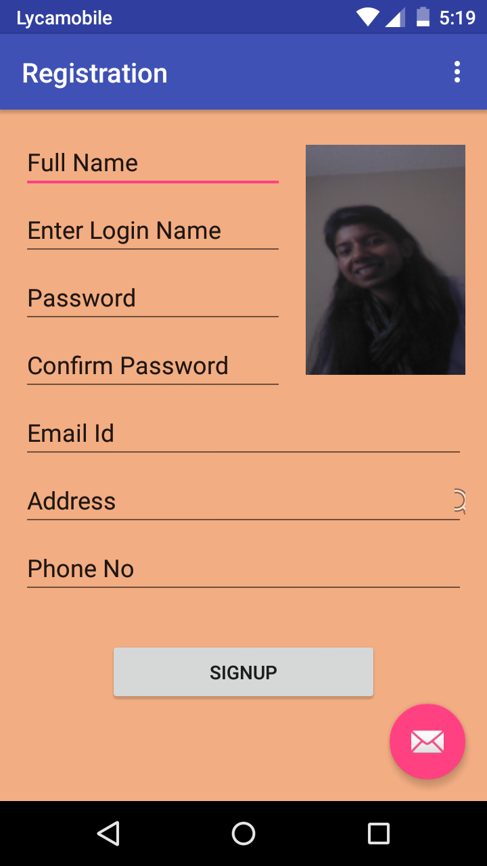

Step 5 : The next step is the address updating in Registration page. By clicking the search button in address tab, the address will be updated without opening and navigating map.

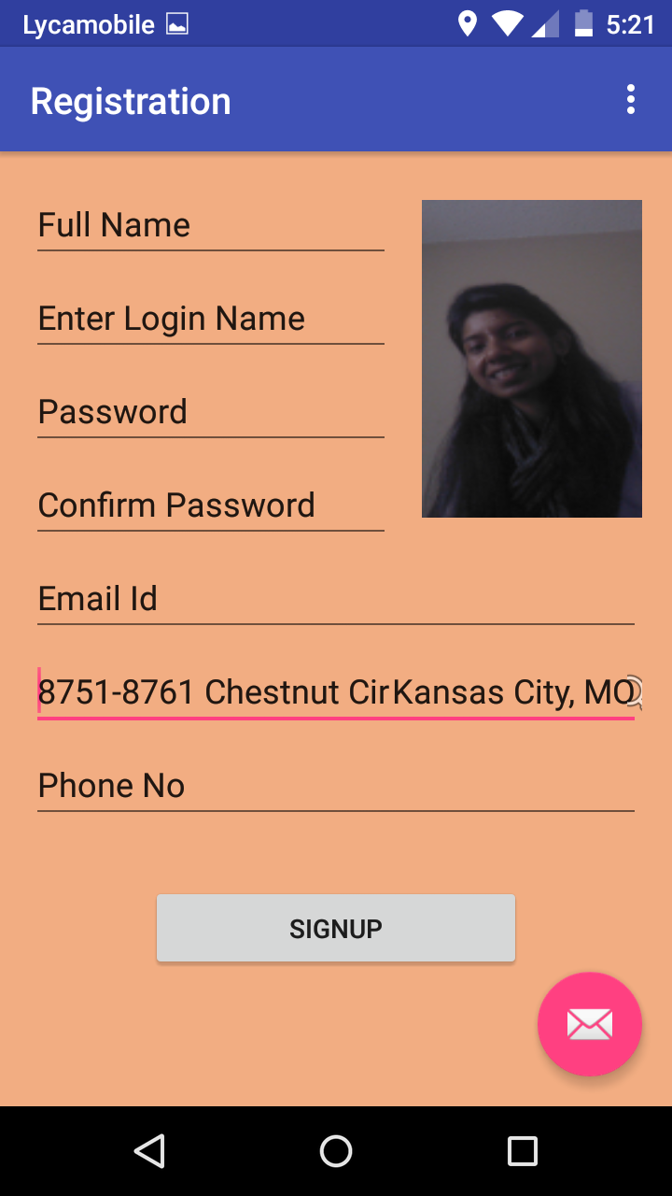

Step 6 : The last page of this assignment is Map navigation page. By clicking the get location button in home page, it will redirect to Google map and then get my current location with marker as shown blow screenshot.

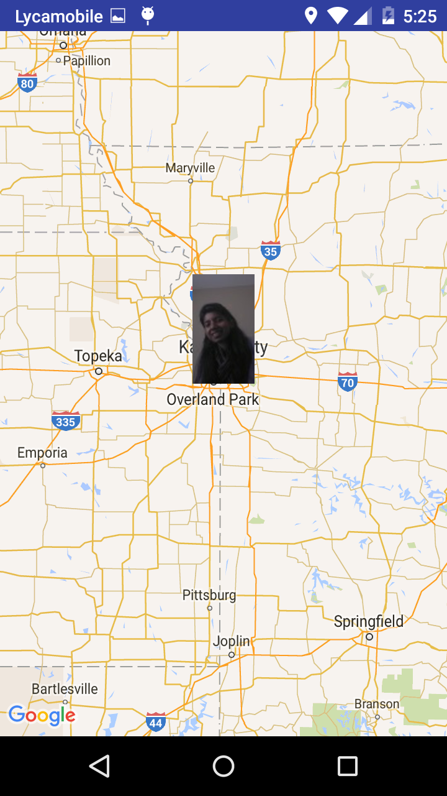

Conclusion : As per the requirement, Created a signup page with basic details like Full name, Email, Phone no, Image, Address etc. The Image has been populated by using Camera or Gallery and the address also has been populated using Location Manager.

