CS551 Advanced Software Engineering
LAB ASSIGNMENT #5
Instructor : Dr. Yugyung Lee
Teaching Assistant : Prady
Student : Fathima Shanthi James
Submission Date : 02/24/2016
Class ID : 58

Favorite Restaurant Analysis with Social Login

In my application, the user can login through Facebook. I used the Fackebook SDK for login process and REST webservice for the homepage activity. My new application name is yourfavcuisine, that means the user can get their favorite restaurant details as per their favorite cuisine.
Step 1: To start the process, the user should login through facebook. As shown in the screenshot, the login page asks the user to login through facebook.

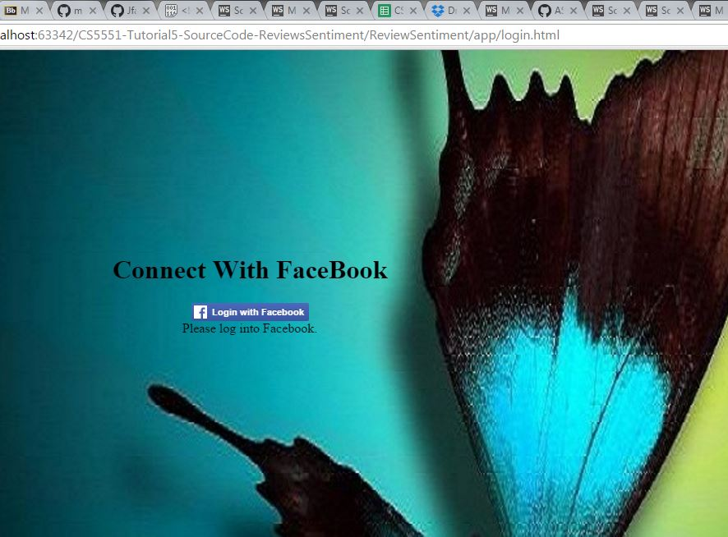
Step 2: As per the below screenshots, we have to enter the user credentials like Email or phone number or password.

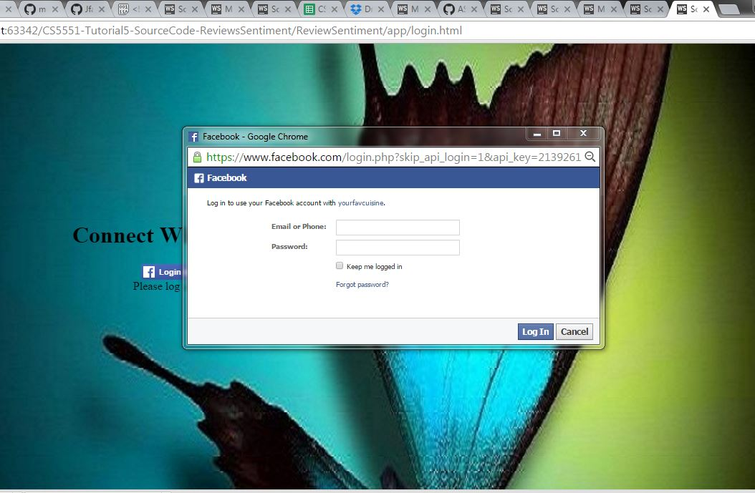

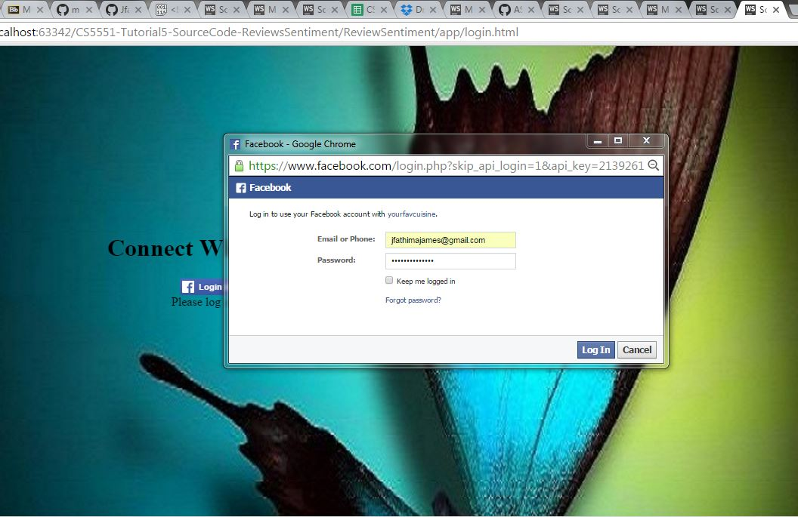

Step 3: Once the user logged in through the facebook. They will redirect to the home page. As shown in the below screenshot, the homepage has "Enter your city name" and "Enter your favorite cuisine" option textboxes. Once the user entered their favorite choice of city and restaurant, they can get the top five picks by clicking the "Get Restaurants" button. After that we can see the top five restaurants of their favorite city based on the cuisine.

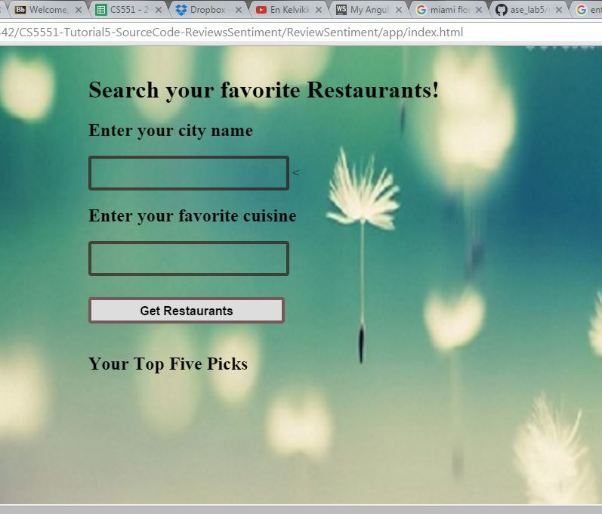

The below screenshot shows the top five picks for the favorite cuisine "Italian" and the city name is Chicago.
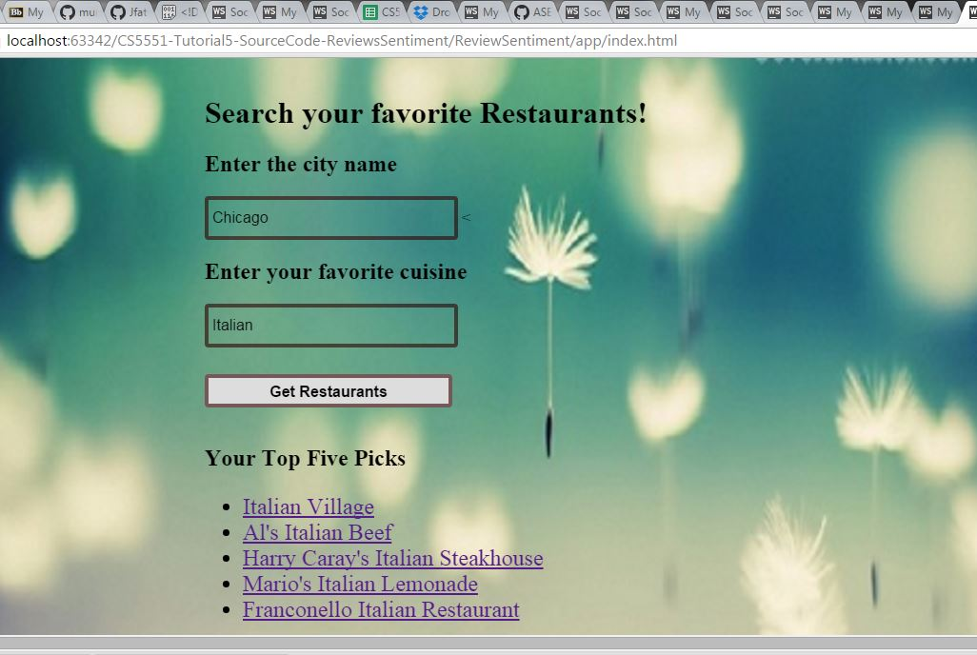

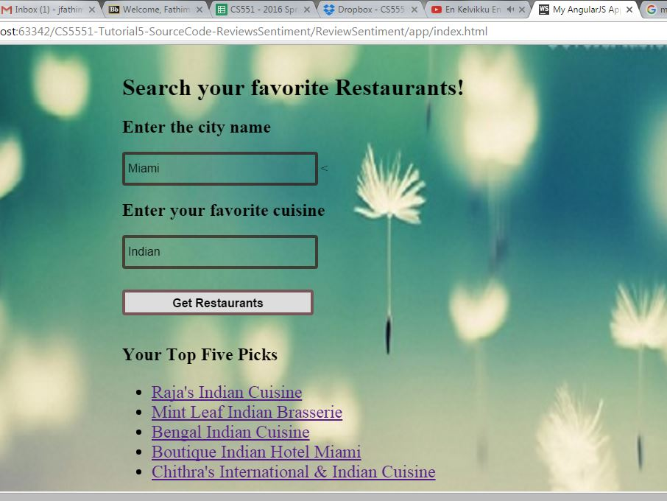
The below screenshot shows the search result for the different city "Kansas city" and different cuisine "Mexican". But we can view the particular restaurant and their sentiment analysis by using the Alchemy API.
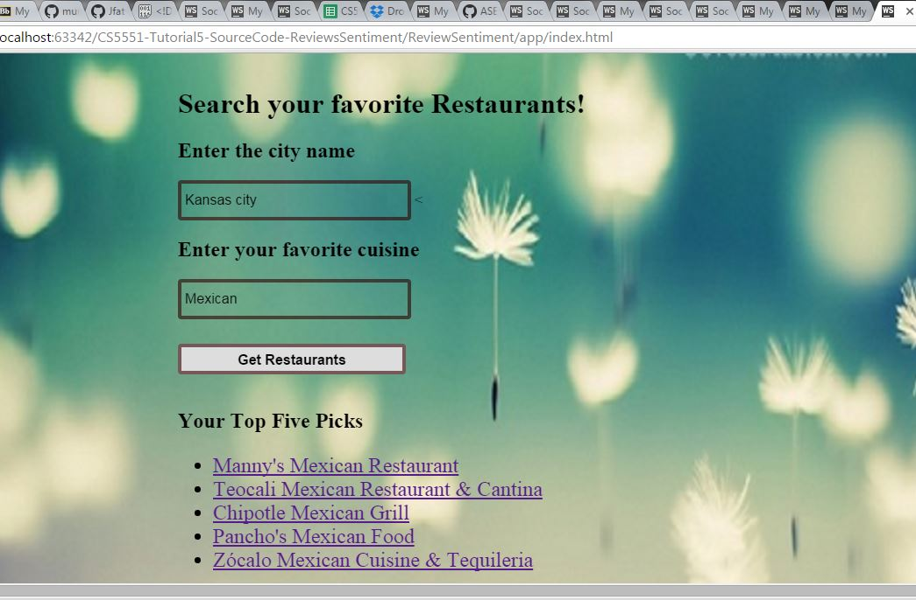
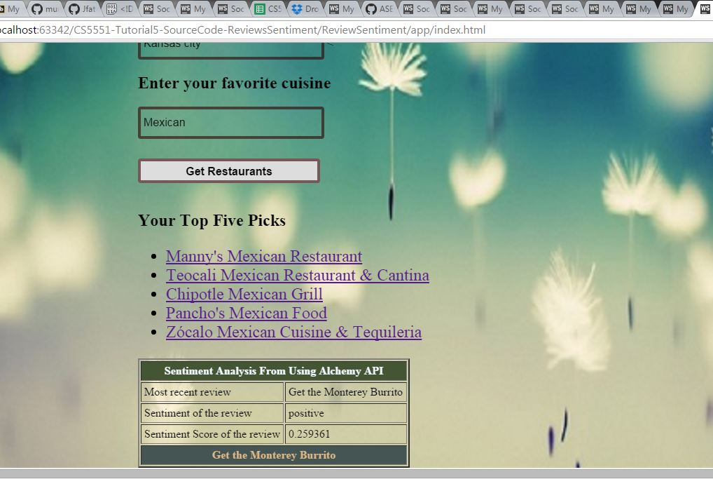
Step 4: Once the user get their favorite cuisine restaurant details, they can easily logout, if they want. The below screenshot shows the logout page.

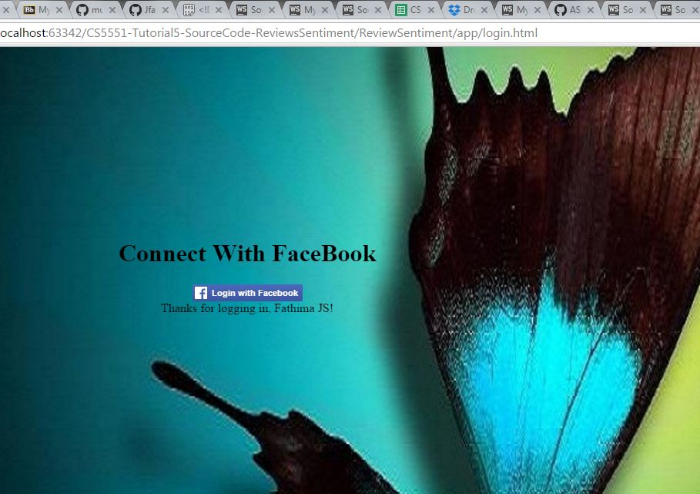

Conclusion:
As per the requirement, the app login page has been created by using the facebook SDK and created a REST webservice for the homepage activity.

