CS551 Advanced Software Engineering
LAB ASSIGNMENT #9
Instructor : Dr. Yugyung Lee
Teaching Assistant : Prady
Student : Fathima Shanthi James
Submission Date : 03/23/2016
Class ID : 58
In this assignment, I created a mobile application related to my project. The home page, we can see all the available features of this application such as register, login, change password and delete account. If the user don't have the existing account, they have to create a new account by clicking the register button. The below screenshot shows the home page.
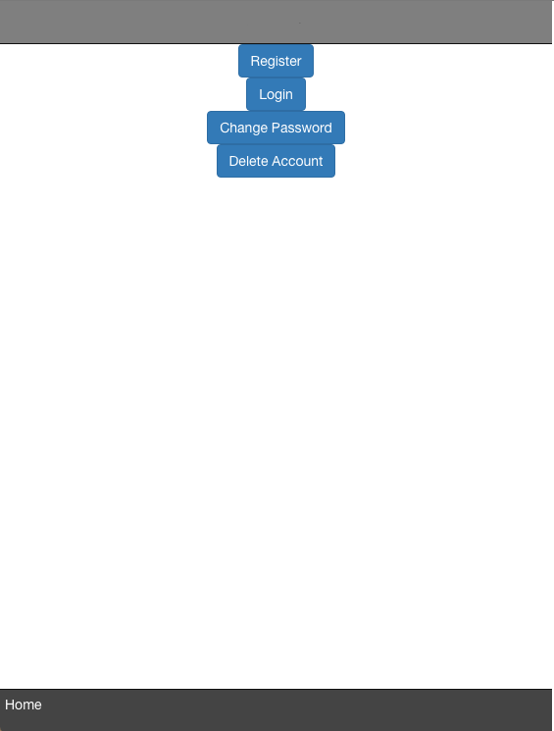

The below screenshot shows the register page. By giving all the basic details, the user can create a new account. Some fields are required and the user should have to enter all those fields otherwise the validation error will be thrown. Once the user create an account, they can login through the login page.

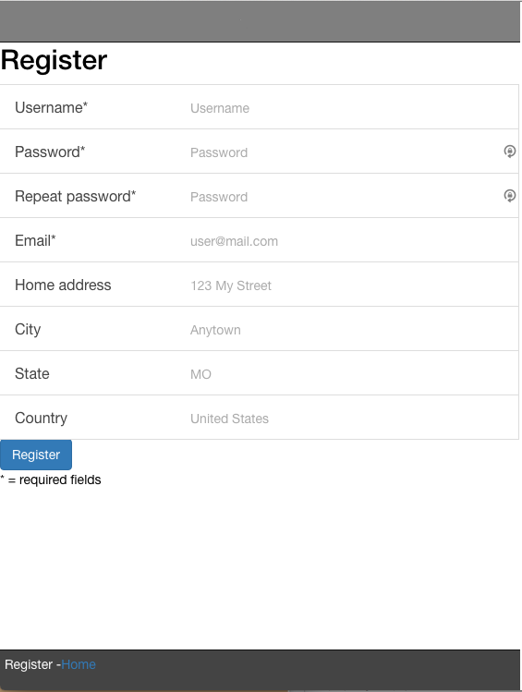

Validation test case I
The required filed validation has been applied there in this register page. So the field with * should have to enter, otherwise the error will be thrown. The screenshot shows the successful test because the validate fields are entered.

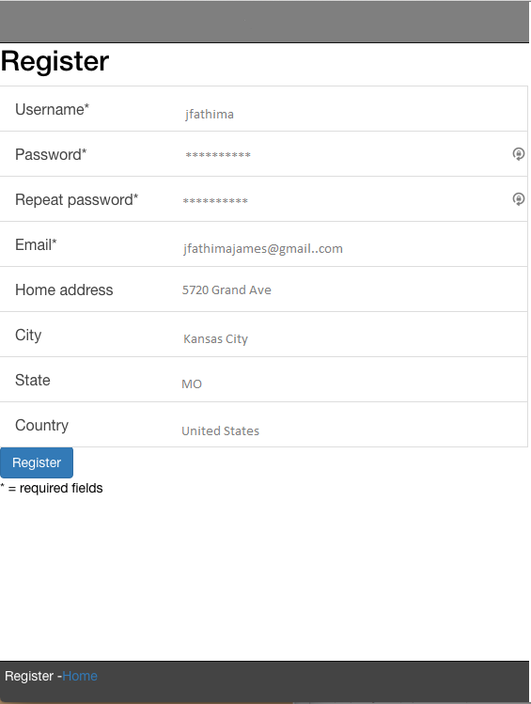

Validation test case II
The blow screenshot shows the failure test case. As shown in the screenshot, the user can't directly click the register page. If it's happened, the validation error will be thrown. They have to give the all the required fields.

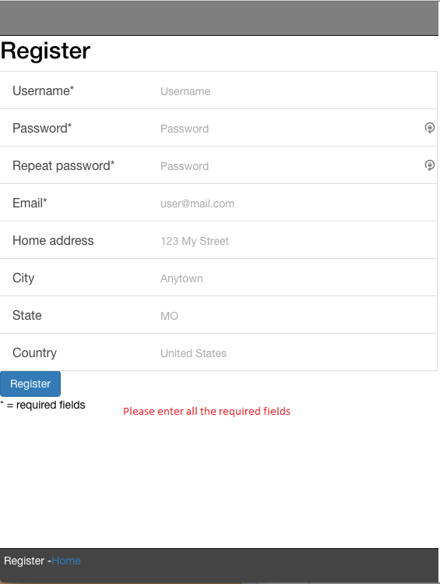

Validation test case III
As per the below screenshot, if the user gives the wrong username or password, the specific error will be thrown. This is the second failure test case. Once the user register their details, they can login through login page.

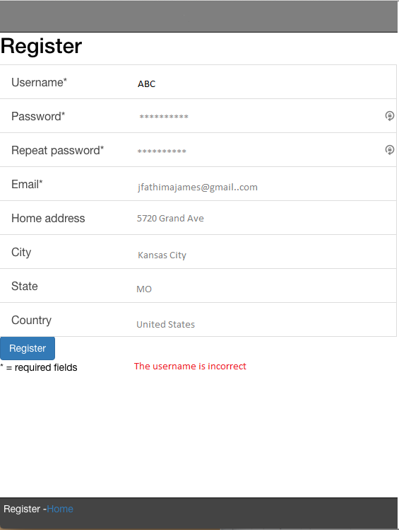

The login page, we have the option to change the password. If the user want to change the password, they change the password as shown the below screenshot.

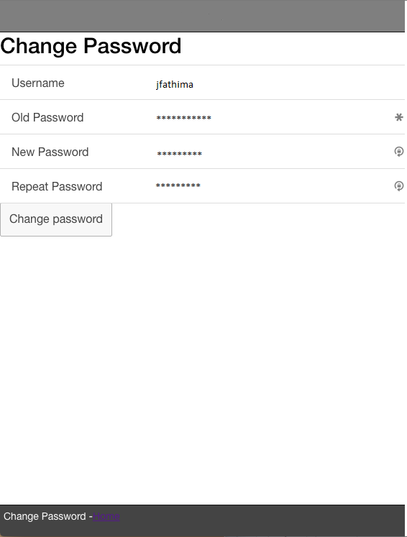

The below screenshot shows the login page. The user can login by giving their login credentials.

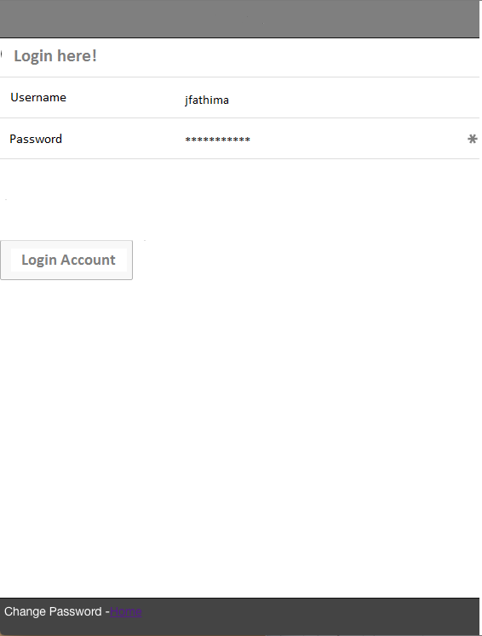

After login, the user can get their location or any other specific location by using the map and giving their specific start and end location.

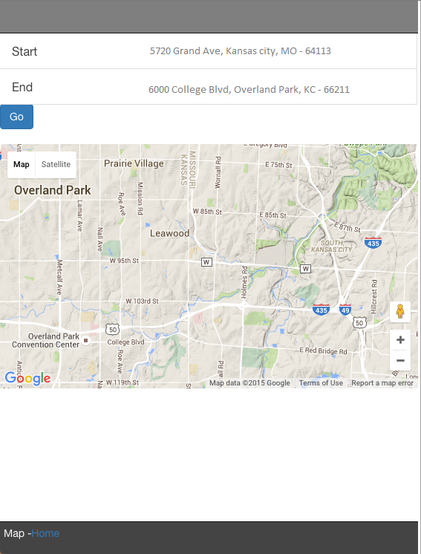

The user can delete their account by giving their login details in delete page as shown in the figure.

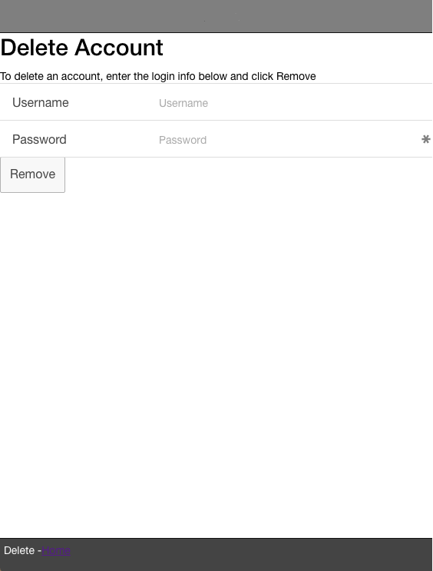

Unit test case:

Unit testing has done by using karma and jasmine. The below screenshot shows the success case.
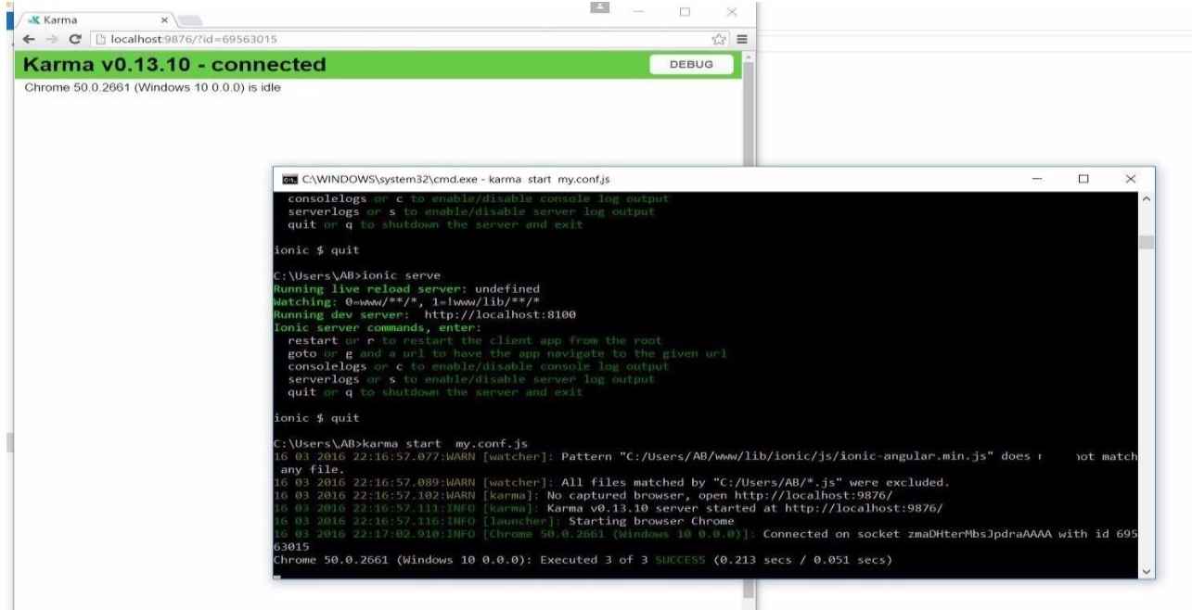

The below screenshot shows the failure test case.

