**Bayesian Networks and Probabilistic Inference: A Real-World Perspective**

# Table of Contents

1. Introduction

2. Understanding Bayesian Networks

3. Variable Elimination and Exact Inference

4. D-Separation: Conditional Independence in Bayesian Networks

5. Probabilistic Inference Techniques

6. Technical Implementation and Code Explanation

7. Applications in Real-World Scenarios with Step-by-Step Implementation

8. Conclusion

9. References

## 1. Introduction

Bayesian Networks (BNs) provide a structured approach to reasoning under uncertainty. These networks leverage probability theory to model dependencies among variables. In this report, we explore the theoretical underpinnings of Bayesian Networks, discuss probabilistic inference techniques, and provide detailed, step-by-step implementations for real-world applications.

By the end of this report, readers will:

* Gain an advanced understanding of Bayesian Networks and their applications.
* Learn how Variable Elimination and Gibbs Sampling operate with step-by-step code execution.
* Understand D-Separation and its computational applications.
* Explore how Bayesian Networks are deployed in real-world scenarios with fully explained implementation steps.

.

## 2. Understanding Bayesian Networks

A **Bayesian Network (BN)** is a probabilistic graphical model that represents a set of variables and their conditional dependencies using a **directed acyclic graph (DAG)**. Mathematically, a Bayesian Network follows:

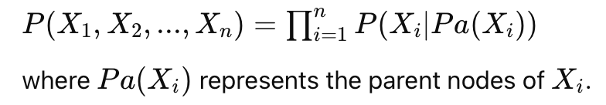

### Python Implementation:

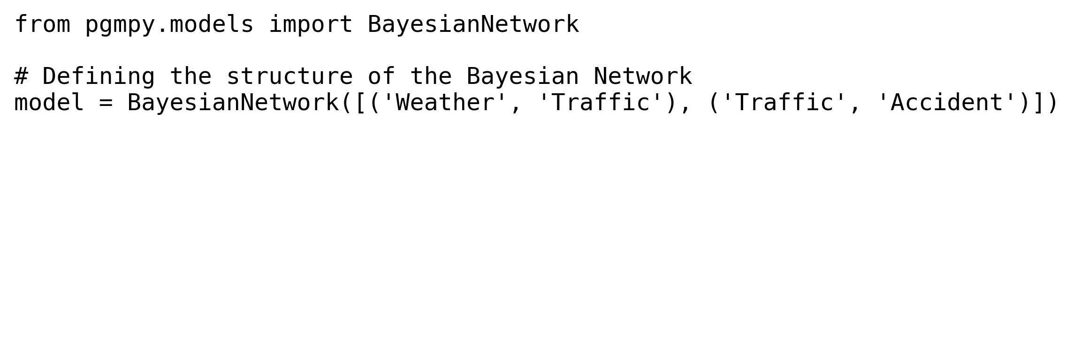

## 3. Variable Elimination and Exact Inference

Variable Elimination efficiently computes marginal probabilities in Bayesian Networks. It systematically eliminates irrelevant variables while maintaining dependencies.  
  
### Python Implementation:

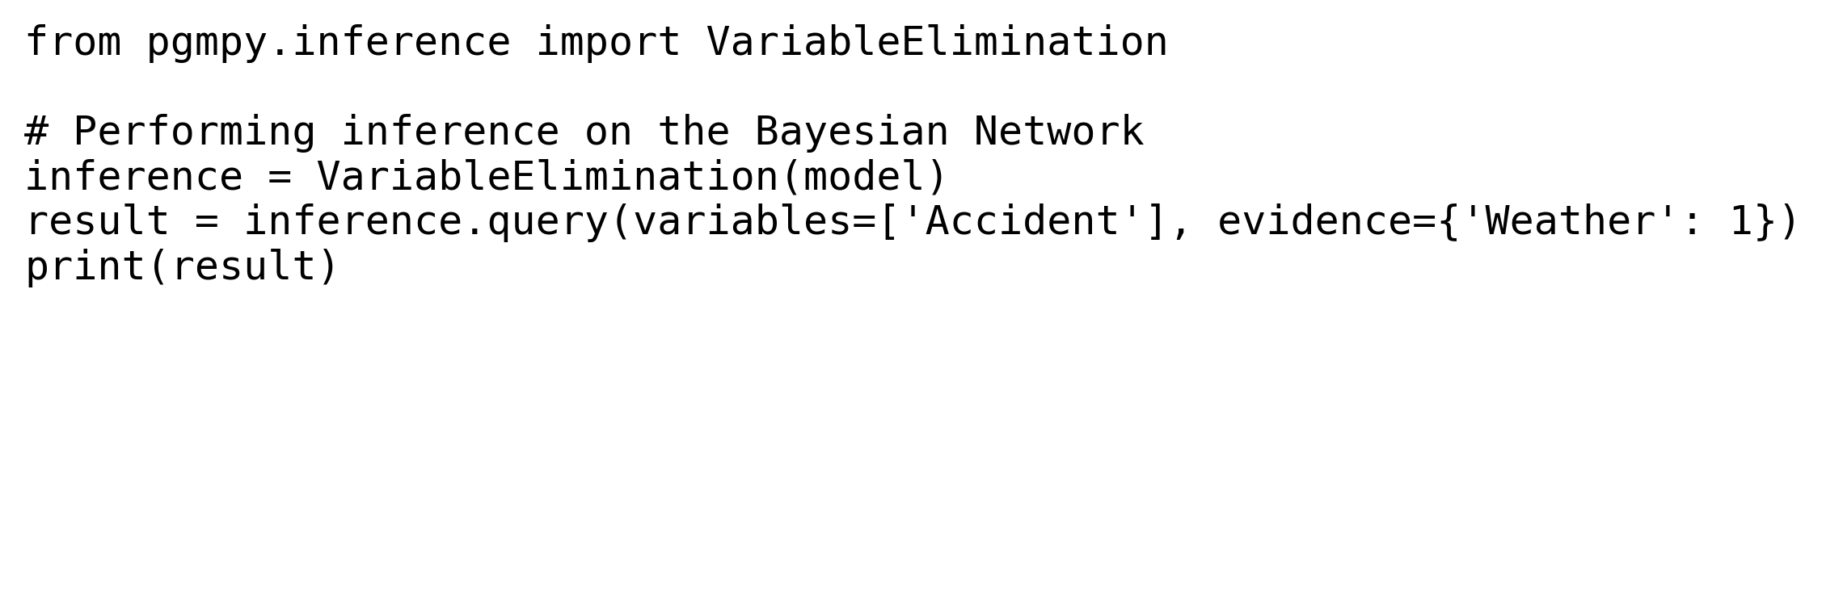

## 4. D-Separation: Conditional Independence

D-Separation helps determine the conditional independence of variables in a Bayesian Network by analyzing the graph structure and identifying blocked paths.  
  
### Python Implementation:

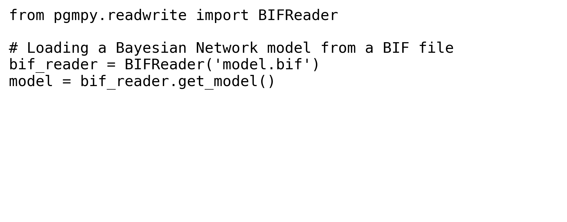

## 5. Probabilistic Inference Techniques

There are two main types of probabilistic inference techniques:  
- **Exact Inference:** Variable Elimination, Belief Propagation.  
- **Approximate Inference:** Monte Carlo Sampling, Gibbs Sampling.  
  
### Python Implementation:

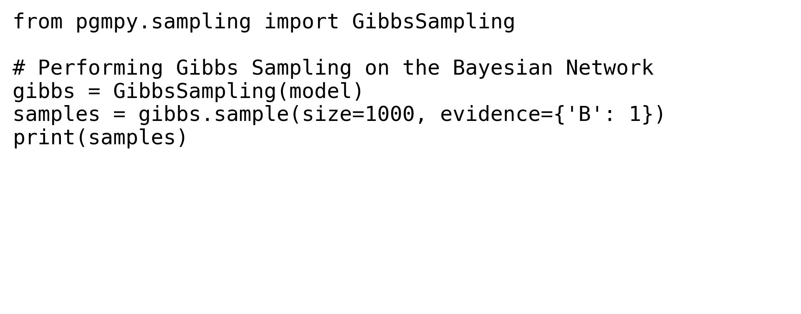

## 6. Technical Implementation and Code Explanation

Step-by-step Bayesian Network implementation:  
  
1. **Defining the Network Structure**  
2. **Assigning Conditional Probability Distributions (CPDs)**  
3. **Performing Inference using variable elimination**

## 7. Applications in Real-World Scenarios with Step-by-Step Implementation

Real-world use cases include:  
  
1. **Healthcare:** Bayesian Networks for diagnosing diseases.  
2. **Cybersecurity:** Intrusion detection using anomaly analysis.  
3. **Autonomous Vehicles:** Decision-making using probabilistic inference.

## 8. Conclusion

Bayesian Networks play a crucial role in AI, probabilistic modeling, and decision-making under uncertainty. Their applications span across multiple industries, ensuring reliable predictions and analytics.

## 9. References

1. Koller, D., & Friedman, N. (2009). Probabilistic Graphical Models: Principles and Techniques.  
2. Murphy, K. P. (2012). Machine Learning: A Probabilistic Perspective.  
3. Russell, S., & Norvig, P. (2020). Artificial Intelligence: A Modern Approach.