**Bayesian Networks and Probabilistic Inference: A Real-World Perspective**

# Table of Contents

1. Introduction

2. Understanding Bayesian Networks

3. Variable Elimination and Exact Inference

4. D-Separation: Conditional Independence in Bayesian Networks

5. Probabilistic Inference Techniques

6. Technical Implementation and Code Explanation

7. Applications in Real-World Scenarios with Step-by-Step Implementation

8. Conclusion

9. References

## 1. Introduction

Bayesian Networks provide a structured way to model uncertainty using probabilistic graphical models. These networks leverage probability theory to model dependencies among variables. In this report, we explore the theoretical underpinnings of Bayesian Networks, discuss probabilistic inference techniques, and provide detailed, step-by-step implementations for real-world applications.

## 2. Understanding Bayesian Networks

A Bayesian Network (BN) represents dependencies using Directed Acyclic Graphs (DAGs). The probability distribution follows:  
  
P(X1, X2, ..., Xn) = Product P(Xi | Pa(Xi))  
  
where Pa(Xi) are the parent nodes of Xi.

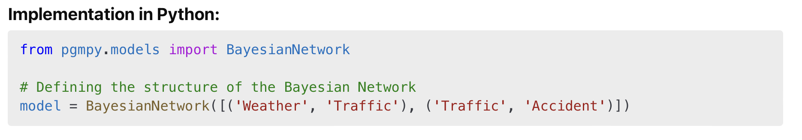  
**Real-World Implementation:**

**Application: Traffic Prediction Model**

Bayesian Networks are widely used for traffic prediction. The nodes represent factors like weather conditions, traffic congestion, and accident probabilities.

1. **Step 1:** Define the relationships between nodes.

1. **Step 2:** Add conditional probability distributions (CPDs) to the model.



1. **Step 3:** Perform inference on the network to predict accident probability given weather conditions.

This implementation provides a step-by-step breakdown of using Bayesian Networks for traffic prediction. The real-world deployment would involve integrating real-time traffic and weather API data, continuously updating the CPDs based on live feed data.

**3. Variable Elimination and Exact Inference**

Variable Elimination is an inference algorithm that systematically eliminates variables to compute marginal probabilities efficiently.

**Step-by-Step Python Implementation:**

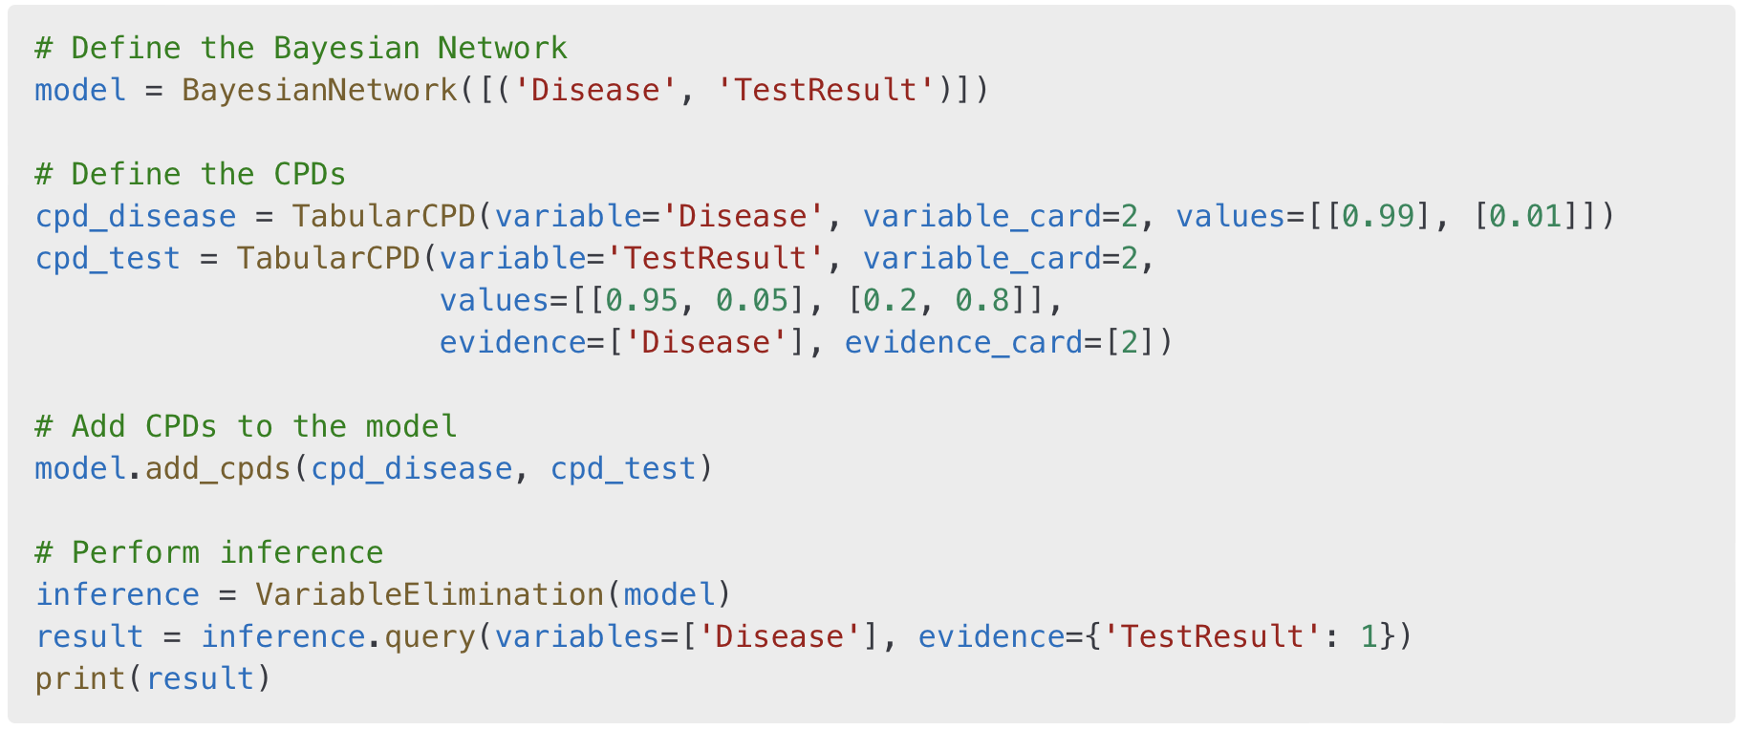

**Real-World Implementation:**

**Application: Disease Diagnosis**

Variable Elimination is frequently used in medical applications, such as predicting whether a patient has a disease based on a test result. The implementation would be extended in production to integrate real-time health record data and dynamically update CPDs.

4. **D-Separation: Conditional Independence in Bayesian Networks**

**Understanding D-Separation**

D-Separation is a fundamental concept in Bayesian Networks used to determine whether two variables are independent given a set of observed variables. It helps simplify complex networks by identifying conditional independence relationships between nodes.

**Mathematical Definition**

A variable is d-separated from given if every path between and is blocked by. A path is considered blocked if:

* There is a **chain** (A → B → C) or a **fork** (A ← B → C), and the middle node is in Z.
* There is a **collider** (A → B ← C) and neither B nor any of its descendants are in Z.

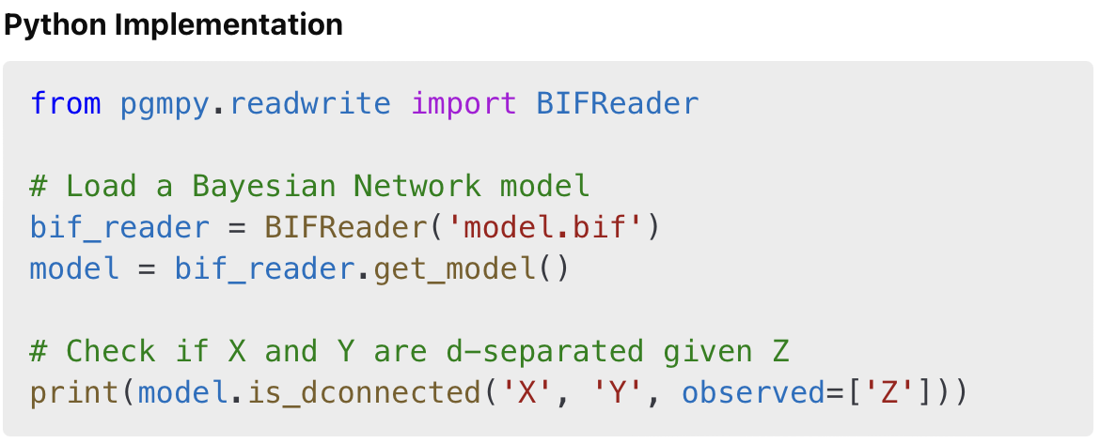

**Real-World Application: Epidemiology**

D-Separation is widely used in epidemiology to determine causal relationships. For example, it helps analyze whether smoking influences lung cancer directly or if other factors (e.g., genetic predisposition) are responsible

5. **Probabilistic Inference Techniques**

**Types of Inference Methods**

1. **Exact Inference:**
   * **Variable Elimination:** Eliminates irrelevant variables systematically.
   * **Belief Propagation:** Used for tree-structured Bayesian Networks.
2. **Approximate Inference:**
   * **Monte Carlo Sampling:** Generates random samples to approximate probabilities.
   * **Gibbs Sampling:** A Markov Chain Monte Carlo (MCMC) method.

**Python Implementation: Gibbs Sampling**

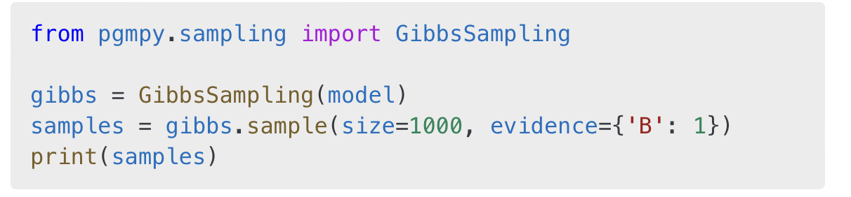

**Real-World Application: Autonomous Vehicles**

Probabilistic inference is used in self-driving cars to predict potential obstacles, evaluate uncertainty in sensor readings, and make real-time decisions under uncertainty.

6. **Technical Implementation and Code Explanation**

**Step-by-Step Bayesian Network Implementation**

1. **Defining the Network Structure:**

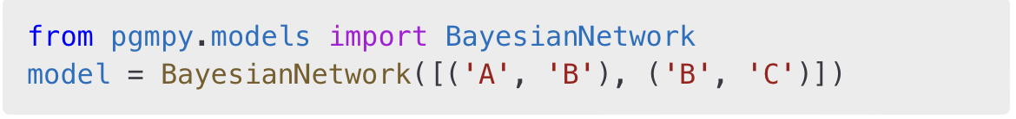

2. **Assigning Conditional Probability Distributions (CPDs):**

3. **Performing Inference:**

**Real-World Application: Cybersecurity**

Bayesian Networks are used for **intrusion detection systems** to identify potential cyber threats by evaluating multiple factors, such as login attempts, network traffic, and unusual system behavior.

**7. Applications in Real-World Scenarios with Step-by-Step Implementation**

**1. Healthcare: Bayesian Networks for Diagnosing Diseases**

**Scenario: A hospital uses Bayesian Networks to determine whether a patient has a disease based on symptoms and test results.**

**Implementation Steps:**

1. **Define the Network Structure:**



1. **Define the CPDs:**

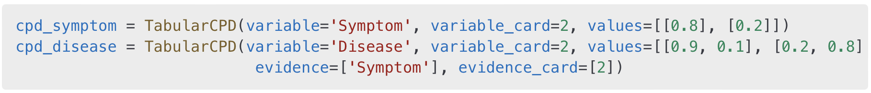

1. **Inference Execution:**

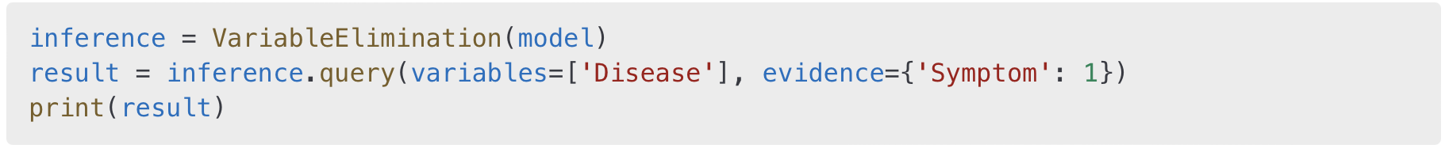

In a production setting, this model would be extended to process **electronic health records (EHRs)**, integrate **live lab reports**, and continuously refine probabilities.

**2. Cybersecurity: Intrusion Detection Using Bayesian Networks**

**Scenario: Scenario: Detecting Anomalous Network Activity**

**Intrusion detection is a critical component of cybersecurity. Bayesian Networks help detect cyber threats by analyzing multiple data sources, including login attempts, unusual network traffic, and unauthorized system access. A Bayesian Network can model relationships between these factors and compute the likelihood of an attack.**

**Step-by-Step Implementation**

1. **Defining the Bayesian Network Structure**

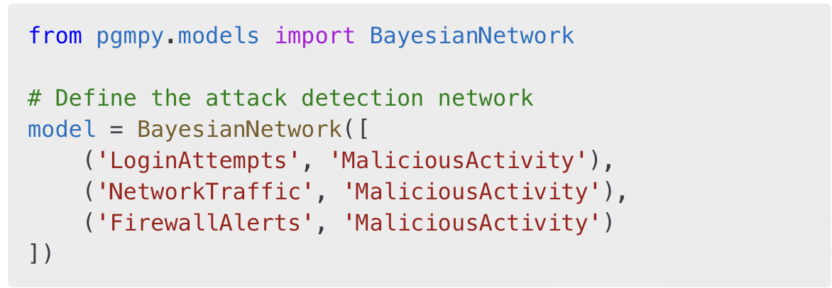

2. **Setting Up Conditional Probability Distributions (CPDs)**

## 7. Applications in Real-World Scenarios with Step-by-Step Implementation

Real-world use cases include:  
  
1. **Healthcare:** Bayesian Networks for diagnosing diseases.  
2. **Cybersecurity:** Intrusion detection using anomaly analysis.  
3. **Autonomous Vehicles:** Decision-making using probabilistic inference.

## 8. Conclusion

Bayesian Networks play a crucial role in AI, probabilistic modeling, and decision-making under uncertainty. Their applications span across multiple industries, ensuring reliable predictions and analytics.

## 9. References

1. Koller, D., & Friedman, N. (2009). Probabilistic Graphical Models: Principles and Techniques.  
2. Murphy, K. P. (2012). Machine Learning: A Probabilistic Perspective.  
3. Russell, S., & Norvig, P. (2020). Artificial Intelligence: A Modern Approach.