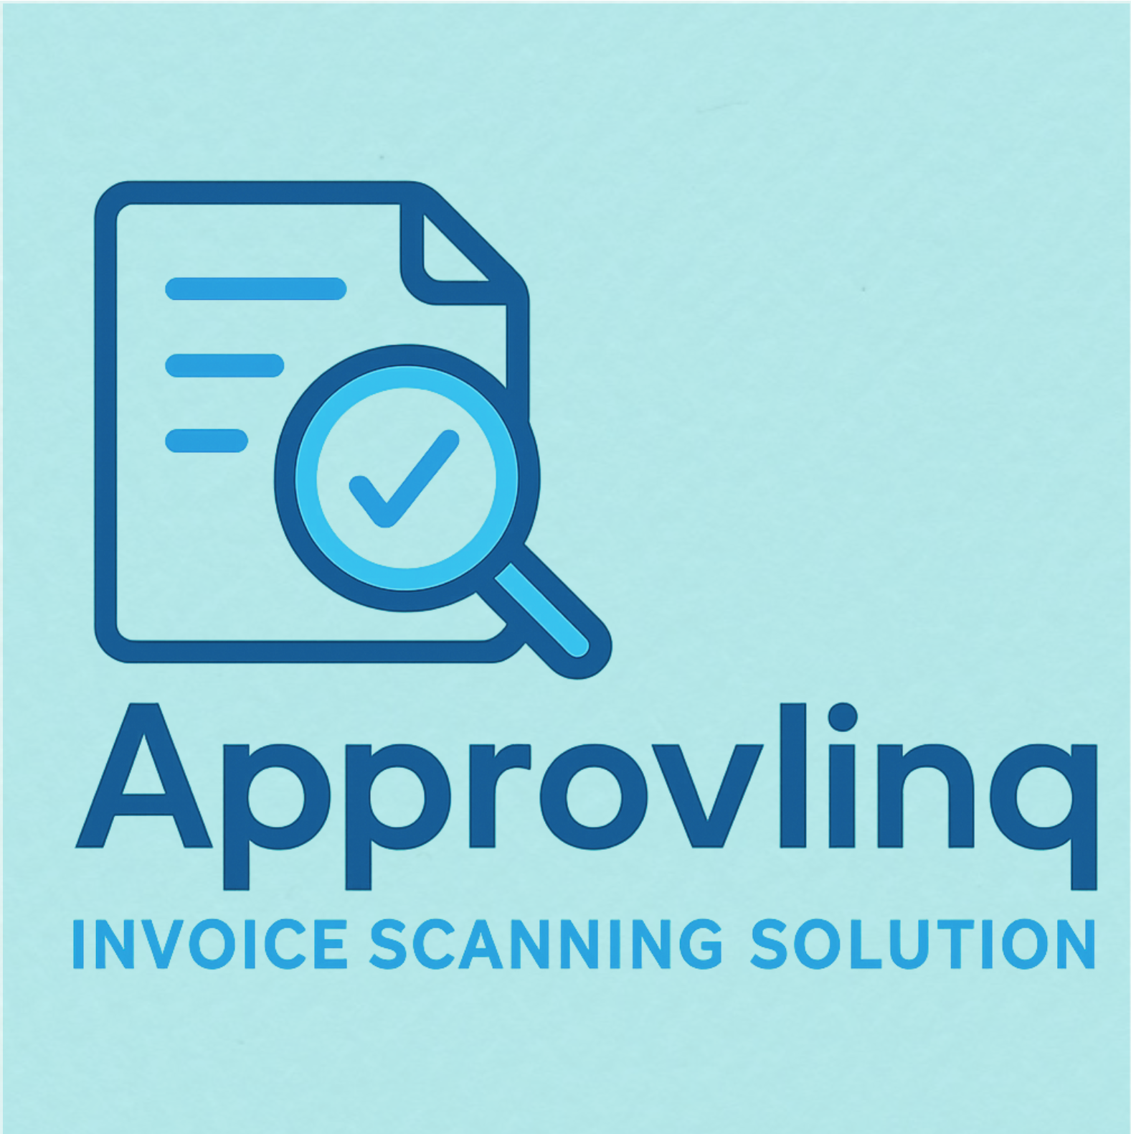

Approvlinq Client Guide
  - Login, tenant administration, scanning workflow and issue reporting
Purpose: help client users adopt Approvlinq quickly and use the platform consistently from day one.
  - Version 3.02
  - This guide follows the same branding used in the platform and can be shared with client administrators, AP users and reviewers.

Contents
1. What Approvlinq does
2. User roles and access
3. Login page
4. Platform Admin page
5. Tenant Admin page
6. Scanning Tool page
7. Issue reporting and resolution tracking
8. Best practice checklist

What Approvlinq does
Approvlinq is a multi-tenant invoice scanning and review platform designed to separate platform administration from client tenant operations.
Each tenant can maintain its own companies, suppliers and AP nominal accounts while invoice batches remain tied to the correct tenant and company.
The platform supports issue logging so that clients and administrators can track operational problems through to resolution.

User roles and access
Role | Main use | Typical permissions
Platform Admin | Service owner or internal support | Create tenants and users, switch active or inactive status, monitor capacity and manage issue logs.
Tenant Admin | Client-side owner or finance lead | Maintain tenant details, companies, suppliers, nominal accounts and submit issues.
Tenant User / Reviewer | Operational user | Use the scanning tool and follow the client workflow defined by the tenant.

Login page
Enter the email address and password assigned to you. After authentication, the platform redirects you to the correct landing page based on your role.
If sign-in fails, first confirm the email spelling, then retry with the correct password. If the user or tenant is inactive, access will be blocked until reactivated by an administrator.
Best use  Use named user accounts only. Do not share credentials between AP staff. | Remember  Temporary passwords should be changed after first access.

Platform Admin page
The Platform Admin page is the control centre for onboarding and support. The page includes simple forms to create tenants and create users.
The Tenant List and User List allow quick activation or deactivation without deleting records. Capacity usage provides a high-level view of companies, batches, files, rows and storage by tenant.
The Issue Log is used to update status from pending to in progress to resolved and to record the actual resolution applied.
Recommended order  Create the tenant first, then create the first tenant user, then share the credentials with the client. | Inactive status  Use inactive when the client should not access the product, for example during non-payment or onboarding hold.

Tenant Admin page
The Tenant Admin page is for client-owned master data and profile maintenance. If a user can access more than one tenant, the selector at the top must be used first.
Create one company for each legal entity or operating entity that needs separate invoice data. Maintain supplier names with posting accounts and AP nominal accounts for granular matching support.
Tenant users can also change their password and raise issues directly from the page.
Best use  Keep supplier and nominal account names aligned with the finance system to improve matching quality. | Minimum setup  Create at least one company before using the Scanning Tool.

Scanning Tool page
The Scanning Tool works in a tenant-and-company context. Select the correct tenant first, then select the company that should own the invoice data.
Create a batch, upload one or more PDF invoices, then run processing. Review the file table and extracted rows before export.
Export Excel should normally be used only after the batch status is no longer processing.
Batch naming  Use a practical naming convention such as period plus supplier group or business purpose. | Review point  Spot-check supplier, invoice number, date, total and any review flags before downstream posting.

Issue reporting and resolution tracking
Clients can submit issues with title, priority and description. Platform administrators can update status and capture the final resolution note so the platform keeps an audit-friendly service history.
A good issue report includes the tenant, company, batch name, example file and a short explanation of what was expected versus what actually happened.
Status meanings  Pending means reported, In Progress means being worked on, and Resolved means a fix or workaround has been recorded. | Tip  Encourage users to mention the company and batch whenever the problem is linked to a specific run.

Field | Good example | Why it helps | Owner
Title | Supplier posting account mismatch | Makes triage faster | Tenant user
Description | Supplier ACME was matched, but posting account remained blank in batch March Utilities | Explains the exact symptom | Tenant user
Resolution note | Added supplier master data and reprocessed affected batch | Leaves a reusable fix record | Platform admin

Best practice checklist
• Create the tenant before creating tenant users.
• Create at least one company before the first batch is scanned.
• Keep supplier names and nominal account names aligned to the target finance system.
• Use inactive status instead of deleting tenants or users when access should stop temporarily.
• Use clear batch names and review extracted rows before export.
• Log issues with enough detail to reproduce the problem.

