RESEARCH ARTICLE
基于多层感知机的多层介质薄膜光谱预测与辅助设计
MLP-Based Spectral Prediction and Data-Driven Design of Multilayer Dielectric Thin Films
姓名 / Name: __________ 学号 / Student ID: 2020276134
λ_target = 480 nm seed = 276134 design_seed = 276135

Abstract
We study whether a small multilayer perceptron (MLP) can act as a fast surrogate for the optical response of a four-layer dielectric thin film and assist the design of a coating that maximises reflectance at a personal target wavelength of 480 nm. Transfer-matrix-method (TMM) spectra were generated for 5,000 random thickness combinations of the fixed stack Air/H/L/H/L/Glass (n_H = 2.30, n_L = 1.45, n_s = 1.52, 40-180 nm per layer, 41 wavelengths from 400 to 800 nm) and split once into 4,000/500/500 training, validation and test samples with seed 276134. The MLP (128-128-64, 28,073 parameters, MSE loss, Adam) predicts the whole spectrum from four thicknesses and reaches a test RMSE of 0.0089 in reflectance units (test MSE 7.93e-05), i.e. about 3.0 % of the mean reflectance. Its error at 480 nm is only 0.0078 on average. Increasing the training set from 500 to 4,000 samples lowers the test RMSE from 0.0289 to 0.0089, but the last doubling yields only a 41 % MSE reduction, i.e. clearly diminishing returns. Screening 10,000 candidates generated with design_seed 276135 takes 0.01 s with the surrogate against 0.1 s for TMM (x13.7), and the best design found by the surrogate reaches a TMM-verified reflectance of 0.6566 at 480 nm. The MLP is therefore an accurate and much cheaper alternative to TMM for large-scale screening, but its ranking must always be confirmed by TMM.
Keywords: optical thin films; transfer matrix method; multilayer perceptron; surrogate model; AI for Science

1. Introduction
Multilayer dielectric thin films are one of the oldest and still most widely used tools of optical engineering. Their optical response is produced by interference between the partial reflections at the layer interfaces, so the reflectance spectrum is controlled by only three families of design parameters: the number of layers, the materials (refractive indices) and the thickness of each layer [1,2]. Because the layers are thin compared with the wavelength, a modest change in thickness strongly modifies the phase accumulated by the wave in that layer, and therefore the position and depth of the interference fringes. Even for the simple four-layer stack considered here, the mapping from thickness to spectrum is strongly non-linear, and the frequency of the fringes grows with the total optical thickness.
The standard physical model of such a stack is the transfer matrix method (TMM) [1,3]. Each layer is represented by a 2x2 characteristic matrix that depends on the optical phase thickness; multiplying the matrices gives the input admittance of the multilayer, from which the amplitude reflection coefficient and the reflectance follow analytically. TMM is exact for the idealised model used here (plane wave, normal incidence, non-dispersive, lossless layers) and it is computationally cheap per design - microseconds to milliseconds. The difficulty appears when a very large number of designs has to be evaluated, for instance when 10,000 candidates must be ranked before a design is chosen: the cost grows linearly with the number of candidates and dominates the whole optimisation loop.
Machine-learning surrogate models offer a way out of this trade-off. A neural network trained on TMM data learns the mapping from design parameters to optical response directly from examples [4], and once trained it evaluates a design in a single forward pass that is orders of magnitude cheaper than a numerical simulation. Such surrogates are now routinely used in the inverse design of optical multilayer structures, either as vectorised regressors or as generative models [4-7]. The price is that a surrogate is only an approximation: it can mis-rank nearly equivalent candidates, and its accuracy depends on how much training data are available. The recommended reading for this assignment reviews this development from classical optimisation to deep learning [4].
This work addresses three questions for a deliberately minimal system - a four-layer Air/H/L/H/L/Glass stack with fixed refractive indices and only the four thicknesses as free parameters. (Q1) Can an MLP predict the reflectance spectrum of the stack accurately? (Q2) How does the prediction error change when the number of training samples grows? (Q3) Can the MLP act as a surrogate that helps to screen a large candidate library and find a design with high reflectance at a personal target wavelength? All three questions are answered with a single fixed dataset, a single fixed train/validation/test split and explicitly recorded random seeds, so that every number reported below can be reproduced. Figure 1 summarises the workflow: TMM generates the data, the MLP is trained on it, the surrogate ranks a new candidate library, and TMM verifies the finalists.
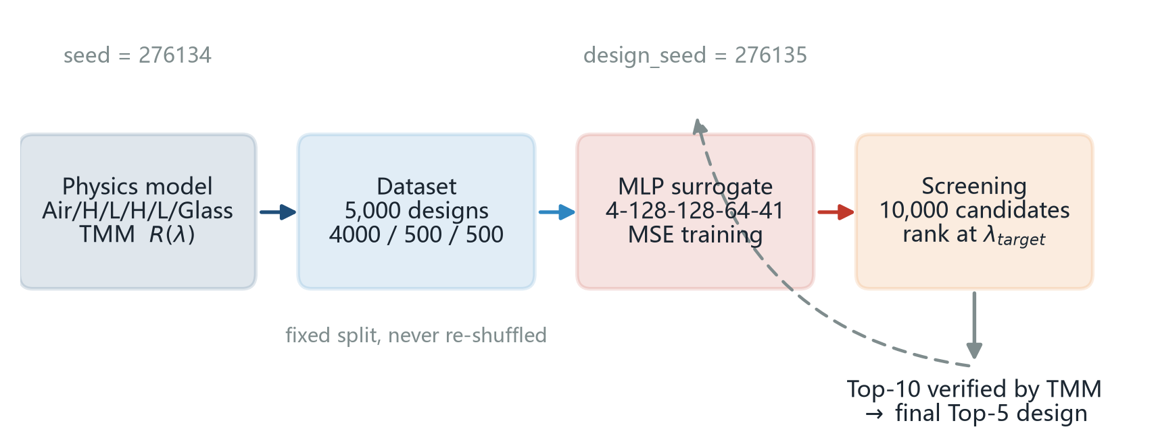
Figure 1. Overall workflow of the AI4S thin-film study. The dataset is generated with seed = 276134; the screening library uses design_seed = 276135 and the final top-5 design is always verified with TMM.

2. Materials and Methods

2.1 Optical model and transfer matrix method
The object of the study is the four-layer stack Air / H / L / H / L / Glass, illuminated at normal incidence by a plane wave. The layers are non-absorbing and non-dispersive with refractive indices n_H = 2.30 (layers 1 and 3) and n_L = 1.45 (layers 2 and 4); the substrate is glass with n_s = 1.52 and the incident medium is air with n_0 = 1.00. The layer thicknesses d_i and the vacuum wavelength λ are measured in nanometres.
The optical phase thickness of layer i is δ_i = 2π n_i d_i / λ. With the optical admittance at normal incidence η_i = n_i, the characteristic matrix of the layer is M_i = [[cos δ_i, i sin δ_i / η_i], [i η_i sin δ_i, cos δ_i]]. The multilayer matrix is the ordered product M = M_1 M_2 M_3 M_4 (light travels from layer 1 towards the substrate), the input admittance is Y = (M_21 + M_22 η_s)/(M_11 + M_12 η_s), and the amplitude reflection coefficient and reflectance are r = (η_0 - Y)/(η_0 + Y) and R = |r|². The implementation (src/tmm.py) evaluates the product layer by layer for whole batches of designs and wavelengths at once. Six unit checks are included in tests/test_tmm.py: a zero-thickness stack reproduces the bare air/glass Fresnel reflectance ((n_0-n_s)/(n_0+n_s))² = 0.0426, a single quarter-wave layer reproduces the analytic value R = ((η_0 - n²/n_s)/(η_0 + n²/n_s))², batched and single-design evaluation agree to 1e-13, and 400 random stacks satisfy 0 <= R <= 1 at all 41 wavelengths. Because the model is lossless, R is used directly as the quantity to be learned.
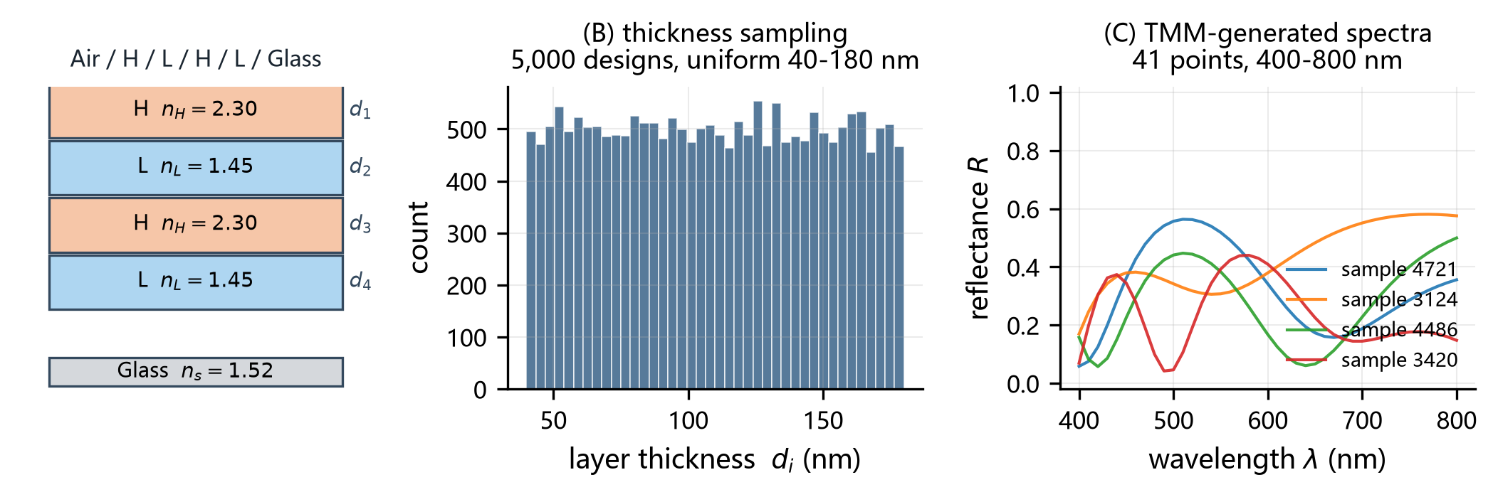
Figure 2. Physical model and TMM-based generation of thickness-spectrum data. (A) the Air/H/L/H/L/Glass stack; (B) distribution of the 20,000 sampled layer thicknesses; (C) four examples of the 5,000 TMM-calculated reflectance spectra.

2.2 Student-specific target wavelength and random seeds
Following the assignment, the personal parameters are derived from the student ID 2020276134. The last two digits are N = 34, so the target wavelength is λ_target = 450 + 10 x (N mod 31) = 480 nm, which corresponds to index 8 of the 41 wavelength samples. The random seed is the integer formed by the last six digits, seed = 276134; it controls the generation of the dataset, the single random permutation that defines the train/validation/test split, and the initialisation of the MLP weights. The design stage uses design_seed = seed + 1 = 276135 so that the candidate structures cannot coincide with the training data. All scripts set the three seeds explicitly (random, numpy and torch) at start-up.
The generated dataset is fingerprinted in results/dataset_fingerprint.json: sha256(thickness) = b01a114170b65a8f..., sha256(spectra) = 55bda16158cadb23..., sha256(split) = 9898a922634fd93b..., with R in [0.0000, 0.6582] and mean R = 0.3017. Re-running src/data.py reproduces these digests, which is how the numerical consistency of the manuscript was checked.

2.3 Dataset generation
5,000 thickness combinations were drawn from a uniform distribution in [40, 180] nm for each of the four layers with seed 276134, and their reflectance was computed with TMM at the 41 wavelengths from 400 to 800 nm in steps of 10 nm. One random permutation of the 5,000 samples, drawn from the same seeded generator immediately after the thicknesses, defines a fixed split of 4,000 training, 500 validation and 500 test samples; the sorted index sets are stored together with the data. This split is used for every experiment in the paper and is never re-shuffled.

2.4 MLP surrogate model
The surrogate is a fully connected network with input dimension 4 (the four layer thicknesses, standardised to [-1, 1] with the fixed constants 110 nm and 70 nm, so that the input scaling does not depend on the training subset), hidden layers 128, 128 and 64 with ReLU activations, and 41 output units, i.e. the architecture 4-128-128-64-41 recommended by the assignment; it has 28,073 trainable parameters. A sigmoid activation is applied to the output because a lossless stack necessarily satisfies 0 <= R <= 1, which makes the network physically bounded by construction. Weights are initialised with He initialisation drawn from the seeded torch generator. The loss is the mean squared error between predicted and TMM-calculated reflectance; training uses Adam with a constant learning rate of 0.001, a batch size of 64 and 2000 epochs, and the minibatch permutation is drawn from a generator seeded with 276134 as well. The weights of the epoch with the lowest validation MSE are kept; training the full model took 83 s on a single CPU core (PyTorch 2.14.0+cpu, 1 thread).
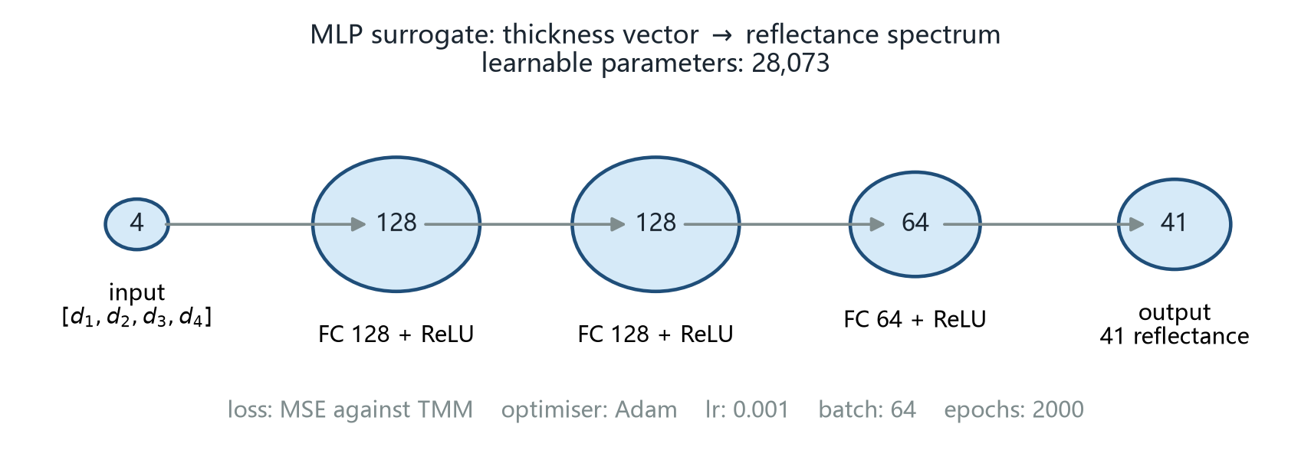
Figure 3. Architecture of the MLP surrogate model (4-128-128-64-41, 28,073 parameters) mapping four layer thicknesses to the 41-point reflectance spectrum.

2.5 Training-size experiment
To isolate the effect of the amount of data, the first 500, 1,000, 2,000 and 4,000 samples of the fixed 4,000-sample training pool were used in turn. Because the pool order is itself the fixed random permutation, the smaller sets are nested subsets of the larger ones. The validation and test sets were never changed, and the seed, architecture, optimiser, learning rate, batch size and number of epochs were identical in the four runs, so any difference in test error is caused by the training-set size alone.

2.6 MLP-assisted thin-film screening
The trained surrogate was used to screen 10,000 new candidate stacks generated with design_seed = 276135 from the same uniform thickness distribution. All candidate spectra were predicted by the MLP, the candidates were ranked by the predicted reflectance at 480 nm, and the ten best were recomputed with TMM. The final ranking is the TMM ranking of those ten candidates, and Table 1 reports the best five. Two quantities are worth separating: the design objective, i.e. R at λ_target, and the agreement between the predicted and the true spectrum of the candidate. Only the second one decides whether the surrogate ranking can be trusted.

3. Results

3.1 MLP training and spectral prediction
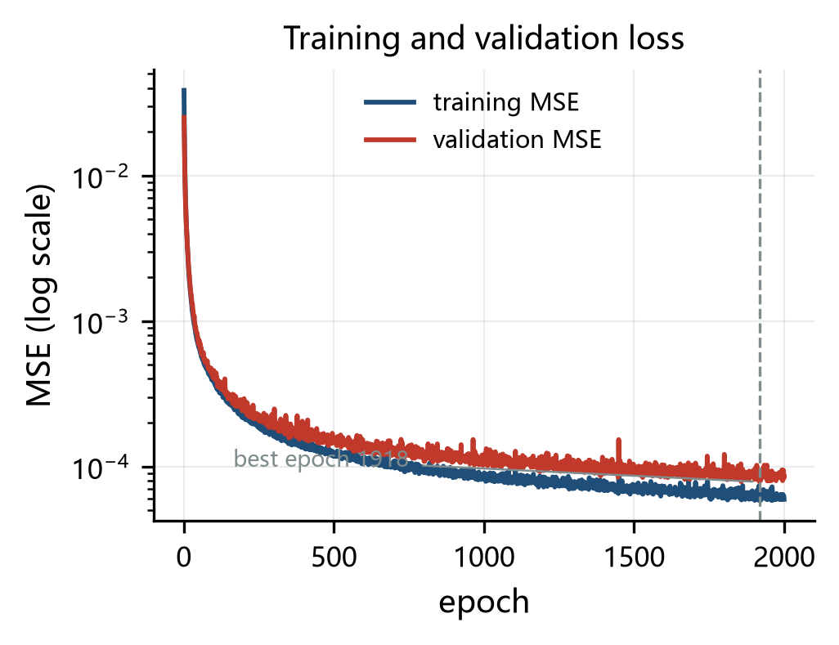
Figure 4. Training and validation losses of the MLP surrogate model.
Figure 4 shows the two loss curves. The training MSE falls from 2.38e-03 at the first epoch to 5.94e-05 at the end of the 2000 epochs, while the validation MSE reaches its minimum 7.83e-05 at epoch 1918 and stays close to the training curve afterwards. The two curves track each other without a visible gap, so the network is not overfitting the 4,000 training samples; the residual error is the approximation error of the surrogate, not memorisation. The kept checkpoint gives a validation MSE of 7.83e-05 (RMSE 0.0089) and a test MSE of 7.93e-05, i.e. RMSE = 0.0089, MAE = 0.0065 and a largest absolute deviation of 0.0712 over all 500 test samples and all 41 wavelengths. Relative to the mean reflectance 0.3017 of the dataset, the test RMSE is 3.0 %. At the personal target wavelength 480 nm the mean absolute error is 0.0078 and the MSE 9.99e-05, slightly better than the spectrum-averaged values.
Figure 5 shows three representative test samples. The MLP reproduces the position and the depth of the interference fringes for all of them; the per-sample MSE of these three samples is 5.6e-05, 6.8e-05, 8.4e-05, i.e. close to the median per-sample MSE of 6.80e-05. The agreement is best where the spectrum is smooth and worst where two nearby thickness combinations produce steep, closely spaced fringes - exactly the regime in which a small thickness change moves a fringe across a sampling interval of 10 nm.
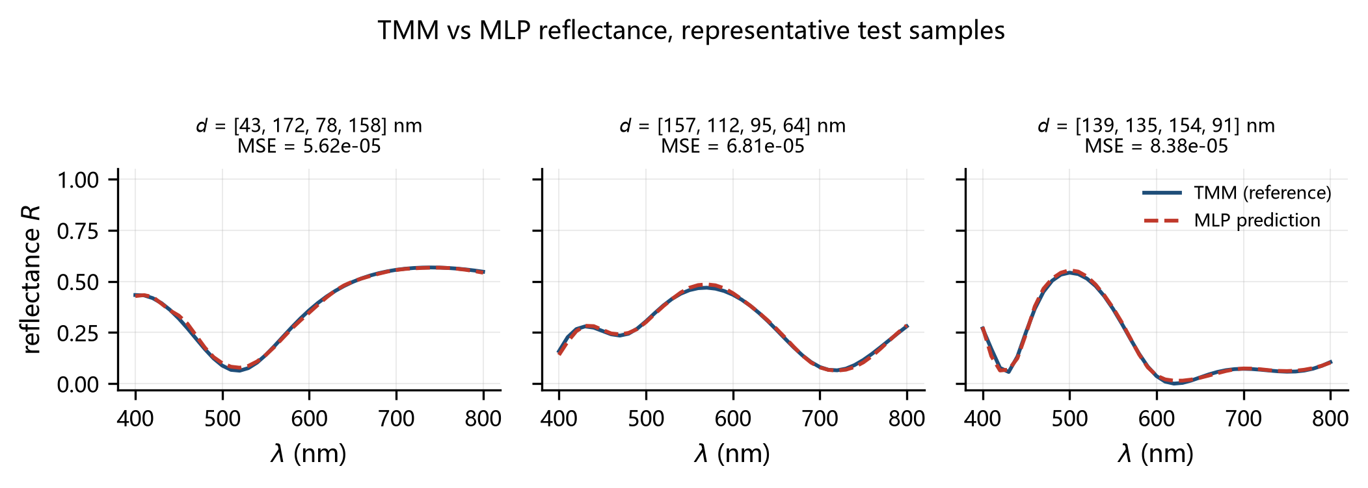
Figure 5. Comparison of TMM-calculated and MLP-predicted spectra on representative test samples. The three designs are close to the median prediction error.

3.2 Effect of training-set size
Train samples | Val MSE | Test MSE | Test RMSE | Test MAE | Best epoch | Time (s)
500 | 8.91e-04 | 8.33e-04 | 0.0289 | 0.0203 | 1837 | 11
1,000 | 3.37e-04 | 2.87e-04 | 0.0169 | 0.0121 | 1971 | 21
2,000 | 1.55e-04 | 1.35e-04 | 0.0116 | 0.0083 | 1938 | 41
4,000 | 7.83e-05 | 7.93e-05 | 0.0089 | 0.0065 | 1918 | 84
Table 2. Effect of the training-set size on the prediction error (500 fixed test samples).
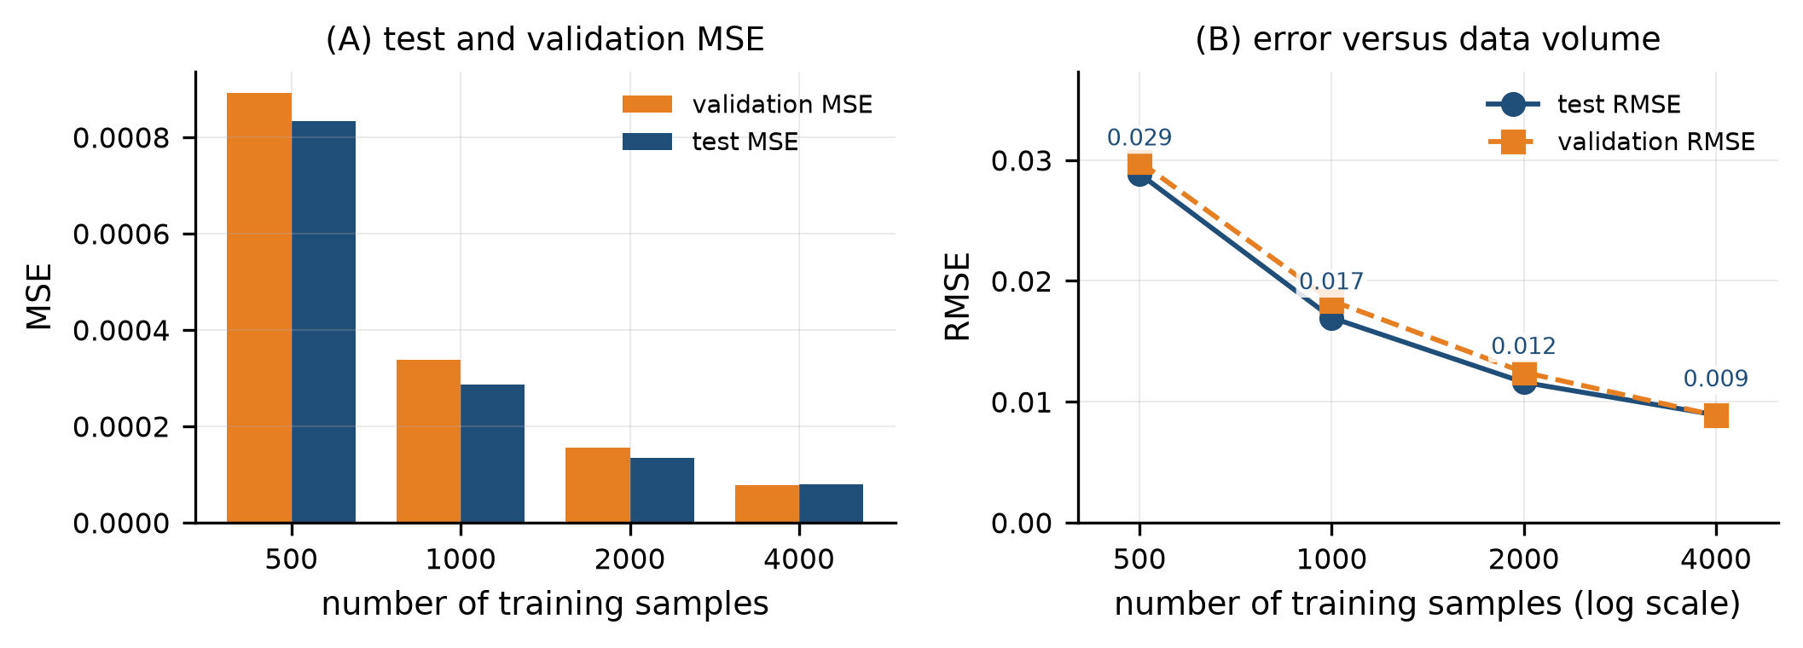
Figure 6. Effect of the training-set size on the test error.
Table 2 and Figure 6 summarise the four runs. The test RMSE decreases monotonically from 0.0289 for 500 training samples to 0.0089 for 4,000 samples, a total reduction of 90 % in MSE. The benefit of each further doubling, however, shrinks steadily: doubling the pool from 500 to 1,000 samples lowers the test MSE by 66 %, from 1,000 to 2,000 by 53 % and from 2,000 to 4,000 by only 41 %. Expressed as RMSE ratios, the three doublings multiply the error by 0.59, 0.68 and 0.77 respectively. The validation and test errors stay within a factor of 1.01 of each other for every training size, which confirms that the fixed validation set is a reliable proxy for the test set. In other words, the model is already data-limited at 500 samples and the returns of adding data decay quickly; a larger model or a better input representation would be needed to exploit 4,000 samples fully.

3.3 MLP-assisted thin-film design
Screening 10,000 candidates took 0.01 s with the surrogate and 0.1 s with TMM on the same machine and the same batch, a speed-up of x13.7. Over the whole candidate pool the surrogate reproduces the TMM spectrum with an MSE of 8.27e-05 (MAE 0.0066); at the target wavelength the mean absolute error is 0.0079 and the largest single error 0.0867. The true (TMM) reflectance at 480 nm over the 10,000 candidates ranges from 0.0001 to 0.6566 with a mean of 0.2994 and a 99.9th percentile of 0.6492, so the designs selected below are in the tail of the distribution.
Figure 7A shows the spectra of the five finalist candidates together with the selected design after TMM verification (the surrogate was used to rank all 10,000 candidates and the Top-10 of that ranking were recomputed with TMM; Figure 7B shows the MLP ranking against the TMM verification for those ten candidates).
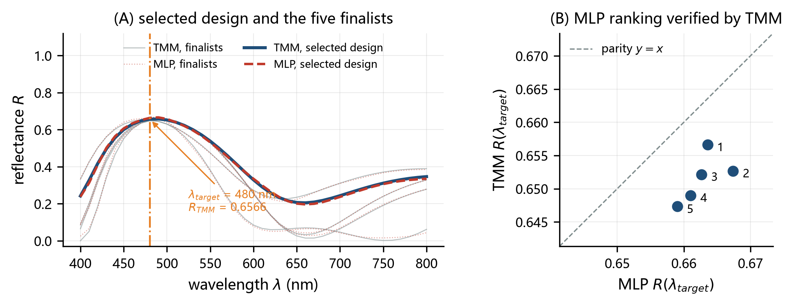
Figure 7. MLP-predicted and TMM-verified spectra of the selected design. (A) the selected design and the five finalist candidates, with the personal target wavelength marked; (B) MLP ranking against the TMM verification for the Top-10 candidates.
Rank | d1 (nm) | d2 (nm) | d3 (nm) | d4 (nm) | MLP R_target | TMM R_target
1 | 51.9 | 86.8 | 158.1 | 77.7 | 0.6636 | 0.6566
2 | 161.5 | 84.9 | 49.7 | 76.1 | 0.6674 | 0.6527
3 | 52.3 | 87.6 | 149.0 | 96.5 | 0.6626 | 0.6522
4 | 155.2 | 95.3 | 51.3 | 86.2 | 0.6610 | 0.6490
5 | 159.3 | 92.8 | 149.1 | 78.1 | 0.6590 | 0.6473
Table 1. Top five candidate thin-film designs selected by the MLP and verified using TMM (λ_target = 480 nm).
The best design found has thicknesses [51.9, 86.8, 158.1, 77.7] nm and reaches a TMM reflectance of 0.6566 at 480 nm; the surrogate predicted 0.6636, an absolute error of only 0.0069. The design beats the 99.9th percentile of the candidate pool (0.6492) and is more than twice the mean reflectance of the pool (0.2994). The re-ranking, however, does change the order: the candidate that the surrogate ranked first (predicted R = 0.6674) ends up 2nd after TMM verification with a true R = 0.6527, whereas the verified winner had been placed 2nd by the MLP. The two candidates differ by only 0.0038 in the predicted reflectance, which is the same order as the surrogate's own error at the target wavelength (0.0079), so the mis-ranking is a direct consequence of the residual prediction error. All five designs in Table 1 were in the surrogate's Top-10, but only 5 of them would have been selected by the raw MLP order, and the corrected Table 1 has to be produced by TMM.

3.4 Representative failure case
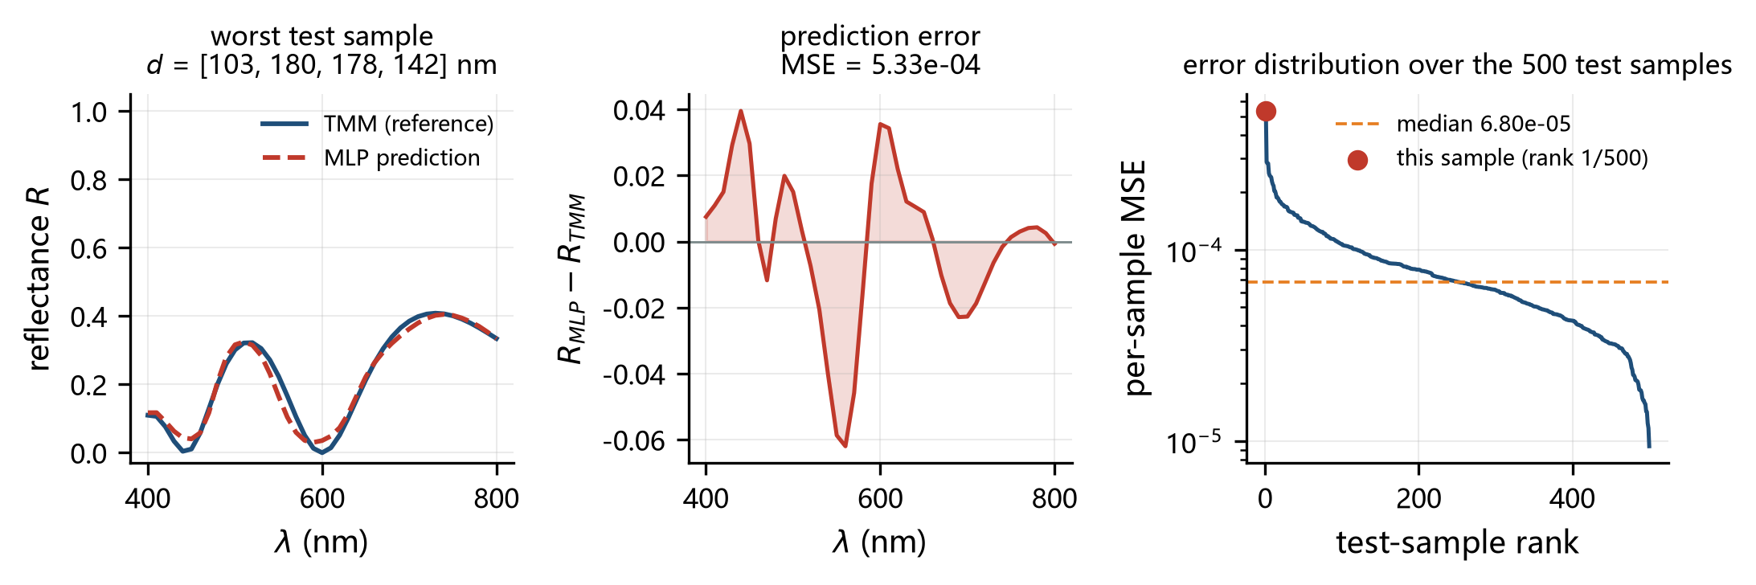
Figure 8. A representative case with relatively large MLP prediction error (rank 1 of the 500 test samples, per-sample MSE 5.33e-04).
The worst of the 500 test samples is shown in Figure 8. Its per-sample MSE is 5.33e-04 (RMSE 0.0231) with a single-wavelength deviation of up to 0.0619 - about 3 times the average test RMSE - for the thicknesses [103.2, 179.8, 178.0, 142.4] nm. Two features of the failure are visible in Figure 8B. First, the error changes sign from one fringe to the next instead of growing with the reflectance itself, which is the signature of a small error in the *position* of the interference fringes rather than of a wrong overall level: the predicted curve is slightly stretched, so it overshoots at some wavelengths and undershoots at neighbouring ones. A shift of the fringe pattern is exactly what a slight mis-estimate of the optical thickness n_i d_i produces, and the four-dimensional input makes this the dominant error mode of the surrogate. Second, the failure is concentrated in the short-wavelength half of the spectrum, where the fringes are sharpest: within the 10 nm sampling interval the reflectance can change by more than 0.05, so the network has to place the extremum to better than one sample. Figure 8C places the sample in the error distribution: the median per-sample MSE is 6.80e-05 and the 95th percentile 1.68e-04, so the worst case is roughly 8 times the median but still within one order of magnitude of it, i.e. the surrogate degrades gracefully rather than failing catastrophically. A denser wavelength sampling would remove part of this error.

4. Discussion
Regarding the first research question, the surrogate reproduces the TMM spectra of unseen designs with a test RMSE of 0.0089, about 3.0 % of the mean reflectance and only 1.4 % of the largest reflectance in the dataset. Figure 5 shows that the residual error is dominated by the placement and the sharpness of the interference fringes rather than by a wrong overall level: the error changes sign from fringe to fringe (section 3.4), which is what a small mis-estimate of the optical thickness n_i d_i produces. Because the mapping thickness -> spectrum is many-to-one in the opposite direction (different stacks can give very similar spectra), part of this residual is irreducible for any deterministic regressor, and an ensemble or a probabilistic output would be needed to go clearly below it.
Regarding the second question, more data help, but with strongly diminishing returns (Figure 6): the error shrinks quickly between 500 and 1,000 samples and then flattens, with the last doubling of the training set buying only 41 % of MSE. This is the expected behaviour of a smooth function approximator: with 500 samples the network cannot cover the four-dimensional thickness cube densely enough, whereas beyond a few thousand samples the error becomes dominated by the architecture and by the optimisation rather than by the data. It also means that for the present problem a practitioner should first improve the model or the input representation (for instance by adding physically motivated features such as the optical thickness n_i d_i) before generating tens of thousands of additional TMM spectra.
Regarding the third question, the surrogate is clearly useful for screening. Ranking 10,000 candidates is x13.7 cheaper with the MLP than with TMM, and the design that survives TMM verification reaches 0.6566 - above the 99.9th percentile of the pool. The surrogate therefore does the part of the work where speed matters (pruning a huge library down to a handful of finalists) and leaves the part where accuracy matters to the physical model. Figure 7B is the quantitative justification: the MLP ranks the ten finalists almost, but not exactly, as TMM does - its own favourite is demoted to second place - and its predicted R_target of the best design differs from the verified value by 0.0069. A design reported on the basis of the surrogate alone would therefore be optimistic and, worse, could name the wrong winner among nearly equivalent candidates; the final numbers in Table 1 must come from TMM. This split of responsibilities - surrogate for search, physics for verification - is the same pattern that is used in the deep-learning-assisted inverse-design literature [4-7].
The study has clear limitations. The optical model is deliberately minimal: no dispersion, no absorption, normal incidence only, and the refractive indices and the number of layers are fixed, so the surrogate learns a four-dimensional map and nothing else. The dataset of 5,000 TMM spectra covers the thickness cube uniformly, but real design problems concentrate on a small region of that cube, where the local data density - and hence the accuracy - would be lower. The failure case in Figure 8 shows the consequence: the surrogate is least reliable exactly for the sharp spectral features that are most interesting for filters. Finally, the MLP was trained with a single seed and a single architecture, so the reported error bars reflect the split rather than the variability of the training procedure; repetitions with different initialisations would be needed to separate the two.

5. Conclusions
A four-layer Air/H/L/H/L/Glass dielectric stack with fixed refractive indices was used to test whether a small MLP can act as a surrogate for the transfer-matrix method. (Q1) Yes: the 4-128-128-64-41 network with 28,073 parameters predicts the 41-point reflectance spectrum of unseen designs with a test RMSE of 0.0089 in reflectance units (3.0 % of the mean reflectance), with a mean absolute error of only 0.0078 at the personal target wavelength 480 nm. (Q2) More training data help but with sharply diminishing returns: the test RMSE drops from 0.0289 at 500 samples to 0.0089 at 4,000 samples, while the last doubling reduces the MSE by only 41 %. (Q3) Yes, with verification: screening 10,000 candidates with the surrogate is x13.7 faster than with TMM, and the selected design reaches a TMM-verified reflectance of 0.6566 at 480 nm, above the 99.9th percentile of the candidate pool, although the final ranking must always be recomputed with the physical model.

Data and Code Availability
The data used in this work were generated using the TMM code developed in this study. All source code, model-training scripts, thin-film screening scripts, environment dependencies, and instructions for reproducing the main results are available at:
https://github.com/Jfzz-KK/123435
The repository reports the student-specific parameters λ_target = 480 nm, seed = 276134 and design_seed = 276135 in its README, together with the commands that regenerate the dataset, train the surrogate, reproduce Figures 1-8 and Table 1, and the sha256 fingerprints of the generated arrays.

References
[1] Macleod, H. A. Thin-Film Optical Filters, 4th ed. CRC Press, Boca Raton, 2010. ISBN 978-1-4200-7302-7.
[2] Born, M., and Wolf, E. Principles of Optics, 7th ed. Cambridge University Press, Cambridge, 1999. ISBN 978-0-521-64222-4.
[3] Byrnes, S. J. Multilayer optical calculations. arXiv:1603.02720, 2016. https://doi.org/10.48550/arXiv.1603.02720
[4] Ma, T., Ma, M., and Guo, L. J. Optical multilayer thin film structure inverse design: From optimization to deep learning. iScience 2025, 28, 112222. https://doi.org/10.1016/j.isci.2025.112222
[5] Liu, D., Tan, Y., Khoram, E., and Yu, Z. Training deep neural networks for the inverse design of nanophotonic structures. ACS Photonics 2018, 5, 1365-1369. https://doi.org/10.1021/acsphotonics.7b01377
[6] Peurifoy, J., Shen, Y., Jing, L., Yang, Y., Cano-Renteria, F., DeLacy, B. G., Joannopoulos, J. D., Tegmark, M., and Soljacic, M. Nanophotonic particle simulation and inverse design using artificial neural networks. Science Advances 2018, 4, eaar4206. https://doi.org/10.1126/sciadv.aar4206
[7] Ma, T., and Guo, L. J. OptoGPT-based design of multilayer thin film structures. Optics Express 2024, 32, 31703-31715. https://doi.org/10.1364/OE.529375
[8] Tikhonravov, A. V., Trubetskov, M. K., and DeBell, G. W. Application of the needle optimization technique to the design of optical coatings. Applied Optics 1996, 35, 5493-5508. https://doi.org/10.1364/AO.35.005493
[9] Martin, S., Rivory, J., and Schoenauer, M. Synthesis of optical multilayer systems using genetic algorithms. Applied Optics 1995, 34, 2247-2254. https://doi.org/10.1364/AO.34.002247
[10] Kingma, D. P., and Ba, J. Adam: A method for stochastic optimization. In 3rd International Conference on Learning Representations (ICLR), San Diego, 2015. arXiv:1412.6980
[11] He, K., Zhang, X., Ren, S., and Sun, J. Delving deep into rectifiers: Surpassing human-level performance on ImageNet classification. In Proceedings of the IEEE International Conference on Computer Vision (ICCV), Santiago, 2015, pp. 1026-1034. https://doi.org/10.1109/ICCV.2015.123
[12] Virtanen, P., Gommers, R., Oliphant, T. E., et al. SciPy 1.0: fundamental algorithms for scientific computing in Python. Nature Methods 2020, 17, 261-272. https://doi.org/10.1038/s41592-019-0686-2

