CSE 201 Project High Level Design Document

## Team Member Names

Patrick Tessmer

John Hoffer

Wei Mao

Yang Sun

## Team Project Title

Bioinformatic Toolkit

### Project Description

The goal of this project is to create a toolkit that takes the functions on several bioinformatic tools already available and to combine them in a single program that is more use friendly than those already in existence. These functionalities are the alignment of DNA RNA and proteins with the users choice of scoring systems or matrices. To create dot Plot representations of the relationship between strands and to preform basic multisequence alignments. All while allowing the user to pull form the NCBI database to make access to information that the user may want to analyze easier.

## Overall Design Description

<Describe the overall design – mention if this is Object Oriented Design or Functional/Procedural design, what components it has (UI, Backend, Front end, Database in backend etc) – use UML diagrams if you want or simple block diagrams>

This Program will be designed in an object oriented manner and contain a UI and a Front end and a back end the program will not be web based but will store saved Jobs.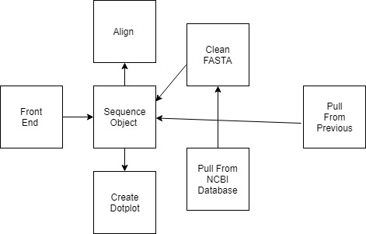

## Class Diagram

Describes The Two no UI Classes of the program.

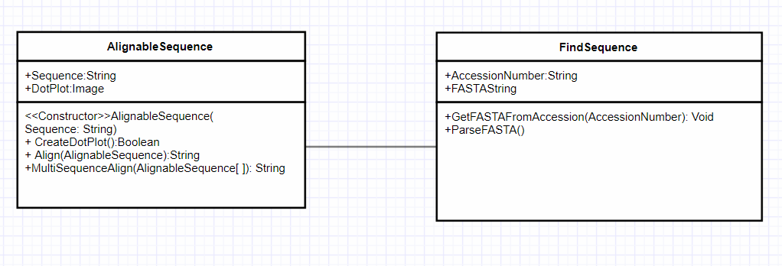

+Save() +SearchSaved()

## Use Case Diagram

Shows the use cases for a User of the Bioinformatic toolkit

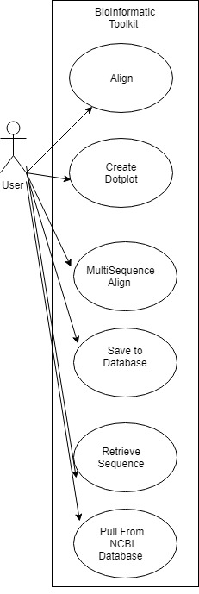

## UML Diagram 2

<Include a short text description of what the UML diagram is showing and then cut and paste your UML diagram here. Use a minimum of 1 class diagram, 2 Use Cases and 2 Sequence diagrams. You are not required to do the OPT and ALT cases in the Sequence diagrams.>

***Repeat the UML Diagram sections as many times as you want to show your UML diagrams.***