NAME: _________________________ AM / PM

Sintel Video

1. What most impressed you about the Sintel video?

The lighting throughout the video was pretty good and adding glare/bloom effects when needed also helped to make it more clean looking but near the end it felt like it was lacking a bit especially when scales was shooting fire from its mouth it looked off but still really great probably tent scene looked the best as you can see the light hitting their face and showing off the details of their hair and wrinkles on their faces.

1. What part of the video did you think needed more polish?

When overlooking the city, the buildings look bizarre from the distance the textures looked really zoomed in.

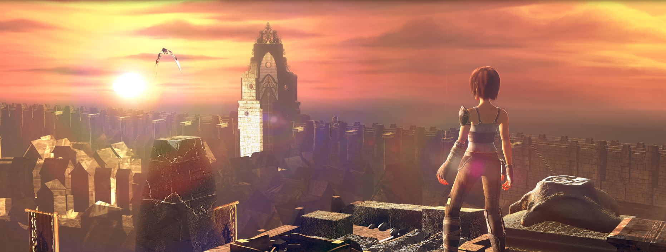

This scene specifically.

1. What models did you see that you felt you could create? Be specific.

The wooden barrels in the town streets.

Why? I just have a feeling as if I made one before.