# Welcome to Mighty Oak Acorn Workbook

## Overview

As part of CSE 170 Technical Teamwork, you will work in teams of 3-4 on four different Acorn projects. This workbook is to assist you in forming those projects.

## Purpose

The purpose of working on projects is to help you better understand the complexity and practicality of the elements you learned in class. You and your team create the projects through careful preparation, guidance by the Spirit, and teamwork using inspiration, collaboration, and innovation.3

## Background

Please read and watch the following information

* <https://www.byui.edu/president/past-presidents/jacob-spori>
* <https://www.byui.edu/devotionals/justin-hodges>

## Requirements

Each project will focus on the Influence model and the Institutional Learning Outcomes.

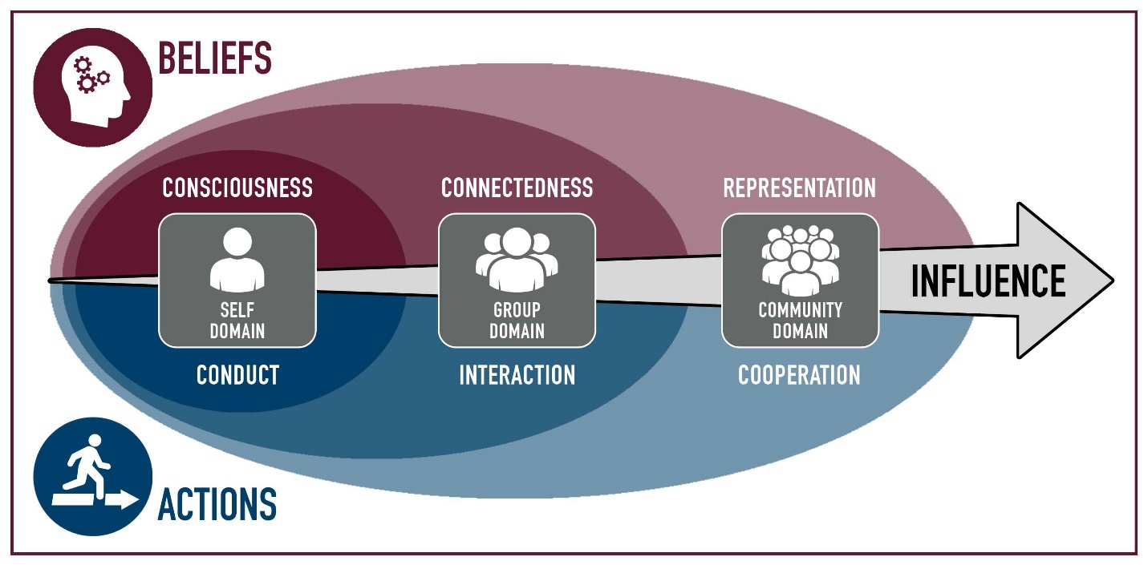

Each project will focus on the Self, the Group, or the Community. Tying in the Belief or Action attributes associated in the Model of Consciousness: Conduct, Connectedness, Interaction, Representation, and Cooperation.

The university has four Institutional Learning Outcomes.

Each of your Acorn Projects will be assigned one of these learning outcomes.

* A Disciple of Jesus Christ
  + We believe in Jesus Christ as the Son of God and strive to follow Him.
* Sound Thinkers
  + We frame and solve problems using creative and critical thinking.
* Effective Communicators
  + We develop and express ideas that are purposeful, organized, and clear
* Skilled Collaborators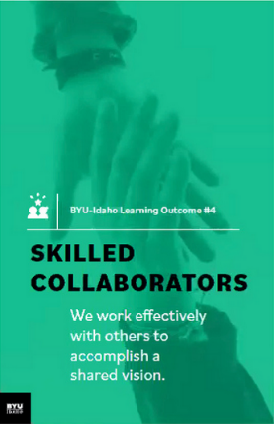
  + We work effectively with others to accomplish a shared vision.

**NOTE: All I.L.O.s need a project.**

# Four Project Breakdown:

A project will consist of the following parts

* List the values associated with the project & a statement of the project vision
* Describe each of your roles
* A statement of your vision of success
* Each project must be a minimum of 10-20 hours.
* The project will have a Specific, Measurable, Achievable, Realistic, Timely Goal.
* Definition of the Goal: Who, What, Where, When, How & Why
* List of Milestone, Achievements, Checkpoints, and Deliverables.

What should you do for your project? That is up to you and your team. You and your team will have to have some brainstorming ideas. Research some ideas, have backup ideas, and work together to synergize to come up with an innovative project.

## Types of Projects

Acorn projects are small; they are smaller than class projects and bigger than individual and team assignments. You work on the Acorn Projects as a team.

Examples of Acorn project:

Rules: You may use one of these examples as is. You may modify another. The other two you must come up with as a team.

* Attend a [Career Services](https://www.byui.edu/career/preparation) event as a team and work on a deliverable
* Participate in “[Get Involved](https://www.byui.edu/get-involved)”: Recreation, Ushering, Get Connected, I-Serve, Peer Mentoring, Rep Council, Tutoring
* Participate in a service project, service information, training that will help other students at BYU-Idaho.
* Create a program together, use a collaborative tool and resource repository.
* Join a Department Society and work together to contribute to a project
* Attend a Society Event such as a Hack-A-Thon, participate as a team
* Participate in a Sport, Sporting Event, or Team activity
* Attend a Leadership conference/activity produced by Student Services
* Participate in an Escape Room, Rope Course, or similar activity
* Discover 4+ campus building activities: for example Geology, Animal, Garden tour, Planetarium
* Plan three group date, with at least 3 activities
* Play 5 different players vs the board, 2-3 times, or an RPG game

# Participation

Each project should be a significant effort. It will require some brainstorming, planning, execution, and reflections.

Each project should for the team be about 10-20 hours cumulative, with multiple sessions. If there are four in a group, this breaks down to 2-4 hours each. I suspect that you will be around 3-5 hours each.

You work together as a team and do not split up the projects individually among yourselves.

# Brainstorming

The following are tools and concepts you should know about brainstorming and managing your team’s project and members. We will be covering each of these throughout the semester in detail and are here for reference and reminders.

* Ownership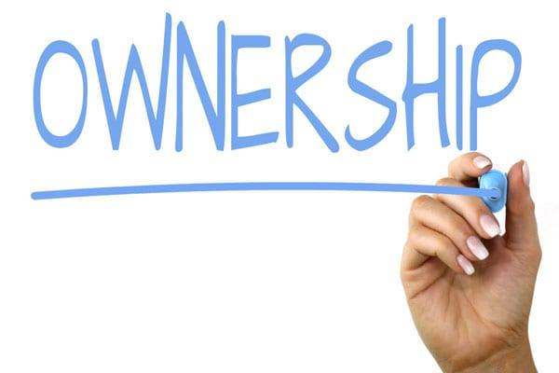
  + Ownership is one of the hardest things to learn. Ownership is taking the goal of the team and making it yours. It goes along with the scripture, “Be One.” You put your whole might, mind, heart, and soul into it.
* Listening
  + Listening is a key element in brainstorming. We have two ears and one mouth. For some reason, our ear does not hear when our mouth is moving and making sounds. Lord intended us to listen twice as much as we talk. If it became a problem, use the tool “the Talking stick,” which the person holding the stick gets to talk about, then pass it along. 
  + “Seek first to understand, then to be understood” – Steven R. Covey
* Brainstorming 
  + This process is where you through ideas on the wall and vote on them. It is best to come prepared with 4-5 ideas, accept other ideas, and be prepared to have your ideas merge with others to be better ideas.
  + A couple of questions to ask to help with the process
    - If you had unlimited finances, what would you do?
    - If you had magic, what would you do?
    - If you had unlimited time, what would you do?
* Problem Solving 
  + We are problem solvers. For thousands of years, your ancestors solved problems. You can solve problems. The problem sometimes is making a choice and committing to it.
  + Steps: Describe the problem, gather information, determine important factors, visualize the solution, create action steps.
* Decision making
  + Do not get stuck in the analysis paralysis loop, which is thinking about a solution and not taking any action. Pick a solution and go with it. A boat never sails if it does not get in the water. 
  + Sort, Rank, and Vote on the solution. And then do it. The change will happen along the way that will make it better.
* Conflict Management
  + Everyone has different experiences and opinions based on those experiences. Everyone has different backgrounds and values-based on those backgrounds. That is ok and is necessary. Without conflict, a boat does not sail, and planes don’t fly. We do not strengthen our muscles, bones, and tendons. Good Conflict Management creates a space where ideas can share, discuss, analyze, poked at, torn apart, and put back together better, without insults, put-downs, or negative feels. 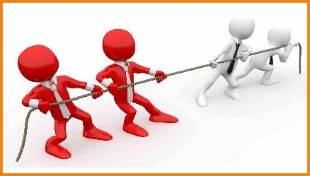
  + “You can empower yourself, but can only encourage others.”
  + Tools: Negotiate with rules and limits, be cooperative, be direct, be aware of yourself and others, establish trust, be open.
* Communication 
  + Oh, communication. Say what you mean. Say what you are going to say, say it, and say what you said. Keeping your thoughts back does not work with brainstorming. Letting everyone participate is also just as important. Being present is also needful. 
    - Form of Communication: Nonverbal, Oral, and Written
    - Blueprint of Communication: Message, Sender, and Receiver
    - Assure good communication: Common ground, Sincerity, Authority (to act, not be acted upon), and clarity.
    - Barriers of Communication: lack of receptiveness and a good environment.
* Coaching and Mentoring 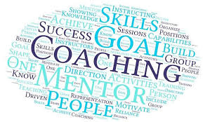
  + Ask for help is necessary. Ask to have some to report to also necessary. You don’t think you need a coach; you can do it on your own. Think again. Every professional has a coach; that is how they got to be a professional—sports, Business, C.E.O., etc.
* Change
  + Things are going to change; plan on it. The first plan never works out. The original idea will not be the final product. Being adaptable is necessary. Ask a carpenter if every cut is exact or is just close enough. Ask an artist if all lines are straight. An Engineer is there no tolerances. Build in the wiggle room. 
    - When change is needed, leading change can make it happen
    - How to lead change: recognize the change, empower others to make the change, base change on value, mission, and vision, establish urgency, move ahead with the unknowns (manage and mitigate the risks, don’t get stuck in analysis paralysis),
* Feedback 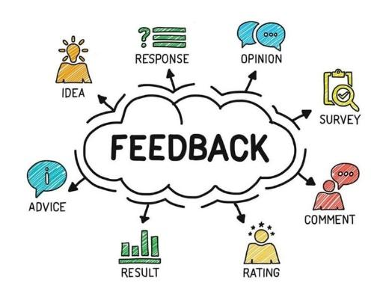
  + You are going to receive feedback. Prepare for it. That is how you learn. Make sure you go in without your eye wide shut, seeing but not seeing. Other perspectives allow you to see what you forgot you saw. Remember, the feedback is not you. It is reality. It is you being looked at through someone else’s eyes and mind, repeated back to you through your eyes and mind. It is like taking a photograph, making a drawing of it, and then you are describing what you saw from the drawing. Receiving feedback is like receiving the word at the end of the play, the game Telestrations.
  + “Consider feedback to be a gift. It truly is.”

# Acorn Project Worksheet Explanation

Record the summary of your brainstorming activities.

## Project Influence

Pick one of the following:

* Self
  + □Belief: Consciousness
  + □Actions: Conduct
* Group
  + □Belief: Connectedness
  + □Action: Interaction
* Community
  + □Belief: Representation
  + □Action: Cooperation

Explain how this project will Influence you, your team/group, or the community.

## Project Mission Focus:

Identify 1 of the following for this Project Goal. Must have one project goal for each I.L.O. 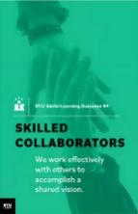

* □Disciple of Jesus Christ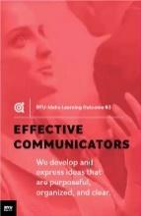
* □Sound Thinkers
* □Effective Communicators
* □Skilled Collaborators

## Personal Values

Values are our core beliefs or desires that guide or motivate our attitudes and actions. List your values and the forms that they take; principles, standards, personal qualities, character traits, or ethics codes.

## Vision Statement

A vision is a picture of future success. Our vision is when we think far enough to realize that there will be challenges for which we can prepare.

## S.M.A.R.T. Goals

*“A Goal Without a Deadline is Only a Dream!”*

Define your Acorn project as a “SMART” (**S**pecific, **M**easurable, **A**ttainable, **R**elevant, and **T**imely) goal.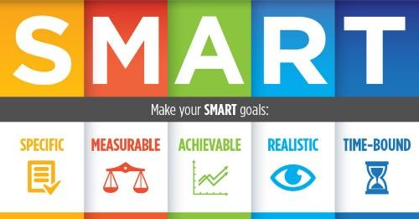

* **Specific** - Describe this Acorn Project Goal in enough detail so that you, your teammates, and the instructor know specifically what you are going to do, how it is important, or how it will impact you. Is it challenging?
* **Measurable** - Describe how this Acorn Project Goal is Measurable**.** How will you know when the goal is completed? What is your exit strategy? What are the milestones?
* **Attainable** - Describe how this Acorn Project Goal is Attainable**.** Can it be accomplished? You have 10-12 weeks to complete the project with four people.
* **Relevant** – Describe how this Acorn Project Goal is Relevant. How does it relate to BYU-Idaho I.L.O.s? How will it help grow your Acorn into a might oak?
* **Timely** - Describe how this Acorn Project Goal is Timely**.** Can it be accomplished in a reasonable amount of time? Ten cumulative hrs. minimum per project

Re-write the SMART goal as a single sentence.

## Milestones

It takes more than one step to complete goals. List up to 10-12 milestones, achievements, checkpoints, or deliverables for your goal. Following the network of high-level objectives, break down each objective into separate activities necessary to accomplish it. Order and prioritize the activities by the longest and plan.

# Approval of Project

You will submit your projects for review & approval to your instructor. Expect a week for feedback. You can continue as if it was approved; meanwhile, your instructor will give you additional tasks and ideas to improve the projects. Submit a final revision with changes for approval. 

# Bi-Weekly Status of Project Update Software Concept. Upgrade System Icon. Application Status.. Royalty Free Cliparts, Vectors, And Stock Illustration. Image 126610927.

As mentioned in the brainstorming, you will have changes, conflicts, decision making. Change is normal. Each week you need to meet with your team to discuss the progress of your Acorn Projects. You can complete them in sequence or parallel.

You will be required to provide the status of your Acorn projects every other week. You will need to indicate the **percentage done**.

# Stages of Team Development

As you move with your Acorn project, you and your team will hit some challenges and accomplish some breakthroughs. Here is a guide to let you know what you will face as your team pulls together. It is expected that each goal has multiple sessions/milestones, to show these phases.

The first stage in a team’s development is **Forming** (“Pickup Sticks,” “Polite”).

Most team members are eager to be on the team. However, they often come with high, unrealistic expectations. These expectations come with some anxiety about how they will fit in, how much they can trust others, and how much time to set aside. Team members are also unclear about norms, roles, goals, and timelines. In this stage, there is a high dependence on the leading figure for purpose and direction. Behavior is usually tentative and polite. The major issues are personal well-being, acceptance, and trust.



The second stage in a team’s development is **Storming** (“At Odds,” “Testing”).

As the team gets some experience working together under their belt, there is a dip in morale as team members experience discrepancies between their initial expectations and reality. The difficulties in accomplishing the task and working together lead to confusion and frustration, and growing dissatisfaction. Negative reactions to each other develop, and subgroups form, which polarize the team. The breakdown of communication and the inability to problem-solve result in lowered trust. The primary issues in this stage concern power. Control and conflict.

The third stage in a team’s development is **Norming** (“Coming Around,” “Valuing”).

As the issues encountered in the second stage are addressed and resolved, morale begins to rise. Task accomplishment and technical skills increase, contributing to a positive, even euphoric feeling—clarity and commitment increase on purpose, values, norms, roles, and goals. Trust and cohesion grow as communication becomes more open and task-oriented. There is a willingness to share responsibility and control. Team members value the differences among themselves. The team starts thinking in terms of “we” rather than “1.1! Because the newly developed feelings of trust and cohesion are fragile, team members avoid conflict for fear of losing the positive climate. This reluctance to deal with conflict can slow progress and lead to less effective decisions. Issues at this stage concern the sharing of control and avoidance of conflict.

The fourth stage in a team’s development is **Performing** (“As One,” “Trusting”).

At this stage, both productivity and morale are high, and they reinforce one another. There is a sense of pride and excitement in being part of a high-performing team. The primary focus is on performance. The purpose of roles and goals are clear. Standards are high, and there is a commitment to meeting standards and continuous improvement. Team members are confident in their ability to perform and overcome obstacles. They are proud of their work and enjoy working together. Communication is open, and leadership is shared. Mutual respect and trust are the norms. Issues include continued refinements and growth. 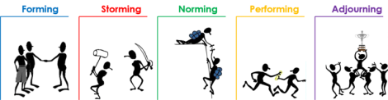

## Pushing Through

As mentioned in the brainstorming, you will have changes, conflicts, decision-making. Each week you need to meet with your team to discuss the progress of your Acorn Projects. You can complete them in sequence or parallel. 

You will be required to provide the status of your Acorn projects every other week. You will need to indicate the **percentage done**.

## The finish line

No runner stops exactly at the finish line; No athlete walks straight to the car and goes home; No engineer throws away all the equipment after an experiment. After camping, what do you keep and what do you throw away. There is clean up, reflection, lessons learned, and preparing to do it again. 

You will need to complete the following for each Acorn:

1. Presentation
   1. Your team will be required to present a 3-5 minute briefing of your Acorn Project to the class.
2. Lessons Learned
   1. You need to reflect on the vision and goal of the project. Think if you were to do each of the projects again, how would you do better. What advice would you give someone?
   2. You need to have at least two lessons learned for each of the 4 Acorn Projects.
   3. Also, additional lesson learned on your team dynamics.
3. S.T.A.R
   1. Write up a summary of your experience in the following format
      1. S. Situation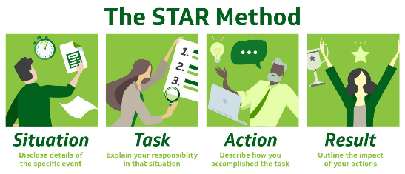
      2. T. Task
      3. A. Achievement
      4. R. Results
4. Participation
   1. Each of you will provide a report on how you participated and
   2. Each of you will report on how each member of the team participated.
   3. As a team, you will determine how many hours you spend on each project.
5. Stop, Start, and Continue
   1. As a team and as an individual, you need to reflect on three things:
      * Stop: List an item that your team and yourself that you need to stop doing that hindered the team and project.
      * Start: List an item that would improve and innovate the project.
      * Continue: List items that went well and is necessary for the success of the project
   * Complete Stop, Start, and Continue for each of your projects.

# Presentation of Acorns Ceremony

On the Last of Class, we will have a ceremony where I will present you with four Acorns, one for each project that you completed.



## Other Resources

* <https://www.byui.edu/mighty-oaks>

**Acorn Project Worksheet**

**Project Mission Focus:** Sound Thinkers

* **Team Name: “Team 6” (we are actually team 7, lol)**
* **Team member’s Names: Dolores, Joanna, and Jacob**
* **Project Title:** D&D with Joanna’s brother Matthew
* **Project Influences: Group, Connectedness and Interaction**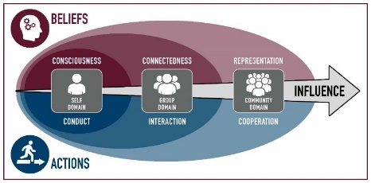

|  |  |  |
| --- | --- | --- |
|  | **Belief** | **Actions** |
| **Self** | □Consciousness | □Conduct |
| **Group** | □Connectedness | □Interaction |
| **Community** | □Representation | □Cooperation |

* **Explain: This project will help us better get to know each other and how we work together as a team. Knowing this will help us grow together in understanding through our strengths and weaknesses, and how to better implement our skills in the future.**
* **Project Values:**

**We hope that by playing D&D, we will be able to foster friendship and collaboration via teamwork while critically thinking our way through our journey to success.**

* **Description:**

**Joanna's brother will join us through Zoom to teach us how to play Dungeons and Dragons, as this will be our first time socializing outside of the classroom, it will help us become more united as a team.**

* **Vision Statement:**

**Our vision for success is to take advantage of the time we meet online to play a session and to climb over any obstacle that comes our way. We will all share the same goal in order to complete the campaign, which is why we will be able to succeed in this task.**

* **SMART Goal:**
  + Specific: Learn how to play D&D. It is important to establish our teamwork through learning how to play D&D together as a group.
  + Measurable: We will be playing twice a week for 2 hours. Our goal is complete once we beat the campaign.
  + Attainable: Due to our busy schedules, we will be meeting over zoom at the same time twice a week, which will be convenient for us to stay on track until we beat the campaign.
  + Relevant: It is relevant because we want to get to know each other in a fun and engaging way that will help us understand ourselves and each other, which in turn will benefit our teamwork for our other projects.
  + Timely: Because of how flexible we can be over zoom, we can easily manage our time while playing D&D. My brother will be the DM, guiding us through the story in a way that gets us to our goal in a timely manner. We also intend to stay true to the plot and concentrate on the task at hand in order to achieve maximum success.

***Summary***:



* **Audience (*Who, What, Where, When, Why, How*):**

Team 6 participating with Joanna’s brother Matthew as the DM.

We will be doing it over zoom every Sunday afternoon.

* **Roles and Responsibilities:**

**Role Responsibilities**

* + **1: Dolores: Time keeper**
  + **2: Joanna: Leader**
  + **3: Jacob: Coordinator**
  + **N:**
* **Milestones**
  + 1. Character introductions
  + 2. Establish our quest
  + 3. First established quest
  + 4. Beating our first enemy
  + 5. Complete quest
* **Instructor Improvements Suggestions**:
  + _________________________________________________________
  + __________________________________________________________

[ ] **Approved** Date: __________________

**Acorn Project Worksheet**

**Project Mission Focus:** A Disciple of Jesus Christ

* **Team Name: “Team 6”**
* **Team member’s Names: Dolores, Joanna, and Jacob**
* **Project Title:** DevoAmigo
* **Project Influences: Self, Consciousness, Conduct.**

|  |  |  |
| --- | --- | --- |
|  | **Belief** | **Actions** |
| **Self** | □Consciousness | □Conduct |
| **Group** | □Connectedness | □Interaction |
| **Community** | □Representation | □Cooperation |

**Explain:**

By attendingthe devotional every Tuesday, We will be able to conduct ourselves according to the time we set aside to gather and listen together, and to build upon our testimony as a team via spiritual messages.

* **Project Values:**

We believe that as we diligently attend the devotionals, we will be able to grow spiritually as a group, which in turn will keep us on the right track as we perform our tasks according to the values of being a disciple of Christ.

* **Description:**

We will be meeting every Tuesday to listen and study the messages given by the speakers as a team. After every devotional, we will sit down and have a discussion about what each of us learned, while also comparing notes, ideas and any insights that come into mind as a way to help keep the spirit with us each week.

* **Vision Statement:**

We intend to gain experience with keeping to a regular schedule so that we'll be disciplined in sticking to the one-hour meeting time we establish for ourselves each week. We are confident that we will be able to meet this objective if we work hard every Tuesday to prepare for the spiritual lessons that will only serve to lead us in the weeks to come.

* **SMART Goal:**
  + Specific: We will be attending the Tuesday devotionals as a team for the rest of the semester. It is important to stay engaged as a team by committing the time that we set for ourselves to attend.
  + Measurable: We will be able to measure our time weekly as we attend the devotional every week.
  + Attainable: We can accomplish this because we will be keeping our schedules open during the time that we need to attend.
  + Relevant: We will be able to grow spiritually together and grow as a team as we keep ourselves on this timely schedule. We will make sure that we attend every week, and we will also feel more engaged as a group as we work to meet each other every Tuesday.
  + Timely: We will be setting aside 1 hour every week in order to attend the devotional.

***Summary***:

* **Audience (*Who, What, Where, When, Why, How*):**

We will be going to every weekly devotional as team 6. We aim to be a part of the community by participating and supporting the speakers who took the time to bring us their message.

* **Roles and Responsibilities:**

**Role Responsibilities**

* + **1: Joanna: Note taker**
  + **2: Dolores: Photographer**
  + **3: Jacob: Coordinator**
  + **N:**
* **Milestones**
  + 1. Go together for the first time to devotional
  + 2. Go together for 3 weeks.
  + 3. Go together for 5 weeks/Quiz each other on what we learned so far.
  + 4. Go together and invite one friend.
  + 5. Go by ourselves with other friends.
* **Instructor Improvements Suggestions**:
  + _________________________________________________________
  + __________________________________________________________

[ ] **Approved** Date: __________________

**Acorn Project Worksheet**

**Project Mission Focus:** Effective Communicators

* **Team Name: “Team 6”**
* **Team member’s Names: Dolores, Joanna, and Jacob**
* **Project Title:** Presentation Website 
* **Project Influences: Group, Connectedness, Cooperation**

|  |  |  |
| --- | --- | --- |
|  | **Belief** | **Actions** |
| **Self** | □Consciousness | □Conduct |
| **Group** | □Connectedness | □Interaction |
| **Community** | □Representation | □Cooperation |

**Explain:** We will be creating a website that will showcase our three projects, including this one, which will help us keep track of our progress and keep us motivated as a team.

* **Project Values:**

We'll be collaborating on the presentations of our four projects. It will serve to keep us motivated while also inspiring us to strive for the completion of our work and establish comradery. We hope to learn more skills when it comes to web design, and as a way to study wdd130 together in order to help each other work through the class and this project as a team.

* **Description:**

We will gather together at the end of every week to work on our website to present an overview of our projects, and to also get the final presentation done. The website’s purpose is to catalog each project we worked to complete. For example, the website will contain information about our D&D campaign, its story and how we managed to complete the campaign as a team. We will also have a photo gallery of each week we attend the devotional and a brief summary about what we learned. Overall, the website will have organized links that will take the user to each of our projects, and will have information about how we completed each project step by step as a team.

This website will be in of itself a project because we will have worked hard to keep everything organized and all of our goals cataloged within it and completed while also writing about our experience creating the website within the website. Also, CSS is a pain for us beginners, and we will work hard to make our project presentation website look good by adding color, images and a welcoming layout.

* **Vision Statement:**

We will be polishing our html/CSS skills by coding this entire website ourselves. it may not be perfect, but we will strive for the best outcome and go beyond our capabilities as an opportunity to improve on our skills.

* **SMART Goal:**
  + Specific: Create a website presentation of our projects and keep track of our progress every week by doing so.
  + Measurable: We will be meeting for an hour or two each week to work on this code.
  + Attainable: We will use this time to practice and polish our weak spots in html. It is something we can attain because we are capable of learning more about this skill.
  + Relevant: It will help us become better at coding and actually do some team work on coding ;)

We are all new to coding, which is why we wanted to do this project in order to better ourselves.

* + Timely: We will be able to keep track of our time through Zoom and make sure everyone meets during a time when we are free and able to work on it together.
  + ***Summary***:
* **Audience (*Who, What, Where, When, Why, How*):**

Our audience is us and those we want to show the website, to inspire success through our accomplishments.

* **Roles and Responsibilities:**

**Role Responsibilities**

* + **1: Joanna: CSS**
  + **2: Dolores: Wireframe**
  + **3: Jacob: HTML**
  + **N:**
* **Milestones**
  + 1. Wireframes
  + 2. Adding HTML
  + 3. Adding CSS
  + 4. Perfecting our website
  + 5. show it to people
* **Instructor Improvements Suggestions**:
  + _________________________________________________________
  + __________________________________________________________

[ ] **Approved** Date: __________________

**Acorn Project Worksheet**

**Project Mission Focus:** Skill Collaborators

* **Team Name: “Team 6”**
* **Team member’s Names: Dolores, Joanna, and Jacob**
* **Project Title:** Stop N’ Serve
* **Project Influences: Group, Connectedness, Interaction**

|  |  |  |
| --- | --- | --- |
|  | **Belief** | **Actions** |
| **Self** | □Consciousness | □Conduct |
| **Group** | □Connectedness | □Interaction |
| **Community** | □Representation | □Cooperation |

**Explain:** The MC is where we will meet to help give our services to the stop N’ serve. We hope to connect with others in a meaningful way, and to show how capable we can be as a team when working with other people.

* **Project Values:** We value helping people in our community and hope to put our teamwork skills to use for the betterment of others.
* **Description:** We will go on Tuesdays from 9-10 am to give our hands for serving in whatever way is needed. We will stop by at the activities and involvement center (MC 101) and ask for things to do.
* **Vision Statement:** We desire to aid others, and get a good grade, and we’ll combine both, making a win-win situation.
* **SMART Goal:**
  + Specific: We will be helping people every week at the MC.
  + Measurable: We will be measuring our time there and what we can accomplish in an hour before our classes start for the day.
  + Attainable: We are able to stop and serve at the MC every morning, which works well for our schedules.
  + Relevant: It is always relevant to serve others whenever we can.
  + Timely: We will be able to serve an hour every Tuesday morning right before the devotional and our classes.

***Summary***:

We will go to the Stop N’ Serve on campus and give our time, and talents to help our school, community, and other students through service.

* **Audience (*Who, What, Where, When, Why, How*):**

We will be going together to the Manwaring Center 101 room, every Tuesday from 9-10 am. We will ask for service to do, get ideas of future big service opportunities we can do together, to be able to help our community, and school in any way we came by offering our talents and time to serve.

* **Roles and Responsibilities:**

**Role Responsibilities**

* + **1: Joanna: Coordinator**
  + **2: Dolores: Service Searcher**
  + **3: Jacob: Time keeper**
  + **N:**
* **Milestones**
  + 1. Go and look for activities we can sign up for the future + do a service
  + 2. Go and Serve for an hour
  + 3. Go to a plan service
  + 4. Go and serve for an hour
  + 5. Bring people to come serve with us for an hour
  + **Instructor Improvements Suggestions**:
  + _________________________________________________________
  + __________________________________________________________

[ ] **Approved** Date: __________________