Where Are You?

* **Health**

Health is combining food, exercise, positivity, hygiene, and relaxation, so we can ensure that our body and mind are in good shape.

* **Work**

Work includes jobs, family life, pets, studying, and everything else that demands effort. Work is something that gives us duties, make life simpler, and has the potential to improve our lives.

* **Play**

Every day, we require at least a little amount of downtime to help us recharge. Play is what provides us personal satisfaction and allows us to take breaks from our job and home lives.

* **Love**

Love may be defined as any positive relationship between two or more individuals, including pets. Health, productivity, motivation, and enjoyment are all advantages of love.

* **Action**

**Define**

1. I am great at balancing my health and knowing what I should eat over what I shouldn’t. I exercise as often as I can which has overall helped my positivity greatly.
2. Overall, my job experience has been great. I know when and how to complete tasks, and I am currently prioritizing my study time properly.
3. Every day, I must play in order to rejuvenate. When I get up in the morning, I use a small amount of time to watch TV or play video games to help me be more productive the next day.
4. Back home, I have a supportive community in my church, a loving family, and a plenty of pets. I make an effort to build positive connections with everyone I encounter, and this has really boosted my self-confidence.

**Measurement**

**Health:** Full

**Work:** 1/4

**Play:** full

**Love:** 1/2

**Analysis**

If I had to improve on any of these categories, it would be love. I love my family, friends and my church, but I don’t try to connect with people as often as I should.

**Summary**

The issue I have is definitely my circle of influence. I avoided people when I was younger and I want to strive to fix that, and already I have been doing a lot better and would love to keep working on my positive connections with other people.

Compass

Workview and Lifeview

**Workview Reflection**

I used to think work was just a way to get through life and make money, which was a draining thought for me when I was younger, and the issue of workview is believing that we will never enjoy our work. It wasn’t until I started working that I realized just how accomplishing any job can feel when I strive to do my best. I enjoy the challenges that work can bring, and see it as an opportunity to grow. With this new positive mindset, I view work as a way to contribute to those around me and my own life.

**Why work?**

To better our lives and find purpose in order to prepare for our uncertain futures.

**What does work mean?**

Work means we do our best to accomplish something difficult, and by doing so, we will be able to gain experience that will benefit our lives.

**What does money have to do with it?**

Money isn’t always involved when we work, but when it is, we are given something that we earned through our efforts. Money through work gives security, wellness and plenty of opportunities.

**Lifeview Reflection**

Lifeview is how we perceive life as a whole and our purpose and place within it. Some have already found their purpose early in life, and others are still trying to figure it out. My whole life revolves around my family, which has given me the purpose needed to further my goals. I value life and the wellness of my family and I understand that even after they are gone, I will have no regrets in my life, because I understand that the person I am working to be is someone who lived to help my family and those around me.

**What is the meaning or purpose of life?**

The purpose of life is to gain as much experience and knowledge that we can. Doing so will not only help us in the next life, but it can also benefit the lives of those who have yet to come to earth who need our experience in order to learn from our mistakes and accomplishments.

**Where do family, country, and the rest of the world fit in?**

We are all striving for a higher purpose in life, therefore, a lot of us have similar goals, and even those who don’t share the same goals still have to endure the hardships of life as everyone else. We are still different, and through our differences we can work together to make our lives easier.

**Is there a higher power, God, or something transcendent, and if so, what impact does this have on your life?**

God plays a huge purpose in my life by giving me knowledge of myself, where I came from and who I am striving to be. Without this knowledge, I would not be here studying at BYU-I in order to further my progression.

Mind map

**Good time journal**

**Activities that kept me energized**

1. Practicing piano
2. Playing video games
3. Going out to eat with friends
4. Movies
5. Writing music
6. Sketching
7. visiting family
8. Sleep
9. Eating
10. Board games

**Activities that do not energize me**

1. Studying
2. Cleaning
3. Cooking
4. Long board games
5. Sports
6. Too much socializing
7. Reading
8. Too much of anything
9. Walking to class
10. Dishes

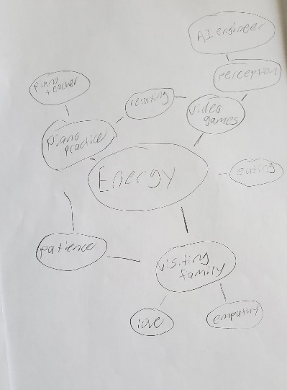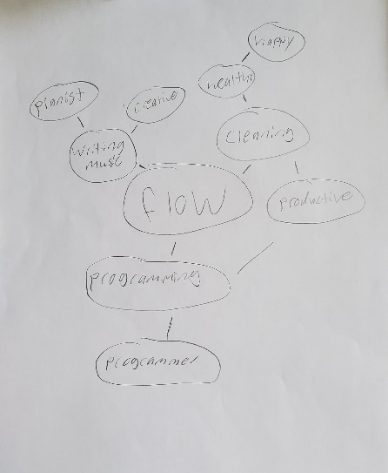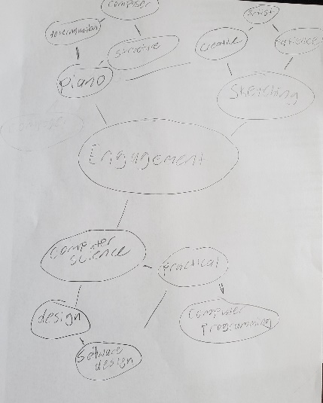

**Odyssey Plan 1**

**My current plan for my future**

**Year 0:** I want to study and save as much money as I can for the next semester.

**Year 1:** To find what it is I want to do for a career and work hard to graduate in that field.

**Year 2-5:** My five-year goal is to graduate and find a career

**Questions this plan addresses:** This plan will help keep me open minded when it comes to finding a career, and it will help me stay on track in my studies as I work to attain a higher education.

**Odyssey Plan 2**

**My secondary plan for my future**

**Year 0:** Continue to practice piano for a future as a musician.

**Year 1:** Go into studying music in collage to better my skill.

**Year 2-5:** To have a job playing piano as a living.

**Questions this plan addresses:** This plan is what I will fall back on if I am unable to find what it is that I want to do in computer science. It is realistic because I have a lot of experience playing piano, and working to become a piano teacher and composer fits my goals and overall morals when it comes to helping those around me.

**Odyssey Plan 3**

**My third plan for my future**

**Year 0:** Work with my cousin who is an artist to strive for a career in art.

**Year 1:** Make money from my art as I work to graduate.

**Year 2-5:** To work as an artist full time.

**Questions this plan addresses:** I love the creativity of art, and becoming an artist will help me address my abilities to express my passion.