W09 Challenge Proposals

Colutyma Productions

Purpose

The purpose of this website is to showcase the films Colutyma Productions has made. It will be an archive of each film, genre, the actors involved, and rating. It will be a place where users can learn about the movies made by Colutyma Productions, and it will give fans the opportunity to send feedback and donations so the producers can continue to better their cinematography and writing skills.

* 1. Audience

The audience for the Colutyma Productions website are film enthusiasts who want to support the amateur film industry. This website will provide an easy way for users to donate and keep up to date with the latest Colutyma films and the actors involved. Users will also be contributing to the feedback needed for the team at Colutyma Productions to improve.

* 1. Data sources
     + External API

I’ll be using The Movie Database (TMDB) API to show several random movies that have a similar genre to the Colutyma film that the user is interested in buying.

* + - localStorage

LocalStorage will be used to store the information of the user’s movie purchase to the donation page. All movies are free with optional donations.

* + - local JSON file.

I’ll have a local JSON file that stores all the information about the Colutyma films. I am also thinking about having another JSON file that will store all the anonymous feedback from users, which will be used to display the overall score of the film.

* 1. Initial Module list

donation.js

movieList.js

actorList.js

search.js

reviews.js

movieData.js

characterPopup.js

headerFooter.js

menu.js

randomMovie.js

* 1. Wireframes for each view of your application

Notes:

Ignore the signup link on the navigation. It will be the link to the donations page. And If I don’t have time, I may not do the upcoming projects page.

I forgot to add the three random movies from the TMDB API on the Movie information page. Underneath the actors, three movies from the TMDB API that are of a similar genre will display so the user knows what kind of movie to expect when ordering a Colutyma film.

Titles, labels, and the layout will most likely change as I work on this project.

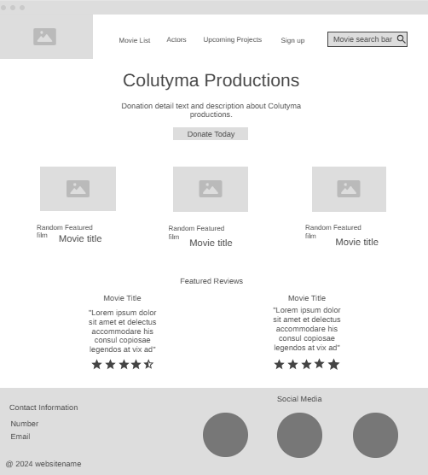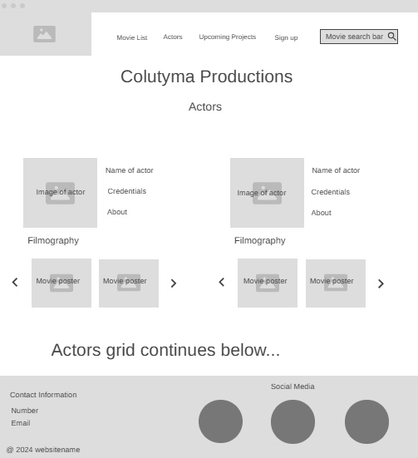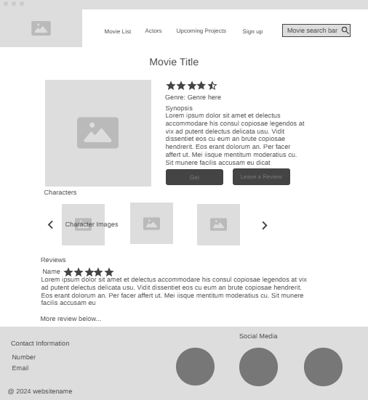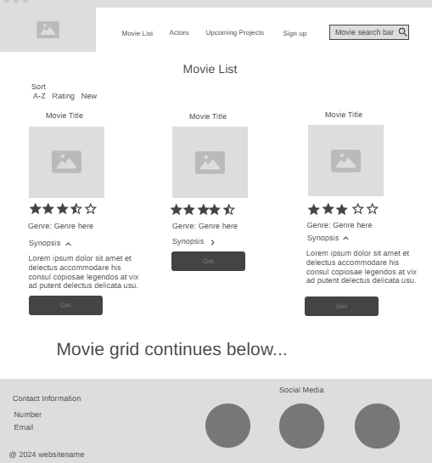

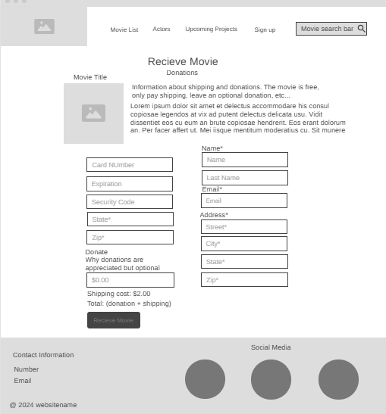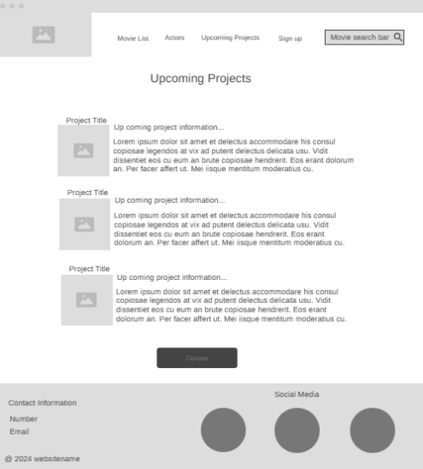

* 1. Colors/Typography/specific Element styling
* Colors

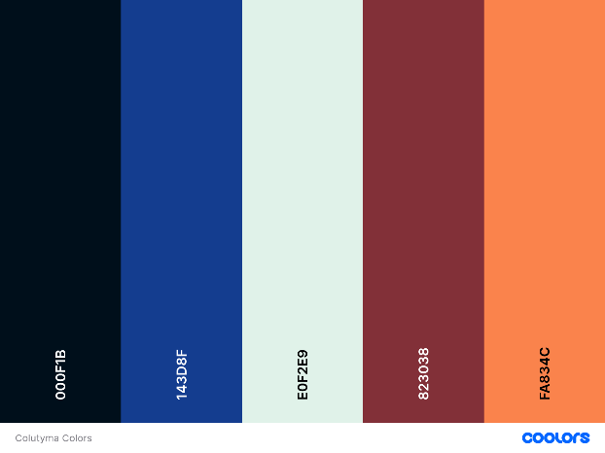

* Typography

Host Grotesk

@import url('https://fonts.googleapis.com/css2?family=Host+Grotesk:ital,wght@0,300..800;1,300..800&display=swap');

Audiowide

@import url('https://fonts.googleapis.com/css2?family=Audiowide&family=Host+Grotesk:ital,wght@0,300..800;1,300..800&display=swap');

* 1. Schedule to provide yourself mile-markers along the way to help you stay on target.

W10: Have all the HTML elements, photos, texts, buttons, possible trailers, all put together on the webpages. And have all JSON files ready for use. And complete headerFooter.js and menu.js.

W11-12: Complete at least over half of these listed JS files, donation.js, search.js, reviews.js, movieData.js, characterPopup.js, movieList.js, actorList.js, randomMovie.js, and more if I have time or have other ideas for the website.

W13: Complete all the CSS and finish up any remaining JS if I’m struggling with any or have not finished the rest.