

Restaurant System Conversion
Phase 2 Support

12/4/2025



Contents
Problem Statement 3
Current State 3
Desired State 3
Remaining Scope of Work 4
Franchise Group Contacts (to be verified) 4
System Integrations (to be verified) 4
Proposed Approach 6
HCSS General Role/Responsibilities 6

The purpose of this document is to revisit the project status based on the Fall 2025 rollout status and suggest changes for the remainder of the rollout.

Problem Statement

Current State
- The Crunchtime and Toast systems have been rolled out to 1 of the 13 franchise groups from 10/ to 11/19/25.
- Fridays, Crunchtime, and Toast have struggled to deliver the rollout to the Sugarloaf franchisee in an organized/effective manner.
- The timeline was aggressive, and the time needed for testing was nonexistent.
- Training and communication were fragmented and unorganized.
- Fridays IT resources were stressed to learn the new system and support the needed configuration and manage hardware/support logistics.
- The contract process was cumbersome.
- Issue reporting and management have been fragmented.
- The franchise group management had post-rollout concerns and needed remedial training.

Desired State
- Apply learnings from the Sugarloaf restaurant rollout to the remainder of the franchisee groups.
- The remaining franchisee groups have a point person to help them through their rollout. This will include helping them understand the process, assisting with contract signatures, coordinating site surveys, hardware logistics, training, communication, and escalation needs.
- The remaining franchisee groups:
  - Received timely communication about the system rollout.
  - Have been effectively trained and have the resources to do their job on the new system.
  - The rollout did not disrupt their business.
- The Friday’s project team is operating in a more streamlined approach regarding rollout details tracking, issue management, and work meetings.
- The remainder of the rollout:
  - is managed by a better-trained support team
  - supports a better tested franchise group-specific configuration
  - allows for a more prepared support and operational team
- See the recommendations section for more details.

Remaining Scope of Work
- 12 more franchise groups and 70-80 more restaurants will need to be rolled out (see list below).
- Work to roll out each one will include:
- Onboarding and contract signatures
- Site Survey and hardware orders/installation
- Franchise group-specific configuration
- Franchise group-specific system interface planning, development, and testing (see list below).
- Communication, training, and onsite support planning & execution
- Stabilize

Franchise Group Contacts (to be verified)
Franchise Group | Contact | Email | Phone | Locs
American Pub | Kishan Patel | kishan@americanpub.us | (909) 264-1550 | 2
Bridgeport Restaurant Group | John Mosesso | jmoerentals@frontier.com | (304) 203-4172 | 1
Cedar Fair | TBD | TBD | TBD | 1
CFC Stripes | Jill Cygan | jcygan@cfcmgmt.com | (216) 328-1121 | 2
Jackmont Hospitality | Daniel Halpern | dhalpern@jackmont.com | (404) 523-5744 | 21
Maui One | Anil Yadav | anil@yadavgroup.net | (510) 792-2628 | 28
Mera | Rafael Aguirre | rafaelat@meracorporation.com | +52 (998) 845-6064 | 5
Metz Culinary | Jeff Metz | jeffm@metzcorp.com | (570) 674-8731 | 7
RLJ Development | Eric Rogers | erogers@rljlodgingtrust.com | (301) 280-7754 | 1
United Restaurant Group | Tony Grillo | tgrillo@atlanticcoastdining.com | (804) 747-5050 | 9
Village XIII | Dale Holt | dholt44@sbcglobal.net | (217) 356-5789 | 1
VNE | Jeremy Gardner | jgardnermail@gmail.com | (501) 472-1000 | 2

System Integrations (to be verified)
Franchise Group | Category | System
American Pub LLC | Accounting | InfoSync
American Pub LLC | Labor/ Payroll | InfoSync
Bridgeport | Labor/ Payroll | InProcess Company
Bridgeport Restaurant Group | Accounting | InProcess Company
Cedar Fair L.P. (via NCR/Micros upload) | Accounting | J.D. Edwards
Cedar Fair, RLJ Development | Labor/ Payroll | Kronos / UKG
CFC Stripes | Accounting | Restaurant 365
CFC Stripes | Labor/ Payroll | MinuteMen HR
Jackmont | Accounting | Great Plains
Maui One, Mera | Accounting | Sage Intacct
Mera (effective 8.12.25) | Labor/ Payroll | UKG
Metz Culinary Management | Accounting | Business Central
United Restaurant Group L.P. | Accounting | Sage 100 ERP
United Restaurant Group L.P. | Labor/ Payroll | Paycom
Village XIII | Labor/ Payroll | Custom Computing Inc
Village XIII, VNE Inc. | Accounting | QuickBooks
VNE Inc. | Labor/ Payroll | Paychex PEO

Recommendations
The following table outlines recommendations for improved project workflow and effectiveness.
Recommendation | Notes
- Create Playbook for Remaining Franchisees | Example Sections  - Process (contract signed, site survey, hardware, training, rollout)  - Suggested communication  - Suggested training kit  - Key learnings from SugarLoaf Restaurant rollout
- Formalize Franchisee Onboarding Process (starting now) | - Formal Kickoff Meeting with Each Franchisee  - Contracts  - Restaurant Site Surveys  - Assess cultural/organizational needs  - Provide Playbook  - Integration Assessment – review system integration needs / nuances/outliers
- Institute Master Rollout Tracking | Expand on the one Eddie and Mario have been using. Create individual worksheets for the below with designated owners for each tab. Examples:  - Master Rollout Schedule by Restaurant  - Site Survey Hardware tracking  - On-site installation support  - Toast configuration/integration milestones by restaurant  - CT configuration/integration milestones by restaurant  One location for CT, Toast, and Fridays to access
- Enhanced Issue Management | Better organize issues for reporting, resolution, and learning.  Examples:  - All issues/questions should be sent to IT help desk. This includes restaurants, internal departments, and franchisees.  - If there are any issues received outside of this flow, the sender should receive a confirmation of receipt with a note about future emails to be routed to the IT. The IT help desk should be copied on this confirmation email.  - If it doesn’t feel appropriate for some people (executives, internal departments, etc.) to contact IT helpdesk, then perhaps another email distribution group could be created for this: (NewSystemExecSupport@fridays.com)  - Need good governance (for content, triage, reporting, resolution)
- Restructure Project Meeting Cadence | Change/institute new meetings with clear agendas.  Suggestions:  - Bi-weekly CT work sessions  - Bi-weekly Toast work sessions  - Weekly joint CT/Toast meeting  - Weekly internal project meeting  - Franchisee specific (as needed)

Proposed Approach
HCSS will facilitate and coordinate the activities necessary to execute the recommendations. Standard process and project management techniques/roles will be used. The project owners will direct HCSS.

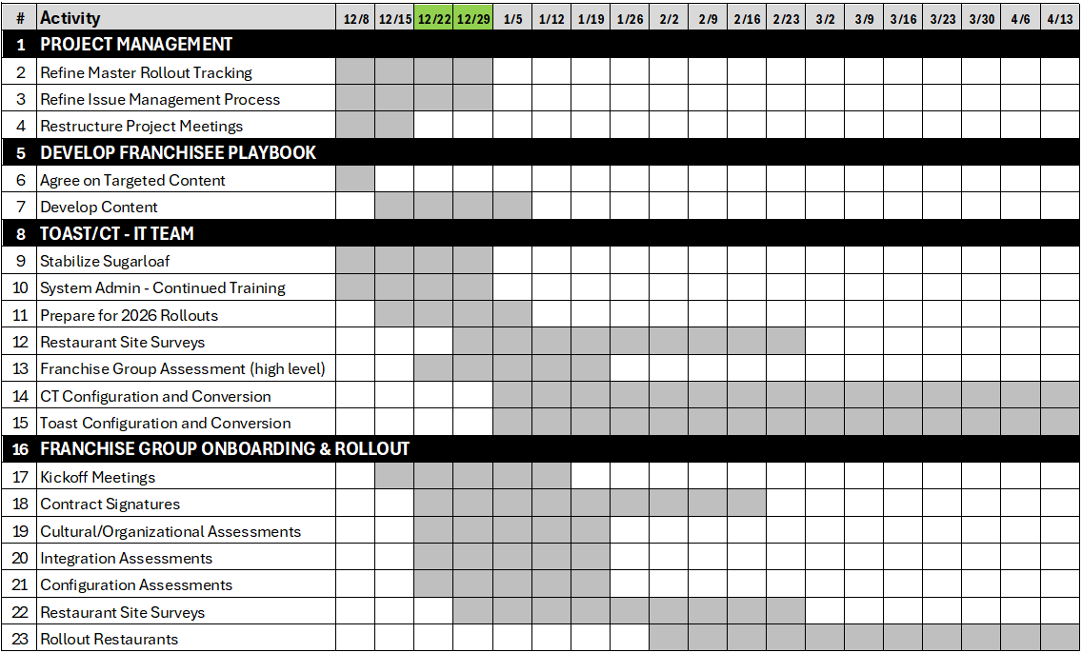

HCSS General Role/Responsibilities
Coordinate between 3rd parties and TGI Fridays workstreams/functions to keep the project on track. This will include normal project management activities and these specifics:
- Facilitate Franchise group onboarding and liaison activities
- Governance and support of master rollout tracking
- Status/Issue reporting
- Risk/issue management and escalation
- Meeting facilitations
- Support for change management (communication, training, post-go-live support, etc.).
- Assist where needed on configuration, data analysis, and testing.

