hamstlOVer
hamstlOVer is a new online hamster store launched in 2025, quickly gaining attention among pet lovers for offering healthy, well-cared-for hamsters and high-quality supplies. To expand its reach, hamstlOVer is developing an official website to promote and sell its hamsters. This site will serve as a central hub where customers can browse available hamster breeds, learn about proper care, and purchase hamsters directly from trusted breeders. It will also provide a registration form for new users to create accounts and stay updated on upcoming letters and promotions.
Following a provided blueprint, the website must be designed to be attractive, interactive, and user-friendly for its target audience of small-pet enthusiasts, incorporating visual effects such as box-shadows on hover to create a fun and engaging experience.
The project requires the creation of two main pages: a Home Page and a Registration Form Page. Key requirements include ensuring that navigation elements and buttons are clearly visible and clickable.
The Form page contains 6 attributes. You must implement client-side validation for the form using JavaScript.
Atributes | Validation
Username | - Must not be empty.  - Must be at least 4 characters long.
Email | - Must not be empty.  - Must be a valid email format (e.g., user@domain.com).  It must not start with ‘@’ and ‘.’, must have at least one character between ‘@’ and ‘.’, must not end with ‘.’, and must not contain spaces.
Password | - Must not be empty.  - Must be at least 6 characters long.
Confirm Password | - Must not be empty.  - Must match the password.
Date of Birth | - Must be older than 13 years old.
Gender | - One option must be selected.
Terms and Conditions | - The checkbox must be checked.

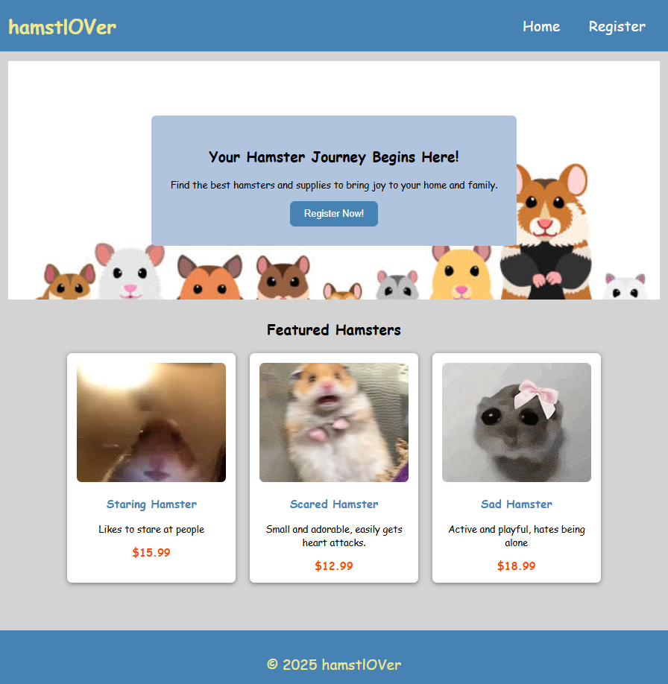
Figure 1. Homepage
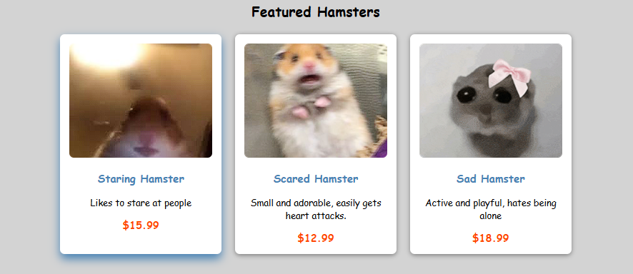
Figure 2. Hamster card when hovered

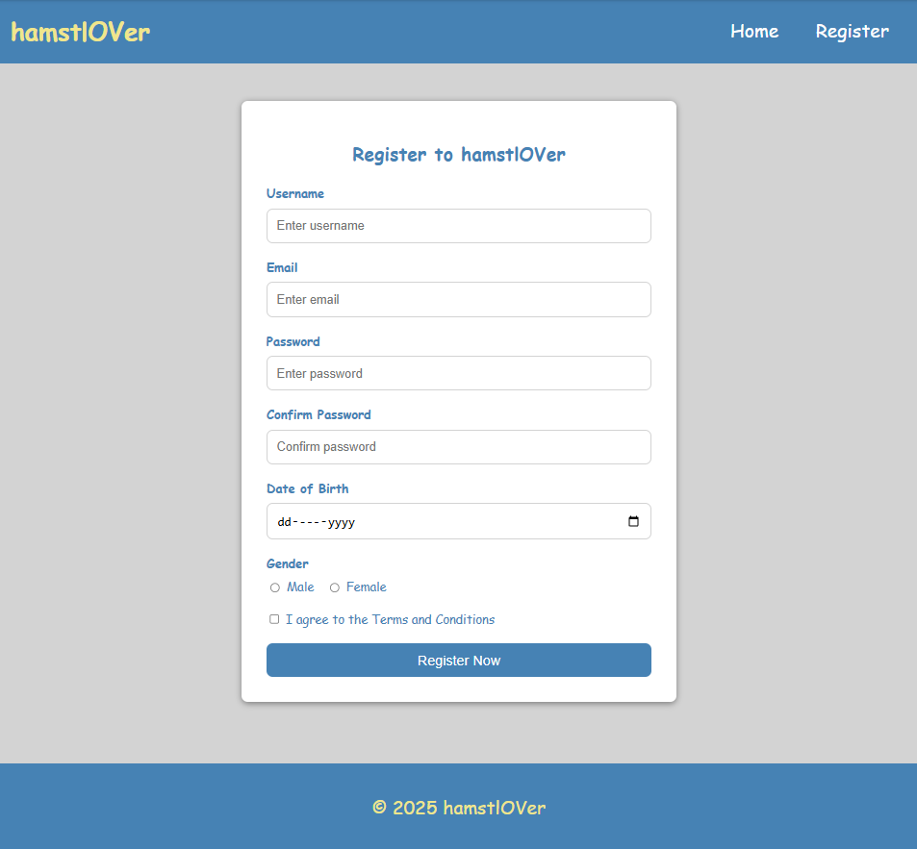
Figure 3. Register Form
Notes:
- Use only external CSS and external JS.
- Use appropriate semantic structures (header, nav, footer, etc.).
- Don’t use tables.
- Don’t use regex.
- Use relative path instead of absolute path.
- Create a hover image with CSS pseudo element in homepage.
- Use at least 5 kinds of CSS property.
- Use at least 5 kinds of suitable components for the form page.

