Project Case | 
COSC6050003
Programming for Business
Computer Science | O262-COSC6050-LS01501-00
Valid on Odd Semester Year 2025/2026 | Revision 00

- Kelompok tidak diperkenankan untuk:
Members of the group are prohibited from:
    - Melihat sebagian atau seluruh jawaban kelompok lain,
Seeing a part or the whole answer from other groups,
    - Menyadur sebagian atau seluruh jawaban dari buku, catatan, video, dan jenis referensi lainnya,
Retell a part or the whole answer from books, notes, videos, and other references,
    - Menyadur sebagian atau seluruh jawaban dari internet,
Retell a part or the whole answer from the internet,
    - Mengumpulkan jawaban yang tidak sesuai dengan tema soal,
Submitting an answer with a different theme from the given case,
    - Melakukan tindakan yang menyebabkan jawaban dicontek oleh orang lain atau kelompok lain, baik disengaja maupun tidak disengaja,
Doing action that could result the answer being copied by someone or other groups, intentionally or unintentionally,
    - Melakukan tindakan kecurangan lainnya.
Committing other dishonest actions.

- Jika kelompok terbukti melakukan tindakan seperti yang dicantumkan pada butir ke-1, maka nilai mahasiswa dan/atau kelompok yang melakukan kecurangan, baik menyontek atau dicontek, akan dinolkan sesuai dengan peraturan yang berlaku.
If it has been proven that a group has committed dishonest actions outlined in point 1 above, the whole groups related to the incident, regardless of which one copies or has their answer copied, will be issued a score of zero according to the regulation.

- Jawaban yang dapat diterima dan dinilai adalah jawaban yang dikumpulkan sebelum batas waktu yang telah ditentukan.
The answer must be submitted before the designated deadline to be accepted and graded,

- Jawaban akan dinilai berdasarkan teknik atau metode yang diajarkan pada kelas praktikum dengan menggunakan software yang sudah ditentukan.
The scoring will be based on the materials taught during the practicum classes using the designated software. Using different software than requested may result in your answer not being graded.

- Jika Anda tidak membaca peraturan ini, maka Anda dianggap sudah membaca dan menyetujuinya.
By taking this exam, you agree to these regulations, regardless of whether you have read it or not.

- Persentase penilaian untuk matakuliah ini adalah sebagai berikut:
The score will be distributed as follows:
Tugas Mandiri  Assignment | Proyek  Project | UAP  Final Exam
40% | 60% | -

- Perangkat lunak yang digunakan pada matakuliah ini adalah sebagai berikut:
This course uses the following software:
Software
Software
Visual Studio Code
XAMPP 8.2.12

- Ekstensi file yang harus dikumpulkan untuk matakuliah ini adalah sebagai berikut:
Your answers must be in the following file extensions:
Tugas Mandiri  Assignment | Proyek  Project | UAP  Final Exam
HTML, CSS, JS | PHP | -

- File yang harus dikumpulkan adalah keseluruhan jawaban beserta dengan aset yang digunakan (gambar, audio, video, dll) dan dokumentasi proyek yang berisikan link referensi aset dan penjelasan mengenai aplikasi yang dibuat (terlampir bersama dengan soal).
Include other files that can support your project, such as: all files in your project, other files (image, audio, video, etc.) used in your project, *.doc file (documentation of your project) that contains all pages in your project, reference links of additional files (image, audio, video, etc.) used in your project, the description about how to use your application, etc.

Soal
Case

Furniland
Furniland is an online platform where people can order furniture products from various vendors. Furniland needs a website so customers can browse available furniture and place their orders online. The website will be managed by the admin of Furniland, allowing them to manage users, vendors, and furniture listings.
As a web developer, you are asked to create a website using PHP for this platform. This means you are expected to use HTTP requests to handle all Create, Read, Update, and Delete (CRUD) operations. There are three (3) types of user roles on this website: Admin, Member, and Guest (non-logged-in user). Minimum pages you need to create for each role are:
- Admin
  - Home (Dashboard)
  - Manage Users
  - Manage Vendors
  - Add and Edit Vendors
  - Manage Products
  - Add and Edit Products
  - View Transactions
- Member
  - Home
  - Product Catalog
  - Product Detail
  - Cart
  - Profile
  - Transaction History
- Guest
  - Home
  - Login
  - Register
Each page shows the name of the Member or Admin. If the user has not logged in (Guest), then they can only access Guest pages. You need to build this website based on the following criteria:
      - Entity Relationship Diagram
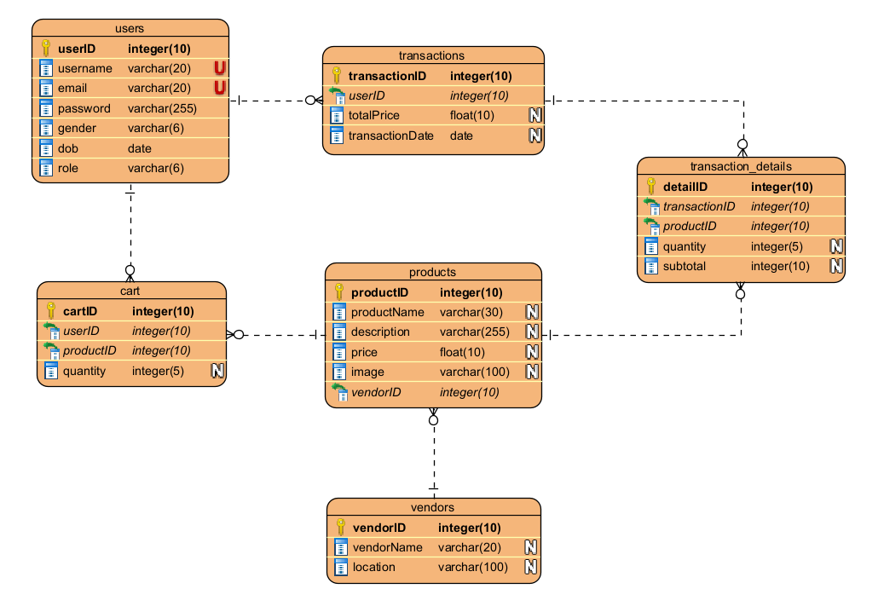
Figure 1. Home Page

This is the Entity Relationship Diagram (ERD) that defines the database structure for Furniland web. You must create SQL query file to create your database. The ERD consists of (6) six main entities:
- Users
- Transactions
- Transaction Details
- Products
- Vendors
- Cart

      - Home
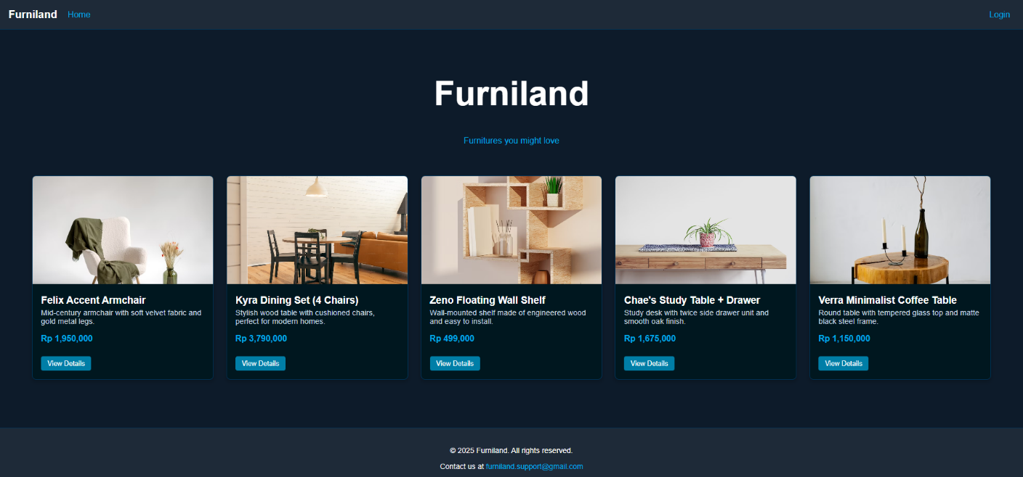
Figure 2. Home Page
This is the website landing page. You need to build this page based on the following criteria:
    - Navigation Bar
      - Show links to each page based on the role (Guest, Member, or Admin)
      - If the company logo is clicked, redirect to the home page
      - If the user’s name is clicked, redirect to the profile page
Figure 3. Navigation bar for Guest

Figure 4. Navigation bar for Admin

Figure 5. Navigation bar for Member

    - Content
      - Show the company name (Furniland)
      - Show (6) six random products taken from the database
      - Each product includes name, vendor, price, and “View Detail” link that will redirect to Product Detail page
    - Footer
      - Show contact information. Feel free to design the rest of the footer.

      - Login
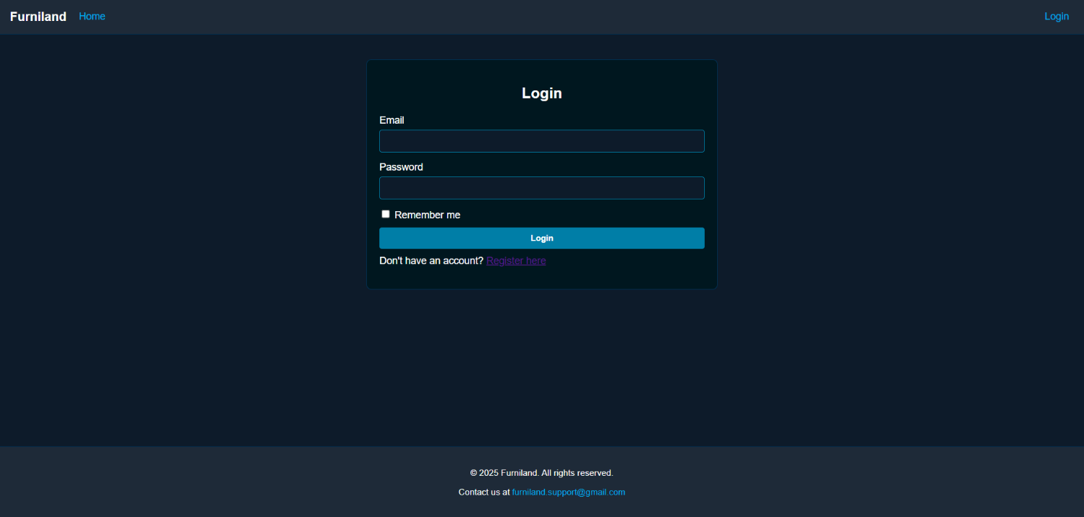
Figure 6. Login Page
This page allows guests to login to the website. Display an error message on the login page if the guest enters the wrong credentials. Build this page based on the following criteria:
Field | Criteria
Email | - Must be filled  - Must match with the database
Password | - Must be filled  - Must match with the database
Remember me | - Add cookie to store User ID when guest login successfully, and will last for 1 week
When the guest login successfully, redirect to home page.

      - Register
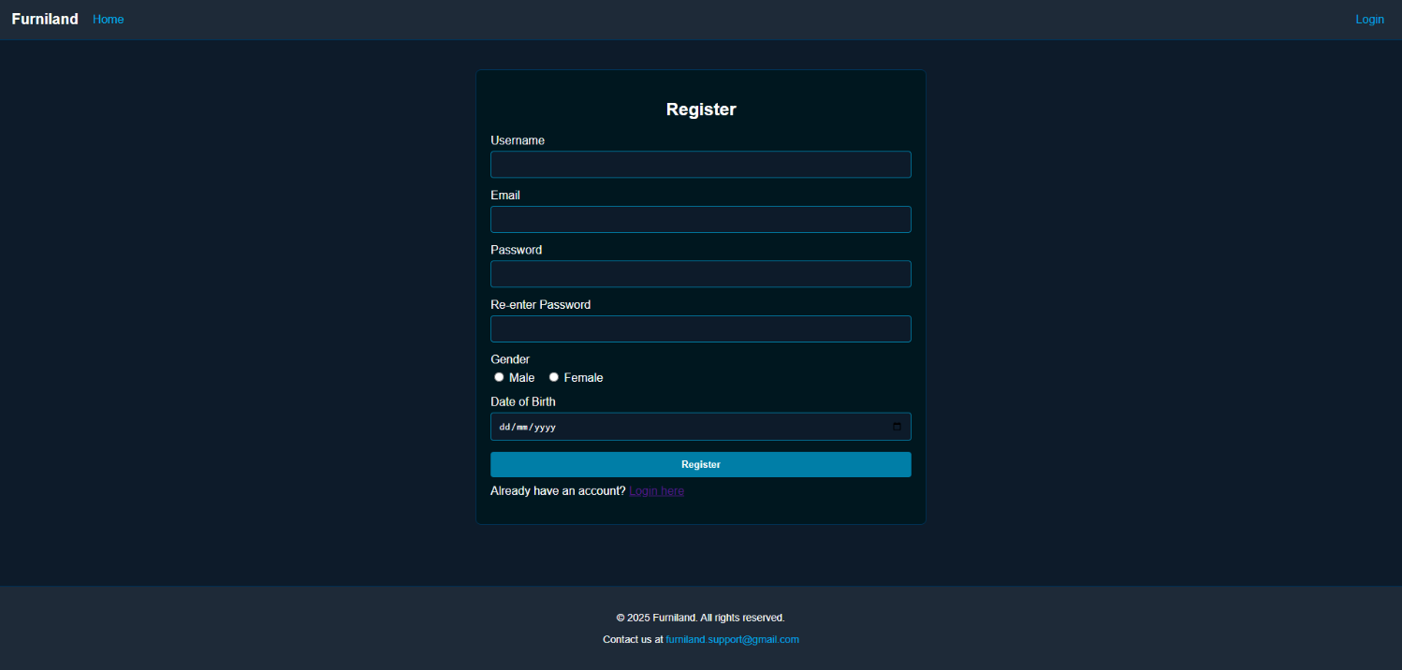
Figure 7. Register Page
This page allows guests to register themselves to the website. Display an error message on the register page if invalid data is entered. Build this page based on the following criteria:
Field | Criteria
Username | - Must be filled  - 4 - 20 characters  - Must be unique
Email | - Must end with ‘@gmail.com’  - Must be unique
Password | - Must be filled  - Minimum 8 characters
Confirm Password | - Must match with Password
Gender | - Must select ‘Male’ or ‘Female’
Date of Birth | - Must be a valid date in the past
When the guest registers successfully, redirect to catalog page.

      - Product Catalog
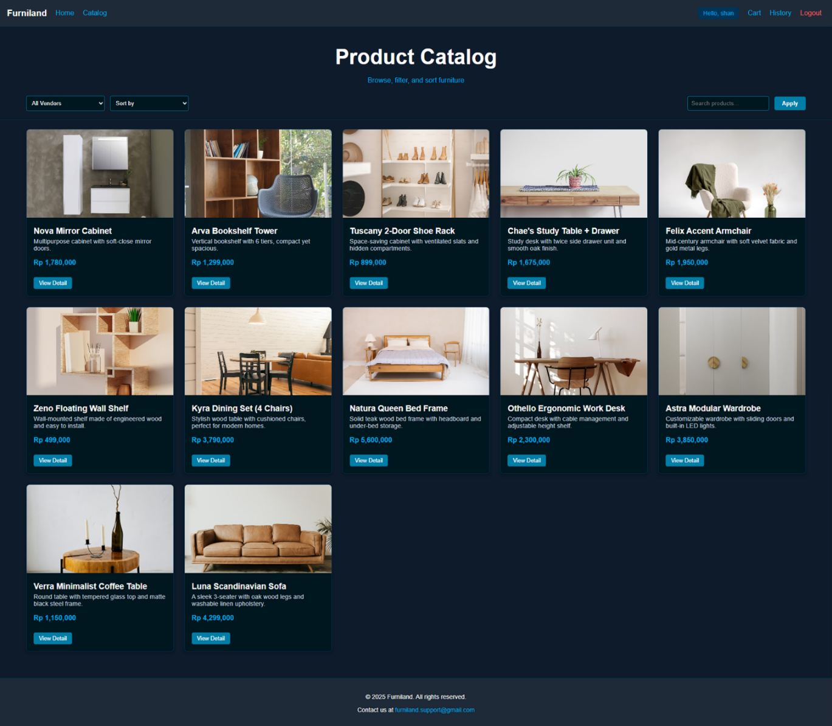
Figure 8. Catalog Page
This page allows all roles to view all available furniture. Build this page based on the following criteria:
- Show product name, vendor, price, and description.
- Provide a “View Detail” link that will redirect to product detail page.
- Provide search input, sort, and vendor filter.

      - Product Detail
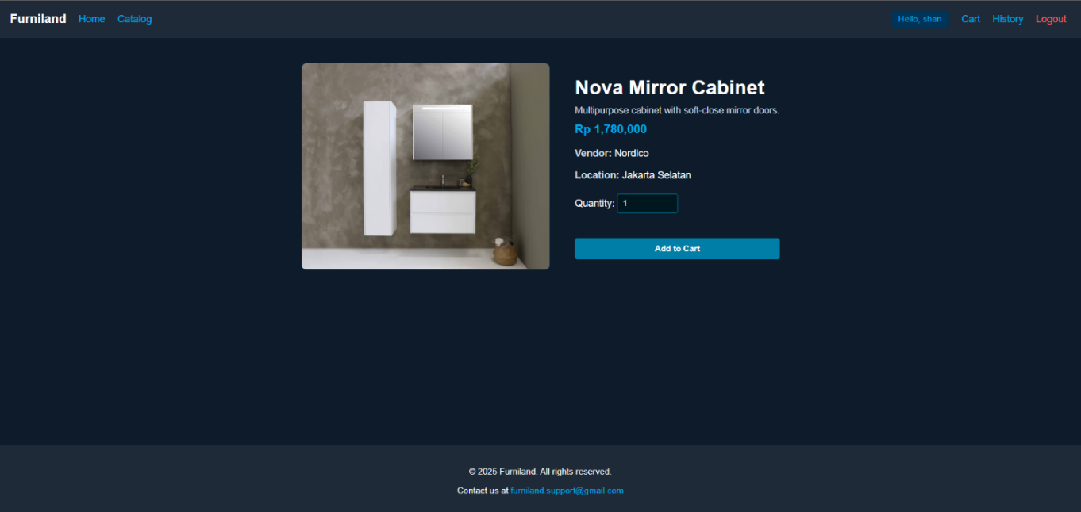
Figure 9. Product Detail Page
This page allows guests and members to see product details. Build this page based on the following criteria:
- Show product name, price, description, vendor name, and vendor location.
- Provide editable quantity input.
- Show “Add to Cart” button.
- Guests cannot add to the cart and will be redirected to login page.
      - Cart
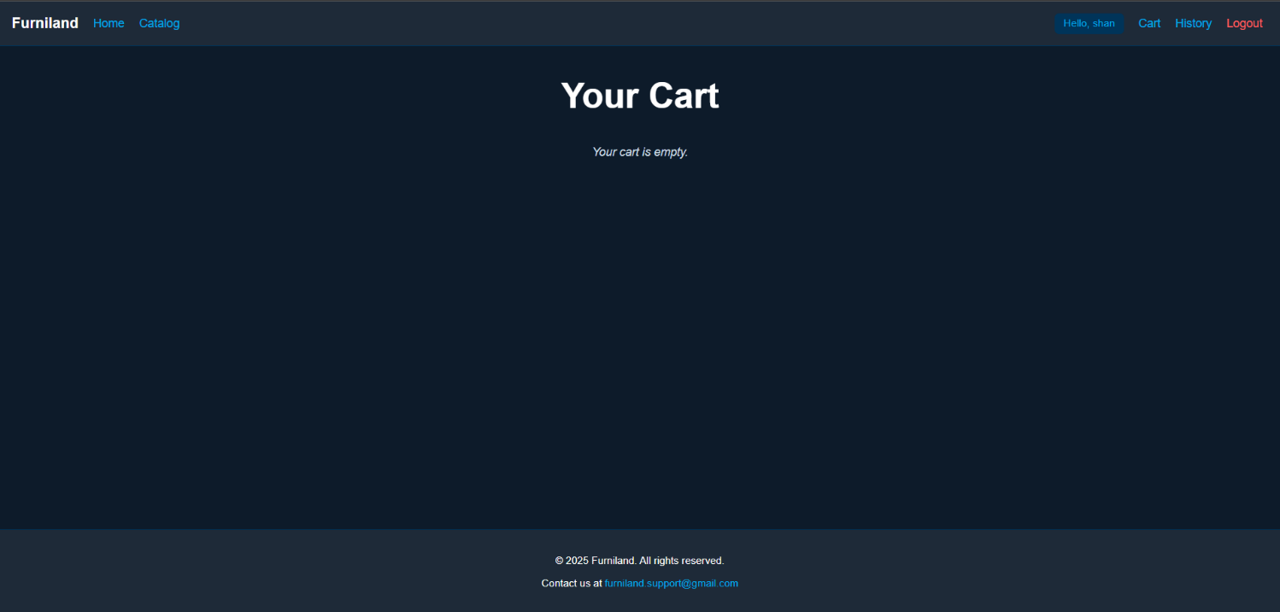
Figure 10. Empty Cart Page
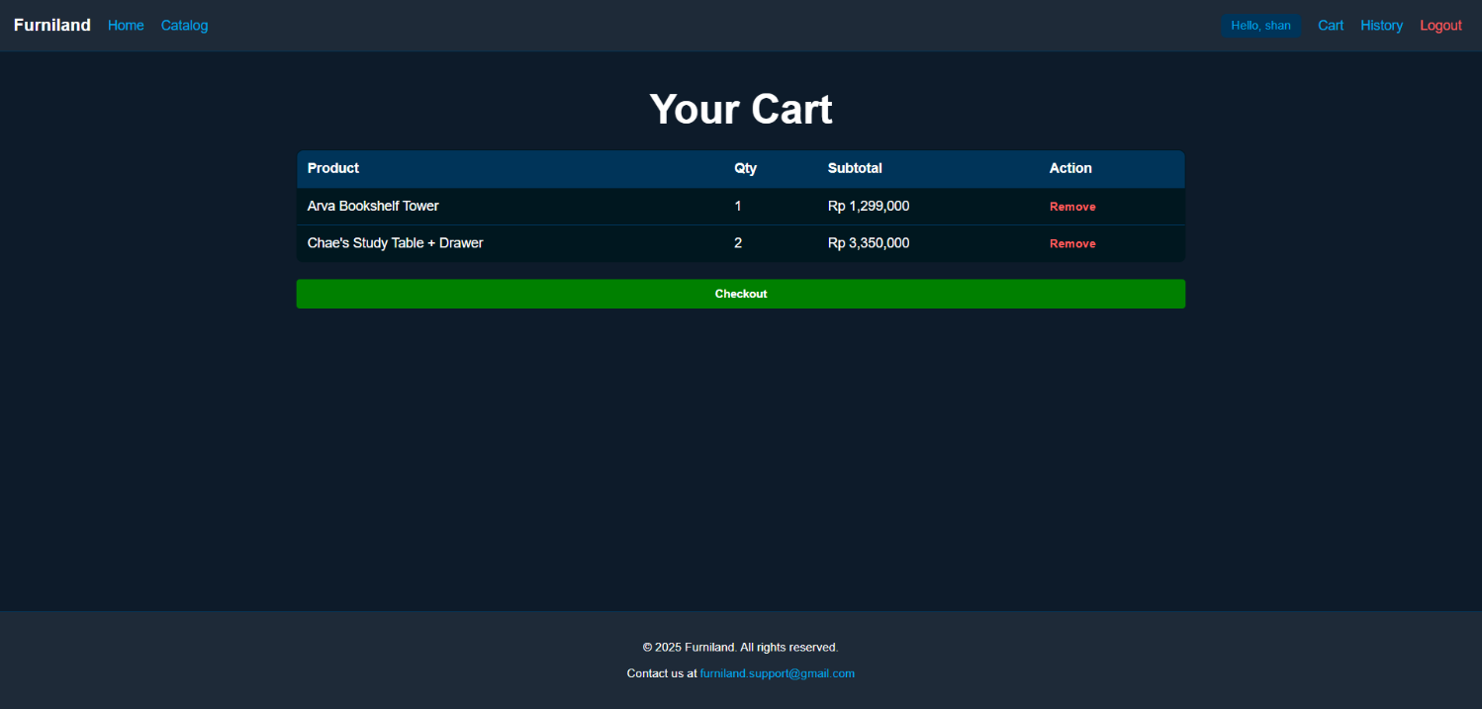
Figure 11. Cart Page
This page allows members to see and manage their cart. Build this page based on the following criteria:
- Show each product (name, quantity, subtotal).
- Provide delete button to remove item.
- Provide “Checkout” button.
      - Transaction History
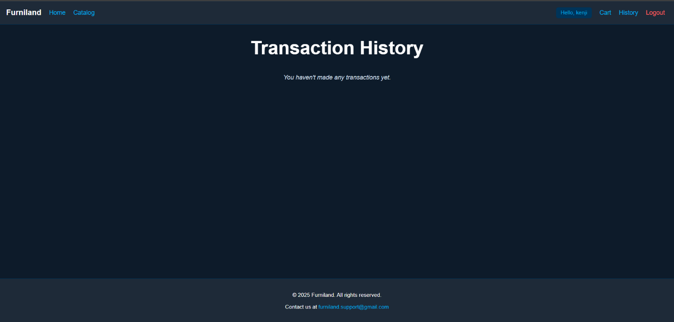
Figure 12. Empty Transaction History Page
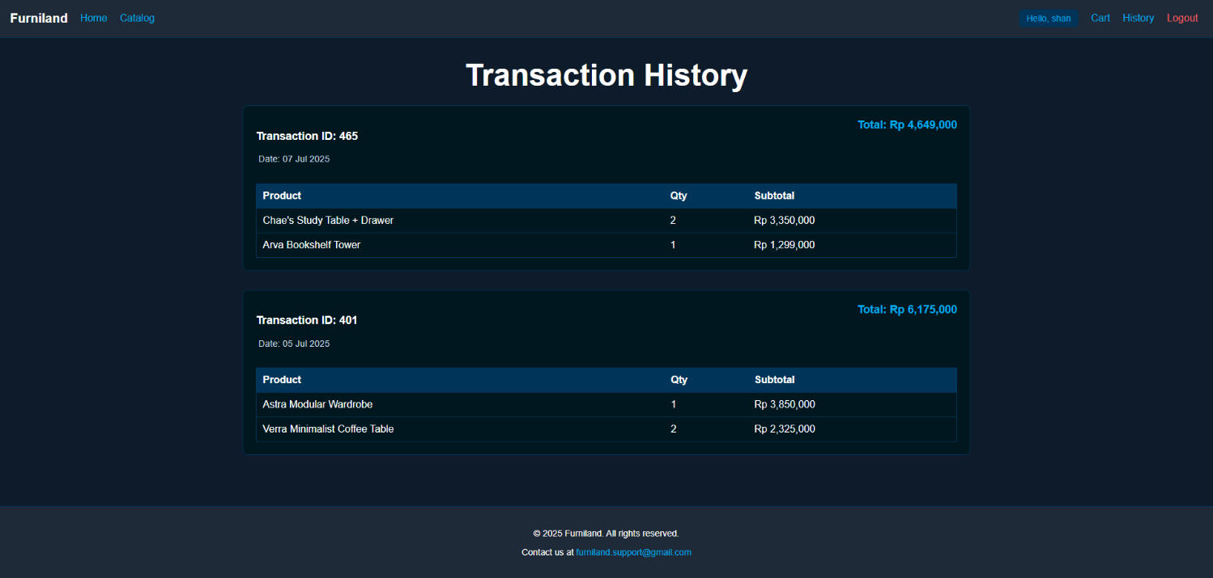
Figure 13. Transaction History Page
This page allows members to see past purchases. Build this page based on:
- Show all history records.
- Each transaction shows: transaction ID, date, total, and list of items

      - Profile
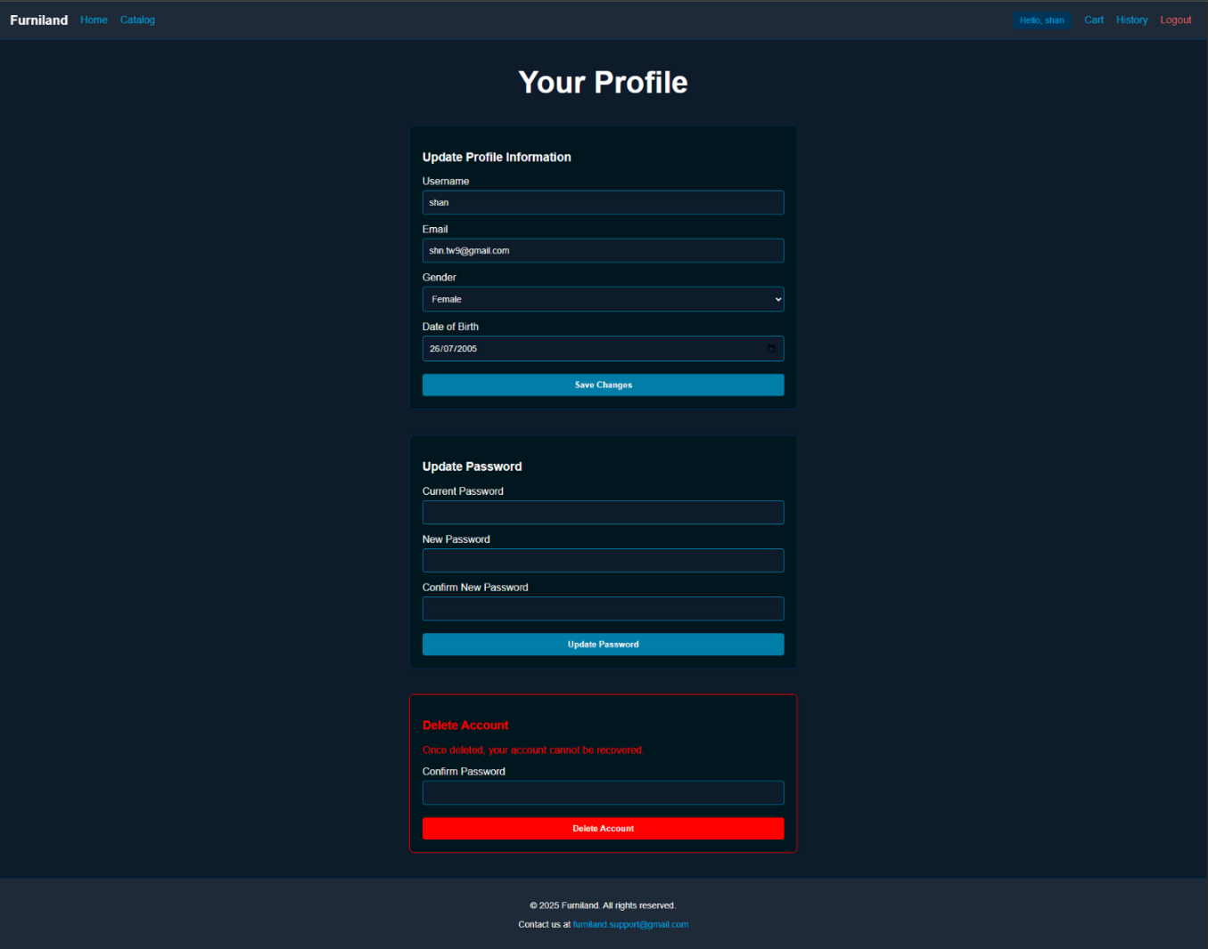
Figure 14. Profile Page
This page allows members and admins to manage their profile. Build this page with the following sections:
- Update Profile Info: Username, Email, Gender, Date of Birth.
- Update Password: Current password, new password, confirm password.
- Delete Account: Confirm password, then delete account from database.
- Validate each field according to register validation.

      - Dashboard
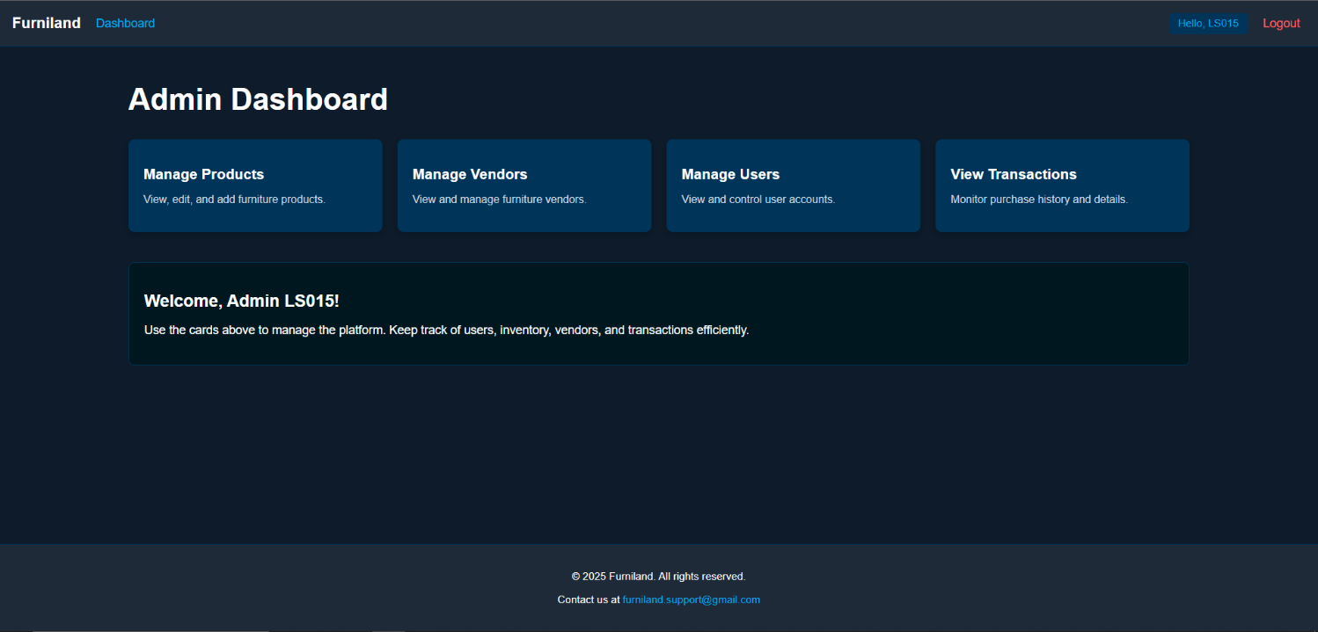
Figure 15. Dashboard Page
This page allows admin to view an overview of the system. You need to build this page based on the following criteria:
- Show a greeting and 4 navigation cards:
  - Manage Users
  - Manage Vendors
  - Manage Products
  - Manage Transactions
- Each card must be clickable and redirect to the respective page.

      - Manage Vendor
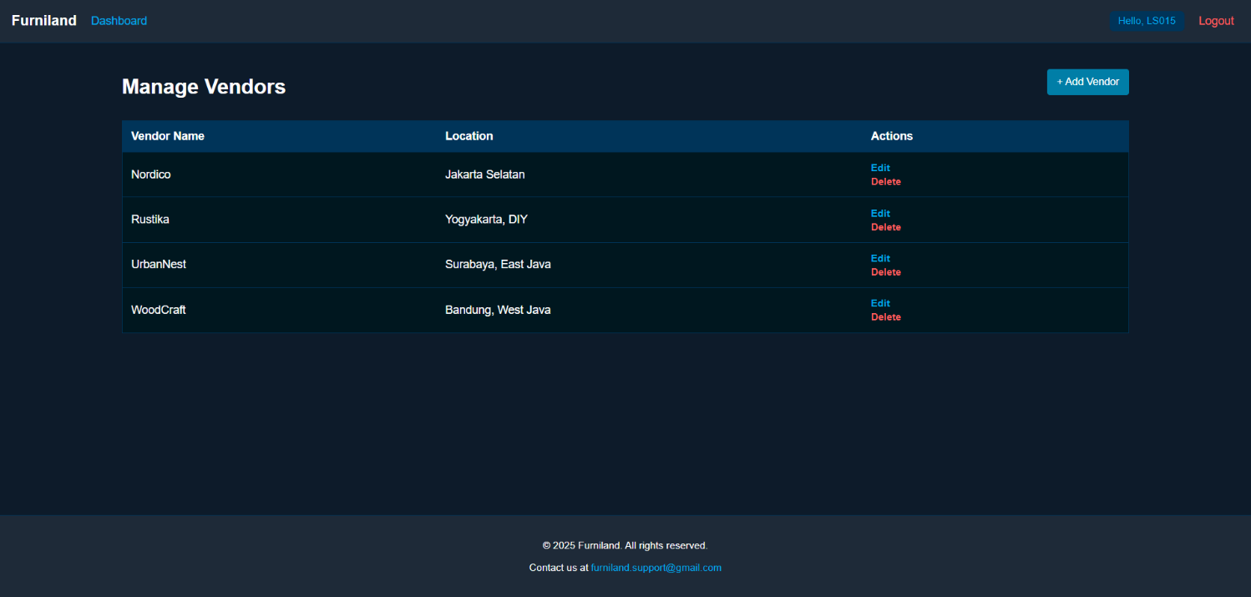
Figure 16. Manage Vendor Page
This page allows admin to manage all vendor data. You need to build this page based on the following criteria:
- Shows a list of all vendors: Vendor name, and location.
- Provide an Add Vendor button to redirect to add vendor page.
- Provide an edit button on each vendor item that will redirect to edit vendor page.
- Provide a delete button on each vendor item that will remove the selected vendor.
- Validate that a vendor can only be deleted if it is not referenced in any product.

      - Add and Edit Vendor
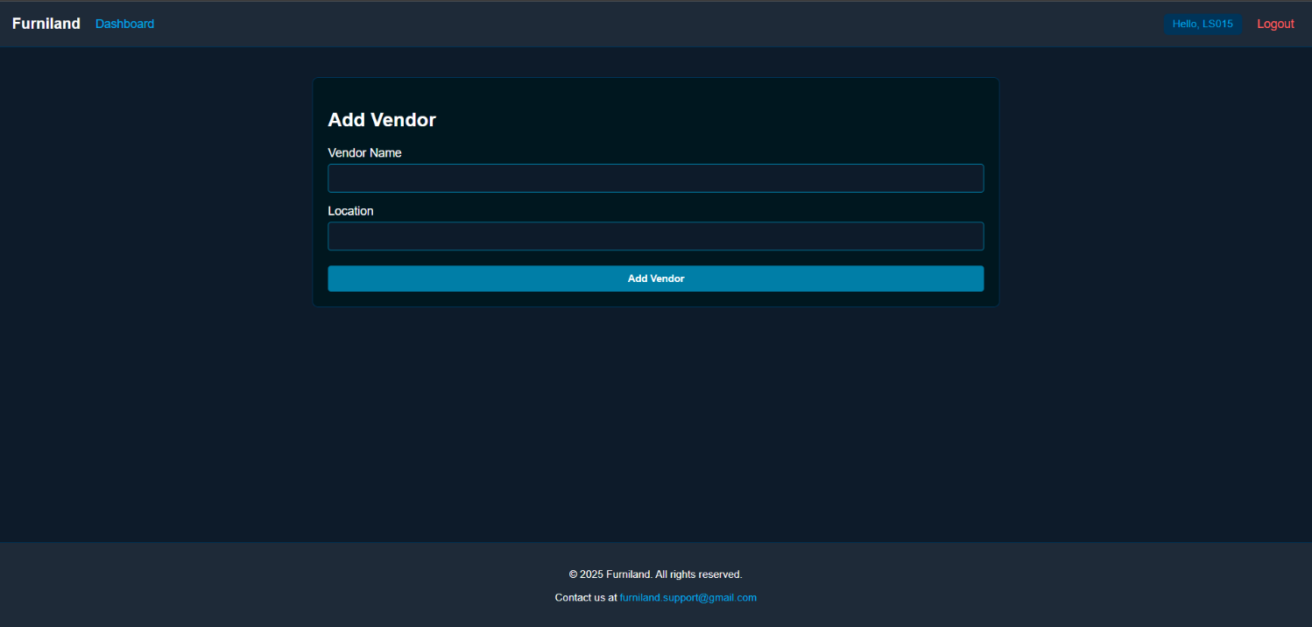
Figure 17. Add Vendor Page
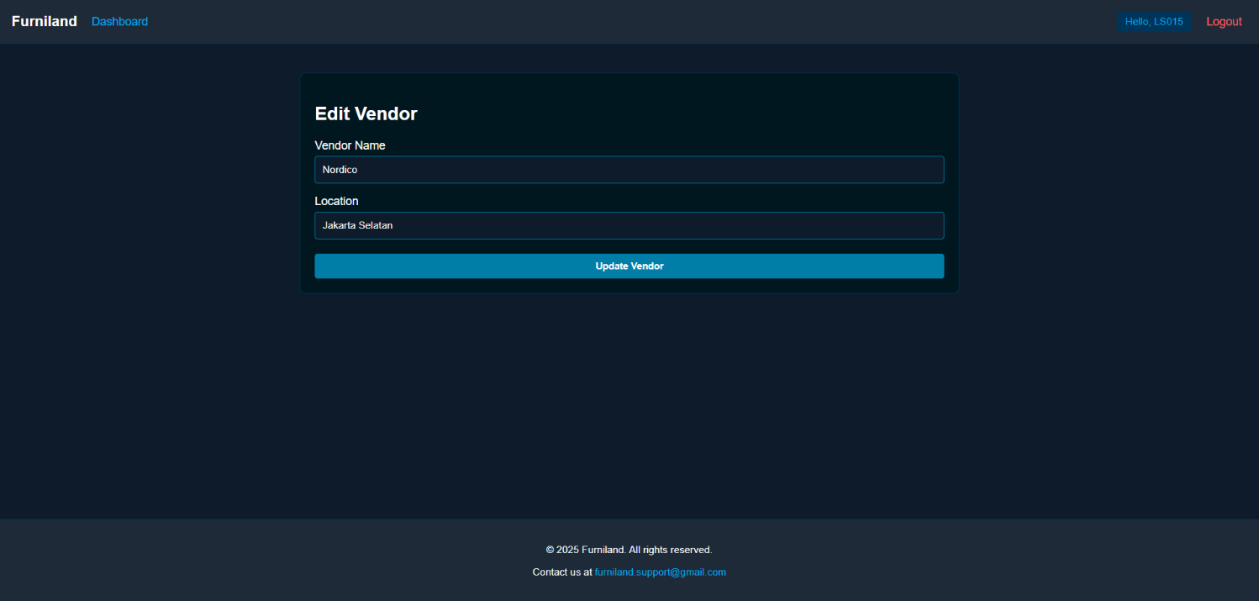
Figure 18. Edit Vendor Page
This page allows admin to insert new vendors and update existing vendor data. You need to build this form based on the following criteria:
Field | Criteria
Name | - Must be filled  - Maximum of 20 characters
Location | - Must be filled  - Maximum of 100 characters
When admin inserts new vendor or updates existing vendor successfully, redirect to manage vendor page.

      - Manage Product
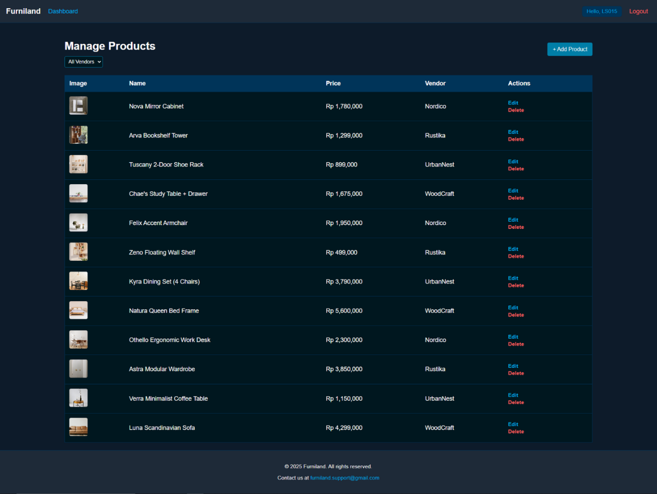
Figure 19. Manage Product Page
This page allows admin to manage all product listings. You need to build this page based on the following criteria:
- Show product’s ID, name, price, vendor, and image thumbnail.
- Provide an Add Products button to redirect to add vendor page.
- Provide a search input to search for product based on product name.
- Provide a dropdown filter to filter product by vendor.
- Provide an edit button on each vendor item that will redirect to edit product page.
- Provide a delete button on each vendor item that will remove the selected vendor.
- Validate that a vendor can only be deleted if it is not referenced in any product.

      - Add and Edit Products
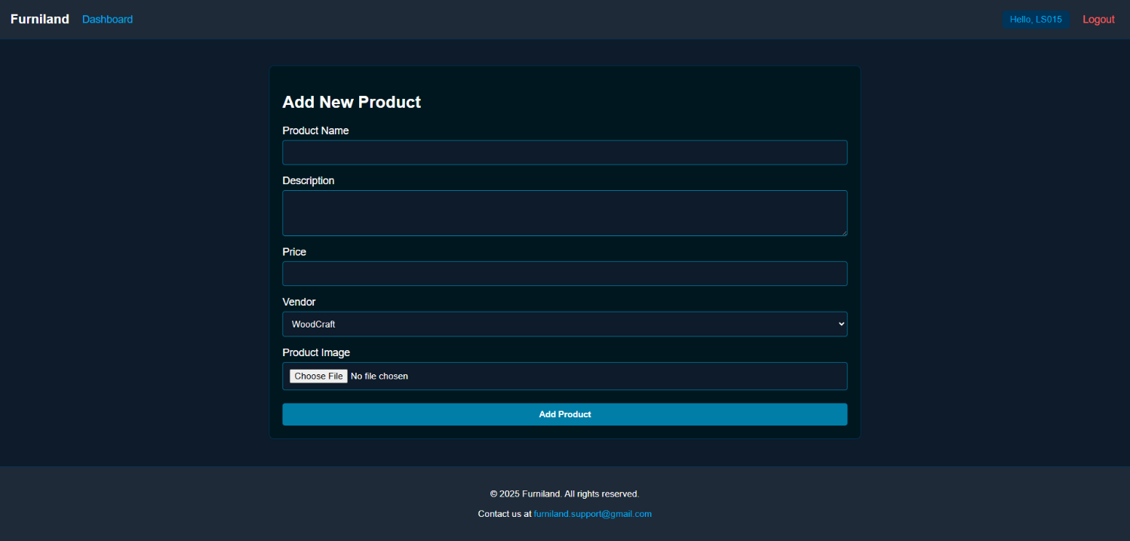
Figure 20. Add Products Page

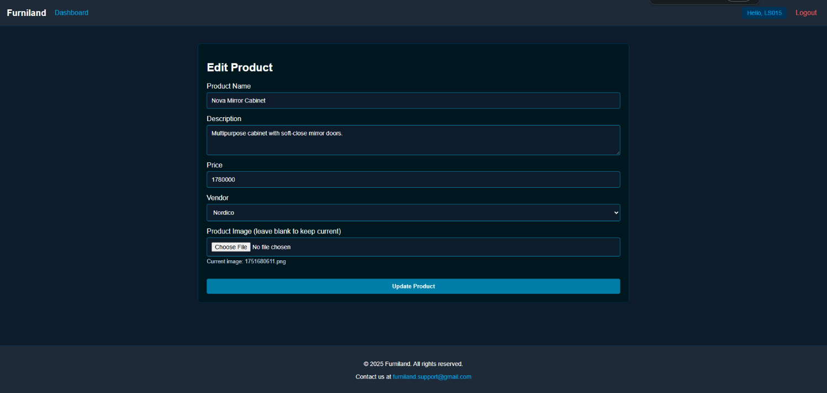
Figure 21. Edit Products Page
This page allows admin to insert new products and update existing product data. You need to build this form based on the following criteria:
Field | Criteria
Name | - Must be filled  - 3–30 characters
Description | - Must be filled
Price | - Must be filled  - Must be numeric > 0
Image | - Must be valid image format .jpg or .png
Vendor | - Must be chosen from existing vendor list
- When admin inserts a new vendor or updates existing products successfully, redirect to manage vendor page.
      - Manage Users
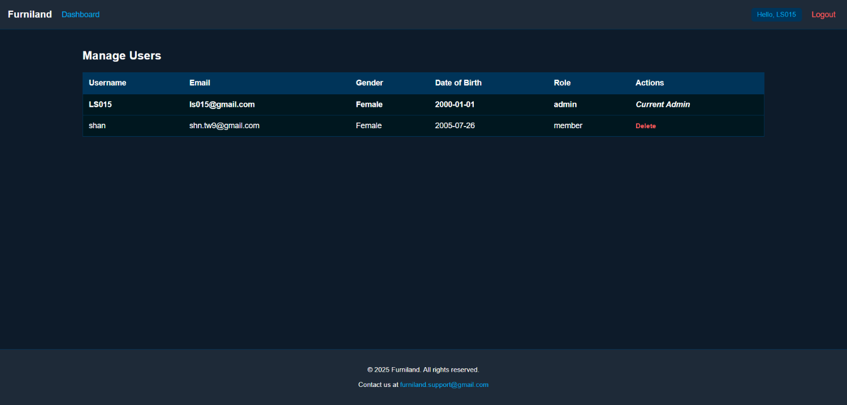
Figure 22. Manage User Page
This page allows admin to view and delete users. You need to build this page based on the following criteria:
- Show user’s username, email address, date of birth, gender, and role.
- Provide a delete button on each user item that will remove the selected user.

      - View Transactions
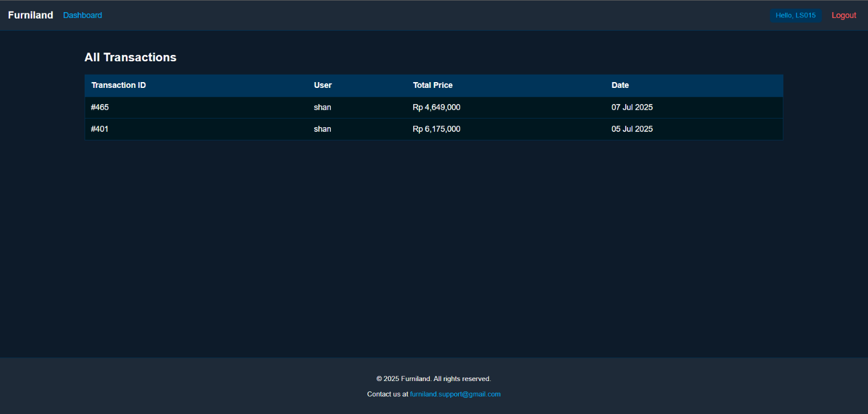
Figure 23. View Transactions Page
This page allows admin to view all completed transactions. You need to build this page based on the following criteria:
- Show transaction ID, user, total price, and transaction date.

Here are the rules that you must follow to create your project:
- Include the other files that can support your project, such as:
  - All files in your project
  - Other files (image, audio, video, etc.) used in your project
  - *.DOC file (documentation of your project) that contains the reference links of additional files (image, audio, video, etc.) used in your project
- If there are some hidden creativities, please note them in the existing documentation because they can greatly affect your project score
- Your project must include HTTP request (GET, POST, DELETE, etc.) in its implementation.
- You must submit the SQL query file used to create your database (CREATE TABLE, INSERT, etc.).
- All validation errors on the website must be clearly communicated, this can be through a toast, modal, inline message, or any method.
- Please fill the database to make it easier for the corrector to mark your score. Also, make sure to include at least one user with an admin role.

If you do not understand, please ask your assistant!

