The Art of Living and Discovering
  - Every day, an invitation to learn, breathe and explore.
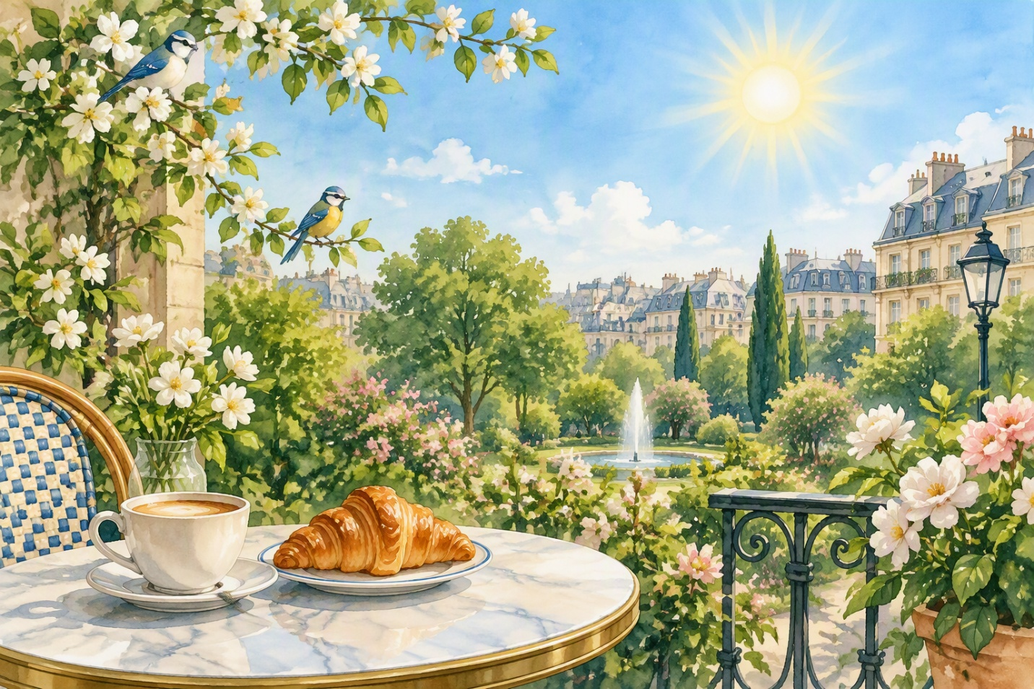

A New Day
Every day is a new opportunity to learn something extraordinary. This morning, the sun shines beautifully in the blue sky and birds sing a sweet melody in the big garden. I like to start my day with a good cup of hot coffee and a fresh croissant from the local bakery. Urban life is always full of surprises, movements and interesting encounters with wonderful people.

Moment of serenity
During my free time, I prefer to read a captivating book, listen to classical music or walk quietly along the river. It is an excellent way to relax, forget daily stress and find lasting inner peace. Sometimes Ifindmy best friends in a cozy little café around the corner to discuss our future projects and share sincere laughter.

