The Art of Living and Discovering
  - Every day, an invitation to learn, breathe and explore.
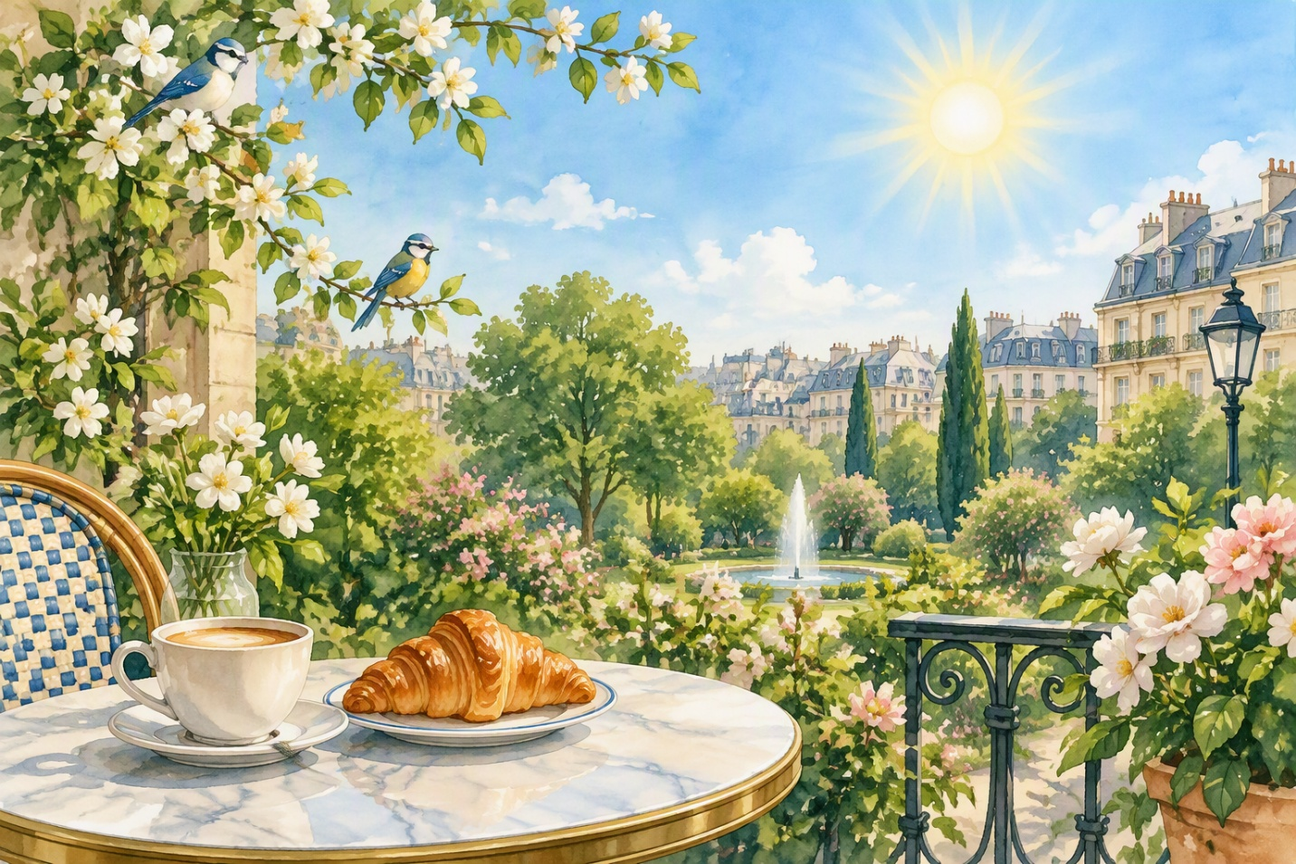

A New Day
Every day is a new opportunity to learn something extraordinary. This morning, the sun shines beautifully in the blue sky and birds sing a sweet melody in the big garden. I like to start my day with a good cup of hot coffee and a fresh croissant from the local bakery. Urban life is always full of surprises, movements and interesting encounters with wonderful people.

Moment of serenity
During my free time, I prefer to read a captivating book, listen to classical music or walk quietly along the river. It is an excellent way to relax, forget daily stress and find lasting inner peace. Sometimes I find my best friends in a cozy little café around the corner to discuss our future projects and share sincere laughter.

