Nishant Jha’s

Analysing and visualizing

we rate dogS dataset

# introduction

The dataset that I will be and analyzing and visualizing is the tweet archive of Twitter user [@dog_rates](https://twitter.com/dog_rates), also known as [WeRateDogs](https://en.wikipedia.org/wiki/WeRateDogs). WeRateDogs is a Twitter account that rates people's dogs with a humorous comment about the dog. These ratings almost always have a denominator of 10. The numerators, though? Almost always greater than 10. 11/10, 12/10, 13/10, etc. Why? Because "they're good dogs Brent." In theory the rates should be between 1 and 10. However, WeRateDogs disagree, they admit almost all dogs deserve a 10 and sometimes more than that. WeRateDogs has over 8 million followers and has received international media coverage.

WeRateDogs has over 6000+ tweets. I was able to analyze around 1500+.

In this report, the topics that we will be covering are:

* Getting to know the most common dog in the dataset.
* Getting to know the most retweeted tweet.
* Getting to know the most favourite tweet.
* Getting to know the tweet with the highest rating.

Let’s dig in!

# The most common dog

Udacity was helpful enough to provide with a dataset where the predictions on dog type were done using the images provided in the tweets.

Now according to the very first algorithm used by Udacity to predict the dog type, the most common dog type was found to be Golden Retriever.

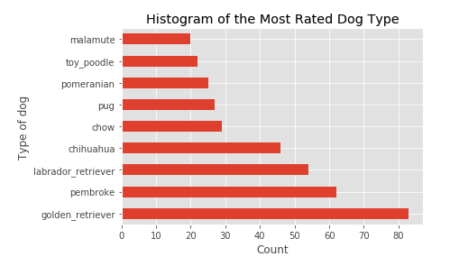

# The most retweeted tweet

This little boy got the largest number of retweets. Legends say he’s still trying (just kidding).

# 

# the most favourite tweet

This cute boy got the largest number of likes. Good deeds really bring the best in you.

# 

# tweet with the highest rating

The hero of this dataset is this smart boy with the highest rating given by WeRateDogs.

He protec!

He attac!

Bust most importantly,

He’s smart!

