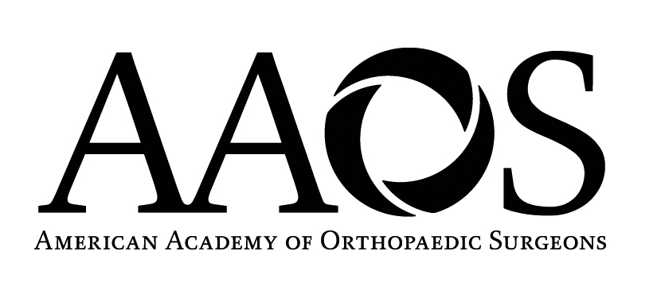
Instructional Course Faculty and Course Description Form

2011 Annual Meeting

February 15 - 19 ~ San Diego, CA

DUE DATE: July 7, 2010
COURSE TITLE: REVERSE SHOULDER ARTHROPLASTY: BEYOND THE BASICS

FACULTY: Two-hour courses limit faculty to 3 speakers and one moderator.

COURSE MODERATOR: Gordon I Groh, MD

MAILING ADDRESS: 129 McDowell St

CITY: Asheville STATE:NC ZIP: 28801

PHONE: 828 2588800 FAX: 828 258 0416

E-MAIL ADDRESS:ggroh@brbj.com

INSTRUCTOR: Michael A. Wirth, MD

MAILING ADDRESS: Dept of Orthopaedics
7703 Floyd Curl Dr.

CITY: San Antonio STATE:Tx ZIP: 78229-3900

PHONE: 512 567 5136 FAX: 512 567 5167

E-MAIL ADDRESS: wirth@uthsca.edu

INSTRUCTOR: Mark A. Frankle, MD

MAILING ADDRESS: 13020 Telecom Parkway N

CITY: Tampa STATE:Fl ZIP: 33637

PHONE: 813 558 6821 FAX: 813 558 6833

E-MAIL ADDRESS: frankle@pol.net

INSTRUCTOR: Joseph Iannotti, MD, PhD

MAILING ADDRESS: Cleveland Clinic Main Campus—Mail Code A41; 9500 Euclid Ave

CITY: Cleveland STATE: Ohio ZIP: 44195

PHONE: 216 445 5151 FAX: 216 445 6255

E-MAIL ADDRESS: ianotj@ccf.org

The 2011 Preliminary and Final Programs will contain a short description of each instructional course. The course description assists registrants in choosing the course curriculum best for them. Below, please include a description of your course in 25 words or less. Descriptions are subject to editing due to space considerations.

COURSE DESCRIPTION (25 words or less- please print or type):

Reverse shoulder arthroplasty indications/techniques/results for disorders including fractures, failed hemi/total shoulder arthroplasty and prosthetic instability. Course includes a review of pertinent biomechanics/biology.

DUE DATE: July 7, 2010

RETURN EMAIL TO: April Holmes @ holmes@aaos.org

