Week 3-2

[**Operators and Expressions, Managing Input and Output Operations**](http://www.rajalakshmicolleges.org/moodle/course/section.php?id=4)

Roll no: 240801137

Name: Jhanani.M

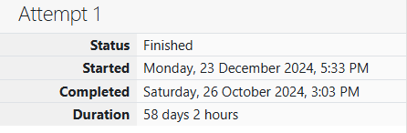

**Problem 1:**

Write a program that determines the name of a shape from its number of sides. Read

the number of sides from the user and then report the appropriate name as part of a

meaningful message. Your program should support shapes with anywhere from 3 up to

(and including) 10 sides. If a number of sides outside of this range is entered then your

program should display an appropriate error message.

**Sample Input 1**

3

**Sample Output 1**

Triangle

**Sample Input 2**

7

**Sample Output 2**

Heptagon

**Sample Input 3**

11

**Sample Output 3**

The number of sides is not supported.

**Code:**

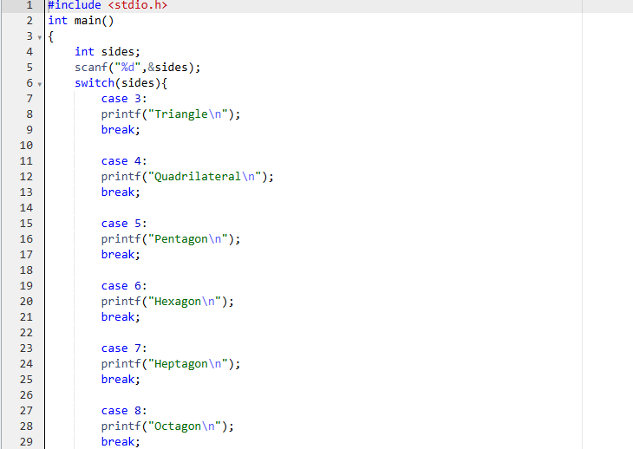

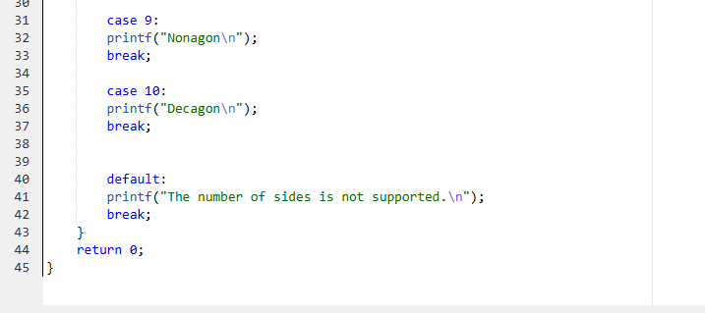

**OUTPUT:**

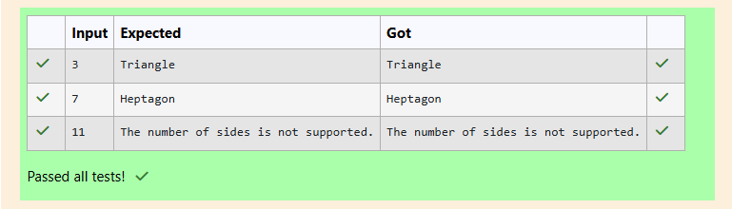

**Problem 2:**

The Chinese zodiac assigns animals to years in a 12-year cycle. One 12-year cycle is

shown in the table below. The pattern repeats from there, with 2012 being another year

of the Dragon, and 1999 being another year of the Hare.

Year Animal

2000 Dragon

2001 Snake

2002 Horse

2003 Sheep

2004 Monkey

2005 Rooster

2006 Dog

2007 Pig

2008 Rat

2009 Ox

2010 Tiger

2011 Hare

Write a program that reads a year from the user and displays the animal associated with

that year. Your program should work correctly for any year greater than or equal to zero,

not just the ones listed in the table.

**Sample Input 1**

2004

**Sample Output 1**

Monkey

**Sample Input 2**

2010

**Sample Output 2**

Tiger

**Explanation:**

• The program reads the year input from the user.

• It calculates the index by using the formula (year - 2000) % 12.

o Here, 2000 is chosen as the reference year because it corresponds to "Dragon."

o The % 12 operation ensures the cycle repeats every 12 years.

o If index is negative (when the year is before 2000), it adjusts by adding 12.

• The animals array holds the animal names in order, so the calculated index directly

points to the correct animal.

**Code :**

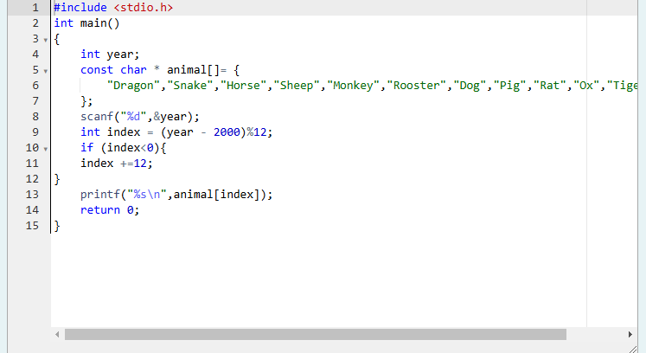 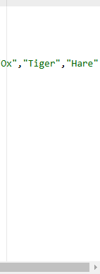

**OUTPUT:**

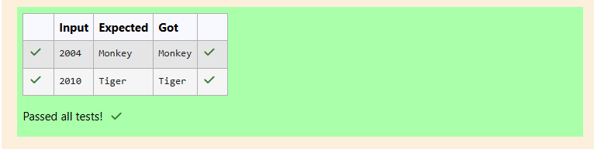

**Problem 3:**

Positions on a chess board are identified by a letter and a number. The letter identifies

the column, while the number identifies the row, as shown below:

Write a program that reads a position from the user. Use an if statement to determine if the

column begins with a black square or a white square. Then use modular arithmetic to report

the color of the square in that row. For example, if the user enters a1 then your program

should report that the square is black. If the user enters d5 then your program should report

that the square is white. Your program may assume that a valid position will always be

entered. It does not need to perform any error checking.

**Sample Input 1**

a 1

**Sample Output 1**

The square is black.

**Sample Input 2**

d 5

**Sample Output 2**

The square is white.

**Explanation of Changes:**

• Now, if (columnIndex + row) % 2 == 0, the program prints "The square is white."

• If (columnIndex + row) % 2 == 1, it prints "The square is black."

**Code:**

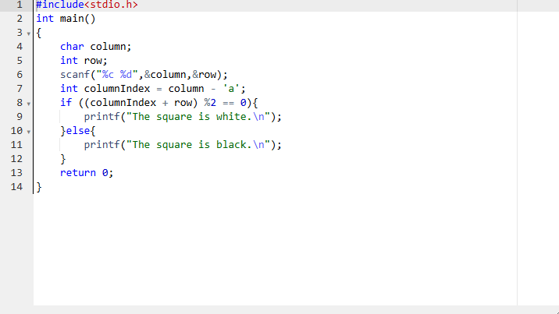

**OUTPUT:**

