ComPHY Project proposal notes:

Carl Jansky

Grote Reber

Hi, Sabrina.  There are two levels of complexity and difficulty that you can apply to your data for your class project.

1) Use the phase of the 12-hour-time-averaged spectra for each pair of antennas to estimate the location on the sky of the source.  This is relatively simple and requires very few calculations, but is still cool.

2) Use averages over much smaller amounts of time than in #1 and determine how the phase changes for every single pair of antennas as time passes (and, more importantly, as the u,v coordinates of the baselines change) and use that information to locate the source on the sky.  This is much more like real radio astronomy and is a technique called "fringe rate mapping."

I would recommend proposing and attempting #2 and, if you fall short, will likely still succeed in #1.  For references, I would recommend those two textbooks\* that I showed you (the purple one and white one; you can stop by Mon morning to check them out again) as well as this

[http://www.nature.com/nature/journal/v158/n4010/abs/158339b0.html](https://webmail.questu.ca/exchweb/bin/redir.asp?URL=http://www.nature.com/nature/journal/v158/n4010/abs/158339b0.html" \t "_blank)

-antennas separated by different wavelengths to discriminate against back ground radiation ( pg 184)

-radiation is recorded for longer time using the earths rotation to keep antennas as a good angle (pg 184)

-used to estimate temp. of distant source

which is the first of several papers for which Martin Ryle eventually won the Nobel Prize for inventing radio interferometry.

-Ian

\*

[http://ca.wiley.com/WileyCDA/WileyTitle/productCd-0471254924.html](https://webmail.questu.ca/exchweb/bin/redir.asp?URL=http://ca.wiley.com/WileyCDA/WileyTitle/productCd-0471254924.html" \t "_blank)

[http://www.aspbooks.org/a/volumes/table\_of\_contents/?book\_id=292](https://webmail.questu.ca/exchweb/bin/redir.asp?URL=http://www.aspbooks.org/a/volumes/table_of_contents/?book_id=292" \t "_blank)

here is a PDF of the latter, for your ongoing reference

[http://www.phys.unm.edu/~gbtaylor/astr423/s98book.pdf](https://webmail.questu.ca/exchweb/bin/redir.asp?URL=http://www.phys.unm.edu/~gbtaylor/astr423/s98book.pdf" \t "_blank)

-antenna arrays are arranged so that when trying to determine the position of the source measurements can be interpolated to get a complete picture (27)

-spacing of two antennas= baseline vector b

traces a circle as earth rotates

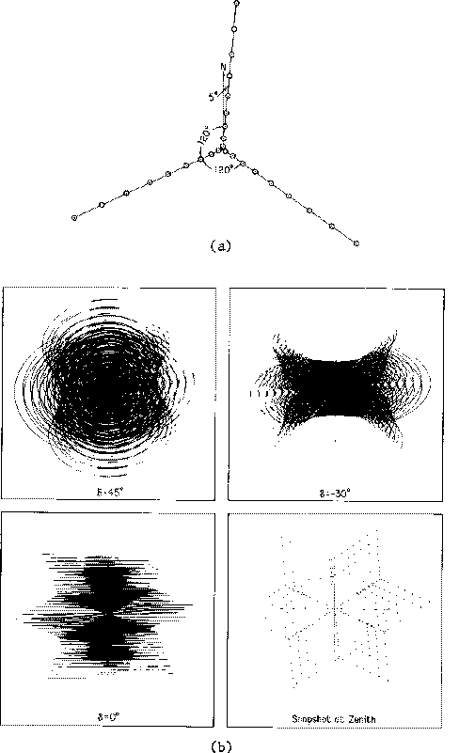

-(a) Configuration of antennas at the Very Large Array (in new mexico)

http://articles.adsabs.harvard.edu//full/1995ApJ...450..559B/0000559.000.html

-Faint Images of Radio Sky provide image of universe outside of traditional optical window. (559)

-produce sky map and source catalog with flux densities for 25% of celestial sphere (559)

-